**WEEK 4**

**spring-rest-handson,** **JWT-handson**

*Superset Id:- 4993066*

***Spring-rest-handson:***

1. **Create a Spring Web Project using Maven:**

Create a SpringLearn Application and build it:

Add Logging to the Application:

Dependency Hierarchy:

Output:

1. **Spring Core – Load Country from Spring Configuration XML:**

**Create Country.java in src/main/java :**

**package** com.cognizant.spring_learn;

**import** org.slf4j.Logger;

**import** org.slf4j.LoggerFactory;

**public** **class** Country {

**private** **static** **final** Logger ***LOGGER*** = LoggerFactory.*getLogger*(Country.**class**);

**private** String code;

**private** String name;

**public** Country() {

***LOGGER***.debug("Inside Country Constructor.");

}

**public** String getCode() {

***LOGGER***.debug("Inside getCode()");

**return** code;

}

**public** **void** setCode(String code) {

***LOGGER***.debug("Inside setCode()");

**this**.code = code;

}

**public** String getName() {

***LOGGER***.debug("Inside getName()");

**return** name;

}

**public** **void** setName(String name) {

***LOGGER***.debug("Inside setName()");

**this**.name = name;

}

@Override

**public** String toString() {

**return** "Country{" +

"code='" + code + '\'' +

", name='" + name + '\'' +

'}';

}

}

**Create a Country.xml in src/main/resources:**

<?xml version=*"1.0"* encoding=*"UTF-8"*?>

<beans xmlns=*"http://www.springframework.org/schema/beans"*

xmlns:xsi=*"http://www.w3.org/2001/XMLSchema-instance"*

xsi:schemaLocation=*"*

*http://www.springframework.org/schema/beans*

*http://www.springframework.org/schema/beans/spring-beans.xsd"*>

<bean id=*"country"* class=*"com.cognizant.springlearn.Country"*>

<property name=*"code"* value=*"IN"*/>

<property name=*"name"* value=*"India"*/>

</bean>

</beans>

**Change SpringLearnApplication code:**

**package** com.cognizant.spring_learn;

**import** org.slf4j.Logger;

**import** org.slf4j.LoggerFactory;

**import** org.springframework.boot.SpringApplication;

**import** org.springframework.boot.autoconfigure.SpringBootApplication;

**import** org.springframework.context.ApplicationContext;

**import** org.springframework.context.annotation.ImportResource;

@SpringBootApplication

@ImportResource("classpath:country.xml") // load the XML bean into Spring Boot context

**public** **class** SpringLearnApplication {

**private** **static** **final** Logger ***LOGGER*** = LoggerFactory.*getLogger*(SpringLearnApplication.**class**);

**public** **static** **void** main(String[] args) {

***LOGGER***.info("START");

ApplicationContext context = SpringApplication.*run*(SpringLearnApplication.**class**, args);

*displayCountry*(context);

***LOGGER***.info("END");

}

**public** **static** **void** displayCountry(ApplicationContext context) {

Country country = context.getBean("country", Country.**class**);

***LOGGER***.debug("Country : {}", country.toString());

}

}

Output:

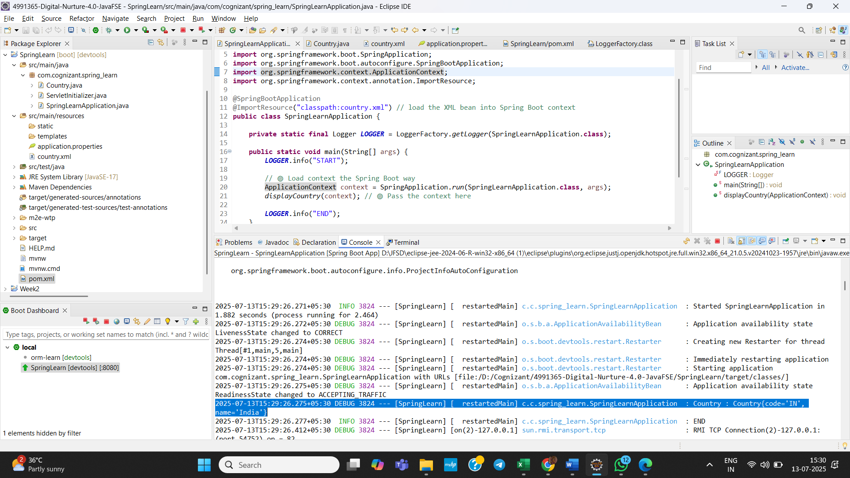

1. **Hello World RESTful Web Service:**

**Create a com.cognizant.spring_learn.controller package**

**Create a HelloController.java :  
package** com.cognizant.spring_learn.controller;

**import** org.slf4j.Logger;

**import** org.slf4j.LoggerFactory;

**import** org.springframework.web.bind.annotation.*;

@RestController

**public** **class** HelloController {

**private** **static** **final** Logger ***LOGGER*** = LoggerFactory.*getLogger*(HelloController.**class**);

@GetMapping("/hello")

**public** String sayHello() {

***LOGGER***.info("START - sayHello()");

***LOGGER***.info("END - sayHello()");

**return** "Hello World!!";

}

}

**Change port to 8083 in application.properties using :**

server.port=8083

**Output:**

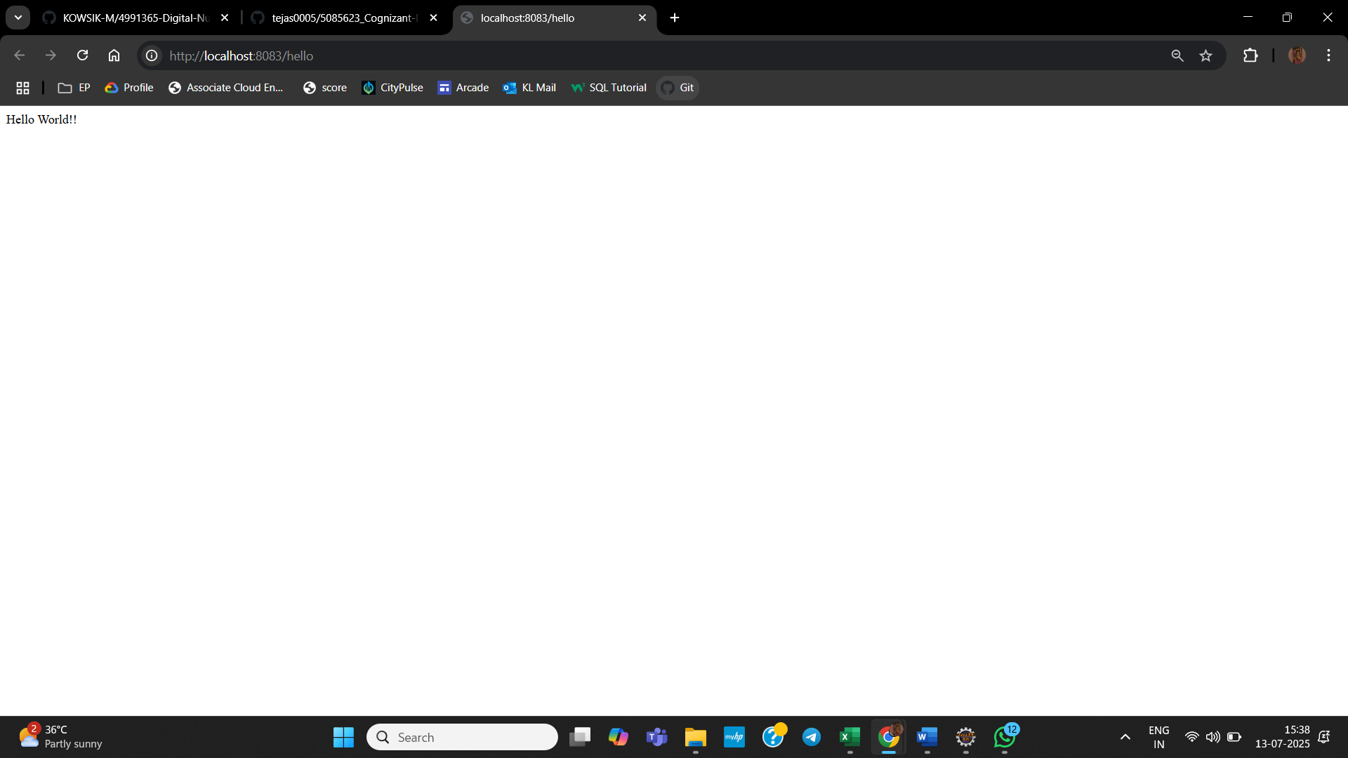

1. **REST - Country Web Service:**

**Create CountryController.java:**

**package** com.cognizant.spring_learn.controller;

**import** com.cognizant.spring_learn.Country;

**import** org.slf4j.Logger;

**import** org.slf4j.LoggerFactory;

**import** org.springframework.beans.factory.annotation.*;

**import** org.springframework.context.ApplicationContext;

**import** org.springframework.web.bind.annotation.*;

@RestController

**public** **class** CountryController {

**private** **static** **final** Logger ***LOGGER*** = LoggerFactory.*getLogger*(CountryController.**class**);

@Autowired

**private** ApplicationContext context;

@RequestMapping("/country")

**public** Country getCountryIndia() {

***LOGGER***.info("START - getCountryIndia()");

Country country = context.getBean("country", Country.**class**);

***LOGGER***.info("END - getCountryIndia()");

**return** country;

}

}

**Output:**

1. **REST - Get country based on country code:**

**Update country.xml with a list of countries:**

<beans xmlns=*"http://www.springframework.org/schema/beans"*

xmlns:xsi=*"http://www.w3.org/2001/XMLSchema-instance"*

xsi:schemaLocation=*"*

*http://www.springframework.org/schema/beans*

*http://www.springframework.org/schema/beans/spring-beans.xsd"*>

<bean id=*"country"* class=*"com.cognizant.spring_learn.Country"*>

<property name=*"code"* value=*"IN"*/>

<property name=*"name"* value=*"India"*/>

</bean>

<bean id=*"countryList"* class=*"java.util.ArrayList"*>

<constructor-arg>

<list>

<bean class=*"com.cognizant.spring_learn.Country"*>

<property name=*"code"* value=*"IN"*/>

<property name=*"name"* value=*"India"*/>

</bean>

<bean class=*"com.cognizant.spring_learn.Country"*>

<property name=*"code"* value=*"US"*/>

<property name=*"name"* value=*"United States"*/>

</bean>

<bean class=*"com.cognizant.spring_learn.Country"*>

<property name=*"code"* value=*"DE"*/>

<property name=*"name"* value=*"Germany"*/>

</bean>

<bean class=*"com.cognizant.spring_learn.Country"*>

<property name=*"code"* value=*"JP"*/>

<property name=*"name"* value=*"Japan"*/>

</bean>

</list>

</constructor-arg>

</bean>

</beans>

**Create a CountryService in a service package:**

**package** com.cognizant.spring_learn.service;

**import** com.cognizant.spring_learn.Country;

**import** org.slf4j.Logger;

**import** org.slf4j.LoggerFactory;

**import** org.springframework.beans.factory.annotation.Autowired;

**import** org.springframework.context.ApplicationContext;

**import** org.springframework.stereotype.Service;

**import** java.util.List;

@Service

**public** **class** CountryService {

**private** **static** **final** Logger ***LOGGER*** = LoggerFactory.*getLogger*(CountryService.**class**);

@Autowired

**private** ApplicationContext context;

**public** Country getCountry(String code) {

***LOGGER***.info("START - getCountry()");

List<Country> countryList = (List<Country>) context.getBean("countryList");

// Lambda-based search (case-insensitive)

Country match = countryList.stream()

.filter(c -> c.getCode().equalsIgnoreCase(code))

.findFirst()

.orElse(**null**);

***LOGGER***.info("END - getCountry()");

**return** match;

}

}

**Update CountryController to get Country by Country Code:**

**package** com.cognizant.spring_learn.controller;

**import** com.cognizant.spring_learn.Country;

**import** com.cognizant.spring_learn.service.CountryService;

**import** org.slf4j.Logger;

**import** org.slf4j.LoggerFactory;

**import** org.springframework.beans.factory.annotation.Autowired;

**import** org.springframework.web.bind.annotation.*;

@RestController

**public** **class** CountryController {

**private** **static** **final** Logger ***LOGGER*** = LoggerFactory.*getLogger*(CountryController.**class**);

@Autowired

**private** CountryService countryService;

@GetMapping("/countries/{code}")

**public** Country getCountry(@PathVariable String code) {

***LOGGER***.info("START - getCountry()");

Country country = countryService.getCountry(code);

***LOGGER***.info("END - getCountry()");

**return** country;

}

}

**Output:**

***JWT-handson:***

1. **Create authentication service that returns JWT:**

**Add Spring Security dependency:**

<dependency>

<groupId>org.springframework.boot</groupId>

<artifactId>spring-boot-starter-security</artifactId>

</dependency>

**Create AuthenticationController.java:**

**package** com.cognizant.spring_learn.controller;

**import** org.slf4j.Logger;

**import** org.slf4j.LoggerFactory;

**import** org.springframework.web.bind.annotation.*;

**import** java.util.HashMap;

**import** java.util.Map;

@RestController

**public** **class** AuthenticationController {

**private** **static** **final** Logger ***LOGGER*** = LoggerFactory.*getLogger*(AuthenticationController.**class**);

@GetMapping("/authenticate")

**public** Map<String, String> authenticate(@RequestHeader("Authorization") String authHeader) {

***LOGGER***.info("START - authenticate()");

***LOGGER***.debug("Authorization Header: {}", authHeader);

Map<String, String> map = **new** HashMap<>();

map.put("token", ""); // JWT will be filled in later

***LOGGER***.info("END - authenticate()");

**return** map;

}

}

**Create a com.cognizant.spring_learn.config and in that SecurityConfig.java:**

**package** com.cognizant.spring_learn.config;

**import** org.springframework.context.annotation.Configuration;

**import** org.springframework.security.config.annotation.web.builders.HttpSecurity;

**import** org.springframework.security.web.SecurityFilterChain;

**import** org.springframework.context.annotation.Bean;

@Configuration

**public** **class** SecurityConfig {

@Bean

**public** SecurityFilterChain filterChain(HttpSecurity http) **throws** Exception {

http.csrf(csrf -> csrf.disable())

.authorizeHttpRequests(authz -> authz

.requestMatchers("/countries").hasRole("USER")

.requestMatchers("/authenticate").hasAnyRole("USER", "ADMIN")

.anyRequest().authenticated()

)

.httpBasic();

**return** http.build();

}

}

**Create a MyUserDetailsConfig:**

**package** com.cognizant.spring_learn.config;

**import** org.springframework.context.annotation.Bean;

**import** org.springframework.context.annotation.Configuration;

**import** org.springframework.security.core.userdetails.*;

**import** org.springframework.security.provisioning.InMemoryUserDetailsManager;

**import** org.springframework.security.crypto.bcrypt.BCryptPasswordEncoder;

**import** org.springframework.security.crypto.password.PasswordEncoder;

@Configuration

**public** **class** MyUserDetailsConfig {

@Bean

**public** InMemoryUserDetailsManager userDetailsService(PasswordEncoder passwordEncoder) {

UserDetails user = User.*builder*()

.username("user")

.password(passwordEncoder.encode("pwd"))

.roles("USER")

.build();

UserDetails admin = User.*builder*()

.username("admin")

.password(passwordEncoder.encode("admin"))

.roles("ADMIN")

.build();

**return** **new** InMemoryUserDetailsManager(user, admin);

}

@Bean

**public** PasswordEncoder passwordEncoder() {

**return** **new** BCryptPasswordEncoder();

}

}

**Output:**

