THE EUROPEAN CENTRAL BANK
Executive Summary
Customer Engagement & Product Utilization Analytics for Retention Strategy
This summary presents the headline findings and recommended actions from an analysis of 10,000 retail banking customers across France, Germany, and Spain, prepared for government and senior-stakeholder review. The full technical analysis and supporting evidence are documented in the accompanying research paper.
20.4%  Overall customer churn | 1.88x  Churn risk, inactive vs active | 833  At-risk premium customers | 2x  Germany churn vs France/Spain

Why This Matters
Retention strategy has historically assumed that wealthier, higher-balance customers are inherently more loyal. This analysis shows that assumption is false: customer engagement — not account size — is the dominant factor separating customers who stay from those who leave. This has direct implications for how the bank allocates relationship-management resources and designs retention programs.

What We Found
- One customer in five (20.4%) has churned across the analyzed base.
- Inactive customers are nearly twice as likely to churn as active customers (1.88x), regardless of how much money they hold with the bank.
- Customers holding two bank products are the most loyal group in the entire dataset (7.6% churn); customers pushed to three or more products show near-total churn (83–100%), pointing to a sales-process issue rather than a loyalty benefit.
- 833 customers — 8.3% of the base — are financially significant (above-median balance and salary) but currently disengaged. These customers are not yet lost, and represent the clearest near-term opportunity for intervention.
- Germany's customer base churns at roughly double the rate of France and Spain, despite holding the highest average balances of the three markets — indicating a market-specific engagement gap rather than a wealth or pricing problem.
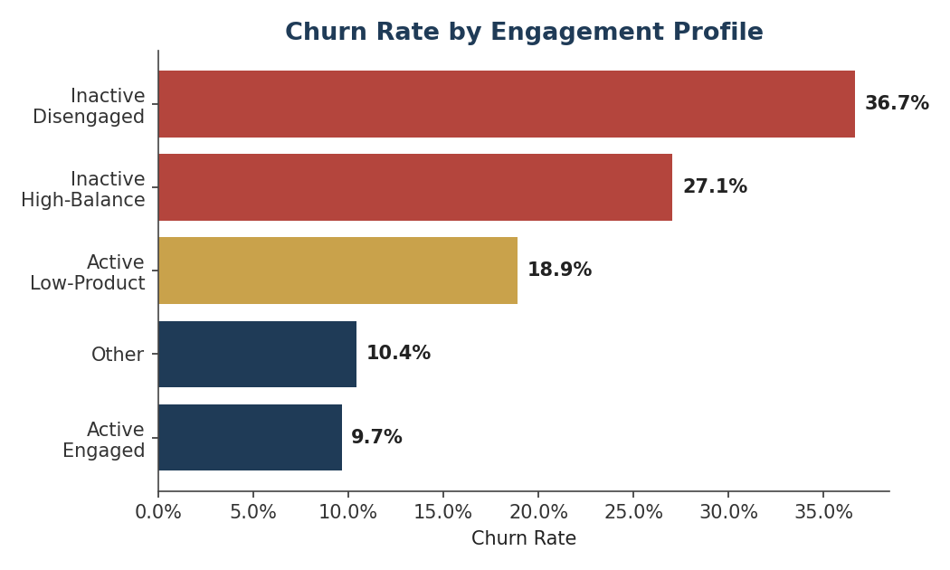
Churn rate by customer engagement profile — the clearest single driver identified in the analysis.

Recommended Actions
Action | Target Population | Priority
Proactive relationship-manager outreach | 833 high-balance, high-salary, inactive customers | Critical
Audit sales process behind 3–4 product accounts | 326 customers with 3+ products (82–100% churn) | Critical
Germany-specific engagement task force | Entire German customer base (32.4% churn) | High
Life-stage financial review program | 41–60 age band (up to 56% churn) | High
Low-cost digital reactivation campaign | 2,521 inactive, low-product customers | Medium

Bottom Line
Retention efforts should be re-prioritized around behavioral engagement rather than account value alone. The 833-customer at-risk premium segment offers the fastest, most defensible return on a targeted retention investment, while the German market and the over-sold product segment warrant structural review. A live analytics dashboard has been delivered alongside this summary so that these indicators can be tracked on an ongoing basis rather than assessed only at the time of this report.

