The European Central Bank
Customer Engagement & Product Utilization Analytics for Retention Strategy
A Behavioral Approach to Understanding and Reducing Customer Churn
Research Paper
Prepared for: Unified Mentor — The European Central Bank
Dataset: 10,000 retail banking customers (France, Germany, Spain)
September 2026

Abstract
Retail banks routinely assume that financial strength — high balances, high salaries — signals customer loyalty. This study tests that assumption against a 10,000-customer dataset from a European retail bank operating in France, Germany, and Spain. Using engagement classification, product-utilization analysis, and a set of relationship-strength KPIs, the analysis finds that behavioral engagement, not wealth, is the dominant driver of churn. Inactive customers churn at nearly twice the rate of active ones; a specific band of over-sold customers (three or more products) churns almost universally; and Germany's high-balance customer base is systematically under-engaged and over-represented in the highest-risk segments. The paper concludes with a prioritized set of retention interventions targeting the roughly 3,300 customers who are simultaneously disengaged and financially significant.

1. Background and Context
Banks increasingly recognize that customer behavior and engagement — not just demographics or account size — determine long-term retention. A customer may appear financially strong, holding a high balance or drawing a high salary, and still leave the institution because the relationship itself is shallow: limited product adoption, low day-to-day engagement, and weak relationship depth with the bank. Understanding how customers actually use banking products and services is therefore essential to designing effective cross-sell strategies, loyalty programs, and engagement-driven retention initiatives. This project evaluates retention through the lens of customer behavior and relationship strength, using the European Central Bank's anonymized retail customer dataset as its evidentiary base.

2. Problem Statement
Despite holding rich data on customer engagement and product usage, the bank currently lacks three things: quantitative insight into which specific behaviors drive retention, clarity on whether product depth genuinely reduces churn or simply correlates with it, and evidence on whether high account balances alone are sufficient to ensure loyalty. In the absence of this evidence, retention strategies tend to be generic — applied uniformly across the customer base — rather than targeted at the behavioral patterns that actually predict attrition.

3. Objectives

3.1 Primary Objectives
- Evaluate the quantitative relationship between customer engagement and churn.
- Measure the retention impact of product count and product mix (the "product depth" effect).
- Identify disengaged yet high-value customers who represent silent, high-impact churn risk.

3.2 Secondary Objectives
- Support the design of engagement-driven retention strategies.
- Improve product-bundling decisions to avoid over-selling and mis-selling.
- Reduce silent churn among premium customers who show no overt distress signals.

4. Dataset Description
The dataset comprises 10,000 anonymized retail banking customers, each described by 13 attributes covering demographics, financial standing, product usage, and churn outcome. There are no missing values and all binary indicators (credit card ownership, active-membership status, churn) are consistent and correctly encoded.
Field | Description
CustomerId / Surname | Unique identifier and surname (anonymization keys, not used analytically)
CreditScore | Customer creditworthiness score
Geography | Customer's home market — France, Spain, or Germany
Gender | Male / Female
Age | Customer age in years
Tenure | Years the customer has held a relationship with the bank
Balance | Current account balance (€)
NumOfProducts | Count of bank products held (1–4)
HasCrCard | Whether the customer holds a credit card (binary)
IsActiveMember | Whether the customer is behaviorally active (binary)
EstimatedSalary | Estimated annual salary (€)
Exited | Churn indicator — target variable (1 = churned)

5. Analytical Methodology
The analysis followed the five-stage methodology specified in the project brief: (1) data ingestion and validation, (2) engagement classification, (3) product utilization analysis, (4) financial-commitment-versus-engagement analysis, and (5) retention-strength assessment. Each stage is summarized below alongside its findings.

5.1 Data Ingestion & Validation
The dataset was loaded and checked for completeness: all 10,000 records are complete across all 14 fields, binary fields (HasCrCard, IsActiveMember, Exited) contain only 0/1 values, and churn labeling is internally consistent (no exited customer shows implausible activity patterns). No records required exclusion.

5.2 Engagement Classification
Customers were classified into behavioral profiles combining activity status, product count, and balance level relative to the base median (€97,199):
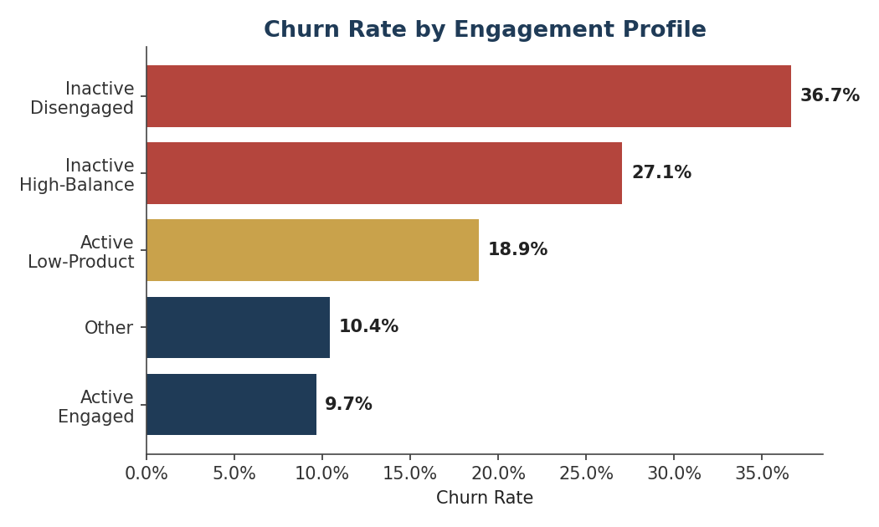
Figure 1. Churn rate by engagement profile.
Engagement Profile | Customers | Churn Rate | Priority
Inactive Disengaged | 2,521 | 36.7% | Critical — highest churn, largest segment
Inactive High-Balance | 813 | 27.1% | Critical — silent premium churn
Active, Low-Product | 2,563 | 18.9% | High — cross-sell opportunity
Other / Mixed | 1,515 | 10.4% | Monitor
Active Engaged | 2,588 | 9.7% | Low — retention model to replicate
The two "inactive" profiles — Inactive Disengaged and Inactive High-Balance — together represent 3,334 customers (33.3% of the base) and churn at 2.7–3.8x the rate of the Active Engaged segment. This is the single clearest signal in the dataset: activity status, more than any other variable, separates loyal customers from those about to leave.

5.3 Product Utilization Analysis
Churn rate by product count reveals a sharply non-linear relationship:
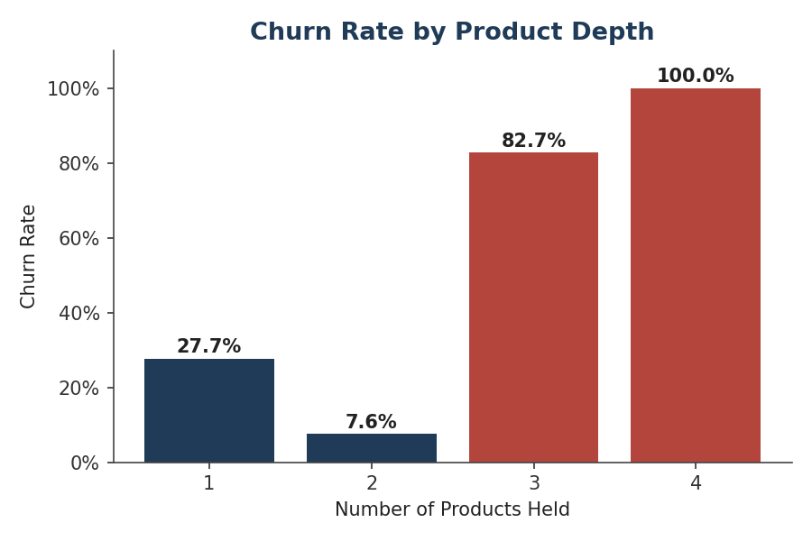
Figure 2. Churn rate by number of products held.
Customers with a single product churn at 27.7%, but this nearly halves to 7.6% for customers holding two products — the strongest retention effect found in the entire analysis. Beyond two products, however, the pattern reverses catastrophically: 82.7% of three-product customers and 100% of four-product customers have churned. This is not a story of "more products, more loyalty." Rather, it indicates that the 3–4 product segment (326 customers, 3.3% of the base) is a distinct population — likely customers who were sold products reactively, through complaint resolution, retention offers, or bundling pressure, and who churned regardless. Product depth of two appears to be the genuine retention sweet spot; three-plus is a red flag requiring investigation into the underlying sales process, not a target for further cross-selling.

5.4 Financial Commitment vs. Engagement Analysis
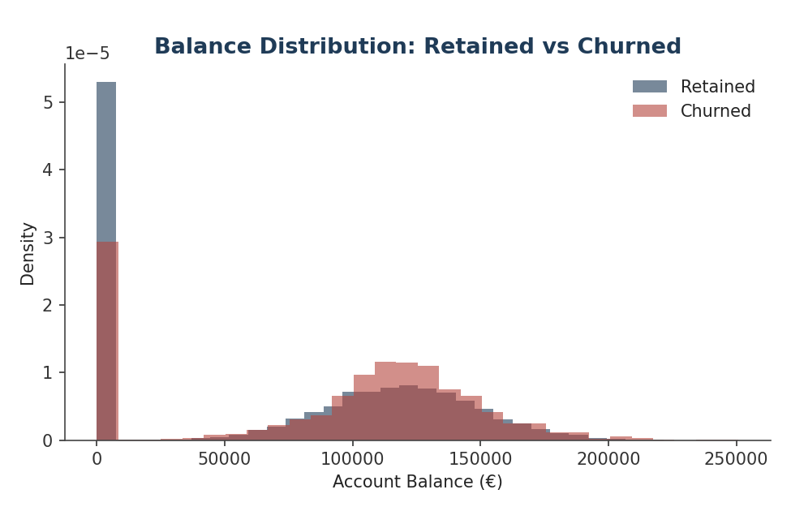
Figure 3. Balance distribution — retained vs. churned customers.
Balance alone is a weak predictor of loyalty: churned and retained customers show broadly overlapping balance distributions, and customers holding a zero balance actually churn less often (13.8%) than those with a positive balance (24.1%), likely reflecting a mix of low-engagement dormant-but-stable accounts and single-product transactional relationships. The more informative cross-cut is balance combined with activity: among above-median-balance customers, those who are inactive churn at 32.3%, versus a much lower rate among active high-balance customers. This confirms the brief's central hypothesis — high balance does not protect against churn once engagement drops.
Cross-referencing balance, salary, and activity identifies 833 customers (8.3% of the base) who are simultaneously above-median balance, above-median salary, inactive, and not yet churned. This is the bank's "at-risk premium" population: financially significant, currently retained, but showing the exact behavioral signature — inactivity — that precedes churn elsewhere in the data.

5.5 Retention Strength Assessment
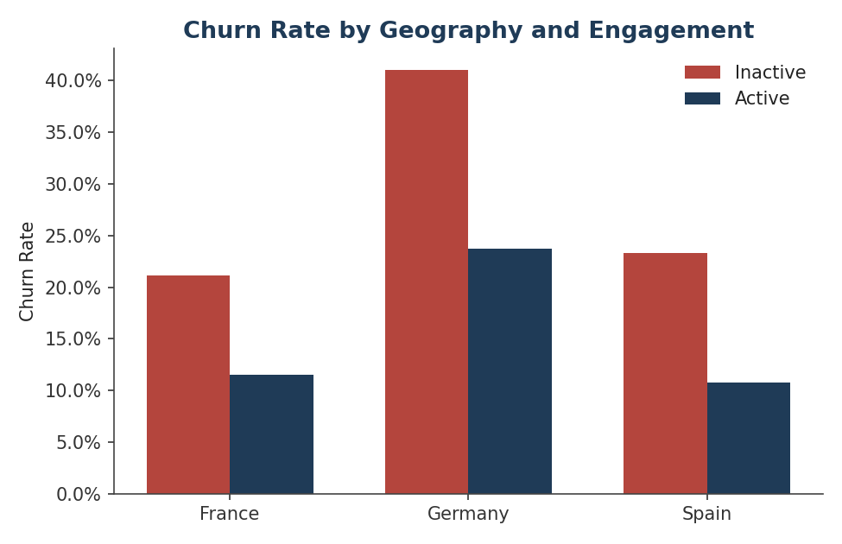
Figure 4. Churn by geography and engagement status.
Germany stands out sharply: 32.4% overall churn versus roughly 16% in France and Spain — double the rate — despite Germany's customers holding the highest average balances (€119,730 vs. a €76,486 base average). Within Germany, inactive customers churn at 41.1% versus 23.7% for active ones, confirming that the German book's elevated risk is an engagement problem layered on top of a wealthy, otherwise attractive customer base, not a product or pricing problem alone.
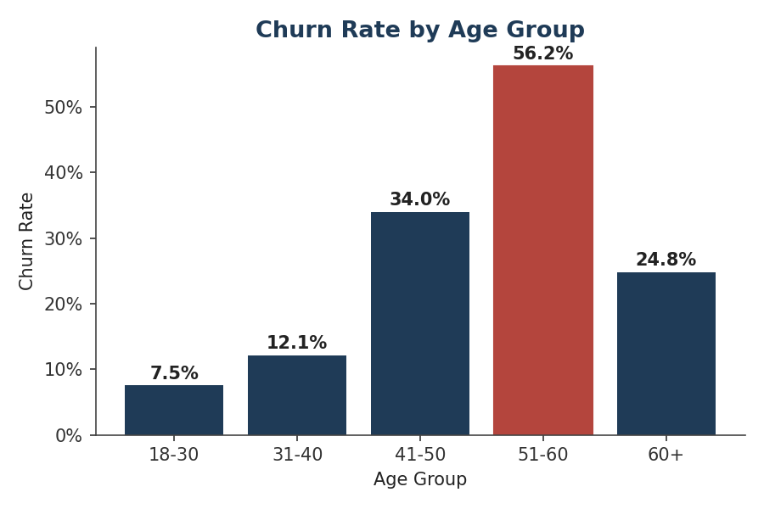
Figure 5. Churn rate by age group.
Age compounds the risk: churn rises steadily from 7.5% (18–30) to a peak of 56.2% among 51–60-year-olds, before falling back for the 60+ group (24.8%), who are likely a more settled, lower-mobility population. The 41–60 age band, which combines high tenure, high balances, and (per the engagement analysis) middling activity, is the bank's highest-value and highest-risk cohort simultaneously.
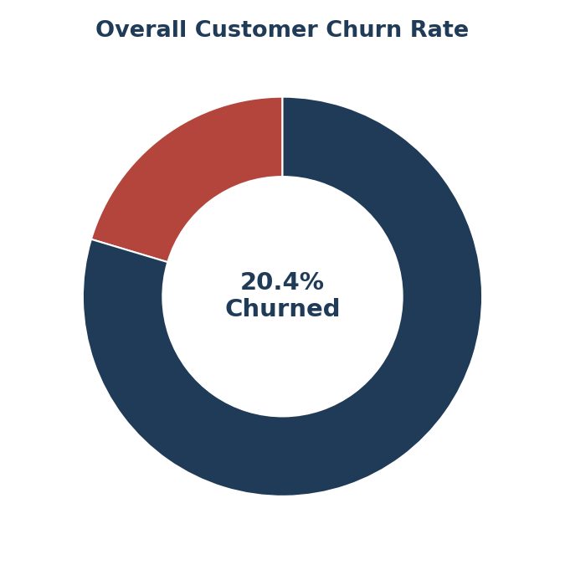
Figure 6. Overall customer churn rate across the 10,000-customer base.

6. Key Performance Indicators
Five KPIs were constructed to translate the behavioral findings into monitorable, dashboard-ready metrics:
KPI | Definition | Measured Value | Interpretation
Engagement Retention Ratio | Churn rate of inactive members vs. active members | 1.88x | Inactive customers are almost twice as likely to churn.
Product Depth Index | Churn rate by number of products held | 1: 27.7% | 2: 7.6% | 3: 82.7% | 4: 100% | Two products is the retention sweet spot; 3+ signals distress, not loyalty.
High-Balance Disengagement Rate | Churn among above-median balance customers who are inactive | 32.3% | Wealth does not protect against churn once engagement drops.
Credit Card Stickiness Score | Churn delta between active card holders and active non-holders | 13.4% vs 16.4% | Card ownership alone has weak effect; activity level dominates.
Relationship Strength Index | Composite of activity status and product depth, correlated to churn | r = -0.16 | Stronger relationships modestly but consistently reduce churn risk.

7. Insights Summary
- Engagement, not wealth, is the dominant churn driver — inactive members churn at 1.88x the rate of active members, holding balance and salary constant.
- Two products is the retention optimum; one product under-serves the relationship, and three or more marks a distressed, near-100%-churn segment requiring root-cause review of how those products were sold.
- Germany is a structurally higher-risk, higher-value market — double the churn rate of France and Spain on a wealthier customer base — and merits a dedicated retention program rather than a pan-European default treatment.
- 8.3% of the customer base (833 customers) are high-balance, high-salary, and inactive: a concrete, addressable "at-risk premium" list for proactive outreach.
- Credit card ownership on its own has little retention effect (20.8% vs. 20.2% churn); its apparent value is fully explained by whether the cardholder is also behaviorally active.
- The 41–60 age band combines high tenure and high value with the steepest churn curve in the dataset, making it the single highest-priority segment for relationship-manager attention.

8. Recommendations

8.1 Immediate Actions
- Launch a proactive outreach program to the 833-customer at-risk premium list, prioritized by relationship manager assignment rather than mass marketing.
- Freeze default cross-sell campaigns pushing customers toward a third or fourth product until the sales process behind the existing 3–4 product cohort is audited.
- Stand up a Germany-specific engagement task force, given the market's disproportionate churn-to-value ratio.

8.2 Structural / Programmatic
- Redesign the cross-sell playbook around a target of exactly two well-matched products per customer, rather than treating product count as a linear loyalty lever.
- Introduce an engagement-first early-warning score (combining activity status, product depth, and tenure) to flag at-risk customers before balance or salary would suggest any concern.
- Build recurring reporting on the five KPIs in Section 6 into quarterly retention reviews, so engagement — not just balance growth — becomes a tracked relationship-management metric.

8.3 Segment-Specific
- For Inactive Disengaged customers (2,521 people, 36.7% churn): low-cost reactivation campaigns — digital nudges, fee waivers, simplified re-engagement products.
- For Inactive High-Balance customers (813 people, 27.1% churn): white-glove relationship-manager outreach; these customers can support the cost of a human touchpoint.
- For the 41–60 age band: proactive life-stage financial reviews (retirement planning, wealth consolidation) that create a reason for renewed engagement.

9. Conclusion
This project reframes customer churn from a behavioral and relationship-strength perspective rather than a purely demographic one. The evidence is consistent across every cut of the data: engagement, not account size, is what keeps customers with the bank. By targeting the specific, quantifiable segments identified here — the at-risk premium 8.3%, the distressed 3-4 product cohort, the German inactive base, and the 41–60 age band — the bank can move from generic retention campaigns to a small number of high-leverage, evidence-based interventions. The accompanying Streamlit dashboard operationalizes these findings for ongoing monitoring by the retention and relationship-management teams.

