EXECUTIVE SUMMARY
Where European retail banking loses its customers
Customer segmentation and churn analysis: France, Germany and Spain (10,000 customers)
One in five customers (20.4%) has left the bank, but the loss is not evenly spread. Four groups account for most of it: German customers, customers aged 46–60, inactive members and customers holding only one product. Targeting these groups is far more efficient than a generic retention campaign.

Key findings
Finding | Evidence
Germany is the hot spot | 32.4% churn vs 16.2% (France) and 16.7% (Spain). 25% of customers, 40% of all churners.
Mid-career and pre-retirement customers leave most | 51.1% churn at ages 46–60, against 7.6% for under-30s. German customers aged 46–60 churn at 67%.
Inactive members are at double the risk | 26.9% churn vs 14.3% for active members; inactive members are 64% of churners.
A second product builds loyalty | Two-product customers churn at 7.6% vs 27.7% for one product. Three or four products: 83–100% (small group; needs review).
Women churn more than men | 25.1% vs 16.5%, in every country and age band.
High-value customers carry the money risk | Top-quartile balances churn at 23.7%; churned customers in this group held €88.7M, 48% of all balances lost.
Tenure, credit score and salary do not explain churn | Churn varies by less than 2 percentage points across their bands.

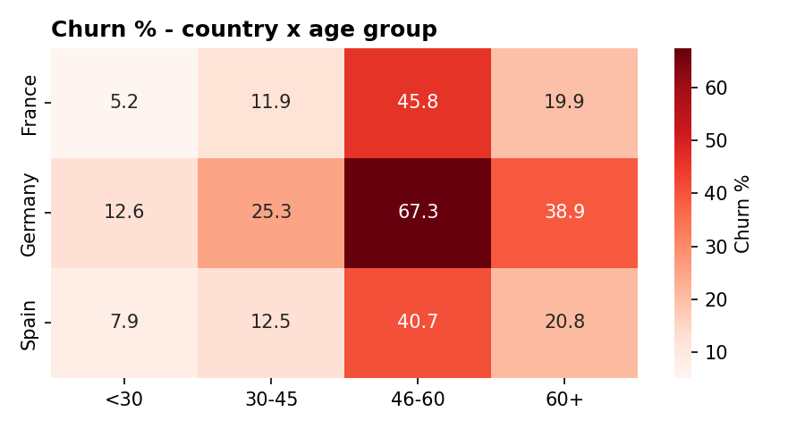
Churn rate (%) by country and age group

Recommended actions
- Germany programme: investigate causes (pricing, competition, service) and pilot retention offers there first.
- 46–60 cohort: proactive relationship-manager outreach and planning propositions; German customers first.
- Reactivation triggers: contact customers as soon as activity lapses, especially those over 45.
- Second-product drive: move the 5,084 single-product customers toward a second product.
- Audit 3–4 product bundles: review sales practice and fees behind 83–100% churn before expanding cross-sell.
- Protect high-balance customers with dedicated coverage and inactivity monitoring.
- Early-warning score: rank customers by risk using age, products, activity, balance and country.

Headline indicators
Indicator | Value
Overall churn rate | 20.4% (2,037 of 10,000)
High-value churn ratio | 23.7%
Geographic risk index (100 = average) | Germany 159 | Spain 82 | France 79
Engagement drop indicator | +12.6 percentage points (inactive vs active)
Balances held by churned customers | €185.6M, 24.3% of all balances

Caveats: the data is one 2025 snapshot, so findings are associations rather than proven causes. It has balances but no revenue or margin figures, so financial exposure is expressed as balance at risk (currency assumed to be euros). Full method, evidence and limitations are in the accompanying research paper, and the Streamlit dashboard allows live exploration of every segment.

