RESEARCH PAPER
Customer Segmentation & Churn Pattern Analytics in European Banking
Exploratory analysis, segment insights and retention recommendations from 10,000 retail customers in France, Germany and Spain

Abstract
Customer churn is one of the largest hidden costs in retail banking. This paper analyses a customer-level dataset of 10,000 retail banking customers across France, Germany and Spain to answer three questions: which customer groups churn most, how churn differs across countries and demographics, and how concentrated churn is among high-value customers.
The overall churn rate is 20.4% (2,037 customers). Churn is highly uneven. Germany churns at 32.4%, twice the rate of France (16.2%) and Spain (16.7%), and contributes 40% of all churners from 25% of the customer base. Customers aged 46–60 churn at 51.1%, women churn at 25.1% versus 16.5% for men, and inactive members churn at 26.9% versus 14.3% for active members. Product holding is the sharpest divider: customers with two products churn at 7.6%, single-product customers at 27.7%, and customers with three or four products at 83% and 100%. Tenure, credit score, estimated salary and credit-card ownership show little or no meaningful relationship with churn. Among the top quartile of customers by balance, churn is 23.7%, and the churned customers in that group held €88.7M, which is 47.8% of all balances lost to churn.
A gradient-boosting model confirms the segmentation findings (cross-validated AUC 0.87), ranking age, number of products, activity status, balance and German residency as the leading drivers. We conclude with seven targeted retention recommendations.

1. Introduction and objectives
Losing existing customers reduces lifetime value, raises acquisition costs and makes revenue unstable. Banks usually track a single headline churn rate, but that number hides where the loss actually happens. Generic retention campaigns are therefore reactive and inefficient. This study applies systematic, segmentation-driven analytics to close that gap.
Primary objectives: (1) measure the overall churn rate; (2) identify churn distribution across customer segments; (3) compare churn behaviour across European regions.
Secondary objectives: (4) understand churn among high-value customers; (5) evaluate engagement and tenure patterns; (6) support strategic planning and marketing decisions.

2. Data and methodology

2.1 Dataset and validation
The dataset contains 10,000 customer records with 13 fields: CustomerId, Surname, CreditScore, Geography, Gender, Age, Tenure, Balance, NumOfProducts, HasCrCard, IsActiveMember, EstimatedSalary and the target Exited (1 = churned). A Year field (constant, 2025) is also present. Validation found no missing values, no duplicate CustomerIds, strictly binary values in HasCrCard, IsActiveMember and Exited, and only the three expected countries. NumOfProducts ranges from 1 to 4. Churn labels are consistent: 2,037 exited and 7,963 retained. The data is a single 2025 snapshot, so it shows who had left, not when.

2.2 Cleaning and segmentation design
Surname and the constant Year field were removed as non-analytical. Categorical variables were typed for grouping, and the following derived segments were created:
Dimension | Segments | Definition
Geography | France, Germany, Spain | As recorded
Age | <30, 30–45, 46–60, 60+ | Age in years
Credit score band | Low, Medium, High | <600, 600–699, 700+
Tenure group | New, Mid-term, Long-term | 0–2, 3–6, 7–10 years
Balance segment | Zero, Low, High | Zero; at or below / above the median non-zero balance (€119,840)
High-value customer | Premium | Balance in top quartile (≥ €127,644)

Band thresholds are analyst-defined because the brief specifies the labels but not the cut-offs; they are documented here and adjustable in the dashboard. Currency is assumed to be euros; the dataset does not state a currency.

2.3 Analytical approach
We computed overall and segment-wise churn rates, each segment’s share of customers versus share of churners, and comparisons of churned versus retained profiles. Geography–age, geography–gender, geography–activity and age–activity interactions were examined, as were salary-versus-balance patterns. Chi-square tests (categorical segments) and Welch t-tests (numeric fields) assessed statistical significance. Finally, logistic regression and gradient boosting (5-fold cross-validated AUC) were used as a cross-check on which variables carry predictive signal. With 10,000 records, even small differences can look significant, so we focus on effect size and treat tests as a filter for noise.

2.4 Key performance indicators
KPI | Definition | Value
Overall churn rate | Exited customers / all customers | 20.4%
Segment churn rate | Churn % within a segment | See Section 3
High-value churn ratio | Churn among top-quartile-balance customers | 23.7%
Geographic risk index | Country churn rate / overall rate × 100 | Germany 159, Spain 82, France 79
Engagement drop indicator | Inactive churn rate − active churn rate | +12.6 pp (relative risk 1.9×)

3. Results

3.1 Overall churn
2,037 of 10,000 customers exited, an overall churn rate of 20.4%, or roughly one customer in five. Churned customers hold 24.3% of all balances (€185.6M of €764.9M), so churners are on average wealthier than the customers who stay (mean balance €91.1k versus €72.7k).
Profile | Churned | Retained
Customers | 2,037 | 7,963
Average age | 44.8 | 37.4
Average balance | €91,109 | €72,745
Average credit score | 645 | 652
Average tenure (years) | 4.9 | 5.0
Average estimated salary | €101,466 | €99,738
Active members | 36% | 55%

The profile gap is driven by age and balance. Credit score, tenure and salary are nearly identical between the two groups, an early sign that the usual “financial stability” explanations do not explain churn here.

3.2 Geographic comparison
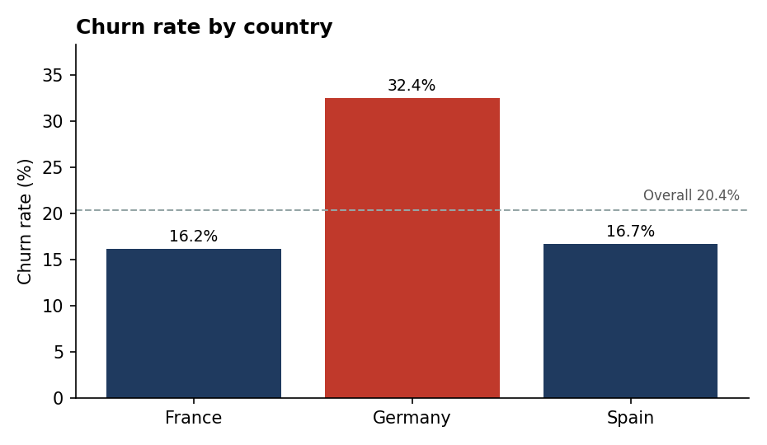
Figure 1. Churn rate by country
Germany is the outlier: 32.4% of German customers left, against 16.2% in France and 16.7% in Spain. Germany holds 25.1% of the customer base but accounts for 40.0% of churners, while France (50% of customers) accounts for 39.8% and Spain for 20.3%. The Geographic Risk Index makes the exposure explicit: Germany 159, Spain 82, France 79 (100 = bank average).
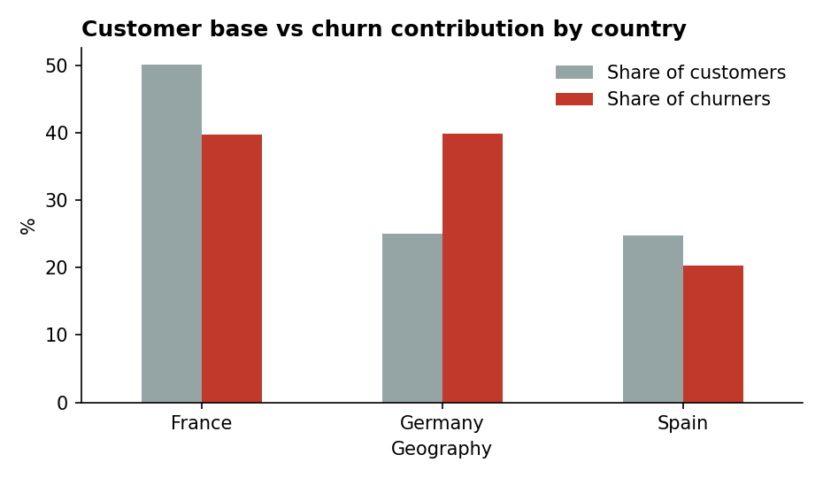
Figure 2. Share of customers vs share of churners by country
Germany’s excess risk is broad-based, not the product of one segment. German churn is higher in every gender, age and activity group and in nearly every product-count group we examined (for example 41.1% among inactive Germans versus 21.1% in France). It is also structurally different: no German customer has a zero balance, whereas 48% of French and Spanish customers do, and German customers hold on average €119.7k versus about €62k elsewhere. The data cannot say whether this reflects product design, pricing, competition or customer mix in Germany, which is a question for qualitative follow-up.

3.3 Age: the strongest single segmentation
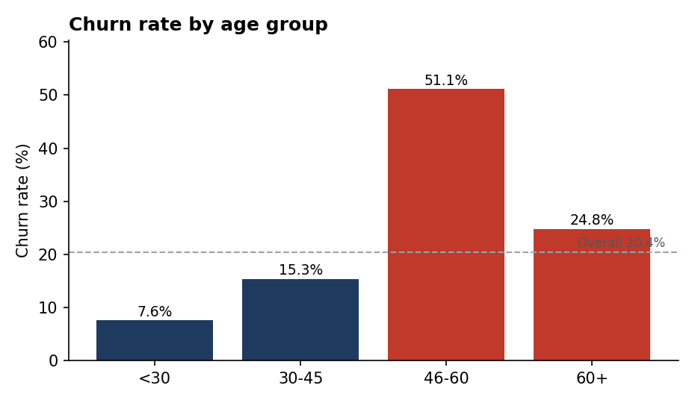
Figure 3. Churn rate by age group
Churn rises steeply with age until 60. Customers aged 46–60 churn at 51.1%, compared with 15.3% for ages 30–45 and 7.6% for under-30s. The 46–60 group is just 16.5% of customers but 41.3% of all churners. Beyond 60 the rate falls to 24.8%, though this group is small (464 customers).
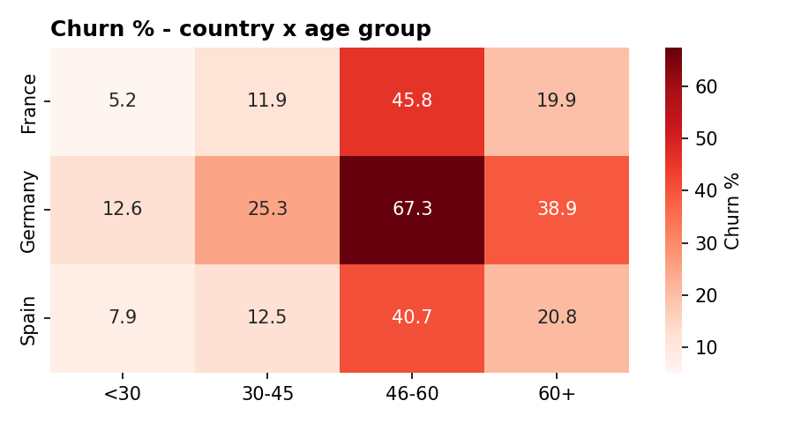
Figure 4. Churn by country and age group (%)
Geography and age compound each other. Germans aged 46–60 churn at 67.3%, meaning two in three leave, compared with 45.8% in France and 40.7% in Spain for the same age band. This single cell (German customers aged 46–60) is the most acute retention problem in the dataset.

3.4 Gender
Women churn at 25.1% versus 16.5% for men. Women are 45.4% of customers but 55.9% of churners. The gap is consistent across all countries (Germany 37.6% vs 27.8%; France 20.3% vs 12.7%; Spain 21.2% vs 13.1%) and all age bands (for ages 46–60, 57.3% vs 45.0%), so it is not an artefact of mix.

3.5 Engagement and product holding
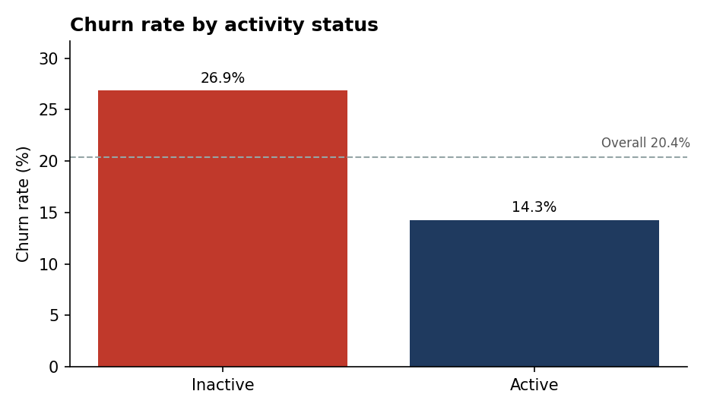
Figure 5. Churn rate by activity status
Inactive members churn at 26.9% versus 14.3% for active members, an Engagement Drop Indicator of +12.6 percentage points. Inactive customers are 48.5% of the base but 63.9% of churners. Activity matters most for older customers: among 60+ customers, 82.0% of inactive members churned versus 11.2% of active members, and among 46–60 year-olds the figures are 68.4% and 35.3% (small cells; interpret with care). Activity status is a snapshot, so it may be partly a consequence of a customer already disengaging rather than a cause.
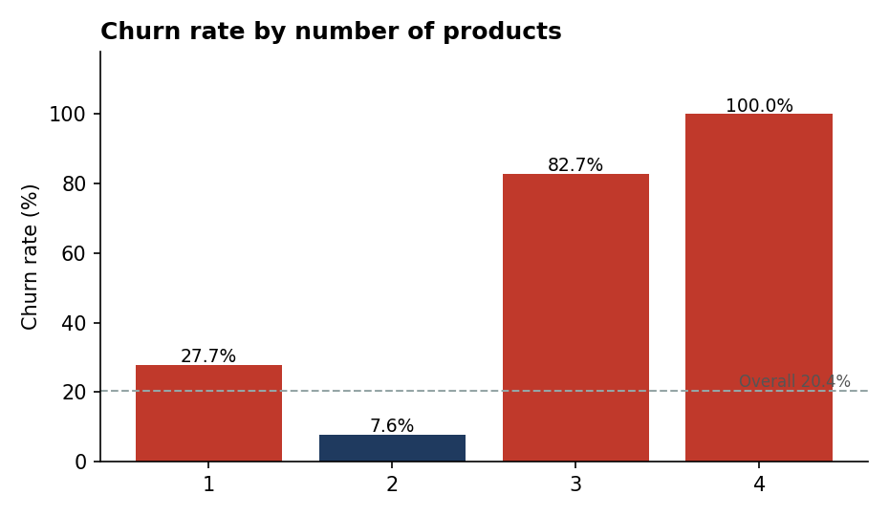
Figure 6. Churn rate by number of products
Product holding shows the largest spread of any variable. Single-product customers churn at 27.7% and hold 69.2% of the churn. Two-product customers churn at only 7.6%, the most loyal group in the bank. Customers with three or four products churn at 82.7% and 100% respectively. The three-to-four-product groups are small (266 and 60 customers), so this is not a large share of volume, but the pattern is extreme and consistent across all three countries. It suggests that a second product deepens loyalty, whereas heavy cross-selling beyond two products may be associated with dissatisfaction or mis-selling; this should be investigated before it is generalised.

3.6 Balance, salary and high-value customers
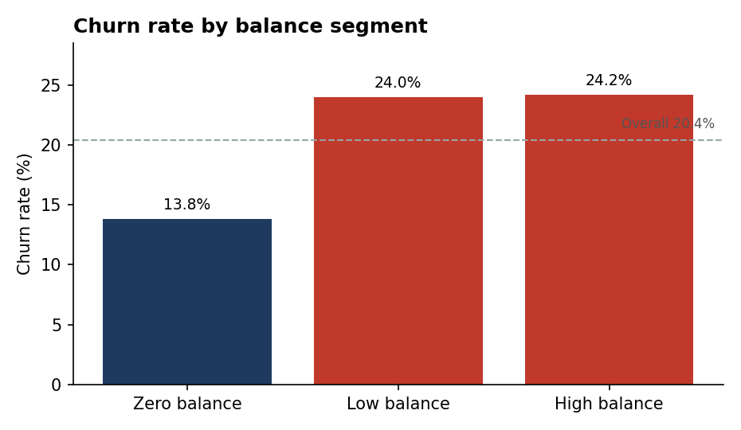
Figure 7. Churn rate by balance segment
Zero-balance customers churn least (13.8%), while low- and high-balance customers churn at about 24%. Part of this gap is a geography effect, because all zero-balance customers are in France or Spain. Within France, churn rises modestly from 13.9% (zero balance) to 16.8% (low) and 19.6% (high); within Germany it is 33.3% and 31.6% for low and high balances, so balance is a weaker driver than the headline suggests once country is held fixed.
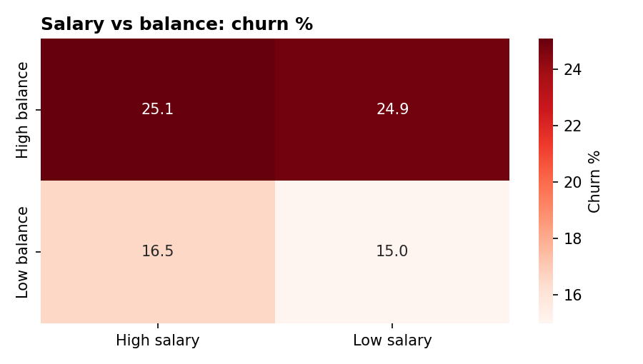
Figure 8. Churn by salary and balance (median splits)
Salary is not a churn driver. Customers with a high balance churn at 24.9–25.1% regardless of salary, while low-balance customers churn at 15.0–16.5% regardless of salary. Balance and salary are essentially uncorrelated in this data (r = 0.01), so a customer’s salary tells us nothing about how much money they keep with the bank or whether they will leave.
For high-value customers (top-quartile balance, 2,500 customers), churn is 23.7%, slightly above the bank average. They account for 29.1% of churners, and the churned customers in this group held €88.7M, equal to 47.8% of all churned balances and 11.6% of the bank’s total balances. Inactive high-value customers churn at 30.5% versus 16.9% for active ones. The revenue risk is therefore a balance-retention problem as much as a headcount problem. Note that the dataset contains balances, not revenue or margin, so we report balance at risk rather than lost income.

3.7 Variables with little or no effect
Variable | Churn range across segments | Significant?
Credit score band | 19.7% – 21.8% | No (p = 0.08)
Tenure group | 19.5% – 21.2% | No (p = 0.25)
Salary tercile | 19.8% – 21.2% | No (p = 0.31)
Has credit card | 20.2% vs 20.8% | No (p = 0.49)

Tenure deserves emphasis: newer and long-standing customers churn at nearly the same rate, so retention effort should not be limited to “new customer onboarding”. Long-tenured customers are just as likely to leave.

3.8 Predictive cross-check
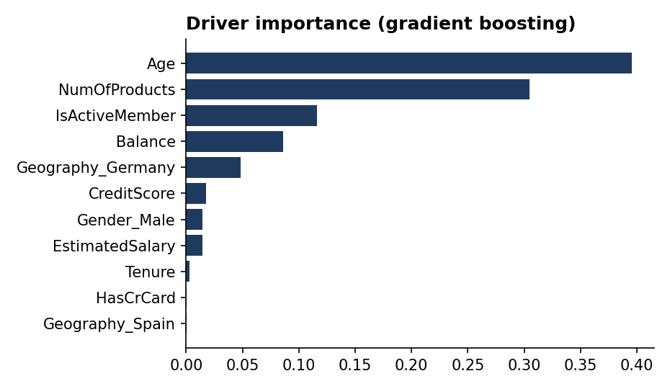
Figure 9. Variable importance, gradient-boosting model
A logistic regression achieved a cross-validated AUC of 0.77 and a gradient-boosting model 0.87, so churn is reasonably predictable from these fields, and the model uses non-linear effects (notably the age peak and the product-count pattern). The importance ranking matches the descriptive findings: age (40%), number of products (31%), activity (12%), balance (9%) and German residency (5%) carry nearly all of the signal, while tenure, credit-card ownership and Spanish residency contribute almost nothing. The model is used here only as validation of the segment analysis and has not been tuned or tested on held-out future data.

4. Recommendations
- Launch a Germany-specific retention programme. Germany drives 40% of churn from 25% of customers. Start with qualitative research (exit interviews, competitor and pricing review) to identify why, and pilot interventions there first.
- Treat customers aged 46–60 as the priority cohort. They are 16.5% of customers and 41% of churners. Offer relationship-manager outreach, pension, savings and wealth-planning propositions, and proactive reviews. Prioritise German customers in this band (67% churn).
- Build a reactivation programme for inactive members. Inactivity roughly doubles churn risk. Trigger outreach when activity lapses, especially for customers over 45, rather than waiting for account closure.
- Move single-product customers to a second product. Two-product customers churn at 7.6% versus 27.7% for one product. A second product (such as a savings or card product) is the most promising loyalty lever, and 5,084 customers are candidates.
- Audit the three- and four-product customers. Churn of 83–100% is a red flag. Review sales practices, fee structures and service quality for these bundles before pushing further cross-sell beyond two products.
- Protect high-balance customers. The top quartile of customers by balance holds €88.7M of churned balance. Assign dedicated relationship management and monitor them for inactivity, which lifts their churn from 17% to 30%.
- Investigate the gender gap and deploy an early-warning score. Understand why women churn 1.5× more than men across every country and age band. Operationalise a scoring model on age, products, activity, balance and country to rank customers by risk, and retire tenure, credit-score and salary as targeting criteria, as they add no signal.

5. Limitations
- Single snapshot (2025): no churn dates, so we cannot separate long-run patterns from recent shifts or measure time-to-churn.
- Associations, not causes. Inactivity, for example, may be a symptom of churn as well as a cause; the causal effect of a second product is untested.
- No revenue, margin, or product-type data: “revenue risk” is measured as balance at risk. Currency is assumed to be euros.
- Small cells: the 3–4 product groups (326 customers) and some age–activity cells are small; the 60+ group has 464 customers.
- Segment thresholds (credit bands, tenure groups, balance split, high-value cut-off) are analyst-defined and may shift results modestly.
- The predictive model was cross-validated but not tested out-of-time and is not ready for deployment without further validation and fairness review, particularly given the gender and age effects.

6. Conclusion
Churn in this bank is not a uniform 20% problem. It is concentrated in identifiable segments: German customers, customers aged 46–60, women, inactive members and customers holding a single product, with extreme rates in the small three-to-four-product group. Conversely, tenure, credit score and salary, which retention strategies often lean on, do not separate leavers from stayers. Targeting the highest-risk intersections, above all German customers aged 46–60, promises far better returns than a generic campaign. The accompanying Streamlit dashboard lets decision-makers filter segments, track KPIs and drill into any of the patterns described here.

Appendix A. Segment churn table
Segment | Customers | Churned | Churn rate | % of churners
Overall | 10,000 | 2,037 | 20.4% | 100%
France | 5,014 | 810 | 16.2% | 39.8%
Germany | 2,509 | 814 | 32.4% | 40.0%
Spain | 2,477 | 413 | 16.7% | 20.3%
Female | 4,543 | 1,139 | 25.1% | 55.9%
Male | 5,457 | 898 | 16.5% | 44.1%
Age <30 | 1,641 | 124 | 7.6% | 6.1%
Age 30–45 | 6,248 | 956 | 15.3% | 46.9%
Age 46–60 | 1,647 | 842 | 51.1% | 41.3%
Age 60+ | 464 | 115 | 24.8% | 5.6%
Credit: Low | 3,034 | 660 | 21.8% | 32.4%
Credit: Medium | 3,818 | 753 | 19.7% | 37.0%
Credit: High | 3,148 | 624 | 19.8% | 30.6%
Tenure: New | 2,496 | 528 | 21.2% | 25.9%
Tenure: Mid-term | 3,977 | 821 | 20.6% | 40.3%
Tenure: Long-term | 3,527 | 688 | 19.5% | 33.8%
Balance: Zero | 3,617 | 500 | 13.8% | 24.5%
Balance: Low | 3,192 | 766 | 24.0% | 37.6%
Balance: High | 3,191 | 771 | 24.2% | 37.8%
1 product | 5,084 | 1,409 | 27.7% | 69.2%
2 products | 4,590 | 348 | 7.6% | 17.1%
3 products | 266 | 220 | 82.7% | 10.8%
4 products | 60 | 60 | 100% | 2.9%
Inactive | 4,849 | 1,302 | 26.9% | 63.9%
Active | 5,151 | 735 | 14.3% | 36.1%

Appendix B. Reproducibility
All figures in this paper can be reproduced from the supplied European_Bank.csv. The Streamlit dashboard (app.py) applies the same validation, cleaning and segmentation rules described in Section 2 and recomputes every KPI dynamically as filters change.

