RESEARCH PAPER
Predictive Modeling and Risk Scoring for Bank Customer Churn
An explainable machine-learning approach to early churn identification in European retail banking
Dataset: European Bank customer file (10,000 customers, France / Germany / Spain) • September 2026

Abstract
Retail banks typically learn that a customer has left only after the account is closed. This paper builds a predictive churn-intelligence system that assigns each customer a churn probability before departure. Using a 10,000-customer European retail-banking dataset (20.4% churn), we compare five model families — logistic regression, decision tree, random forest, gradient boosting and XGBoost — under a leakage-safe protocol (stratified 80/20 split, 5-fold cross-validation, out-of-fold threshold tuning). The champion model, XGBoost, reaches a held-out ROC-AUC of 0.870, and at its tuned operating point achieves 62% precision and 65% recall. The score is well calibrated, and the top-risk 20% of customers contain 63% of all churners (3.1× lift). SHAP, permutation importance and partial-dependence analysis show that churn is driven mainly by customer age, product depth and activity status, with a strong Germany effect; tenure, credit score, salary and card ownership add almost nothing. We translate these findings into a risk-tiering scheme, a what-if simulator delivered as a Streamlit application, and a set of prioritised retention actions, and we document the limitations — notably a cross-sectional dataset and an anomalous churn pattern among customers with three or four products — that must be resolved before operational deployment.

1. Introduction

1.1 Background and motivation
Customer churn erodes customer lifetime value, destabilises revenue, removes cross-sell and up-sell potential and weakens the long-term competitiveness of retail banks. Acquiring a replacement customer is generally far more expensive than retaining an existing one, so even modest improvements in retention targeting have a disproportionate financial effect.
Traditional churn analysis is descriptive: it explains why customers left. Modern retention management requires the opposite — an early-warning capability that identifies customers who are likely to leave while there is still time to act. This enables proactive retention campaigns, personalised offers and targeted engagement instead of broad, costly and reactive outreach.

1.2 Problem statement
Despite holding rich customer-level data, banks often lack (i) accurate churn-prediction models, (ii) quantitative churn-risk scores and (iii) explainable insight into churn drivers. Retention activity is consequently reactive, broad and inefficient.

1.3 Objectives
Primary objectives: (1) predict customer churn with high accuracy; (2) generate calibrated churn-probability scores; (3) identify the key churn drivers.
Secondary objectives: (4) reduce false positives in churn detection; (5) improve the interpretability of machine-learning models; (6) enable scenario-based churn-risk analysis.

1.4 Contributions
- A reproducible, leakage-safe modelling pipeline comparing five model families on identical folds.
- A calibrated probability score, an explicit precision–recall operating-point analysis and a three-tier risk classification validated on held-out data.
- A multi-method explainability study (SHAP, permutation importance, partial dependence, logistic-regression odds) and a feature-set ablation that tests whether churn is driven by behaviour or demographics.
- An interactive Streamlit application (risk calculator, probability distribution, feature-importance dashboard, what-if simulator, batch scoring).

2. Data and Preprocessing

2.1 Dataset
The file contains 10,000 customer records and 14 columns. The target is Exited (1 = churned, 0 = retained); 2,037 customers (20.37%) churned, giving a moderately imbalanced classification problem. There are no missing values and no duplicate customer identifiers.
Variable | Type | Description / treatment
CustomerId, Surname | Identifier | Non-informative — removed (also avoids leakage through repeated surnames)
Year | Constant | Equals 2025 for every row — removed (zero variance; dataset is a single cross-section)
CreditScore, Age, Tenure, Balance, EstimatedSalary | Numeric | Retained; scaled only for logistic regression
NumOfProducts | Ordinal (1–4) | Retained as numeric
HasCrCard, IsActiveMember | Binary | Retained
Geography (France / Germany / Spain), Gender | Categorical | One-hot encoded
Exited | Binary target | 1 = churned

2.2 Preprocessing and leakage control
All transformations (feature engineering, one-hot encoding, scaling) are wrapped in a single scikit-learn pipeline that is fitted only on training folds. This guarantees that no information from validation or test data leaks into preprocessing. Numeric scaling (standardisation) is applied only to logistic regression, since tree-based models are scale-invariant.

2.3 Train–test strategy
- Stratified 80/20 split (8,000 training / 2,000 test), preserving the churn rate (20.37% vs 20.35%). The test set is used once, for final reporting.
- Stratified 5-fold cross-validation on the training set for model selection, hyper-parameter search and threshold tuning.
- Champion selection by mean cross-validated ROC-AUC (not test performance).
- Threshold selection from out-of-fold training predictions (F1-optimal), so the operating point is also chosen without touching the test set.

3. Exploratory Data Analysis
Figures 1–3 summarise how the churn rate varies across the customer base. Several patterns stand out and later prove decisive in the models.
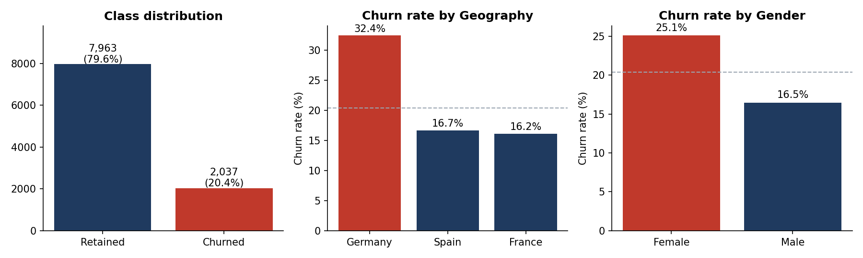
Figure 1. Class balance and churn rate by geography and gender.
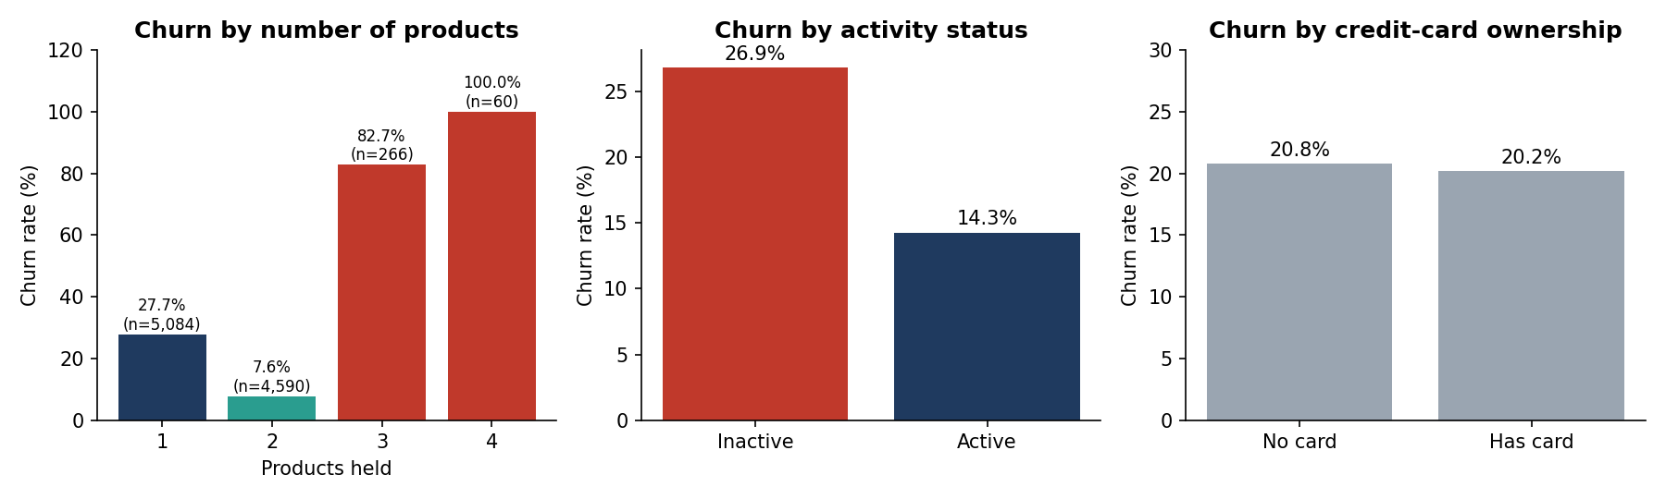
Figure 2. Churn by product depth, activity status and credit-card ownership.
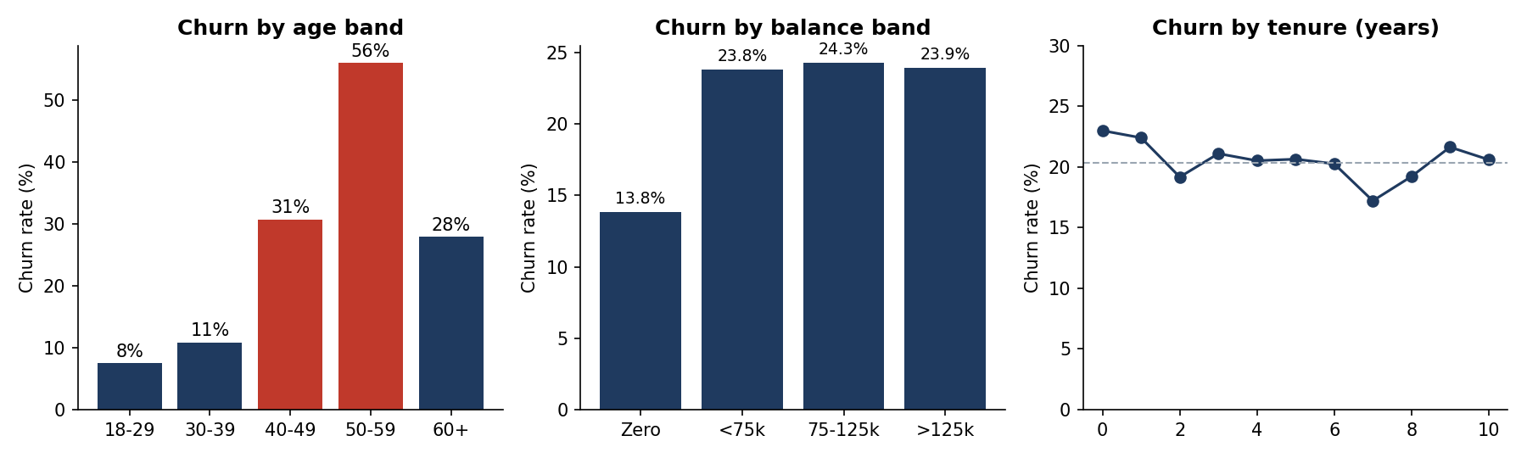
Figure 3. Churn by age band, balance band and tenure.

3.1 Key observations
- Geography. German customers churn at 32.4%, twice the rate in France (16.2%) and Spain (16.7%). Germany is also structurally different: its customers hold on average about €120k versus €62k elsewhere, and it has no zero-balance accounts, whereas ~48% of French and Spanish customers do.
- Gender. Women churn at 25.1% versus 16.5% for men (χ² p < 10⁻²⁵).
- Product depth is non-monotonic. One-product customers churn at 27.7% and two-product customers at only 7.6%, but the 266 customers with three products churn at 82.7% and all 60 customers with four products churned (100%).
- Activity. Inactive members churn at 26.9% versus 14.3% for active members. The combination is powerful: inactive single-product customers churn at 36.7%, active two-product customers at 5.6%.
- Age is the strongest single signal. Churn rises from 7.6% (18–29) and 10.9% (30–39) to 30.8% (40–49) and 56.0% (50–59), then falls to 27.9% for customers aged 60+. The relationship is therefore inverted-U shaped, not linear.
- Balance. Customers with a positive balance churn more (24.1%) than those with none (13.8%); churners hold ≈€186M, about 24% of all balances in the file, so revenue at risk is disproportionate to their headcount.
- No signal in tenure, salary or card ownership. Tenure is flat at 17–23% across all years; credit-card ownership is not associated with churn (20.8% vs 20.2%, χ² p = 0.49).
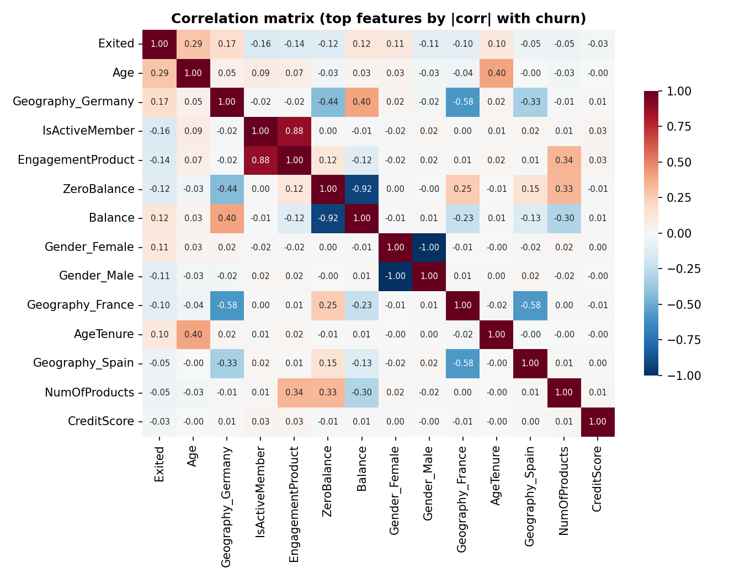
Figure 4. Correlation matrix of the features most associated with churn (including engineered features).
Pearson correlations with churn are modest (Age +0.29, Germany +0.17, IsActiveMember −0.16, EngagementProduct −0.14, Balance +0.12), which already suggests that linear models will underperform: the strongest effects (age, product count) are non-linear.

4. Feature Engineering
Five derived features were created, covering the four families required by the project brief plus a zero-balance indicator.
Feature | Definition | Rationale
BalanceSalaryRatio | Balance ÷ (EstimatedSalary + 1) | Share of income held with the bank; proxy for wallet share
ProductDensity | NumOfProducts ÷ (Tenure + 1) | Speed of product adoption; deepening vs. stagnating relationship
EngagementProduct | IsActiveMember × NumOfProducts | Interaction: product depth matters most when the customer is active
AgeTenure | Age × Tenure | Interaction capturing long-standing older customers
ZeroBalance | 1 if Balance = 0 | Dormant or transactional-only relationship

Honest assessment. Gradient-boosted trees learn interactions on their own, so engineered features add little for the champion model: XGBoost trained on raw features alone achieves a test ROC-AUC of 0.870 versus 0.870 with engineered features (Section 7.4). They are retained because they aid business interpretation (e.g. EngagementProduct ranks 7th in SHAP importance) and cost nothing in accuracy.

5. Model Development
Five model families were trained on identical data and folds. Tree-based and boosted models were tuned with randomised search (8 configurations, 5-fold CV, ROC-AUC objective).
Model | Role | Imbalance handling | Selected hyper-parameters
Logistic Regression | Interpretability benchmark | class_weight = balanced | L2, C = 1.0, standardised inputs
Decision Tree | Transparent rules | class_weight = balanced | max_depth 6, min_leaf 49, min_split 57
Random Forest | Bagged trees | balanced_subsample | 150 trees, max_depth 10, min_leaf 15, max_features 0.6
Gradient Boosting | Boosted trees | Threshold tuning | 154 trees, lr 0.079, depth 4, min_leaf 53
XGBoost | Advanced boosted trees | Threshold tuning | 207 trees, lr 0.068, depth 3, min_child 3, λ 2.56, subsample 0.84, colsample 0.72

For the boosted models we deliberately did not re-weight classes: doing so distorts predicted probabilities. Instead the probabilities are left as learned and imbalance is handled at decision time by tuning the classification threshold — which keeps the risk score interpretable as a genuine probability.

6. Results

6.1 Model comparison
Model | CV ROC-AUC | Test ROC-AUC | Test PR-AUC | Accuracy | Precision | Recall | F1
Logistic Regression | 0.766 ± 0.021 | 0.776 | 0.469 | 73.0% | 40.2% | 66.3% | 0.500
Decision Tree | 0.832 ± 0.008 | 0.830 | 0.616 | 81.5% | 53.9% | 62.7% | 0.580
Random Forest | 0.858 ± 0.011 | 0.863 | 0.704 | 85.9% | 66.7% | 60.9% | 0.637
Gradient Boosting | 0.863 ± 0.009 | 0.865 | 0.713 | 83.7% | 58.4% | 69.0% | 0.633
XGBoost | 0.864 ± 0.010 | 0.870 | 0.719 | 84.9% | 62.1% | 65.4% | 0.637
Table 1. Held-out test performance. Accuracy, precision, recall and F1 are evaluated at each model's out-of-fold F1-optimal threshold; the champion is in bold.
Ensembles clearly outperform the linear baseline (ROC-AUC 0.776), confirming that the drivers of churn are non-linear and interactive. The three ensemble methods are close; XGBoost had the highest cross-validated AUC (0.864) and was chosen as champion. The gap between XGBoost and gradient boosting (0.005 AUC) is within about one cross-validation standard deviation, so the choice among the top three is not decisive; XGBoost is preferred for its regularisation, speed and native exact SHAP support.
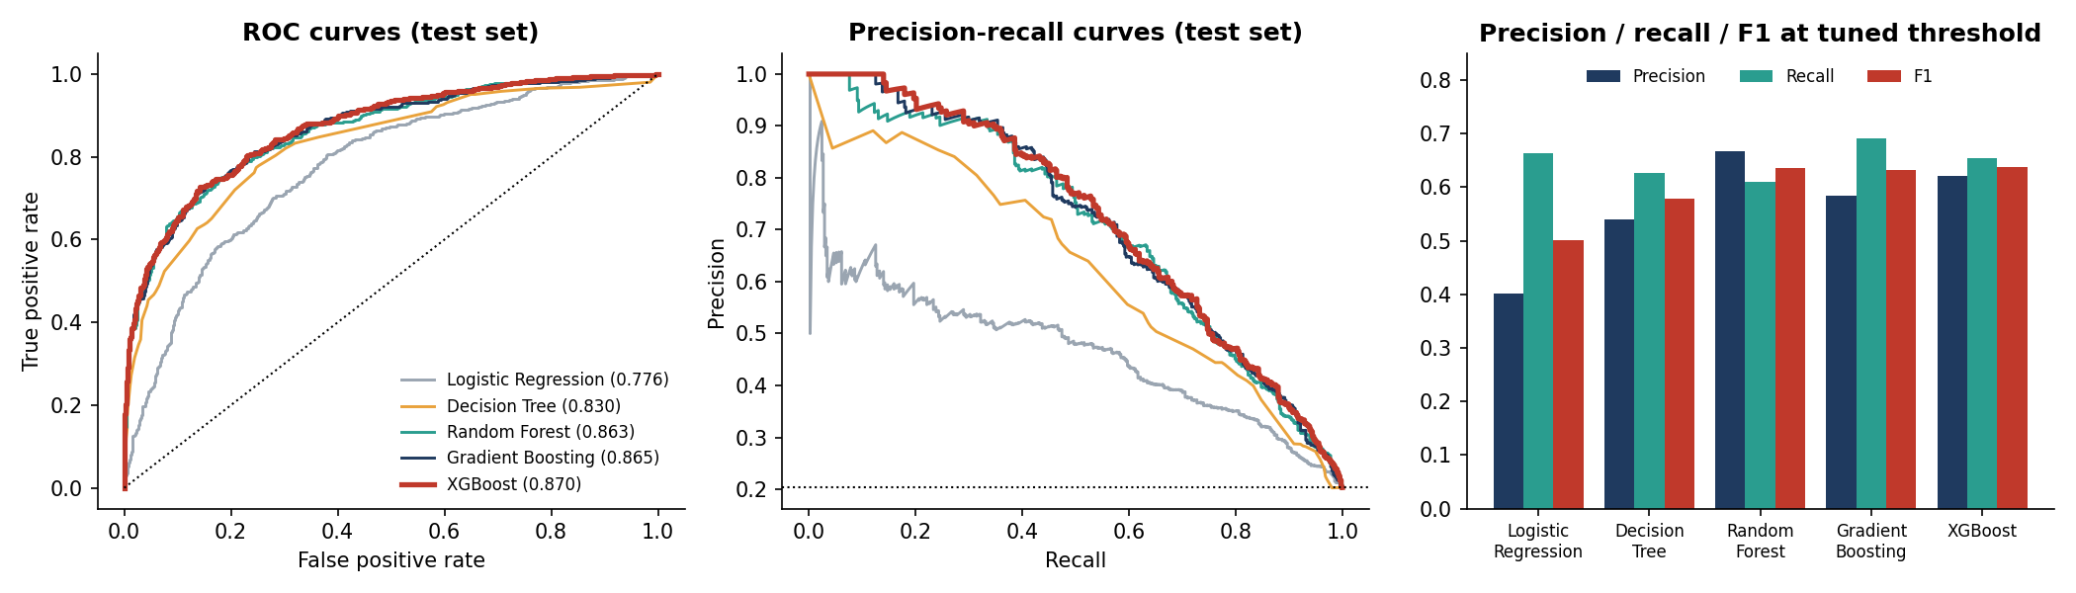
Figure 5. ROC curves, precision–recall curves and metrics at the tuned threshold (test set).

6.2 Choosing the operating point: controlling false positives
A churn score becomes a decision only once a threshold is set. The threshold trades wasted retention offers (false positives) against missed churners (false negatives). Table 2 shows the trade-off for the champion model on the test set (407 actual churners among 2,000 customers).
Threshold | Flagged | True churners | False alarms | Precision | Recall | F1 | False alarms per hit
0.20 | 636 | 309 | 327 | 48.6% | 75.9% | 0.593 | 1.06
0.25 | 525 | 296 | 229 | 56.4% | 72.7% | 0.635 | 0.77
0.31 (tuned) | 428 | 266 | 162 | 62.1% | 65.4% | 0.637 | 0.61
0.40 | 332 | 233 | 99 | 70.2% | 57.2% | 0.631 | 0.42
0.50 | 254 | 198 | 56 | 78.0% | 48.6% | 0.599 | 0.28
0.60 | 187 | 158 | 29 | 84.5% | 38.8% | 0.532 | 0.18
0.70 | 145 | 131 | 14 | 90.3% | 32.2% | 0.475 | 0.11
Table 2. Precision–recall trade-off for XGBoost across decision thresholds.
At the default 0.50 threshold XGBoost is very precise (78%) but misses more than half of all churners (recall 49%). The F1-optimal threshold of 0.31 balances the two (precision 62%, recall 65%). Because the score is a genuine probability, the bank can set the threshold from campaign economics: the break-even precision for a campaign equals contact cost ÷ (retention success rate × value of a retained customer). Cheap digital nudges justify a low threshold (~0.20, catching 76% of churners); expensive relationship-manager calls justify a high one (≥0.60, precision ≥ 84%). This directly addresses the secondary objective of reducing false positives — the dashboard exposes the threshold as a slider.
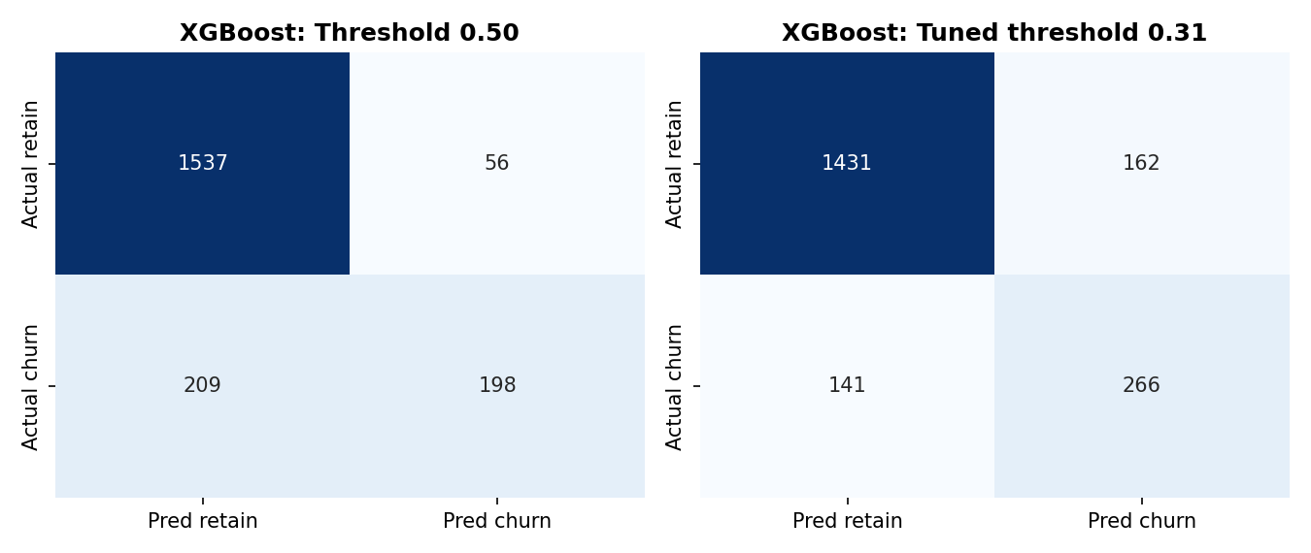
Figure 6. Confusion matrices at the default (0.50) and tuned threshold.

6.3 Calibration and probability quality
The model separates the two classes well (Figure 7, left) and its probabilities are reliable (right): predicted and observed churn rates agree within a few percentage points across deciles. Calibration also holds by segment — for instance predicted vs actual churn is 32.1% vs 30.0% in Germany, 16.3% vs 17.1% in France, 8.6% vs 8.4% for two-product customers and 26.4% vs 27.5% for inactive members. A well-calibrated score can therefore be used directly for expected-loss and campaign-ROI calculations.
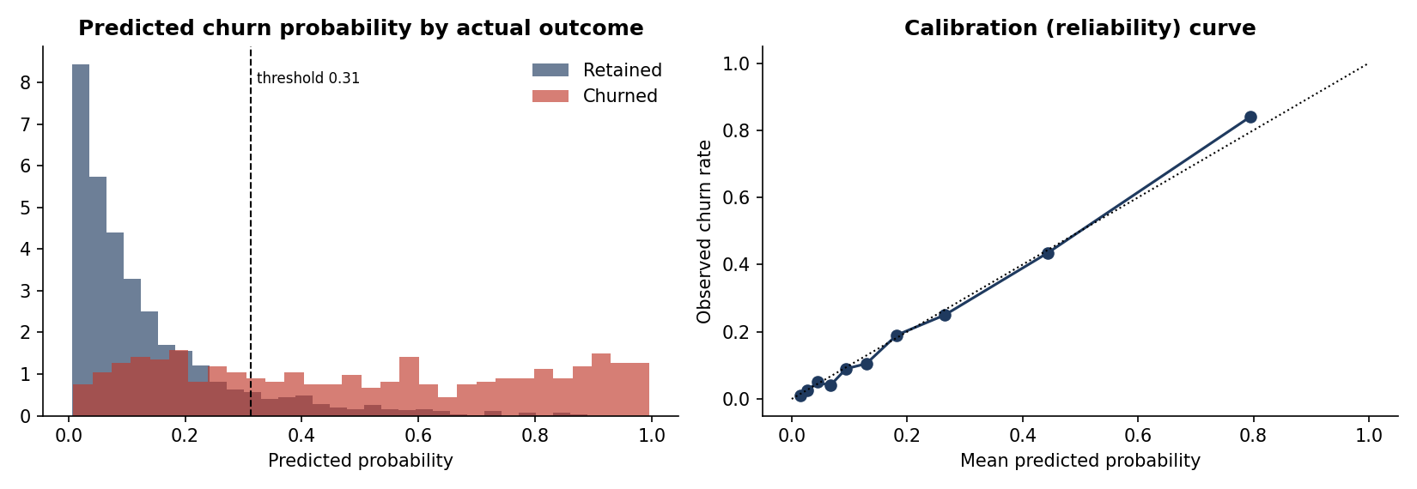
Figure 7. Score distribution by outcome and reliability curve (test set).

6.4 Targeting efficiency: lift, gains and risk tiers
Ranking customers by score concentrates churners at the top: the highest-risk decile has an actual churn rate of 84% (4.1× lift), and contacting the top 20% of customers reaches 63% of all churners. Reaching the same 255 churners by random contact would require about 1,250 calls instead of 400 — roughly 3× fewer contacts for the same result.
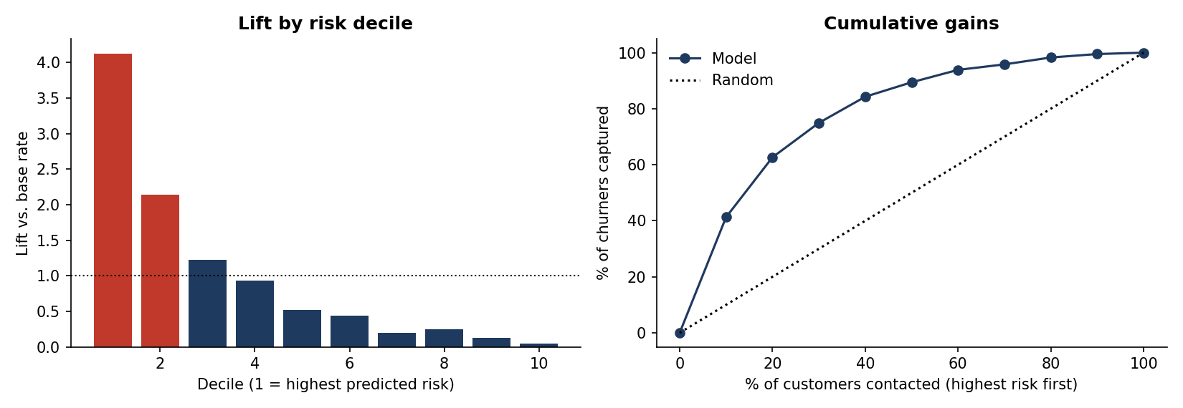
Figure 8. Lift by decile and cumulative gains curve (test set).
Risk tier | Customers | Churners | Actual churn rate | Share of all churners
High (p ≥ 60%) | 187 | 158 | 84.5% | 38.8%
Medium (30–60%) | 254 | 110 | 43.3% | 27.0%
Low (p < 30%) | 1559 | 139 | 8.9% | 34.2%
Table 3. Three-tier risk classification on the test set.
The tiers are well separated: High-risk customers churn about ten times as often as Low-risk ones (84.5% vs 8.9%). Two cautions follow. First, the Low tier still contains 139 churners (34% of the total): roughly one in three departures is not predictable from these variables and would require additional behavioural data (transactions, complaints, digital logins). Second, the High tier is small (9% of customers), so it is best treated as a priority list for high-touch intervention, with the Medium tier addressed through lower-cost campaigns.

7. Model Explainability
Explainability is critical for regulatory compliance and business trust. We use four complementary lenses, and their agreement gives confidence in the findings.

7.1 Global importance: SHAP and permutation
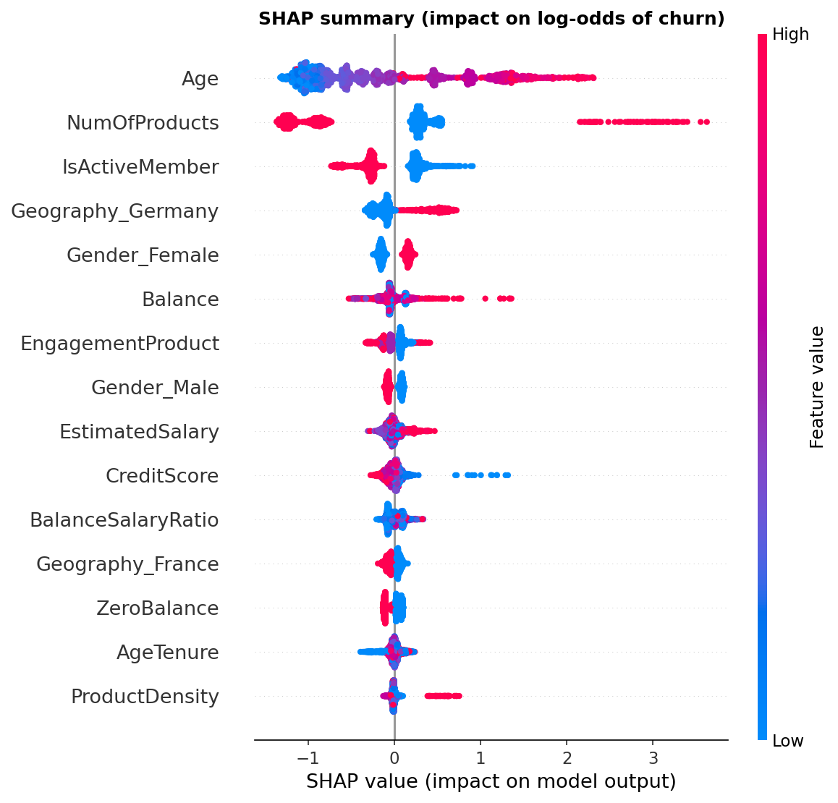
Figure 9. SHAP summary plot: each dot is a customer; colour shows the feature value, position shows the impact on churn log-odds.
Both SHAP (mean absolute contribution) and permutation importance (drop in test AUC when a feature is shuffled) give the same ranking: Age (SHAP 0.82, AUC drop 0.127), NumOfProducts (0.76, 0.114), IsActiveMember (0.31, 0.032), Geography (Germany 0.23, 0.017), Balance (0.11, 0.028) and Gender (0.16, 0.008). Tenure, CreditScore, HasCrCard and EstimatedSalary have permutation importance indistinguishable from zero, i.e. once the leading variables are known, they add no predictive value.
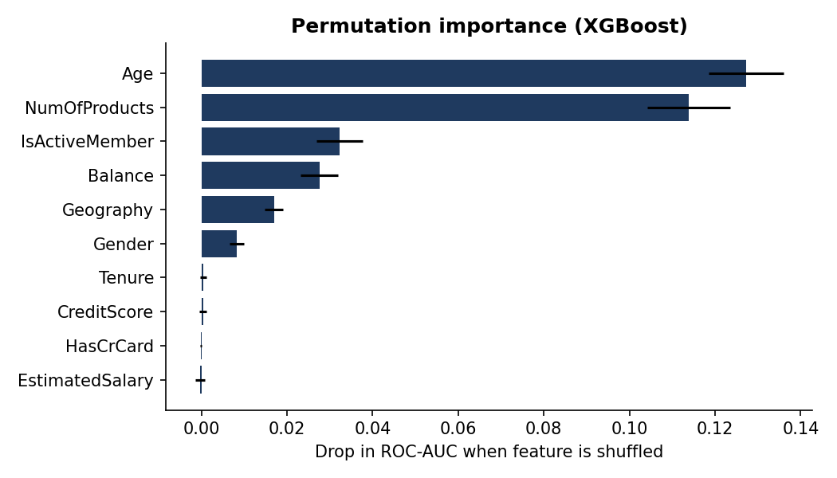
Figure 10. Permutation importance on the test set (mean ± SD over 15 repeats).

7.2 Direction and shape of effects: partial dependence
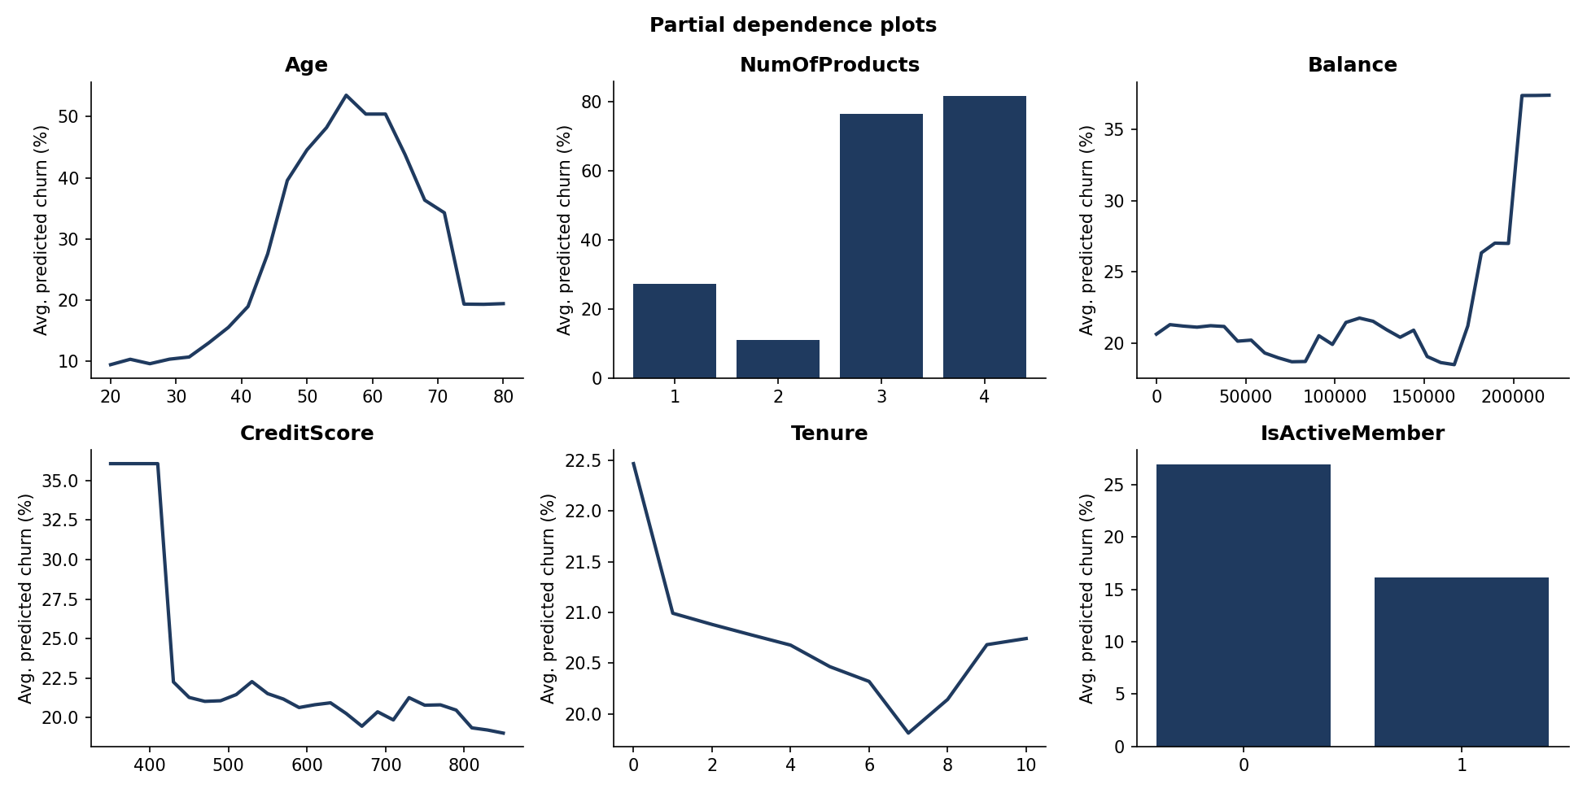
Figure 11. Partial dependence of predicted churn on six key features.
- Age: ≈10% below age 30, climbing steeply from the early 40s to a peak of ≈53% around age 56, then falling back to ≈19% beyond about age 74.
- Products: the average predicted churn is ≈27% with one product, ≈11% with two, and ≈76–82% with three or four.
- Activity: being inactive raises average predicted churn from ≈16% to ≈27%.
- Balance: roughly flat (≈20%) up to about €170k, then increasing. Estimates above ~€200k rest on very few customers and should be read with care.
- Credit score and tenure: essentially flat — consistent with their near-zero permutation importance.

7.3 Interpretable benchmark: logistic regression
The logistic-regression benchmark (Figure 12) agrees on the direction of the leading effects — being older, German, female or inactive raises the odds of churn — but it cannot represent the inverted-U age curve or the fall-then-explosion pattern across product counts (its linear product coefficient is slightly negative and is partly offset by the EngagementProduct interaction, an instance of collinearity that makes individual coefficients unreliable), which is why it trails the ensembles by roughly 0.09 AUC. It remains valuable as a transparent sanity check for regulators.
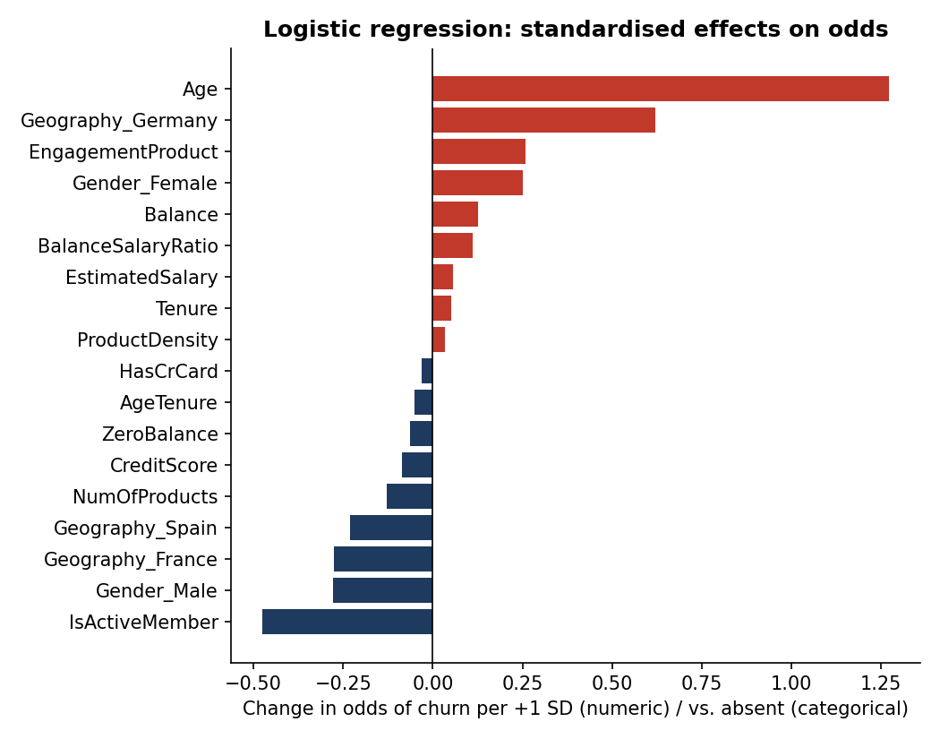
Figure 12. Logistic regression: change in odds of churn per standardised unit.

7.4 Ablation: behaviour or demographics?
The project brief frames churn as a behavioural, engagement-and-product phenomenon rather than a demographic one. We tested this directly by retraining the champion configuration on restricted feature sets (Table 4).
Feature set | CV ROC-AUC | Test ROC-AUC
All features (champion) | 0.864 | 0.870
Raw features only (no engineering) | 0.864 | 0.870
Without Gender | 0.861 | 0.866
Without Age-based features (Age, AgeTenure) | 0.810 | 0.804
Behavioural only (products, activity, balance, tenure, card, engineered) | 0.773 | 0.773
Demographics only (Age, Gender, Geography) | 0.775 | 0.778
Table 4. Feature-set ablation for the XGBoost configuration.
- Engineering adds nothing measurable for the boosted model (0.870 with and without).
- Age is indispensable: removing Age and AgeTenure drops test AUC by 0.065 (to 0.804).
- Behaviour alone and demographics alone are about equally predictive (0.773 vs 0.778), and combining them yields 0.870 — a large gain, showing that the two families are complementary and interact (e.g. inactivity is far more damaging for customers in their 40s–50s).
- Removing Gender costs only 0.004 AUC (0.866), which is relevant to the fairness discussion in Section 10.
Interpretation
Churn is not purely behavioural in this dataset: age is the single strongest predictor. The behavioural levers (activity and product depth) are, however, the ones the bank can influence, which is why they anchor the retention strategy below. Demographics are best used to prioritise and tailor outreach, behaviour to design the intervention.

8. Scenario-Based Churn-Risk Analysis
The Streamlit what-if simulator lets a relationship manager change a customer's engagement or product holding and observe the score. Figure 13 illustrates the logic for a representative high-risk profile: a 45-year-old inactive German woman with a single product, €120k balance and €100k salary.
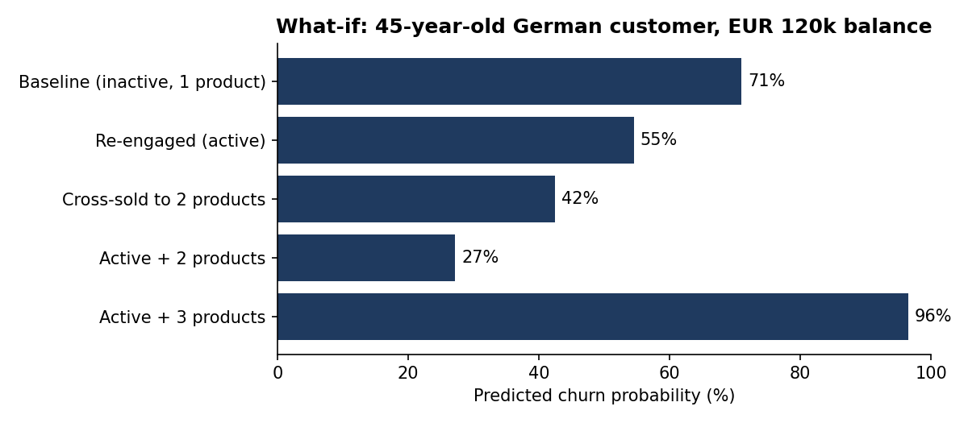
Figure 13. Illustrative what-if analysis for one customer profile.
Re-engaging this customer lowers the modelled probability from 71% to 55%; cross-selling a second product lowers it to 42%; doing both brings it to 27% — a 44-point reduction that moves her from the High tier to the Low tier. The same tool shows the opposite effect for a third product (≈96%).
Caution: the three-and-four-product anomaly
In this dataset 3-product customers churn at 83% and 4-product customers at 100%. The model faithfully reproduces this pattern, but it is unlikely to be a causal effect of owning more products; it more plausibly reflects mis-selling, poor bundle economics, or a data artefact. It must not be read as a recommendation to cross-sell beyond two products, nor as evidence that it is safe to do so. The what-if outputs throughout are associations learned from historical data, not causal effects of an intervention; incremental impact should be measured with controlled campaigns.

9. Business Recommendations
- Activate the inactive. Inactive members churn at almost twice the rate of active ones (26.9% vs 14.3%); in the 40–60 age band with a single product the rate is 59.5% (n = 1,049). Launch a trigger-based re-engagement programme (app onboarding, salary-account switching, personalised alerts) aimed at this segment first.
- Move single-product customers to two products. The two-product state has the lowest churn of any product group (7.6%). Design a second-product journey (savings, card, insurance) with a clear incentive. Stop at two until the three-and-four-product anomaly is understood.
- Investigate the 3–4-product cohort immediately. 326 customers churn at 83–100%. Audit their pricing, fees, complaints and how the products were sold; treat them as an at-risk book regardless of model score.
- Run a Germany market review. German churn is double that of France and Spain even after controlling for the other drivers (mean SHAP impact 0.23 log-odds). Benchmark competitor pricing and service levels, and pilot a targeted German retention offer.
- Create a life-stage proposition for customers aged 45–62. This group churns at ≈49% (56% at 50–59). Retirement planning, wealth management and dedicated advisers are natural hooks.
- Protect high-balance relationships. Churners hold about a quarter of all balances; assign named bankers to High-risk customers with balances above roughly €150k.
- Operationalise the score. Score the base weekly; give the top 20% (High + upper-Medium) a treatment plan; set the threshold from campaign economics (Table 2); and hold out a random control group so that the incremental effect of each campaign can be measured (uplift), rather than merely the propensity to churn.

10. Limitations, Fairness and Governance

10.1 Data limitations
- Cross-sectional snapshot. All records carry the same year (2025). There is no time dimension, so we could not perform out-of-time validation, and the churn-label window (how long after observation a customer counts as churned) is not documented.
- Possible stylised data. Several patterns are unusual for a real portfolio: no zero-balance accounts in Germany, near-uniform tenure and salary distributions, and 100% churn among four-product customers. Before deployment the pipeline should be re-validated on the bank's own data.
- Limited behavioural depth. There are no transaction, channel-usage, complaint or pricing variables. About one-third of churners sit in the Low-risk tier, which points to information the current variables do not capture.
- Small tails. Only 60 four-product and 266 three-product customers; estimates for these groups are uncertain.

10.2 Modelling caveats
- The 2,000-customer test set gives roughly ±4–5 percentage points of uncertainty (95% interval) on precision and recall; differences of ~0.005 AUC between the top three models are not statistically decisive.
- Hyper-parameter search was deliberately light (8 configurations per model) for reproducibility; a larger search might add marginally to performance.
- Propensity to churn is not the same as persuadability. Some high-risk customers cannot be retained and some low-risk customers would respond well; uplift modelling on campaign data is the natural next step.

10.3 Fairness and regulatory considerations
The model uses Gender and Geography, both of which the data show to be associated with churn. Using protected or proxy attributes to decide who receives an offer can raise fairness and legal issues in the EU, and automated profiling is subject to transparency expectations under data-protection law. We recommend: (i) excluding Gender from the operational scoring model — the ablation shows this costs only 0.004 AUC; (ii) reporting error rates and calibration by gender, age band and country as part of routine model monitoring; (iii) retaining SHAP-based reason codes for each score, as provided in the dashboard; and (iv) obtaining legal and compliance review before any scoring drives customer-facing decisions. Any use of the score should favour customers (extra service, better offers), not penalise them.

10.4 Monitoring
Track score drift (population stability index), calibration, and lift monthly, and retrain at least quarterly or when the calibration curve departs from the diagonal by more than about five percentage points.

11. Streamlit Application
The accompanying application (app.py) operationalises the analysis for non-technical users. It loads the trained pipeline and requires no retraining.
Module | What it does
Customer churn risk calculator | Enter a customer profile in the sidebar; get churn probability, binary flag, risk tier and a SHAP-based explanation of the score, plus suggested retention actions.
Probability distribution | Places the customer within the distribution of test-set scores, shows score separation by outcome, tier composition, and predicted-vs-actual rates by segment.
Feature-importance dashboard | SHAP and permutation rankings, interactive partial-dependence plots for seven features, and the logistic-regression benchmark.
What-if scenario simulator | Adjust activity, products, balance, tenure, card, credit score and salary; compare baseline vs scenario; sensitivity sweeps over engagement × products and over age.
Model performance | Model comparison table, live confusion matrix and precision/recall/F1 at any threshold, precision–recall curve and decile lift table.
Batch scoring | Upload a CSV of customers, score and tier them, and download the results.

Run with: pip install -r requirements.txt, then streamlit run app.py. The full pipeline can be reproduced with python train.py, python explain.py and python eda.py.

12. Conclusion
A gradient-boosted model can identify likely churners with strong discrimination (ROC-AUC 0.870), produces trustworthy probabilities, and concentrates 63% of churners in the riskiest 20% of the customer base. The drivers are consistent across methods: age, product depth, activity status and (to a lesser extent) geography, with tenure, credit score, salary and card ownership contributing essentially nothing. Behavioural factors — activity and product holding — are the most actionable levers, while age and geography help prioritise and tailor outreach. The what-if simulator turns these insights into a practical tool, and the risk tiers into a workable targeting scheme.
Three points deserve emphasis for decision-makers. First, the model ranks risk, not causal effect: retention actions should be tested against control groups. Second, the anomalous churn among three- and four-product customers needs a business investigation rather than a modelling fix. Third, fairness safeguards — particularly removing gender from the operational model — cost almost nothing in accuracy and should be adopted from the outset.

Appendix A. Reproducibility and Deliverables
File | Purpose
churn_utils.py | Feature engineering, preprocessing pipeline and risk-tier function shared by all scripts
train.py | Splits data, tunes and evaluates all five models, selects champion, tunes threshold, saves artefacts
eda.py, explain.py, ablation.py | Exploratory figures; SHAP / permutation / PDP / lift / calibration analysis; feature-set ablation
app.py | Streamlit dashboard
models/, outputs/, figures/ | Trained pipeline, metric tables (JSON/CSV) and all figures used in this paper
requirements.txt, README.md | Environment and run instructions (random seed 42 throughout)

