Report: Optimising NYC Taxi Operations
Include your visualisations, analysis, results, insights, and outcomes. Explain your methodology and approach to the tasks. Add your conclusions to the sections.

Data Preparation
  - Loading the dataset
    - Sample the data and combine the files
Sampling was carried out to extract 0.75% of data for each hour, per day
for analysis. First, the working directory is set to the location of multiple Parquet data files containing trip records. It then loops through each file, reading it into a temporary DataFrame. For each record, it extracts the pickup date and hour from the datetime column. The code then iterates through each unique date and each hour of that day, randomly selecting 0.75% of the data for every hour. This approach ensures that the sample maintains hourly and daily patterns found in the full dataset, helping preserve the time-based structure which is important for analysis. Finally, all the hourly samples from each file are concatenated into a single DataFrame, forming a representative and compressed dataset suitable for performing EDA efficiently.

Data Cleaning

Fixing Columns
    - Fix the index
The index of the sampled DataFrame was reset using the command df.reset_index(drop=True, inplace=True)
The 'store_and_fwd_flag' column was dropped as it is related to how data is sent and assuming that it doesn’t affect service, revenue, or experience of taxi rides. Also, this column contained 3.33% missing values.
    - Combine the two airport_fee columns
After sampling, the resultant DataFrame contained two separate columns for airport fee: airport_fee and Airport_fee. The Airport_fee column had negative values which were converted to positive values and it also had Nan values which were replaced with zero. Similarly, the airport_fee contained NaN values which were replaced with zero. After this both the columns were concatenated into a single airport_fee column and the redundant Airport_fee column was dropped from the DataFrame(df).

Handling Missing Values
    - Find the proportion of missing values in each column
The proportion of missing values in each column of the df is as follows:
VendorID | 0.000
tpep_pickup_datetime | 0.000
tpep_dropoff_datetime | 0.000
passenger_count | 0.033
trip_distance | 0.000
RatecodeID | 0.033
PULocationID | 0.000
DOLocationID | 0.000
payment_type | 0.000
fare_amount | 0.000
extra | 0.000
mta_tax | 0.000
tip_amount | 0.000
tolls_amount | 0.000
improvement_surcharge | 0.000
total_amount | 0.000
congestion_surcharge | 0.033
airport_fee | 0.000
date | 0.000
hour | 0.000

    - Handling missing values in passenger_count
The passenger_count column comprised of 3.3 % missing/NaN values. These NaN values were imputed with 1, since 75% of the data is 1, and it's likely the mode.
There were also zeros in the passenger_count column which were replaced with 1 (median)
Further, the column datatype was changed to int from float.
    - Handle missing values in RatecodeID
RatecodeID column contained around 3.3 % missing/NaN values. These were imputed with 1 (median). Since the median is very clearly 1, and 75% of values are 1 indicating that most trips are typical, metered fares. Thus, imputing missing values with 1 is a safe approach
    - Impute NaN in congestion _surcharge
The congestion_surcharge column contained around 3.3 % missing/NaN values. These were imputed with median (2.5).

Handling Outliers and Standardizing Values
    - Check outliers in payment type, trip distance and tip amount columns
2.3.1.1 Payment type:
Payment type is mostly type 1 (using credit card). There is no payment type category 0 defined in the data dictionary which accounted for around 3.345 % of the data.
A new category called 'unknown' was added to the column where payment_type is 0
2.3.1.2 Trip distance
It was found that trips typically lied between 1.06 and 3.47 miles (25th to 75th percentile). The median (50%) is 1.8 miles indicating most trips are short. Max value is a massive 22,528 miles, which is clearly unrealistic for a taxi ride. Standard deviation is very high (45.39) thereby confirming extreme outliers.
IQR (Interquartile Range) Method was used to remove the outliers. The lower and upper bounds in the trip distance were computed and the values beyond these were removed.
Entries where trip distance = 0 were also removed from the dataset
2.3.1.3 Fare Amount
There is a skewed distribution for fare amount. The max ($300.09) is far above the 75th percentile ($17.70), suggesting a right-skewed distribution with some very high fares. Outliers are present. $0 fares and those above $100 or $200 might be data anomalies or special cases (e.g., long-distance trips or discounts). Most rides likely fall between $8.60 and $17.70.
Assuming 0$ fares could either represent invalid records (e.g., canceled trips) or missing data, these were dropped from the dataset

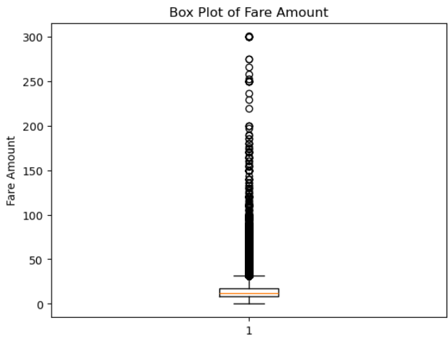
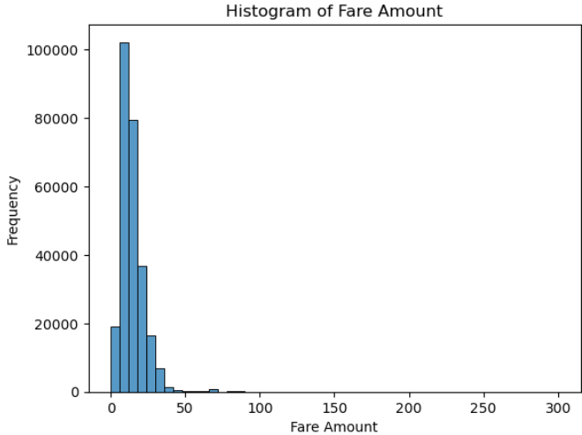
Zero fares were dropped from the dataset assuming that 0 fares could either represent invalid records (e.g., cancelled trips) or missing data.
Entries where trip_distance is 0 and fare_amount > 100 while the pickup location and drop off location are different were checked. Thess could be mistakes in data entry or a failure in the system that records the trip data, resulting in a zero-trip distance being logged despite a fare being charged. Hence, these entries were removed from the dataset.
Fare amounts above cap_value set to $200 were dropped from the dataset.
2.3.1.3 Tip Amount
The median ($2.66) is slightly below the mean indicating the presence of outliers (e.g., the $150.29 max). A large number of tips are in the $1–4 range. Some trips had no tips (Min: $0.00).
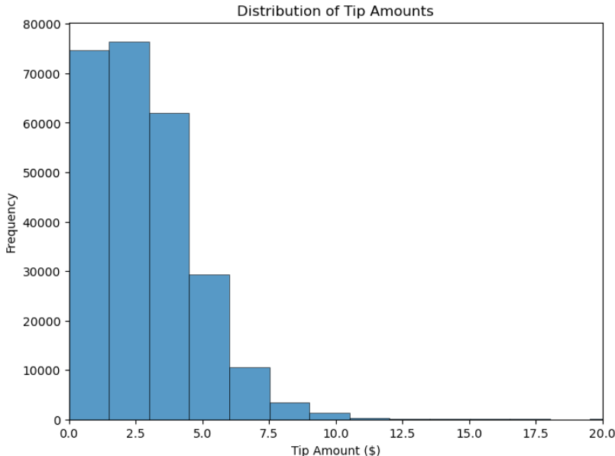
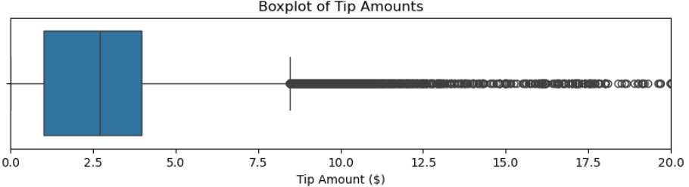
The outliers in tip_amount using IQR with lower bound =

Exploratory Data Analysis

General EDA: Finding Patterns and Trends
    - Classify variables into categorical and numerical
CATEGORICAL | NUMERICAL
- VendorID  - tpep_pickup_datetime  - tpep_dropoff_datetime  - RatecodeID  - PULocationID  - DOLocationID  - payment_type | - passenger_count  - trip_distance  - pickup_hour  - fare_amount  - extra  - mta_tax  - tip_amount  - tolls_amount  - improvement_surcharge  - total_amount  - congestion_surcharge  - airport_fee

    - Analyse the distribution of taxi pickups by hours, days of the week, and months
3.1.2.1 Hourly trends in taxi pickups
The number of taxi pickups per hour was grouped by the pickup_hour column.
pickup_hour | pickup_counts
0 | 6545
1 | 4663
2 | 3071
3 | 1956
4 | 1092
5 | 963
6 | 2847
7 | 6365
8 | 9163
9 | 10348
10 | 11228
11 | 12140
12 | 13122
13 | 13342
14 | 14191
15 | 14570
16 | 14619
17 | 16301
18 | 17488
19 | 15410
20 | 13639
21 | 13606
22 | 12335
23 | 26470

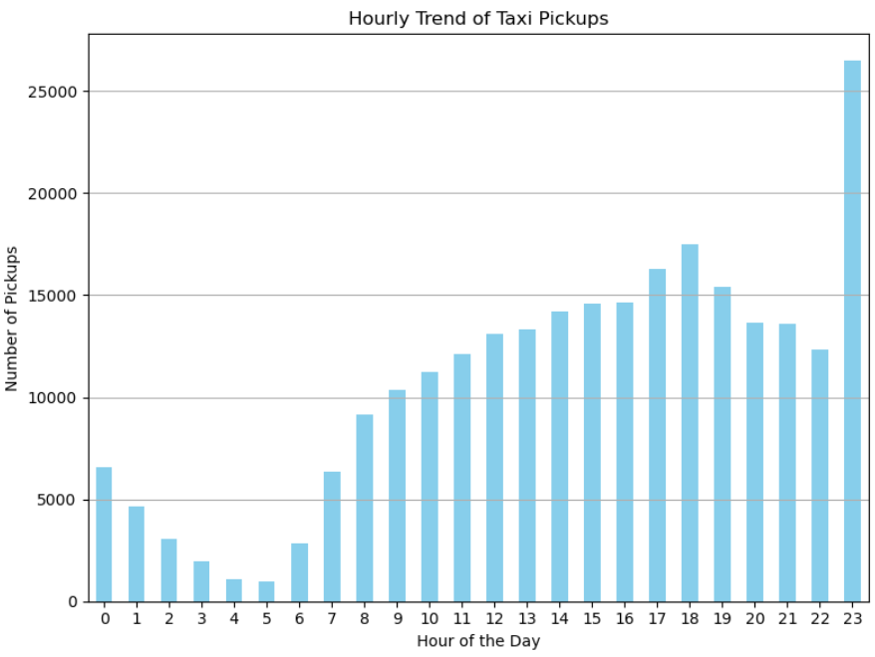
The following insights could be derived from this analysis:
Peak hour is 23:00 with 26,470 pickups likely due to end-of-day activities, nightlife, or shift changes.
Second peak hour is 18:00 with 17,488 pickups which is consistent with evening rush hour.
Lowest activity is observed at 5:00 with only 963 pickups which is expected during early morning when demand is typically low.
From 6:00 to 17:00, there's a gradual rise in pickups, showing consistent daytime activity.
3.1.2.2 Daily trends in taxi pickups
A new column called ‘day_of_week was created in the df. From the ‘date’ column day name (like 'Monday', 'Tuesday', etc.) was extracted using Pandas datetime accessor: ‘.dt.day_name()’ which converts each date to its weekday name. Further, the number of pickups per day of the week was extracted using ‘value_counts()’

day_of_week | pickup_counts
Monday | 30801
Tuesday | 36801
Wednesday | 39945
Thursday | 39970
Friday | 37664
Saturday | 39598
Sunday | 30695

A bar plot of showing Day of the week Vs Number of pickups was plotted
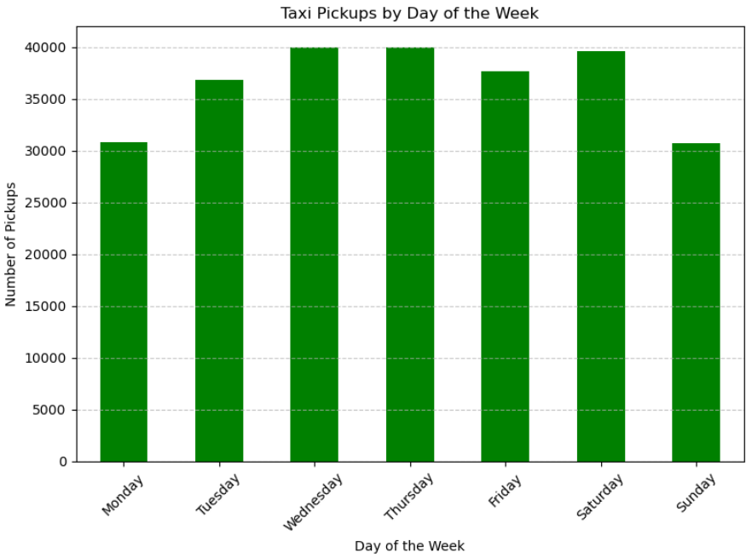
The following insights could be derived from this analysis:
Thursday has the highest number of pickups (39970)
Sunday (30695) and Monday (30801) have the lowest.
There is a steady increase from Monday to Thursday, then a slight drop on Friday, with Saturday picking back up.
3.1.2.3 Monthly trends in taxi pickups
To find the monthly trends in pickups, data was grouped by month and the number of pickups for each month was counted.

pickup_month | pickup_count
01-01-2023 | 19843
01-02-2023 | 19798
01-03-2023 | 23900
01-04-2023 | 22462
01-05-2023 | 24450
01-06-2023 | 22505
01-07-2023 | 19356
01-08-2023 | 18465
01-09-2023 | 17815
01-10-2023 | 23143
01-11-2023 | 20980
01-12-2023 | 22757

Further, a line plot showing Month Vs Number of pickups was plotted.
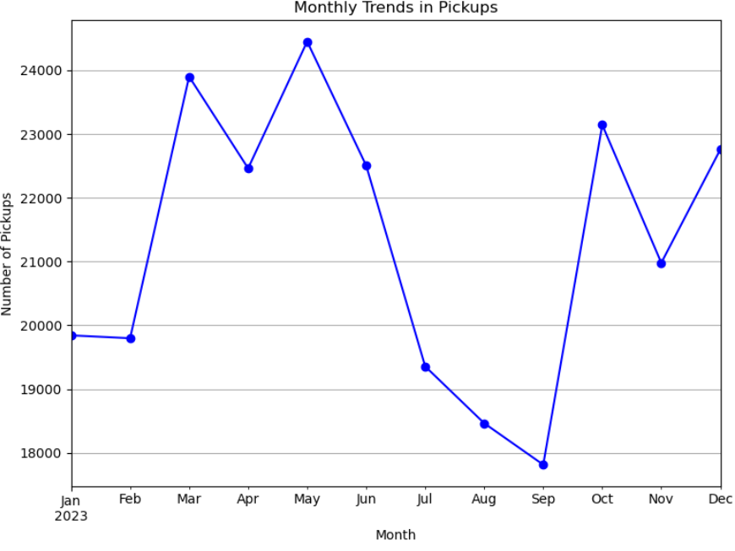
The following insights could be drawn from this analysis:
- Peak month is May with the highest number of pickups (24,450)
- September is the month with lowest pickups (17,815).
- Pickups are higher in spring (March–May) with a dip in April and fall (October–December) with a dip in November and pickups are lower during late summer (July–September).
    - Filter out the zero/negative values in fares, distance and tips
Zero values were present in the tip_amount column. Negative values were already taken care during data cleaning step.
A DataFrame copy with non-zero entries for tip_amount were created
    - Analyze the monthly revenue trends

To analyze the monthly revenue trends, data was grouped by pickup_month and sum of the total amount was computed.

Month | Monthly Revenue
2023-01 | 332755.90
2023-02 | 339425.46
2023-03 | 409519.95
2023-04 | 375533.92
2023-05 | 427064.44
2023-06 | 392944.60
2023-07 | 320490.49
2023-08 | 307787.28
2023-09 | 311869.75
2023-10 | 417057.83
2023-11 | 376975.98
2023-12 | 395564.97
Further, a line plot showing Month Vs Revenue in USD was plotted.
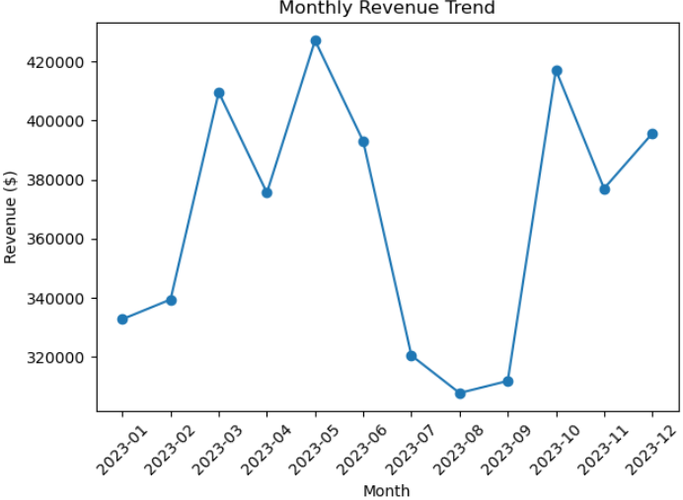
The following insights could be drawn from this analysis:
- Peak month is May ($427,064.44) with highest revenue, followed October ($417,057.83) and March ($409,519.95)
- August ($307,787.28) has the lowest revenue, followed by September ($311,869.75) and July ($320,490.49)
- Overall pattern shows that revenue peaked in late spring (May) and again in early fall (October). Summer months (July–Sept) showed a dip in revenue. Winter months (Jan, Feb, Dec) had moderate to low revenues, but December saw a small recovery.

    - Find the proportion of each quarter’s revenue in the yearly revenue
To calculate the revenue proportion of each quarter, a new column named ‘quarter’ was added to the df with non-zero values. Further, the data was grouped by quarter and the sum of total amount in each quarter and ratio in each quarter was determined.
Further a pie chart was plotted to display the revenue percentage in each quarter
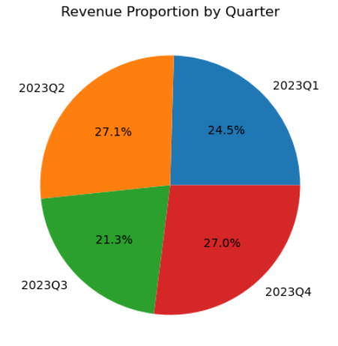
The following insights could be derived:
Q2 had the highest revenue proportion at 27.13%, suggesting peak activity, possibly due to rise in tourism in summers
Q3 was the lowest at 21.33%, indicating a seasonal dip or other operational factors.
Q1 and Q4 were fairly close, both contributing about 25-27%, indicating consistent performance in colder months.

    - Analyse and visualise the relationship between distance and fare amount
Correlation between fare_amount and trip_distance was found to be 0.8810. This indicates a strong positive linear relationship. This means. As trip distance increases, the fare amount tends to increase proportionally.
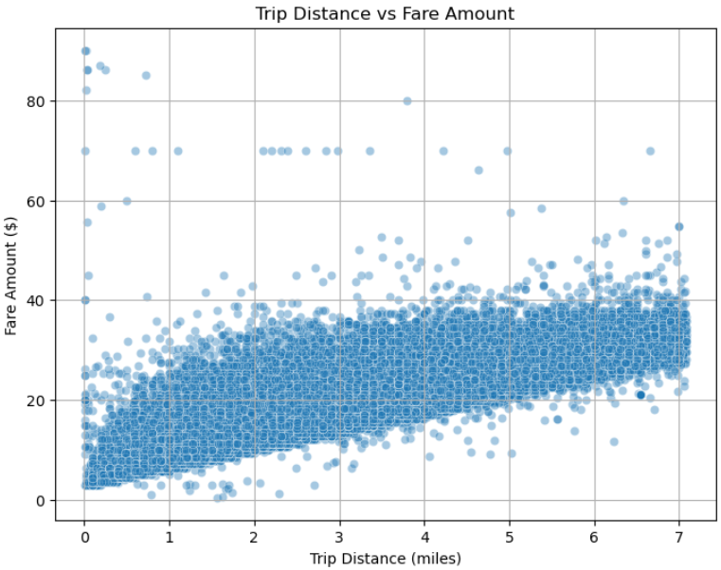
However, as Correlation ≠ causation, while distance and fare are linked, other factors (e.g., traffic, waiting time, surcharges) might influence fare too.
    - Analyse the relationship between fare/tips and trips/passengers
3.1.7.1 Fare Amount and Trip Duration
A correlation of 0.9251 was found between fare_amount and trip_duration. This indictates an even stronger positive linear relationship than with trip distance. This suggests: that as trip duration increases, the fare amount increases significantly.
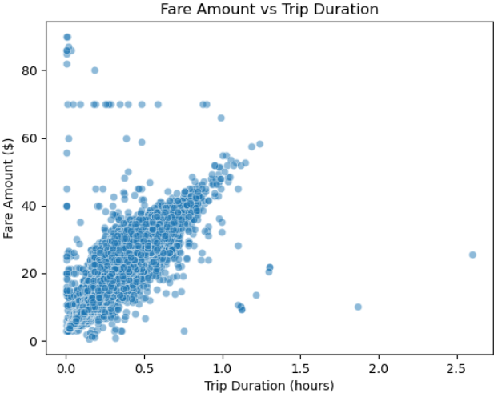
3.1.7.2 Fare Amount and Passenger count
A correlation of 0.0127 was found between Fare Amount and Passenger Count. The value is very close to 0, suggesting almost no linear correlation between the number of passengers and the fare amount.
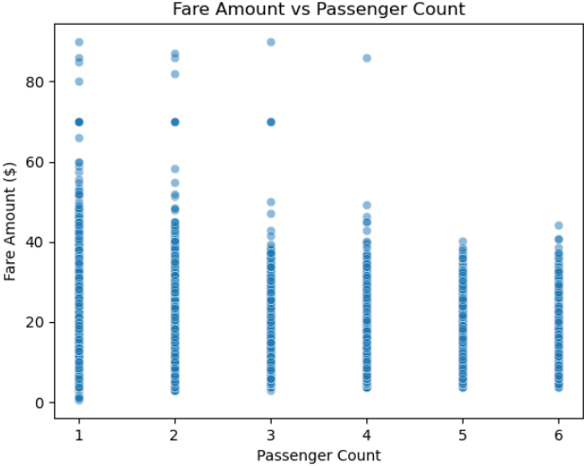

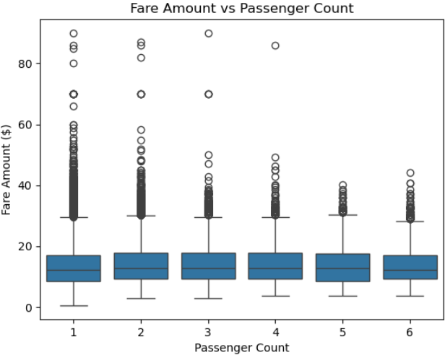
3.1.7.3 Tip Amount and Trip Distance
A correlation of 0.6040 between Tip Amount and Trip Distance suggests a moderately strong positive linear relationship. As trip distance increases, the tip amount tends to increase as well. However, the correlation isn't perfect (i.e., not close to 1.0). While longer trips tend to receive higher tips, the tip behavior isn’t purely based on distance.
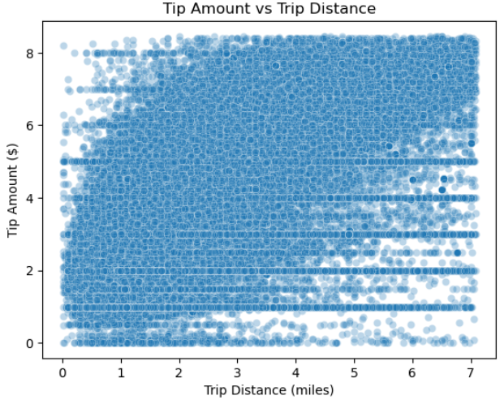

    - Analyse the distribution of different payment types
To determine the distribution of different payment types, the value count was computed and count plot was created.
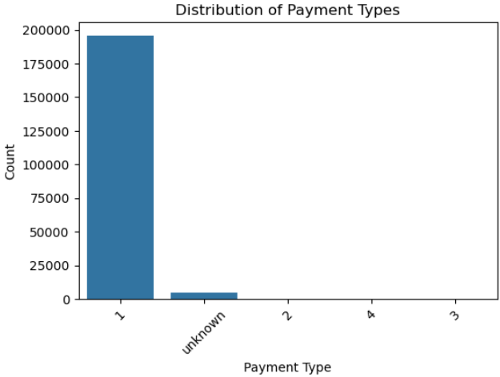
Insights that can be drawn from this analysis:
Credit cards (type 1) are overwhelmingly the most used payment method (195745 counts).
Cash (type 2) is low, which may be due to sampled dataset (5 counts)
Types 3 (Dispute) (1 count) and 4 (No charge) (3 counts) are rare and often relate to special cases.
    - Load the taxi zones shapefile and display it
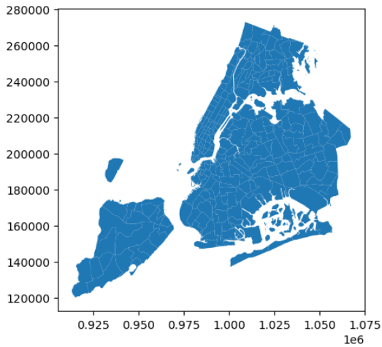
    - Merge the zone data with trips data
The zones data into trip data using the locationID and PULocationID columns.
A copy of zones geodataframe for pickup and dropoff was created. Further, merged pickup zone data and dropoff zone data with the trip records df.
    - Find the number of trips for each zone/location ID
To find the number of trips for each zone/location ID, data was grouped by PULocationID and DOLocationID, number of trips for each was calculated.
LocationID | total_trips
237 | 25098
236 | 24057
161 | 23294
162 | 17537
142 | 17360
230 | 16584
170 | 16165
186 | 15966
239 | 15577
163 | 14595

Further, a bar plot of LocationID vs Trip counts was plotted for the top 10 trip counts
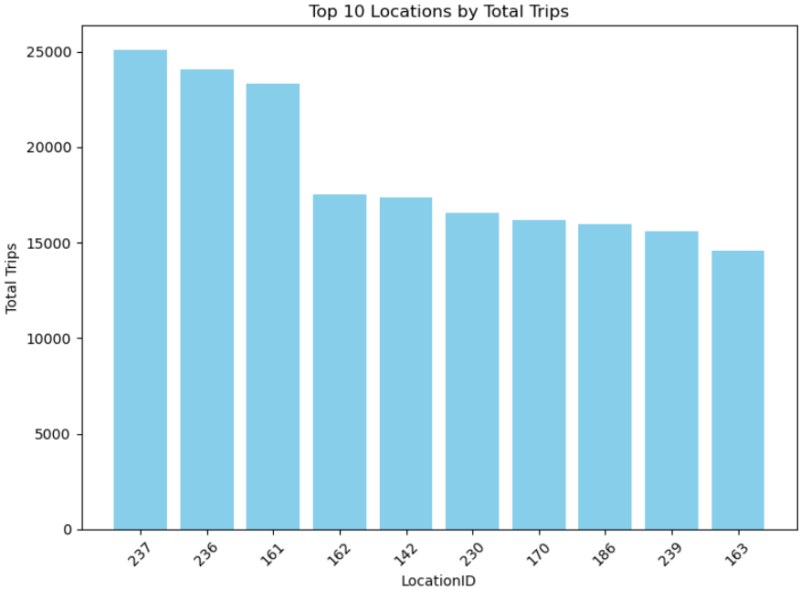
This indicates the top ten busiest zones are 237 - Upper East Side South (25098 trips), 236 - Upper East Side North (24057 trips), 161 - Midtown Center (23294 trips), 162 - Midtown East(17537 trips), 142 - Lincoln Square East(17360 trips) , 230 - Times Sq/Theatre District (16584 trips), 170 - Murray Hill(16165 trips), 186 - Penn Station/Madison Sq West(15966 trips) , 239 - Upper West Side South(15577 trips) and 163 - Midtown North (14595 trips)
    - Add the number of trips for each zone to the zones dataframe
The zones and trips_df were merged into merged_df with 'LocationID' column as key thereby adding total trips (trip_counts) data to the zones dataframe
    - Plot a map of the zones showing number of trips

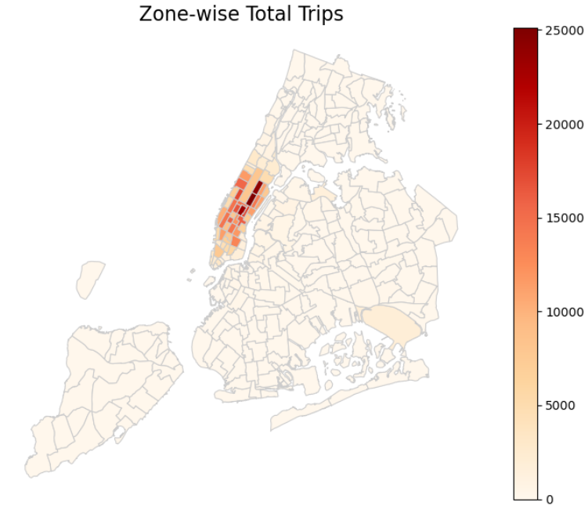
    - Conclude with results
Conclusions that can be drawn from the analysis so far are as follows:
3.1.14.1 Busiest hours, days and months
- Busiest hours - There is a significant spike in pickups at hour 23, followed by hours 17 and 18
- Busiest days - Wednesday and Thursday have the highest pickup counts, with 40,631 and 40,708, respectively. Saturday also sees a high count of 40,388, indicating that weekends and mid-week are the busiest days.
- Busiest months - May 2023 - 24,796, March 2023 - 24,228, October 2023 - 23,973
3.1.14.2 Trends in revenue collected
- The highest revenue occurred in May 2023 (425,966.05) and October 2023 (415,559.17).
- The lowest revenue occurred in August 2023 (307,189.31) and July 2023 (319,888.91).
- The revenue increases and decreases, with a notable dip around mid-year (June-July) and a recovery towards the end (October-December).
3.1.14.3 Trends in quarterly revenue
- There was a steady increase from Q1 to Q2.
- Q3 saw a dip compared to Q2.
- However, Q4 rebounded and returned to a level similar to Q2. Overall, the trend shows a fluctuation, but there seems to be a recovery towards the end of the year.
3.1.14.4 Dependency of fare amount on trip distance, trip duration and passenger counts
- A correlation of 0.9251 between Fare Amount and Trip Duration indicates a strong positive relationship between the two variables. This means that as the trip duration increases, the fare amount tends to increase as well, and vice versa. In practical terms, this suggests that longer trips are generally associated with higher fares, likely because more time on the trip results in higher costs for the service
- A correlation of 0.0127 between Fare Amount and Passenger Count indicates a very weak positive relationship between the two variables. Essentially, there is almost no relationship between the number of passengers and the fare amount. A value close to 0 suggests that changes in the number of passengers have little to no impact on the fare amount. In practical terms, this could mean that the fare is not heavily influenced by the number of passengers, which could imply that the fare is either set for the entire trip regardless of the number of passengers or is primarily influenced by other factors like distance and time
- A correlation of 0.8810 between Fare Amount and Trip Distance indicates a strong positive linear relationship. As trip distance increases, fare amount also tends to increase. However, it is not perfect (not 1.0) thereby implying that other factors (like surcharges, traffic delays, tolls, time of day) also influence the fare

3.1.14.5 Dependency of tip amount on trip distance
- A correlation of 0.6040 between Tip Amount and Trip Distance suggests a moderately strong positive linear relationship. As trip distance increases, the tip amount tends to increase as well. However, the correlation isn't perfect (i.e., not close to 1.0). While longer trips tend to receive higher tips, the tip behaviour isn’t purely based on distance.
3.1.14.6 Busiest zones
The top five busiest zones based on total trips are:
- Upper East Side South – 25,282 trips
- Upper East Side North – 24,245 trips
- Midtown Center – 23,516 trips
- Midtown East – 17,688 trips
- Lincoln Square East – 17,550 trips

Detailed EDA: Insights and Strategies
    - Identify slow routes by comparing average speeds on different routes
The average speed on different routed were calculated and was sorted in ascending order to find the slow routes
Slowest 5 routes were identified as follows:

PU_zone | DO_zone | pickup_hour | trip_duration | trip_distance | avg_speed
Inwood Hill Park | Inwood Hill Park | 7 | 0.173333 | 0.02 | 0.115385
TriBeCa/Civic Center | West Concourse | 15 | 0.979167 | 0.14 | 0.142979
Midtown Center | JFK Airport | 20 | 1.039167 | 0.2 | 0.192462
LaGuardia Airport | Times Sq/Theatre District | 15 | 1.021944 | 0.25 | 0.244632
Flatbush/Ditmas Park | Flatbush/Ditmas Park | 2 | 0.165 | 0.05 | 0.30303

    - Calculate the hourly number of trips and identify the busy hours
Hourly number of trios was determined by grouping the data by 'pickup_hour' and trips counts. The busiest hour was found to be 23 (11 PM) with 26494 trips
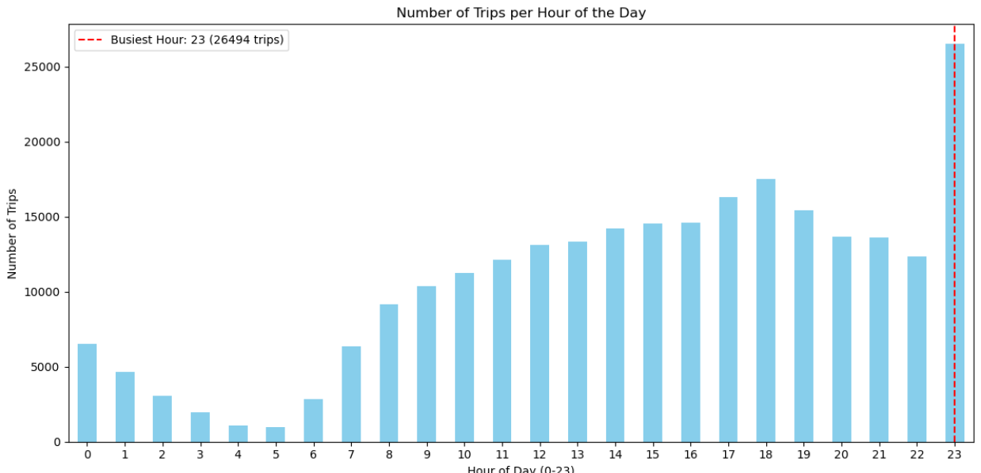

    - Scale up the number of trips from above to find the actual number of trips
The actual number of trips in the busiest hours was determined by scaling up the number of trips and pickup hour by the scaling factor ≈ 133.33
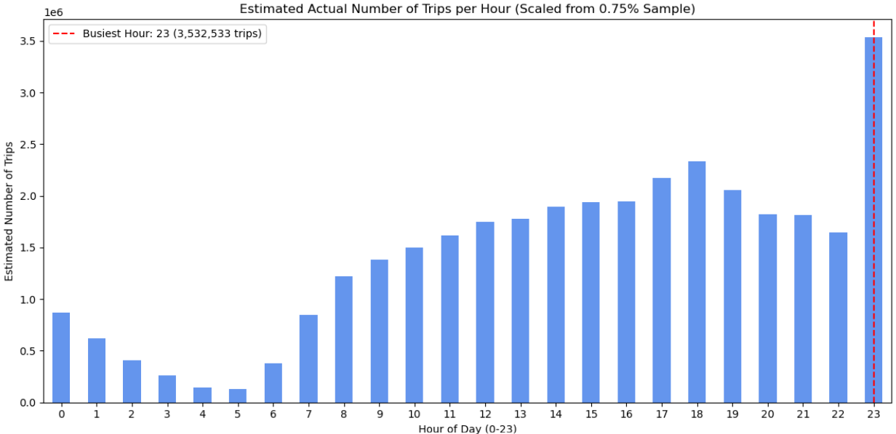
The top 5 (busiest) pickup hours were found to be
Hour | Number of trips
23 | 3532533
18 | 2331866
17 | 2173866
19 | 2054800
16 | 1949200

    - Compare hourly traffic on weekdays and weekends
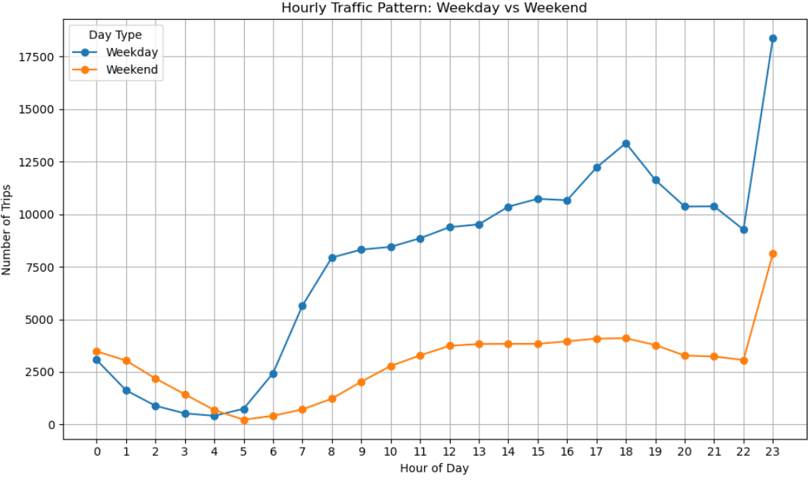
Insights that can be derived from the above analysis are:
- Weekday Trends:
  - Early morning (6 - 9 AM) and evening (4 -7 PM) show strong commuter peaks.
  - Peak hour: 23 (11 PM) is quite high, likely due to nightlife or shift workers.
- Weekend Trends:
  - Late morning to evening (10 AM - 6 PM) shows higher activity.
  - Early hours (1- 4 AM) are significantly higher than weekdays which is consistent with leisure/nightlife activity.
- Overall Patterns:
  - Weekdays show a more structured commuting pattern.
  - Weekends have flatter midday activity and strong late-night traffic, suggesting recreational travel.

    - Identify the top 10 zones with high hourly pickups and drops
Top 10 zones with high hourly pickups
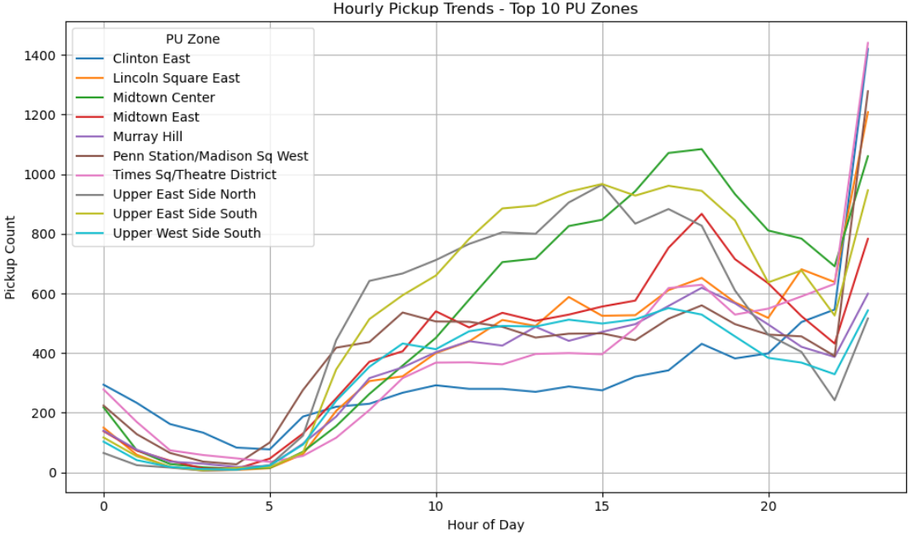
Top 10 zones with high hourly drop offs
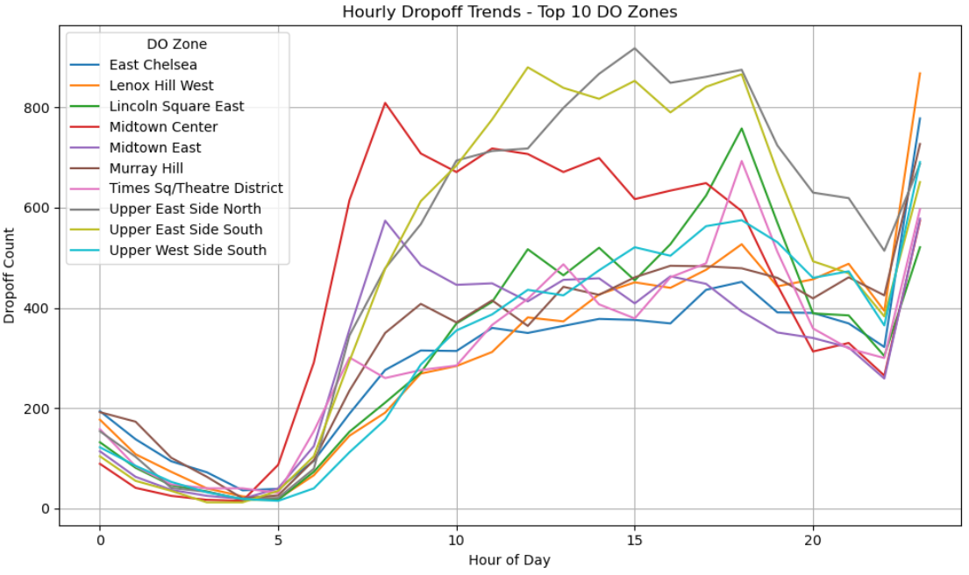
    - Find the ratio of pickups and drop-offs in each zone
Top 10 highest pickup/dropoff ratios:
 | pickup_count | dropoff_count | pickup_dropoff_ratio
LaGuardia Airport | 1309 | 180 | 7.272222
JFK Airport | 1607 | 304 | 5.286184
Parkchester | 5 | 1 | 5
Crotona Park East | 4 | 1 | 4
East Elmhurst | 252 | 71 | 3.549296
Oakland Gardens | 2 | 1 | 2
Manhattan Beach | 2 | 1 | 2
Penn Station/Madison Sq West | 9730 | 6236 | 1.560295
Greenwich Village South | 4126 | 2749 | 1.500909
Central Park | 4701 | 3297 | 1.425842
Bottom 10 lowest pickup/dropoff ratios:

 | pickup_count | dropoff_count | pickup_dropoff_ratio
Saint George/New Brighton | 0 | 1 | 0
Laurelton | 0 | 31 | 0
Cambria Heights | 0 | 18 | 0
East Flushing | 0 | 7 | 0
Hunts Point | 0 | 4 | 0
Homecrest | 0 | 2 | 0
Hollis | 0 | 4 | 0
Highbridge Park | 0 | 4 | 0
Highbridge | 0 | 10 | 0
Brownsville | 0 | 3 | 0

    - Identify the top zones with high traffic during night hours

PU_zone | pickup_count | DO_zone | dropoff_count
East Village | 3175 | East Village | 1834
West Village | 2544 | West Village | 1121
Clinton East | 2402 | Clinton East | 1353
Times Sq/Theatre District | 2101 | Times Sq/Theatre District | 998
Greenwich Village South | 1863 | Greenwich Village South | 559
Penn Station/Madison Sq West | 1858 | Penn Station/Madison Sq West | 898
Lower East Side | 1790 | Lower East Side | 955
Lincoln Square East | 1463 | Lincoln Square East | 848
Midtown Center | 1424 | Midtown Center | 848
Midtown South | 1345 | Midtown South | 930

    - Find the revenue share for nighttime and daytime hours
Revenue shares for nighttime and daytime hours are as follows:
Day -- 82.50 %
Night – 17.50 %
    - For the different passenger counts, find the average fare per mile per passenger
passenger_count | fare_per_mile_per_passenger_in_USD
1 | 11.605318
2 | 5.711694
3 | 4.119702
4 | 4.026132
5 | 1.653842
6 | 1.329573

This indicates that:
  - As more passengers share a taxi, the cost per mile per passenger decreases significantly. The total fare (which depends on distance and time) is being shared among more people, making individual rides cheaper. This thereby, encourages ride sharing or pooling to reduce costs per person.

    - Find the average fare per mile by hours of the day and by days of the week
time_period | day | night
day_of_week
Friday | 9.938189 | 8.447647
Monday | 10.77296 | 10.90946
Saturday | 10.74095 | 9.360906
Sunday | 10.82913 | 38.46763
Thursday | 11.52597 | 9.130775
Tuesday | 10.51176 | 13.61154
Wednesday | 12.17726 | 8.250916

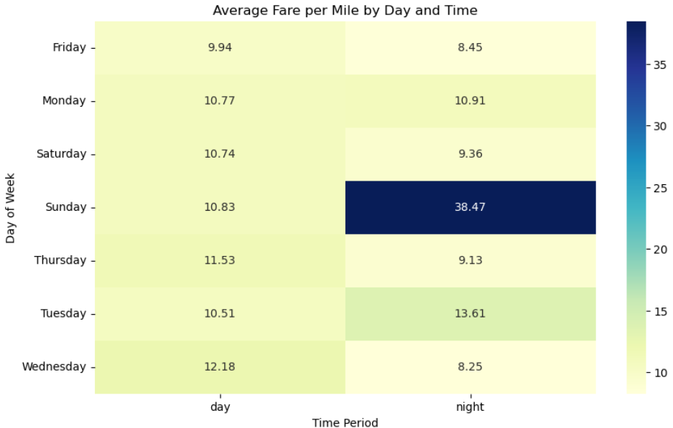
This indicates that:
  - Sunday night has an unusually high value: 38.467629. This is significantly higher than any other value, which could indicate a surge in demand (possibly due to weekend events).
  - Wednesday day (12.177256) has the highest daytime value, suggesting more expensive or longer trips compared to other weekdays.
  - Monday and Saturday values are relatively consistent between day and night, suggesting stable traffic patterns.
  - Tuesday night (13.611541) is also notably high compared to other nights.
Overall, NYC taxi fares are generally higher during the day on weekdays due to traffic and demand

    - Analyse the average fare per mile for the different vendors
VendorID | fare_per_mile
6 | 6.426728
1 | 8.327199
2 | 12.794881

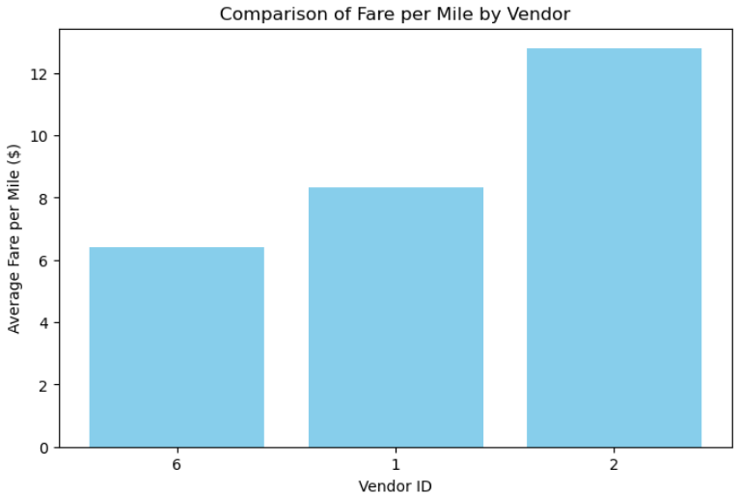
This indicates that:
      - VendorID 6 has the lowest fare per mile at ~$6.43.
      - VendorID 2 has the highest fare per mile at ~$12.79.
      - VendorID 1 is in between at ~$8.33.

    - Compare the fare rates of different vendors in a distance-tiered fashion

 | Vendor 1 | Vendor 2 | Vendor 6
distance_tier
Long (>5 miles) | 4.912931 | 5.012207 | 5.321479
Medium (2-5 miles) | 6.247271 | 6.445276 | 7.847762
Short (<=2 miles) | 9.50897 | 16.74307 | NaN

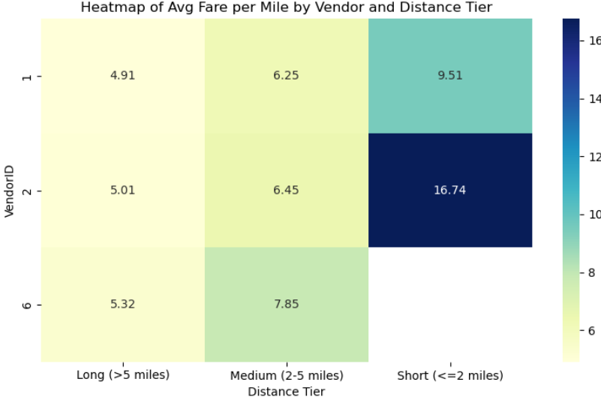
The following insights can be drawn from above analysis:
- Short-distance trips (<=2 miles):
  - Vendor 2 has much higher values (16.74) than Vendor 1 (9.51), suggesting Vendor 2 might charge more.
  - Vendor 6 has missing data (NaN), indicating either no short trips recorded or missing/incomplete data.
- Medium-distance trips (2–5 miles):
  - Values are higher than long trips for all vendors, particularly Vendor 6 (7.85), which suggests trips in this tier might be more common or more profitable.
  - Vendor 6 again shows the highest value.
- Long-distance trips (>5 miles):
  - Vendor 6 shows the highest value (5.32), followed by Vendor 2 and Vendor 1.
  - This could reflect higher fares, or longer durations, or differences in routing.
    - Analyse the tip percentages
3.2.13.1 Tip percentage by Trip distance

distance_tier | tip_pct
Long (>5 miles) | 14.26659
Medium (2-5 miles) | 18.32128
Short (<=2 miles) | 22.21776

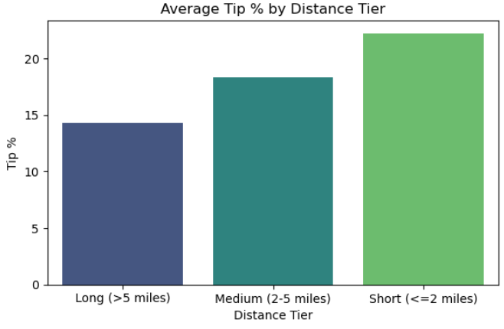
The following insights can be drawn from the above analysis:
- Shorter Trips Get Higher Tips
  - Short trips (<=2 miles) have the highest average tip percentage at 22.22%.
  - Medium trips (2 – 5 miles) have a lower average tip percentage at 18.32%.
  - Long trips (> 5 miles) receive the lowest average tip percentage at 14.27%.
- Tip Percentage Decreases as Distance Increases (There is a clear inverse relationship between trip distance and tip percentage)
- This may suggest that passengers are more generous on shorter rides, possibly because the absolute tip amount remains small even when tipping a high percentage.
- On longer rides, passengers may tip less as a percentage to avoid high absolute tip amounts.

3.2.13.2 Tip percentage by Passenger count

passenger_count | tip_pct
1 | 20.79211
2 | 20.16888
3 | 19.29739
4 | 17.79372
5 | 20.83065
6 | 21.09407

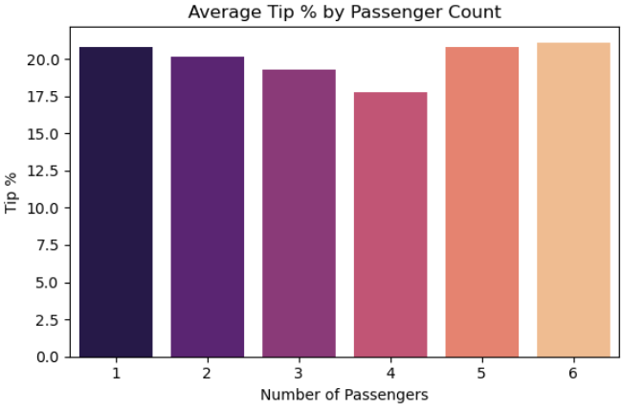
The following insights can be drawn from above analysis:
- Tip percentage is highest for single passengers (1 passenger):
  - 20.79% - this suggests solo riders might be more generous or simply default to standard tipping norms.
- Tip percentage decreases as passenger count increases - up to 4 passengers:
  - It drops from 20.79% (1 passenger) down to 17.79% (4 passengers).
  - This could indicate cost-sharing behaviour. When people split the fare, they may tip less collectively, or feel less personal responsibility to tip generously.
- Tip percentage increases again for 5 and 6 passengers:
  - 20.83% (5 pax) and 21.09% (6 pax).
  - This might suggest larger groups (possibly tourists or corporate rides) tipping better, possibly due to a group leader tipping on behalf of everyone, or pre-included gratuity in larger group fares.
Thus overall, it can be said that solo and large-group passengers tend to tip more generously While mid-sized groups (2–4) may tip less, possibly due to cost-splitting or unclear tipping responsibility.

3.2.13.3 Tip percentage by Pickup Hour

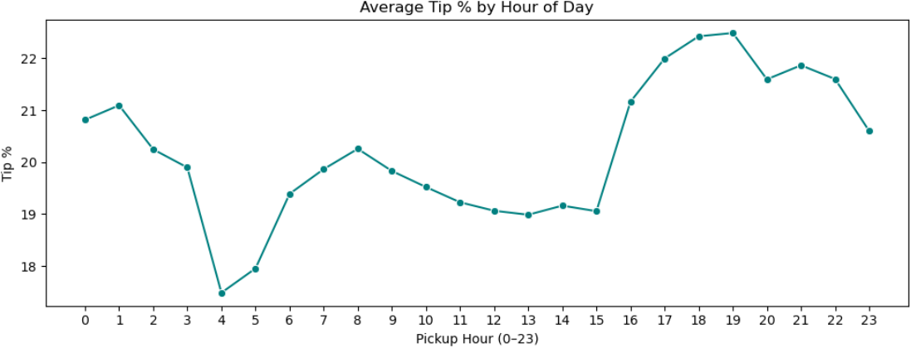
The following insights can be drawn from above analysis:
  - Highest tipping hours are between 17:00 (5 PM) to 22:00 (10 PM), peaking around 18:00–20:00:
  - Lowest tipping hours are early morning, especially around 4 AM and 5 AM
  - Midday tipping (11 AM – 3 PM) seems more stable but slightly lower compared to evening.
  - After 9 PM, tip percentages remain relatively high (above 20%) until midnight,
  - Thus, it can be summarised that the tip percentages are lowest early morning and midday. Evening hours (especially 6 PM–9 PM) show the highest tipping behaviour

    - Analyse the trends in passenger count
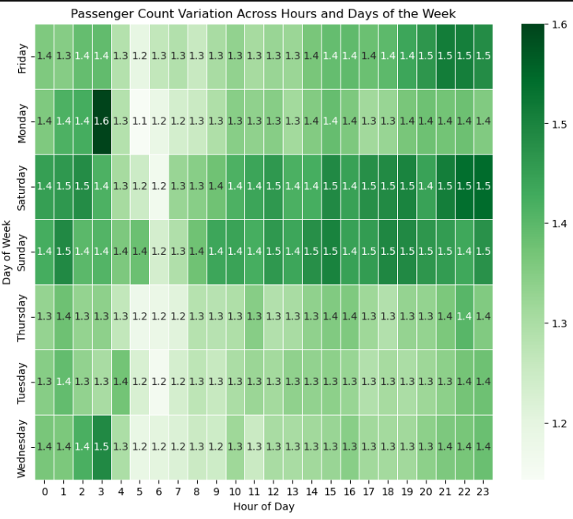.
The various insights that can be drawn from this analysis are:
- Evening Peak (Around 17:00–21:00) Shows Highest Passenger Counts Across Most Days: Especially on Friday, Saturday, and Sunday, values are significantly higher in the evening hours (e.g., 18:00–22:00). This reflects people going out for social activities, dining, and nightlife during weekends.
- Late Night Hours (0:00–2:00) Are Also Busy on Weekends: Saturday and Sunday (i.e., Friday and Saturday nights) show high values in the early morning hours (post-midnight), likely due to late-night returns from outings.
- Weekdays Show Modest Peaks During Commute Hours: A small increase in values around 8:00 - 10:00 AM and 16:00 - 18:00 PM, particularly on Monday to Thursday, suggests commute-related rides. Tuesday to Thursday appear relatively stable without extreme peaks.
- Saturday Is the Busiest Day (Overall): Values are generally high across most hours, especially in the afternoon and evening, indicating high leisure activity.
- Monday Morning Dip: Early hours (5:00 - 8:00 AM) show relatively lower values on Monday, possibly reflecting slower start after the weekend.
- Sunday Daytime Is Active Too: Notable increase in midday to evening (12:00 - 20:00), likely from leisure travel, returning home, or tourist activity.
Thus, it can be summarised as follows:
- Highest demand: Friday & Saturday evenings, and early weekend mornings (midnight–2 AM).
- Moderate demand: Weekday commute hours.
- Lowest demand: Early weekday mornings (especially Monday), late night mid-week.

    - Analyse the variation of passenger counts across zones
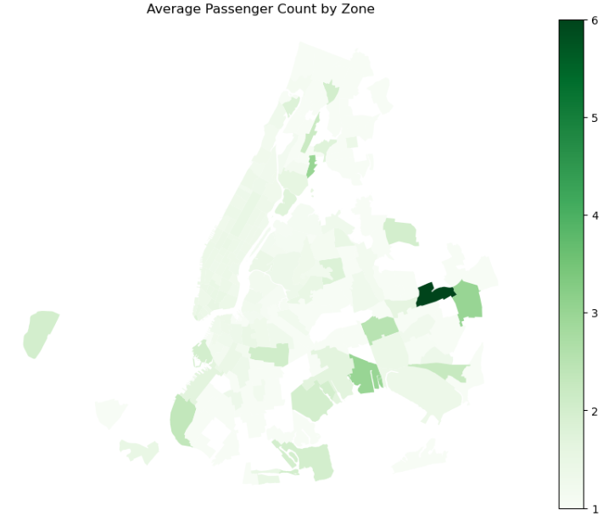

Top 10 zones by average passenger count

zone | avg_passenger_count
Jamaica Estates | 6.00
Queens Village | 3.00
Howard Beach | 3.00
Longwood | 3.00
Richmond Hill | 2.50
Bay Ridge | 2.33
Springfield Gardens South | 2.25
Claremont/Bathgate | 2.20
Crown Heights North | 2.07
Canarsie | 2.00

This indicates that:
- Jamaica Estates has the highest average passenger count at 6 passengers per trip, which could indicate frequent use of larger group travel, possibly via larger taxis or vans.
- Queens Village, Howard Beach, and Longwood all average 3 passengers per trip, suggesting moderate group travel from these zones.
- As the list goes down from Richmond Hill to Canarsie with 2 passengers per trip, it shows smaller groups, which is more typical of general taxi usage.
Bottom 10 zones by average passenger count

zone | avg_passenger_count
Sunset Park East | 1.00
Flatbush/Ditmas Park | 1.00
Pelham Parkway | 1.00
West Brighton | 1.00
Prospect-Lefferts Gardens | 1.00
East New York/Pennsylvania Avenue | 1.00
East Flatbush/Farragut | 1.00
Rego Park | 1.00
East Concourse/Concourse Village | 1.00
Ridgewood | 1.00

This indicates that:
- Low Ride-Sharing Activity: - An average of 1 passenger per trip suggests that most trips in these zones involve single riders, indicating low use of shared rides
- Residential or Low-Demand Areas - Many of these zones (e.g., Flatbush, East Flatbush, Pelham Parkway) are primarily residential neighbourhoods, where taxis are likely used individually for personal errands or commuting, not by groups.
- Potential Underutilization of Taxis - These areas might not have high taxi demand, either due to alternative transport options (like subways/buses) or lower population density
    - Analyse the pickup/dropoff zones or times when extra charges are applied more frequently.
3.2.16.1 Pickup/dropoff zones where extra charges are applied more frequently.

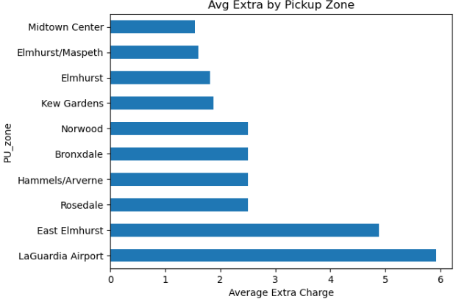

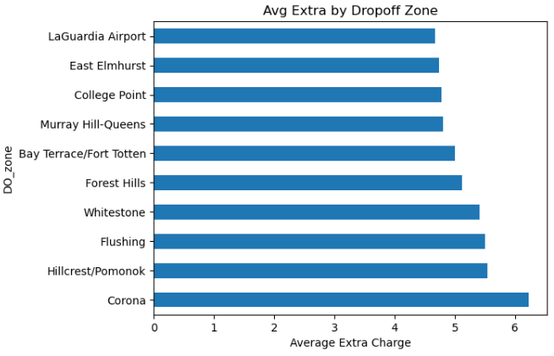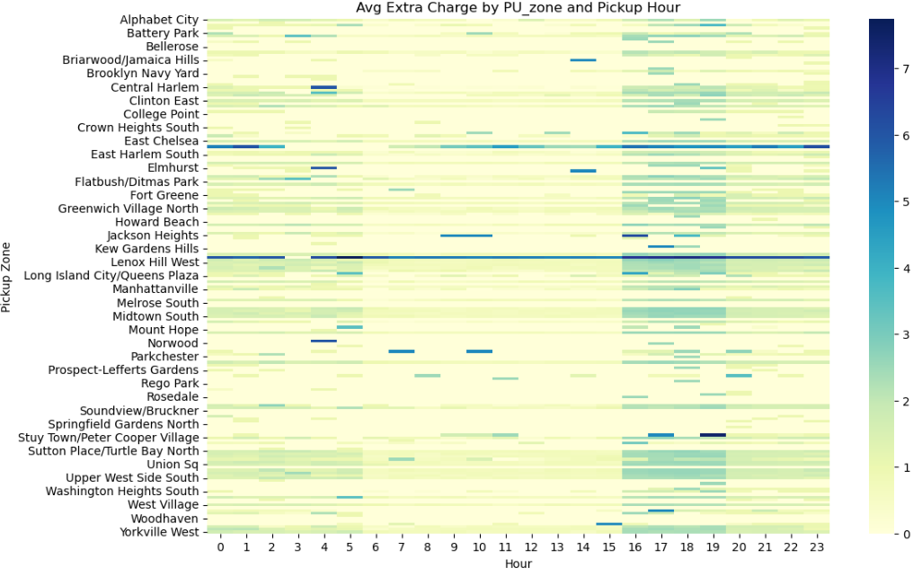
From the above analysis, it can be seen that:
- Extra charges are frequently levied in Lenox Hill West zone followed by East Chelsea zone.
- It can also be seen that extra charges are levied mostly in the late evening (16 – 19) hours of the day for almost all the zones.
3.2.16.2 Times when extra charges are applied more frequently.
3.2.16.2 .1 Hours of the day when extra charges are applied more frequently.
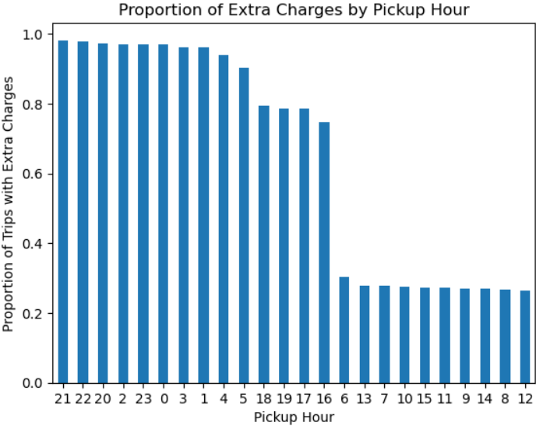

This indicates that:
  - Extra Charges Peak at Night (Especially Late Night): Highest surcharges are observed during: 9 PM (21) – 0.982, 10 PM (22) – 0.979, 8 PM (20) – 0.974, 2 AM (2) – 0.970, 11 PM (23) – 0.970. These hours likely reflect high demand or night-time surcharge policies, possibly due to limited supply of cabs
  - Early Morning to Afternoon Shows Low Extra Charges Lowest extra charges are observed during 12 PM (12) – 0.264, 8 AM (8) – 0.267, 2 PM (14) – 0.271, 9 AM (9) – 0.271, 11 AM (11) – 0.271. These hours are off-peak, possibly due to lower demand, more availability of drivers, night surcharge not in effect
  - Unexpected Dip in Early Morning (6 AM to 7 AM): 6 AM (6) – 0.302, 7 AM (7) – 0.278. These are surprisingly low, despite being early morning hours
3.2.16.2.2 Time period of the day when extra charges are applied more frequently.
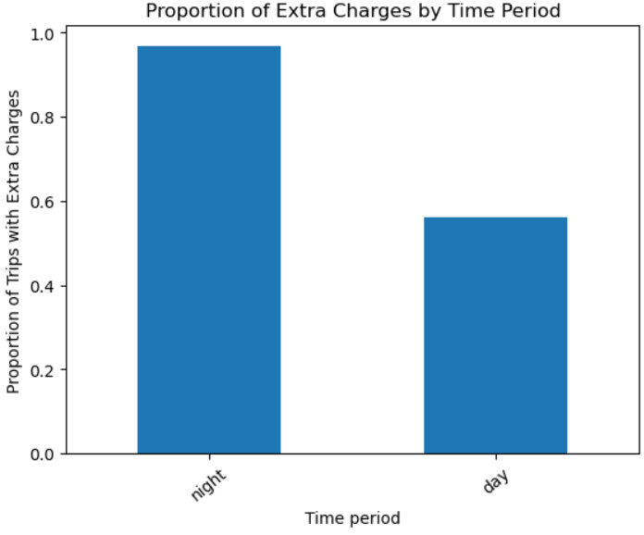
The following insights can be drawn from the above analysis:
- Extra charges at night are higher: 96.8% of taxi rides at night include extra charges. This is significantly higher compared to 56.0% during the day. This might be due to hortage of drivers during off-peak hours.

3.2.16.2. 3 Day of the week when extra charges are applied more frequently.
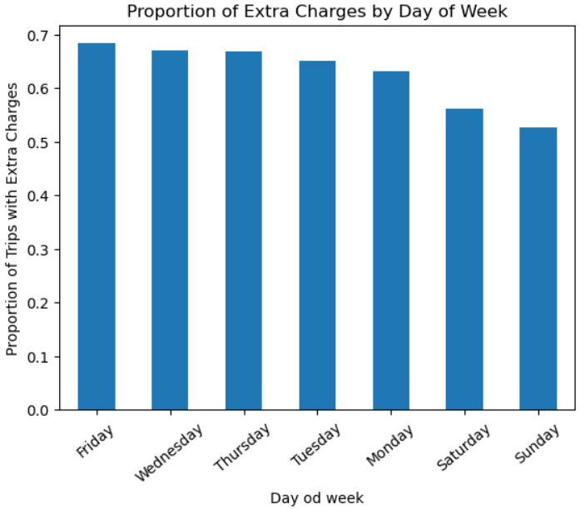
This indicates that:
- The highest extra charges occur on Fridays, followed by Wednesday and Thursday, indicating higher demand during the beginning of the weekend.
- The lowest charges are typically seen on Sunday, suggesting reduced demand as the weekend ends.

Conclusions

Final Insights and Recommendations
    - Recommendations to optimize routing and dispatching based on demand patterns and operational inefficiencies.
To optimize routing and dispatching for NYC taxis based on the demand patterns and operational inefficiencies, several recommendations can be made:
1. Dynamic Fleet Distribution Based on Time of Day & Demand Peaks
- Peak Hours (Evening & Night): During the high-demand hours, particularly 18:00 (rush hour) and 23:00 (nightlife/shift changes), ensure that more vehicles are dispatched to the busiest zones like the Upper East Side, Midtown, Times Square, and the Penn Station area. These areas have the highest pickup counts, so prioritizing them during these times can maximize efficiency.
- Early Morning (Low Demand): For low-demand hours like 5:00 AM, dispatch a smaller fleet and allocate them to zones that consistently show moderate demand during the early morning, such as Jamaica Estates or other moderately busy areas.
2. Optimal Vendor Allocation
- Vendor-Based Optimization: Since VendorID 2 has the highest fare per mile, it could be more profitable for longer trips or trips with higher demand, particularly during peak hours. Assigning VendorID 2 to longer-distance trips (> 5 miles) can maximize revenue. Meanwhile, VendorID 6, with lower fares per mile, can handle medium-distance trips (2 - 5 miles) or shorter trips efficiently, as it has competitive pricing.
3. Zone-Based Routing Optimization
- High-Demand Zones (e.g., Upper East Side, Midtown): Use real-time data to send more vehicles to these areas during evening and weekend peaks.
- Low-Demand Zones: During off-peak times, reduce the number of taxis in these zones to avoid empty trips. For example, zones like Queens Village or Howard Beach, with moderate group travel, could have fewer taxis during early morning or late-night hours.
4. Leverage Extra Charges During Peak Hours
- Extra Charges and High-Demand Times: Extra charges are higher at night (especially around 9 PM to 2 AM). Use this as an opportunity to increase fare optimization by sending more taxis to popular late-night zones (like nightlife areas in Midtown and Times Square) where extra charges are likely to be applied more frequently.
- Adjust Fleet Size Based on Extra Charges: For example, Friday and Saturday evenings show higher demand and extra charges. Ensure an increased fleet during these times in areas with frequent surcharges to capitalize on higher fares.
5. Group Travel Optimization
- Larger Group Travel (Jamaica Estates, Queens Village): For areas like Jamaica Estates, where average passenger count is higher (6 passengers per trip), prioritize larger vehicles like SUVs or vans. This can improve efficiency by matching vehicle size to the group size and reducing empty rides.
6. Time-of-Day Fare Optimization
- Fare Trends: Fare per mile varies across hours of the day. For instance, Sundays show unusually high fares at night, while Wednesdays see high daytime fares. To optimize fare collection, focus on maximizing trips during these high-fare periods and direct taxis to high-demand zones during these hours to benefit from the surge.
7. Traffic and Commuter Flow Awareness
- Weekday Commute Optimization: Weekdays show commuter peaks between 6 AM to 9 AM and 4 PM to 7 PM. For these periods, deploy taxis to key commuter hubs (such as Grand Central or Penn Station) to efficiently serve the peak commuter demand.
- Weekend Leisure Activity: On weekends, activity peaks later in the day. Focus on deploying taxis to entertainment and nightlife hubs, where demand tends to rise from 10 AM to 6 PM, especially on Fridays and Saturdays.
8. Optimizing Tips and Customer Experience
- Tip-Based Incentive Program: Since the average tip percentage is higher for short trips ($2 miles) and solo passengers, consider offering incentives to drivers for completing short, single-passenger trips during high-demand hours, such as weekday evenings or weekends.
- Prioritize High-Tip Areas: Identify zones where tips are typically higher (e.g., 17:00 - 22:00) and ensure taxis are in these areas during these hours. This could further improve driver satisfaction and profitability.
9. Regular Fleet Adjustments Based on Weekly Trends
- Adjust Fleet Size Weekly: Given that certain days (Wednesday, Thursday) see higher overall demand than others (e.g., Monday or Sunday), maintain a larger fleet during high-demand days and reduce fleet size during lower demand days.
- Seasonal Adjustments: In months with lower demand (e.g., September and August), consider scaling down fleet size or reassigning vehicles to other, higher-demand locations (e.g., tourist-heavy areas during the summer).
By combining dynamic dispatching based on demand, optimizing vehicle allocation by fare trends and passenger counts, and leveraging predictive data analytics, NYC taxi services can significantly enhance efficiency, reduce operational costs, and improve customer satisfaction

    - Suggestions on strategically positioning cabs across different zones to make best use of insights uncovered by analysing trip trends across time, days and months.

Strategically positioning cabs across different zones based on the insights from trip trends across time, days, and months can significantly optimize taxi dispatching and improve operational efficiency. Below are some targeted suggestions for zone positioning to leverage these insights:
1. Peak Time (Evening & Night) Strategy:
- Key Zones for Evening and Night:
  - Upper East Side, Midtown, Times Square, and Penn Station: These zones show high demand in the evening and night, especially around 18:00 - 23:00. Positioning more cabs here during these hours will ensure quick responses to the large volume of requests, optimizing the fleet’s effectiveness during high-demand hours.
  - Strategy: Increase the fleet around 17:30 - 18:30 to capture commuters heading home and those attending nightlife or events. Ensure taxis are positioned near popular destinations (bars, restaurants, theaters) around 20:00 - 22:00, and be ready for the shift changes and late-night events around 23:00.
- Late Night (Weekend Nights) Strategy:
  - Times Square, Midtown, Lower Manhattan (e.g., SoHo, Greenwich Village): These areas have higher activity late at night, particularly from 11 PM to 2 AM. Position taxis in these areas to cater to nightlife demand.
  - Strategy: Increase fleet size post-midnight, as demand is notably higher during late-night hours on weekends, especially from 1 AM to 3 AM. Zones around nightlife hotspots should be prioritized for coverage.
2. Weekday Commuter Trends Strategy:
- Morning Rush (6:00 AM to 9:00 AM):
  - Midtown, Penn Station, Grand Central: These are key hubs for commuter traffic, showing strong demand during morning rush hours.
  - Strategy: Position taxis near transit stations and major office districts during morning rush hours. Increased presence in these areas from 7:00 AM to 9:00 AM can cater to commuters heading to work.
- Evening Rush (4:00 PM to 7:00 PM):
  - Midtown, Times Square, Upper East Side, and Downtown: Evening rush hour shows consistent demand across these zones. Position taxis to cater to both commuters and those heading out after work.
  - Strategy: Increase fleet size in key business districts (Midtown and Financial District), where people head out for dinner or entertainment. Ensure a higher presence in residential areas like the Upper East Side to capture demand during the evening rush.
3. Weekend Trends and Leisure Activity Strategy:
- Daytime Leisure Activity (10:00 AM to 6:00 PM on Saturday and Sunday):
  - Times Square, Upper East Side, Upper West Side, Central Park, SoHo, Greenwich Village: Weekend daytime demand peaks in areas with entertainment, tourism, and shopping.
  - Strategy: Position cabs around tourist attractions, shopping districts, and cultural landmarks. This ensures taxis are available for both tourists and locals. Central Park and major shopping should see high taxi presence during weekend afternoons.
- Late Night on Weekends (1:00 AM to 3:00 AM on Friday and Saturday nights):
  - Midtown, Times Square, Lower Manhattan: Late-night demand spikes as bars, clubs, and entertainment venues empty.
  - Strategy: Ensure high fleet presence around zones with active nightlife, particularly in the theatre areas and near popular bars and clubs.
4. Monthly Trends and Seasonality Strategy:
- Spring and Early Fall (March–May, October–December):
  - All Zones (Particularly Midtown, Times Square, Upper East and West Sides, Central Park): These months see higher pickups. Position taxis near tourist-heavy areas (Central Park, Midtown, Times Square) as spring and fall bring more tourists and outdoor events.
  - Strategy: During these months, ensure that there are more taxis available during the daytime in tourist-centric zones. Late spring (May) and early fall (October) should see a slightly larger fleet size due to increased tourist activity.
- Summer (July–September):
  - Tourist Zones (Midtown, Times Square, Central Park, Downtown): While summer months see a dip in demand overall, tourist hotspots like Times Square and Central Park still experience consistent demand.
  - Strategy: Focus on zones that cater to tourists, as there will still be high demand in these areas despite overall lower activity. The fleet can be adjusted to slightly smaller size in residential areas to save resources.
- Winter (January–February, December):
  - Business Districts (Midtown, Penn Station, Financial District): Demand tends to dip, but business zones still see moderate demand.
  - Strategy: Focus on core business areas and increase fleet presence during peak hours to meet the demand from commuters. Winter months may also see special events (e.g., New Year's Eve), so positioning taxis around key event venues will be profitable.
5. Group Travel & Larger Vehicle Strategy:
- Zones with High Group Travel (Jamaica Estates, Queens Village, Howard Beach): These areas have larger passenger groups, with an average of 3 - 6 passengers per trip.
  - Strategy: Position larger vehicles (vans, SUVs) during peak group travel hours, typically weekends and late evenings, to accommodate larger groups. These vehicles should be dispatched to neighbourhoods with frequent group trips or higher passenger counts.
7. Extra Charges and Fare Strategy:
- High Extra Charges (9 PM to 2 AM): Extra charges are highest at night. Focus on areas with nightlife and high demand during these times to maximize revenue.
  - Strategy: Prioritize placing taxis in areas where demand is highest at night, such as bars, clubs, and nightlife districts, to ensure taxis are in the right place when extra charges are applied.
By positioning taxis dynamically based on demand patterns across the day, week, month, and specific zones, this strategy will ensure the fleet operates at peak efficiency, reducing idle time, minimizing customer wait times, and maximizing both fare revenue and customer satisfaction.

    - Propose data-driven adjustments to the pricing strategy to maximize revenue while maintaining competitive rates with other vendors.

To optimize revenue while maintaining competitive pricing in a dynamic market like NYC taxis, leveraging the insights from the trip data can help in creating a data-driven, adaptive pricing strategy. Below are some actionable adjustments based on the data:
1. Surge Pricing for Peak Demand Hours
- Data Insights: Peak hours are identified at 18:00 - 23:00, with a spike at 23:00. Similarly, weekends show increased demand, particularly late-night (post-midnight) on Fridays and Saturdays. Additionally, certain zones (e.g., Midtown, Times Square) show sustained demand during peak hours.
- Adjustment: Implement surge pricing during high-demand hours (e.g., evenings, late nights, weekends) to maximize revenue. This could include a tiered surge model where prices increase by a percentage during high-demand hours (e.g., 20–30% during the 18:00 - 23:00 window and 40% during the 23:00 - 2:00 window).
- Strategy: Analyze demand elasticity during peak times and adjust surge percentages to avoid alienating customers while still capturing premium fares. For instance, limit surge pricing to specific zones or limit it to special events to keep the competitive edge.
2. Time-of-Day Pricing Adjustments
- Data Insights: Average fare per mile varies across hours. For example, Sunday night shows an unusually high fare per mile, likely due to surge or high-demand events. Conversely, weekday mornings and mid-day show more stable, lower fare amounts.
- Adjustment: Adjust pricing based on time of day, considering higher fares during specific times with high demand. For example, raise the fare per mile during evening rush hours, and decrease fares during early morning low-demand hours (5:00 AM - 6:00 AM) to attract more passengers.
- Strategy: Develop a flexible pricing model where rates are adjusted based on time, keeping fares competitive during lower-demand times and increasing during high-demand periods. This could include dynamic adjustments based on real-time demand predictions.
3. Pricing by Trip Distance and Duration
- Data Insights: There’s a strong correlation between fare amount and trip distance (0.881) and trip duration (0.925). Trips that are longer in duration tend to have higher fares, while shorter trips might need additional incentives or promotions.
- Adjustment: Implement a distance-based pricing model where the fare per mile varies based on trip distance:
  - Short-distance trips (<= 2 miles): Increase prices slightly during high-demand times but keep rates relatively competitive during low-demand times to capture more short-trip passengers.
  - Medium-distance trips (2–5 miles): Offer moderate increases in fares during evening rush and surge hours.
  - Long-distance trips (> 5 miles): Offer premium pricing during peak times, as these trips tend to be more profitable for vendors like Vendor 6, who charge higher for longer durations.
- Strategy: Introduce distance-tiered pricing for different time slots. This approach ensures that both short and long trips remain profitable without losing customers to competitors.
4. Tiered Pricing for Different Vendor Fares
- Data Insights: VendorID 2 has the highest fare per mile ($12.79) and VendorID 6 has the lowest ($ 6.43). There are clear differences in fare structures across vendors, and customers may have preference for cheaper options unless quality and service justify a higher price.
- Adjustment: Offer tiered pricing based on vendor performance and demand. Vendor 6, with the lowest fare per mile, could be positioned in low-demand zones or during low-traffic periods. Vendor 2, which has a higher fare per mile, could cater to high-end or business districts, offering premium services (e.g., faster service, luxury cars).
- Strategy: Implement a pricing differentiation strategy where taxis from different vendors are assigned to zones based on expected customer willingness to pay. This would ensure that high-demand areas with premium customers are served by vendors with higher rates, while lower-traffic areas are serviced by lower-cost vendors.
5. Adjusting Pricing Based on Passenger Count
- Data Insights: Tip percentages are highest for solo passengers (20.79%) and decrease as the passenger count increases, suggesting passengers are more likely to tip generously for solo trips, but the fare might increase with more passengers (due to larger vehicle size or group discounts).
- Adjustment: Group Pricing Strategy: For trips with more passengers (e.g., 4 - 6), introduce slightly higher fares to account for the larger vehicle used and the increased space required. However, offering group discounts for larger parties (e.g., 5 or 6 passengers) could attract more group travel and urge customers to opt for larger vehicles.
- Strategy: Introduce dynamic fare discounts or premium rates based on passenger count. For instance:
  - 1 - 2 passengers: Standard fare.
  - 3 - 4 passengers: Slightly increase fare (10% premium for larger vehicles).
  - 5+ passengers: Introduce a group discount to encourage larger groups to book taxis and improve operational efficiency, while maintaining competitive pricing.
6. Hourly Adjustments to Tip Percentages
- Data Insights: Tip percentages peak from 17:00 - 22:00, with 18:00 - 20:00 showing the highest. Tips are lowest early morning, particularly around 4:00 - 5:00.
- Adjustment: Adjust the base fare or introduce incentives during peak tipping hours (e.g., 17:00 - 22:00) to increase revenue, while offering promotions or discounts during low-tipping hours (early mornings).
- Strategy: Introduce tip-based discounts or bonuses during peak tipping periods. For example, increase the base fare slightly but allow for a higher tipping reward system to attract passengers during peak tipping hours. Conversely, reduce the base fare during low tipping times to maintain customer interest.
7. Dynamic Pricing for Extra Charges
- Data Insights: Extra charges are applied more frequently during the evening (especially 9 PM - 2 AM) and are highest on Fridays, followed by Wednesday and Thursday.
- Adjustment: Implement a dynamic extra charge model that can change based on the zone, demand, and specific time of day. This model should be especially focused on high-demand hours such as weekends and late nights.
- Strategy: Increase extra charges during busy periods (late-night weekends, peak events) to maximize revenue. Conversely, reduce them during low-demand periods to avoid scaring off potential customers. Dynamic extra charges can also be adjusted based on real-time demand forecasts
By implementing these data-driven adjustments, the pricing strategy can better respond to fluctuations in demand, enhance revenue during high-demand times, and remain competitive by offering flexible, adaptive pricing that maximizes both profit and customer satisfaction.

