AI ASSISTANT CODING

ASSIGNMENT-2

NAME : MOGILI KEERTHI
HT.NO : 2303A51427
BATCH : 21
LAB 2 :
Exploring Additional AI Coding Tools beyond Copilot – Gemini (Colab)
and Cursor AI
Task 1: Cleaning Sensor Data
❖ Scenario:
❖ You are cleaning IoT sensor data where negative values are invalid.
❖ Task:
Use Gemini in Colab to generate a function that filters out all negative
numbers from a list.
❖ Expected Output:
➢ Before/after list
➢ Screenshot of Colab execution

Prompt:
Generate a python function that filters out all negative numbers from a list
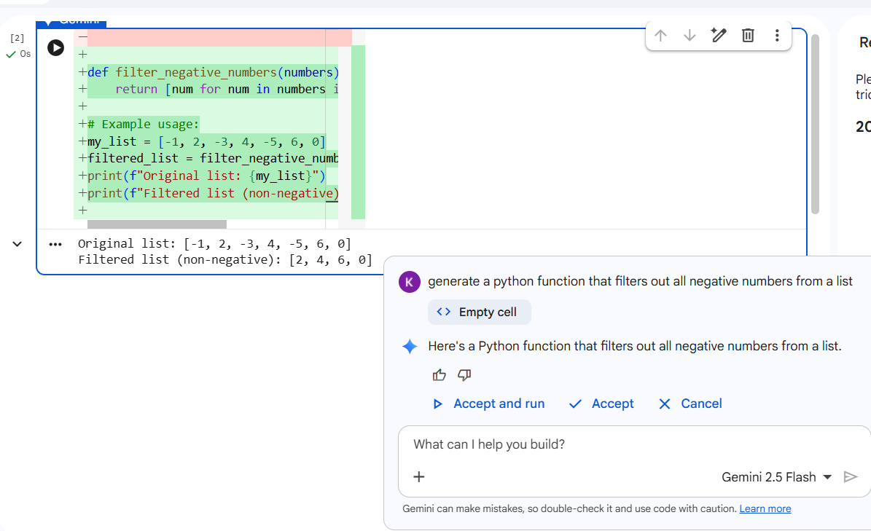
BEFORE LIST & AFTER LIST :
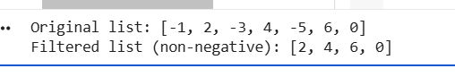

Task 2: String Character Analysis
❖ Scenario:
You are building a text-analysis feature.
❖ Task:
Use Gemini to generate a Python function that counts vowels, consonants,
and digits in a string.
❖ Expected Output:
➢ Working function
➢ Sample inputs and outputs
Prompt:
Generate a python function that counts vowels, consonants, and digits in a string.
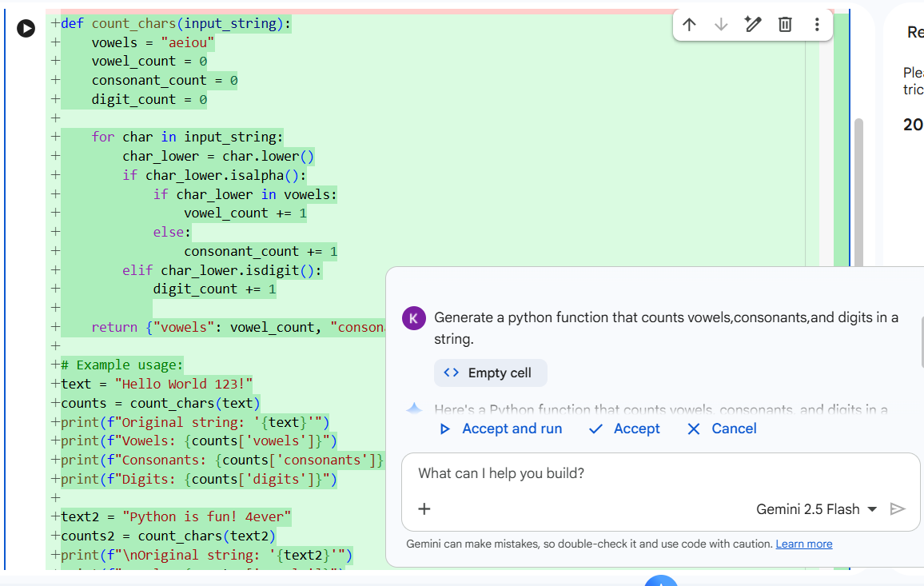
SAMPLE INPUT & OUTPUT :
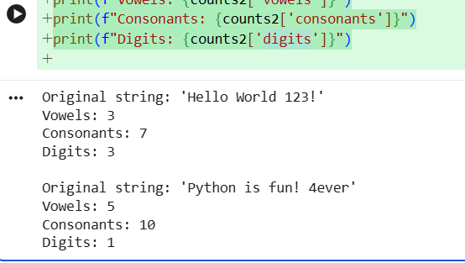
Task 3: Palindrome Check – Tool Comparison
❖ Scenario:
You must decide which AI tool is clearer for string logic.
❖ Task:
Generate a palindrome-checking function using Gemini and Copilot, then
compare the results.
❖ Expected Output:
➢ Side-by-side code comparison
➢ Observations on clarity and structure

Prompt:
Generate a palindrome-checking function
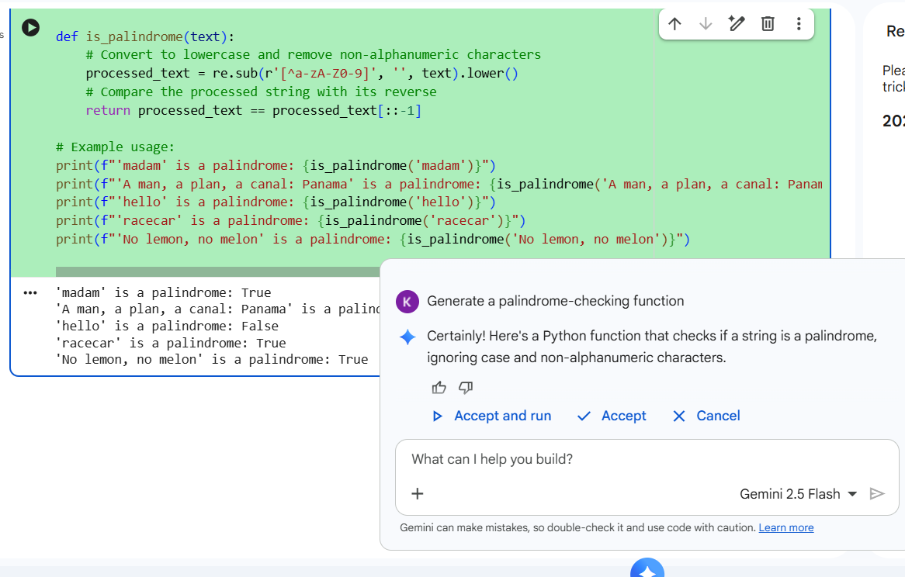
INPUT & OUTPUT :
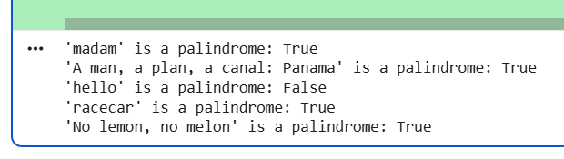

OUTPUT USING COPILOT :
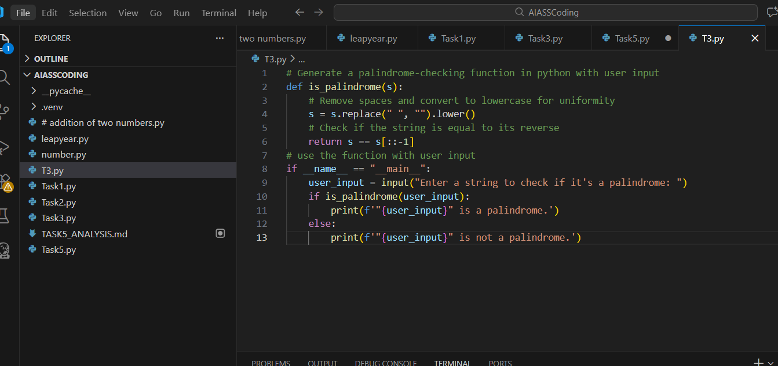
INPUT & OUTPUT :
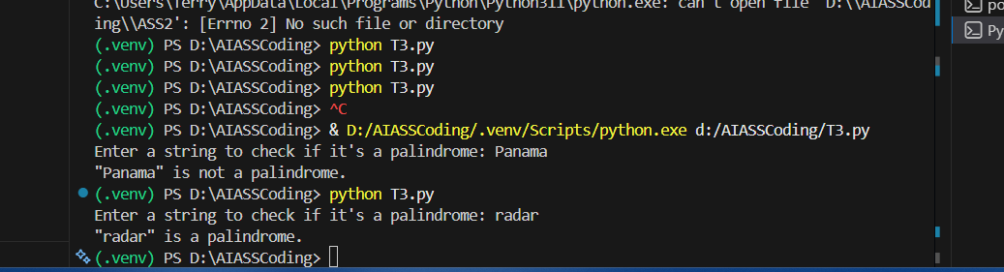
Task 4: Code Explanation Using AI
❖ Scenario:
You are reviewing unfamiliar code written by another developer.
❖ Task:
Ask Gemini to explain a Python function (prime check OR palindrome
check) line by line.
❖ Expected Output:
➢ Code snippet
➢ AI explanation
➢ Student comments on understanding
Prompt:
Explain the palindrome function line-by-line.
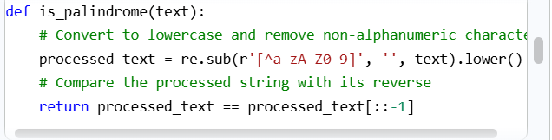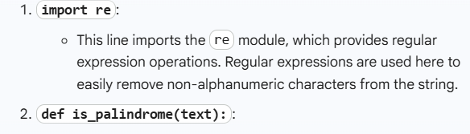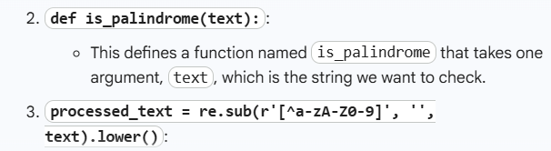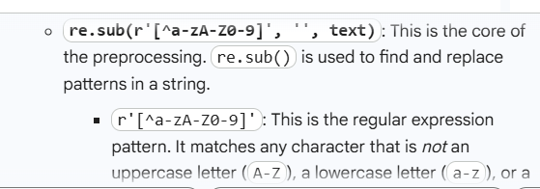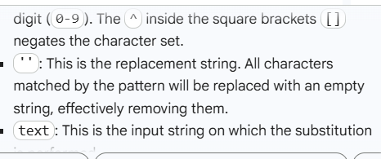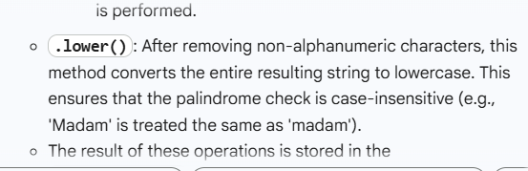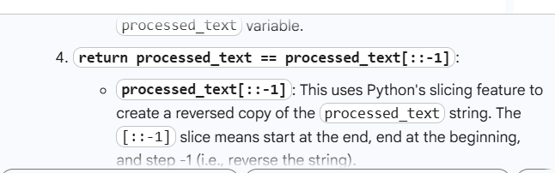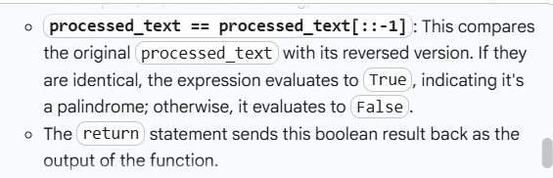
My own experience using both Gemini and GitHub Copilot:
While using Gemini in Google Colab, I found the explanations to be very clear and helpful in understanding the logic behind the code. Gemini was especially useful for learning and analyzing Python programs step by step. GitHub Copilot, was faster in generating code directly inside the editor and helped me complete tasks quickly. Copilot felt more suitable for continuous coding, while Gemini was better for conceptual clarity. Overall, using both tools together improved my coding efficiency and understanding.

