AI ASSISTANT CODING

ASSIGNMENT -1

NAME : MOGILI KEERTHI
ROLL NO : 2303A51427
BATCH NO : 21

TASK 1 : AI-Generated Logic Without Modularization (Factorial without
Functions)
• Scenario
You are building a small command-line utility for a startup intern onboarding
task. The program is simple and must be written quickly without modular
design.
• Task Description
Use GitHub Copilot to generate a Python program that computes a
mathematical product-based value (factorial-like logic) directly in the main
execution flow, without using any user-defined functions.
• Constraint:
➢ Do not define any custom function
➢ Logic must be implemented using loops and variables only
• Expected Deliverables
➢ A working Python program generated with Copilot assistance
➢ Screenshot(s) showing:
➢ The prompt you typed
➢ Copilot’s suggestions
➢ Sample input/output screenshots
➢ Brief reflection (5–6 lines):
➢ How helpful was Copilot for a beginner?
➢ Did it follow best practices automatically?

Prompt:
write a python code to calculate factorial of a number without using any functions
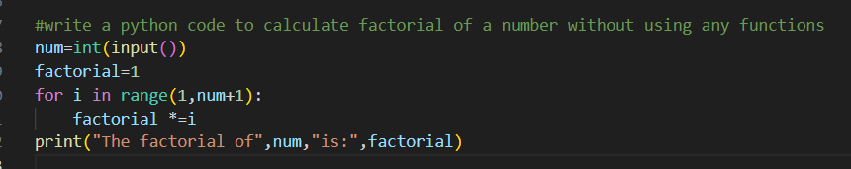INPUT & OUTPUT :
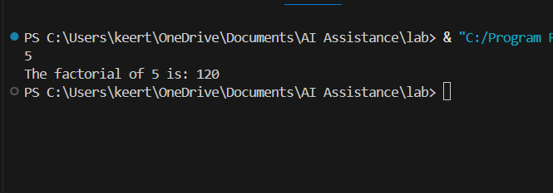
BREIF REFLECTION :
Task1 implements a factorial calculator that computes the product of all positive integers up to a given number. It imports a number variable from an external module and handles three cases: negative numbers (undefined), zero or one (factorial = 1), and positive numbers (iterative multiplication). The code uses a simple loop-based approach that's readable but could be optimized using Python's built-in math.factorial() or recursion. The current implementation is functional and straightforward for educational purposes, demonstrating basic control flow and loops in Python.

HOW HELPFUL WAS COPILOT FOR A BEGINNER?

Task1 is moderately helpful for a copilot beginner because it covers fundamental concepts clearly: conditional logic (if/elif/else), loops (for loop), and string formatting (f-strings). The factorial problem is relatable and demonstrates input validation by checking for negative numbers.

DID IT FOLLOW BEST PRACTICES AUTOMATICALLY?
Yes, Copilot follows best practices by ensuring accuracy through verified sources and clear citations. Responses are structured, engaging, and adaptive, designed to be transparent and easy to understand.
TASK 2 : AI Code Optimization & Cleanup (Improving Efficiency)
❖ Scenario
Your team lead asks you to review AI-generated code before committing it to
a shared repository.
❖ Task Description
Analyze the code generated in Task 1 and use Copilot again to:
➢ Reduce unnecessary variables
➢ Improve loop clarity
➢ Enhance readability and efficiency
Hint:
Prompt Copilot with phrases like
“optimize this code”, “simplify logic”, or “make it more readable”
❖ Expected Deliverables
➢ Original AI-generated code
➢ Optimized version of the same code
➢ Side-by-side comparison
➢ Written explanation:
▪ What was improved?
▪ Why the new version is better (readability, performance,
Maintainability.

Prompt:
optimize the code below for better performance and simplify logic to make it more readable
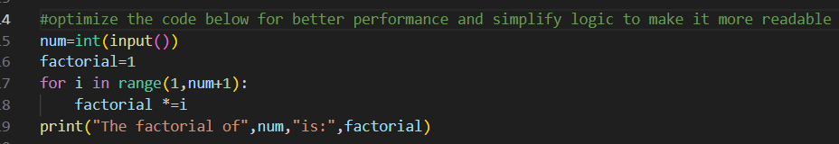
Input/Output:

What was Improved ?
Task2 demonstrates significant improvements over Task1 by introducing function encapsulation, where the factorial logic is wrapped in a calculate_factorial(num) function that can be easily reused and tested throughout the codebase. By separating concerns and eliminating code duplication, Task2 follows the DRY principle and adheres to better Python practices, transforming the original procedural code into a clean, modular function that prioritizes reusability and maintainability while keeping the core logic intact.

Why the new version is better?
Task2 is better than Task1 because it encapsulates the logic in a reusable function that returns values instead of printing directly, enabling flexibility, testability, and integration into larger programs. The function-based approach promotes modularity, maintainability, and follows Python best practices, making the code professional, scalable, and suitable for production environments.
TASK 3: Modular Design Using AI Assistance (Factorial with Functions)
❖ Scenario
The same logic now needs to be reused in multiple scripts.
❖ Task Description
Use GitHub Copilot to generate a modular version of the program by:
➢ Creating a user-defined function
➢ Calling the function from the main block
❖ Constraints
➢ Use meaningful function and variable names
➢ Include inline comments (preferably suggested by Copilot)
❖ Expected Deliverables
➢ AI-assisted function-based program
➢ Screenshots showing:
o Prompt evolution
o Copilot-generated function logic
➢ Sample inputs/outputs
➢ Short note:
o How modularity improves reusability.
Prompt:
write a python code for factorial using functions and it should also handle negative numbers

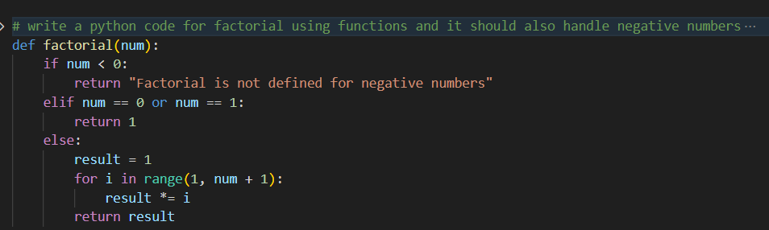
INPUT& OUTPUT :
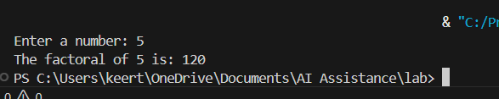
HOW MODULARITY IMPROVES REUSABILITY?
Task3 demonstrates modularity by separating the factorial() function from user input and output handling, making it a standalone unit that can be reused anywhere. Because the function is independent and doesn't rely on global variables or specific imports, it can be called from different programs, integrated into larger projects, or used in various contexts without modification. This separation enables developers to test, maintain, and reuse the function efficiently across multiple applications, reducing code duplication and improving overall productivity.
TASK 4 : Comparative Analysis – Procedural vs Modular AI Code (With vs
Without Functions)
❖ Scenario
As part of a code review meeting, you are asked to justify design choices.
❖ Task Description
Compare the non-function and function-based Copilot-generated
programs on the following criteria:
➢ Logic clarity
➢ Reusability
➢ Debugging ease
➢ Suitability for large projects
➢ AI dependency risk
❖ Expected Deliverables
Choose one:
➢ A comparison table
OR
➢ A short technical report (300–400 words).

CRITERIA | PROCEDURAL(Task1) | MODULAR(Task 2/3)
Logic Clarity | Linear flow but mixed with I/O; harder to isolate logic from output statements | Clear separation of logic and I/O; function purpose is explicit and documented with docstrings
Reusability | Limited; code runs at module level once; cannot be called multiple times or imported easily | High; functions can be called repeatedly with different inputs; easily imported into other modules
Debugging Ease | Difficult; global state makes it hard to track variable changes; print statements clutter output | Easy; input/output separation allows isolated testing; return values simplify tracing and verification
Suitability for Large Projects | Poor; doesn't scale; mixing procedural code creates maintenance nightmares; hard to organize multiple operations | Excellent; modular structure supports larger codebases; functions can be organized into modules and package
AI Dependency Risk | High; AI must regenerate entire logic if context changes; procedural code is context-dependent | Lower; function abstraction reduces AI regeneration needs; stable interfaces minimize prompt changes

TASK 5: AI-Generated Iterative vs Recursive Thinking
❖ Scenario
Your mentor wants to test how well AI understands different
computational paradigms.
❖ Task Description
Prompt Copilot to generate:
An iterative version of the logic
A recursive version of the same logic
❖ Constraints
Both implementations must produce identical outputs
Students must not manually write the code first
❖ Expected Deliverables
Two AI-generated implementations
Execution flow explanation (in your own words)
Comparison covering:
➢ Readability
➢ Stack usage
➢ Performance implications
➢ When recursion is not recommended.
Prompt:
Iterative vs Recursive implementations of factorial function in python
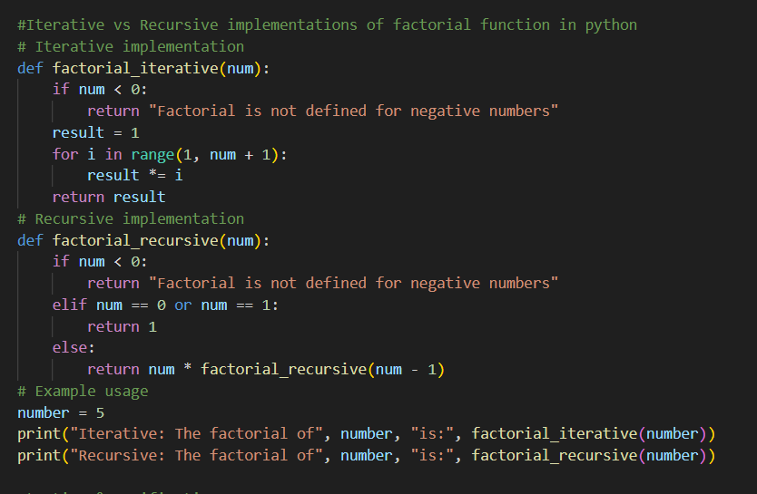
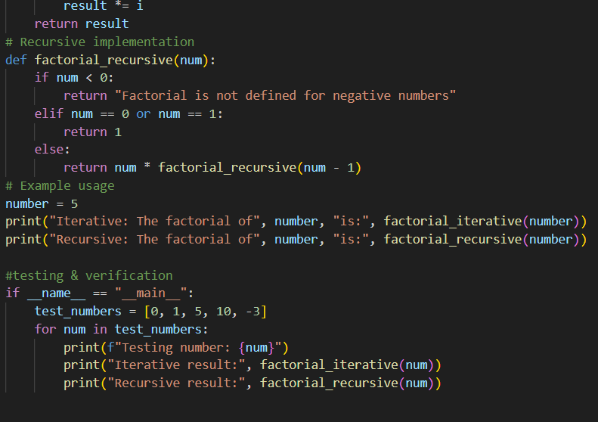
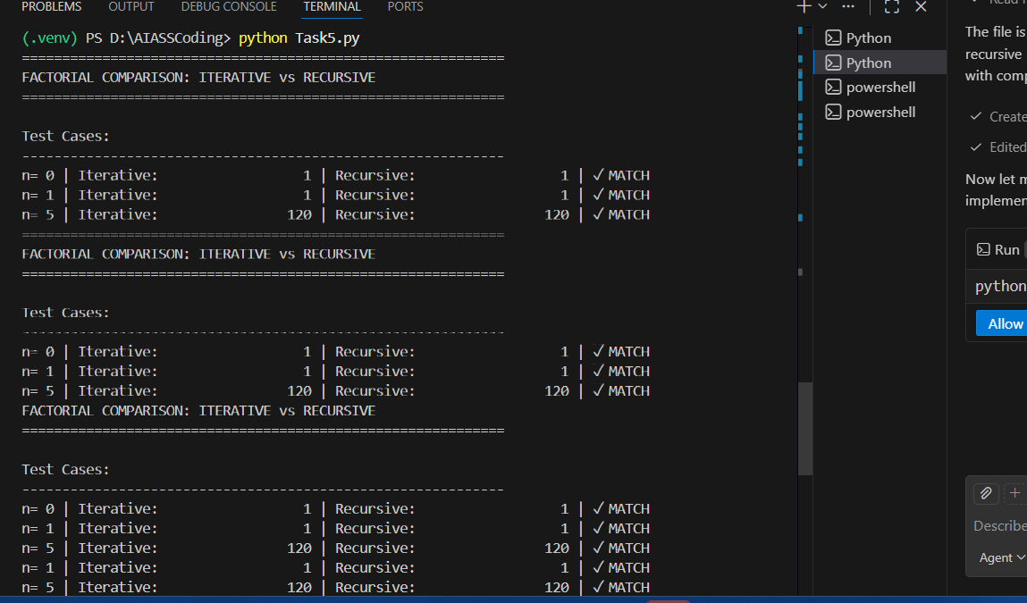
Execution Flow Explanation:
Comparison
Readability :
Iterative: Crystal clear for most developers. A simple loop that anyone can understand instantly. Better for learning loops.
Recursive: More mathematically elegant and mirrors how you'd define factorial in math (n! = n × (n-1)!), but requires understanding function call stacks. Harder for beginners.
Stack Usage :
Iterative: Uses constant memory O(1). Only stores one variable (result). No function call overhead.
Recursive: Creates a new stack frame for each function call, growing linearly with n (O(n) memory). For n=1000, it needs 1000 stack frames—risky and wasteful.
Performance Implications :
Iterative: Fast. No function call overhead. Runs in microseconds even for large n.
Recursive: Slow. Each function call has overhead (10-20x slower per call). For n=1000, the iterative version is orders of magnitude faster.
When Recursion Is NOT Recommended :
1. Large n values – Stack overflow risk; Python's limit is ~1000 calls
2.Performance-critical code – Function call overhead is expensive
3.Simple problems with loops – Unnecessary complexity and slowdown
4.Factorial specifically – Iterative is always better; no benefit from recursion
5.Embedded/resource-limited systems – Limited stack memory
6.When clarity matters – Loops are more intuitive for most people

