Week-01-01-Practice Session-Coding

Question:

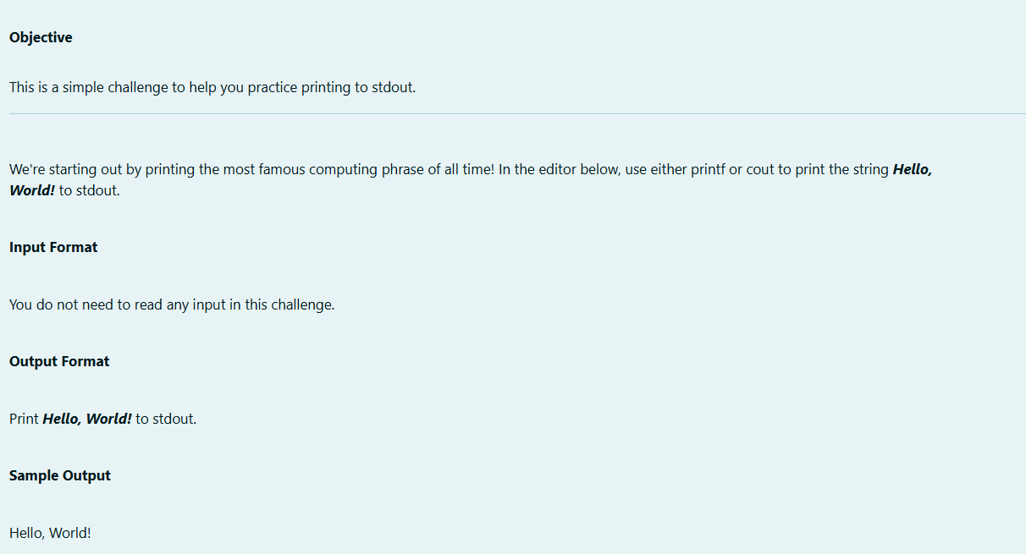

Program:

Output:

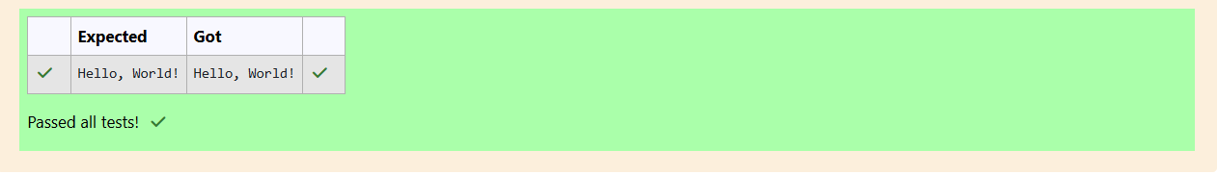

Question:

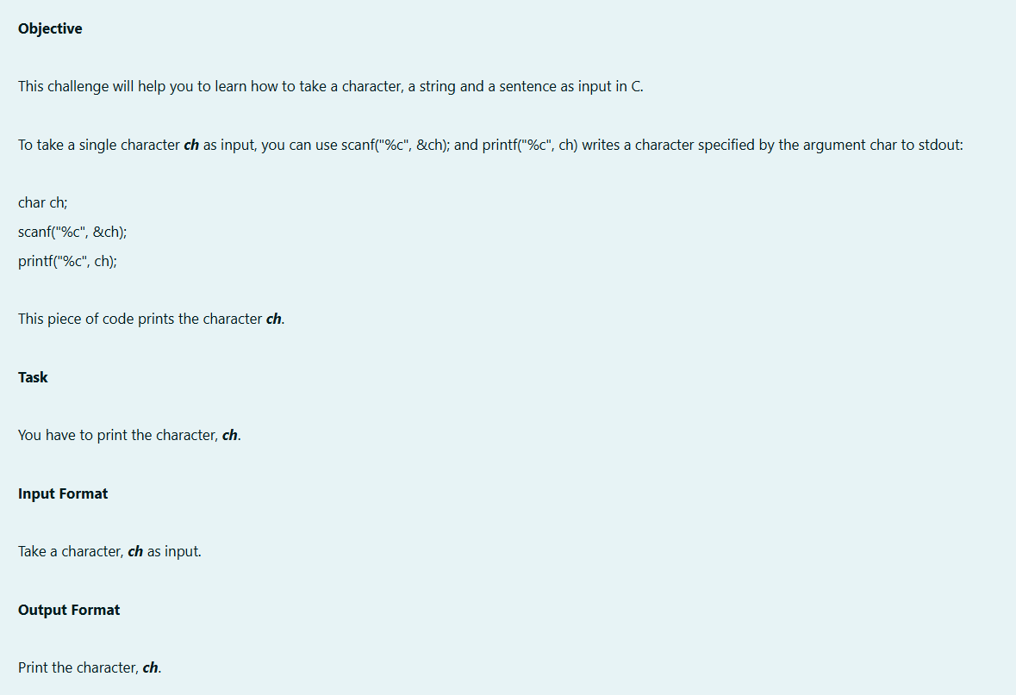

Program:

Output:

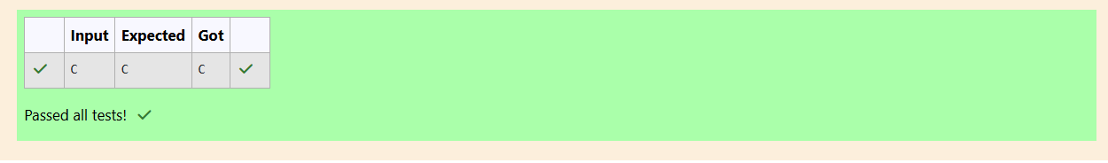

Question:

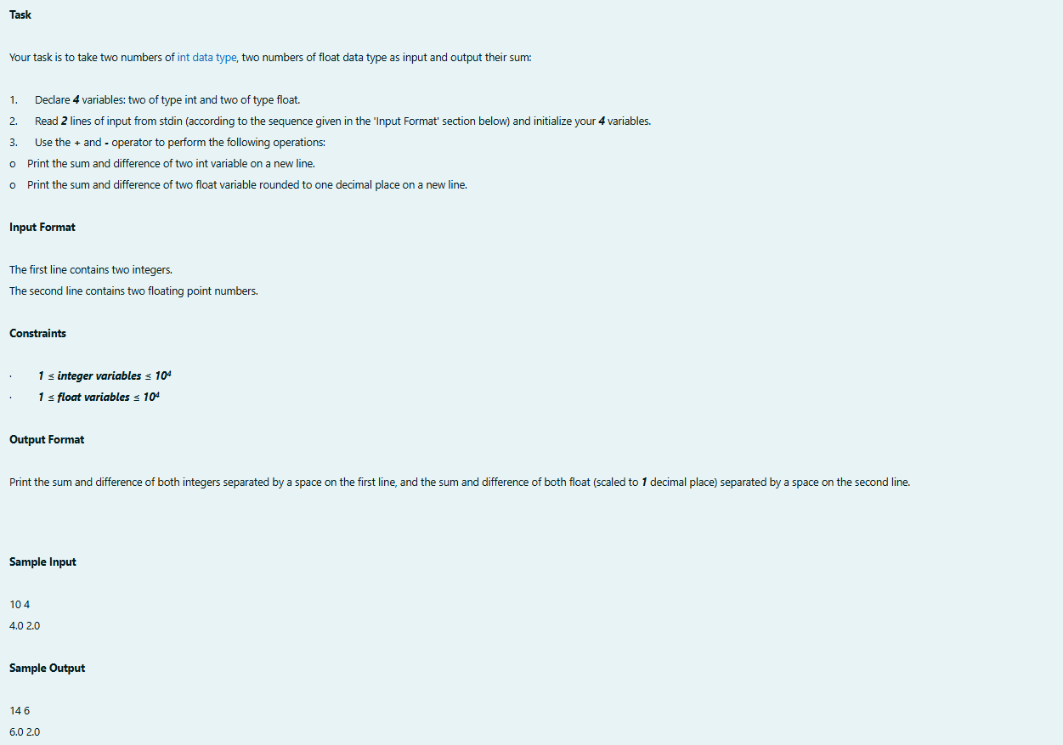

Program:

Output:

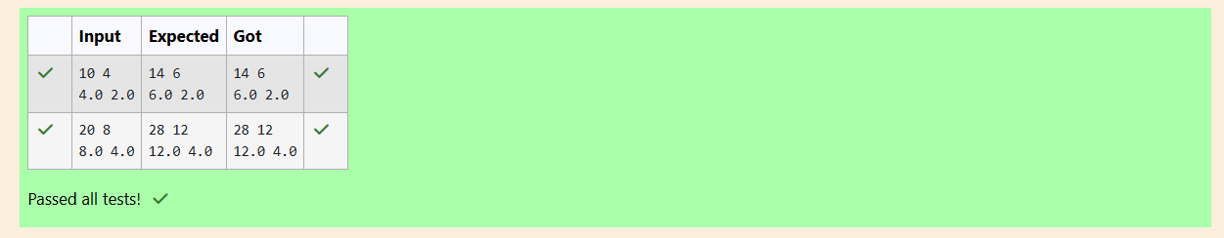

Week-01-02-Practice Session-Coding

Question:

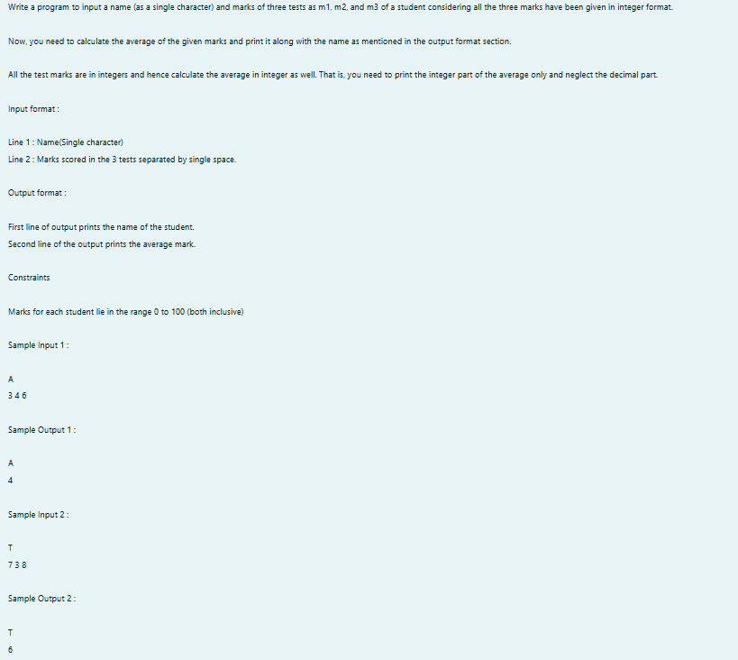

Program:

Output:

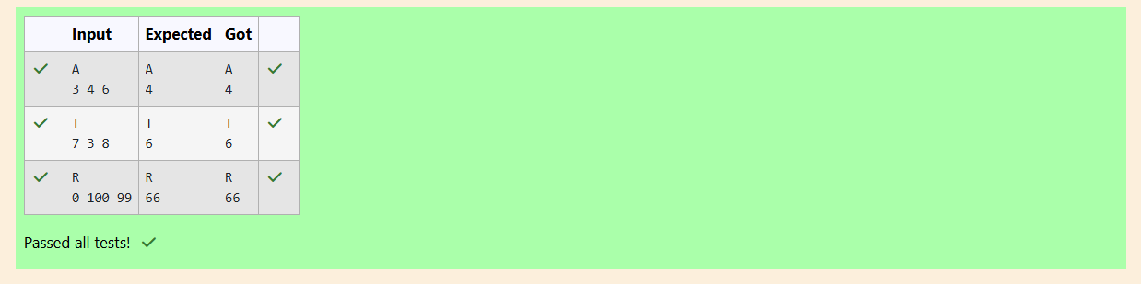

Question:

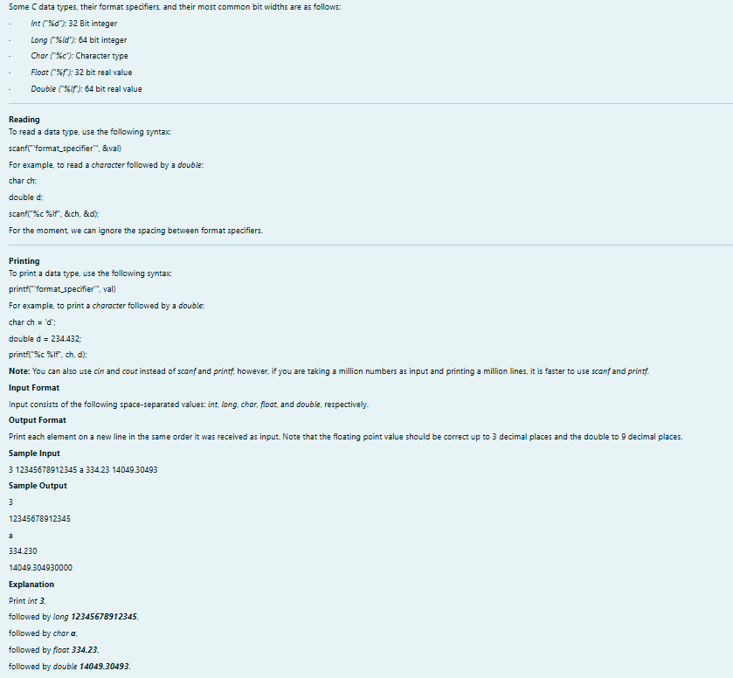

Output:

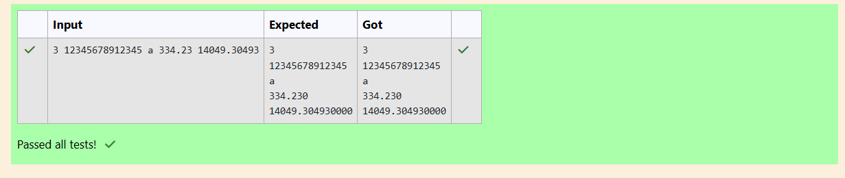

Question:

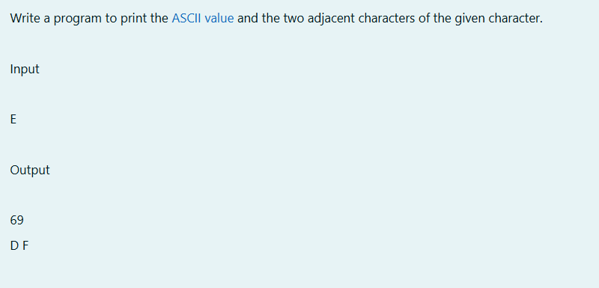

Program:

Output:

