Week-02-01-Practice Session-Coding

Question:

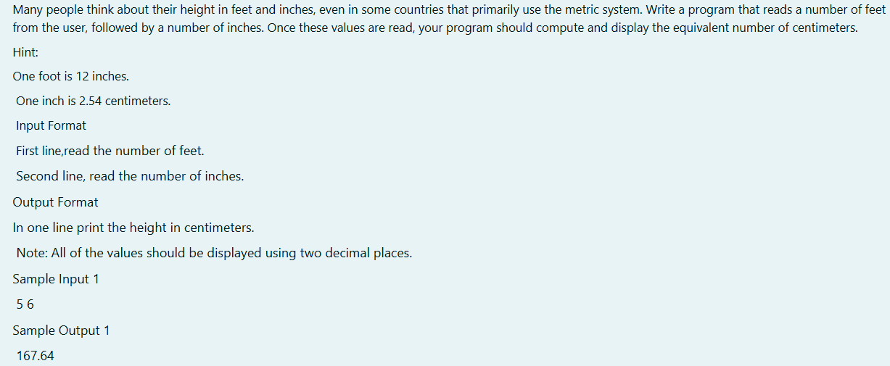

Program:

Output:

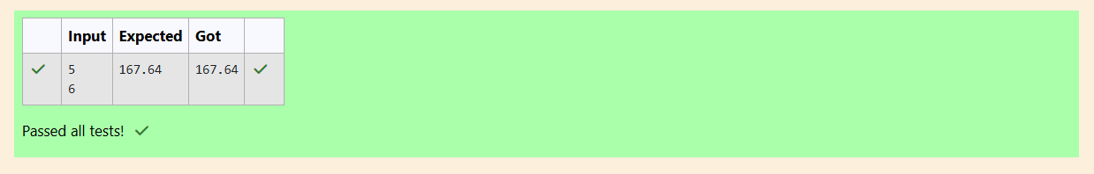

Question:

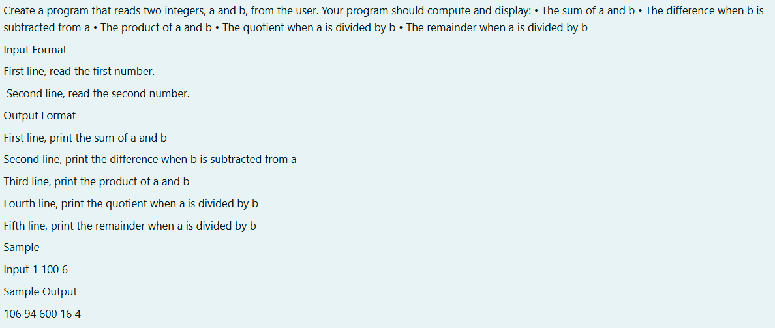

Program:

Output:

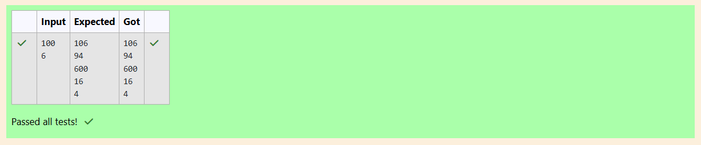

Question:

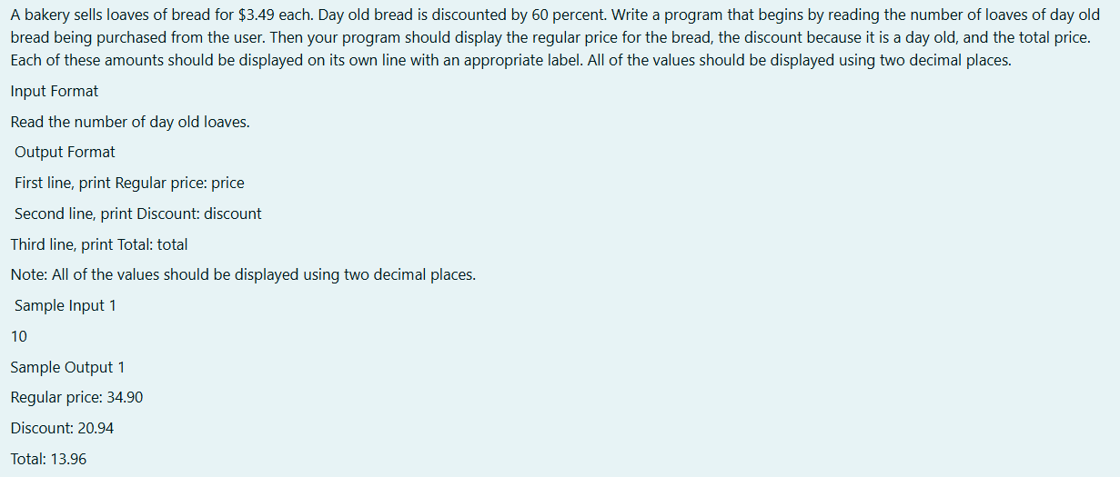

Program:

Output:

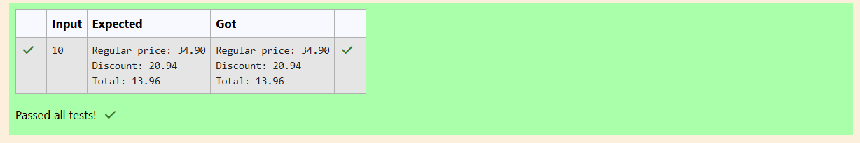

Week-02-02-Practice Session-Coding

Question:

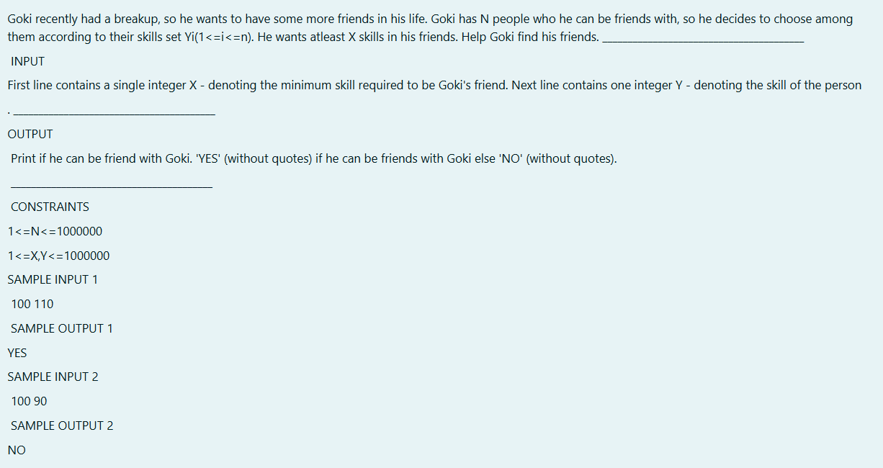

Program:

Output:

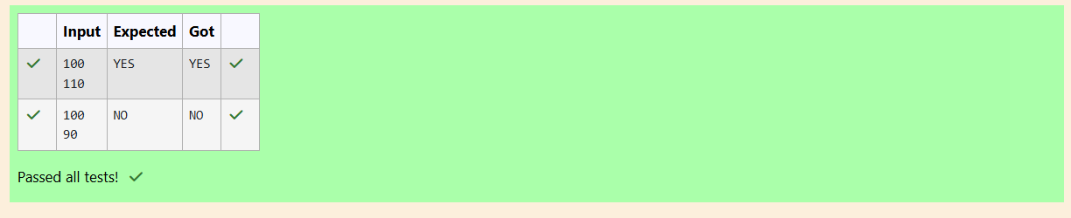

Question:

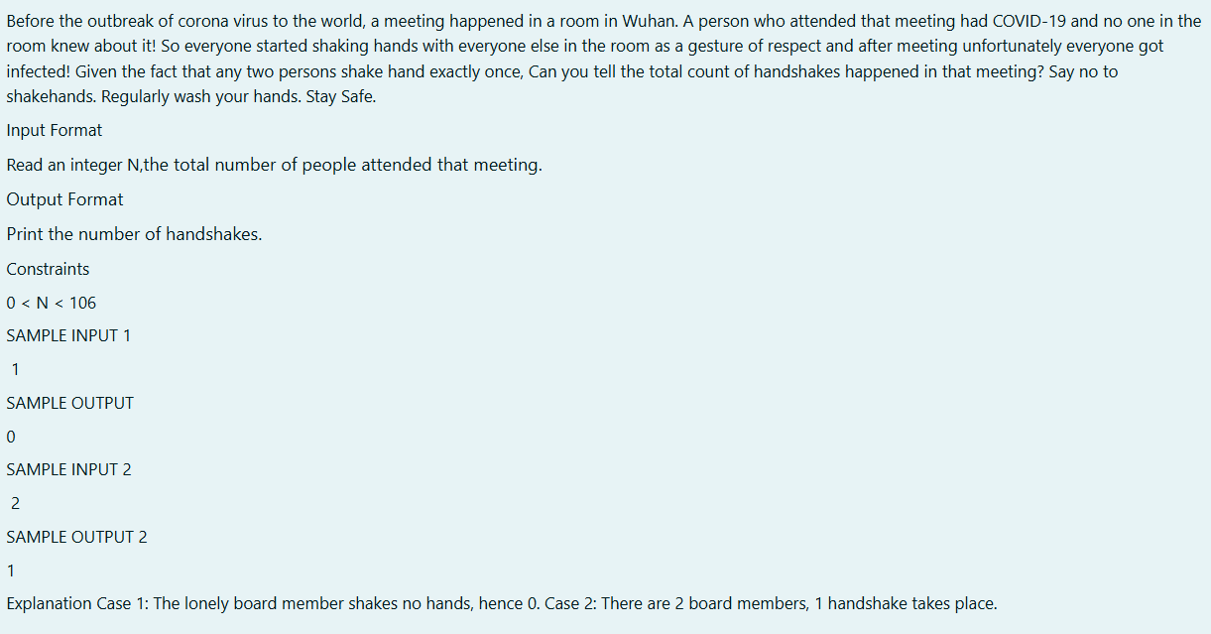

Program:

Output:

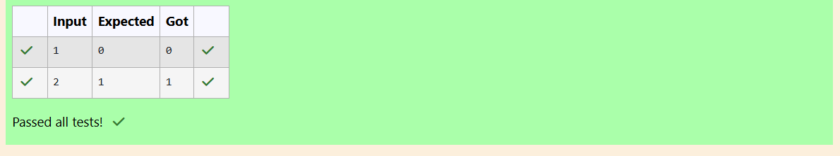

Question:

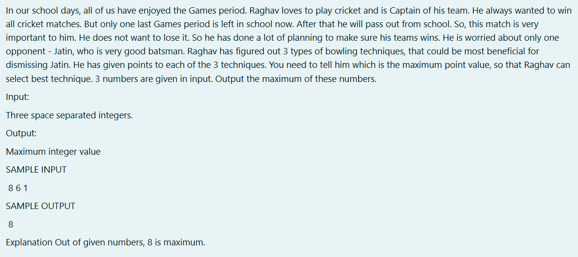

Program:

Output:

