Week-03-01-Practice Session-Coding

Question:



Program:

Output:

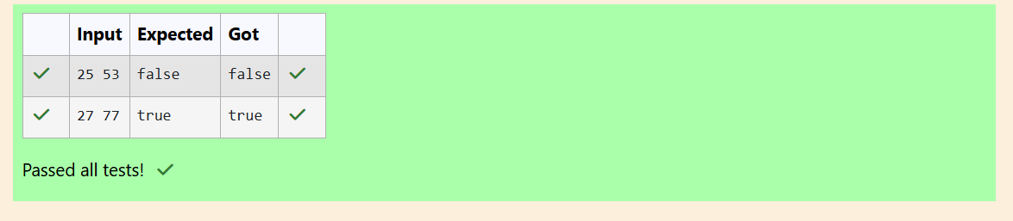

Question:

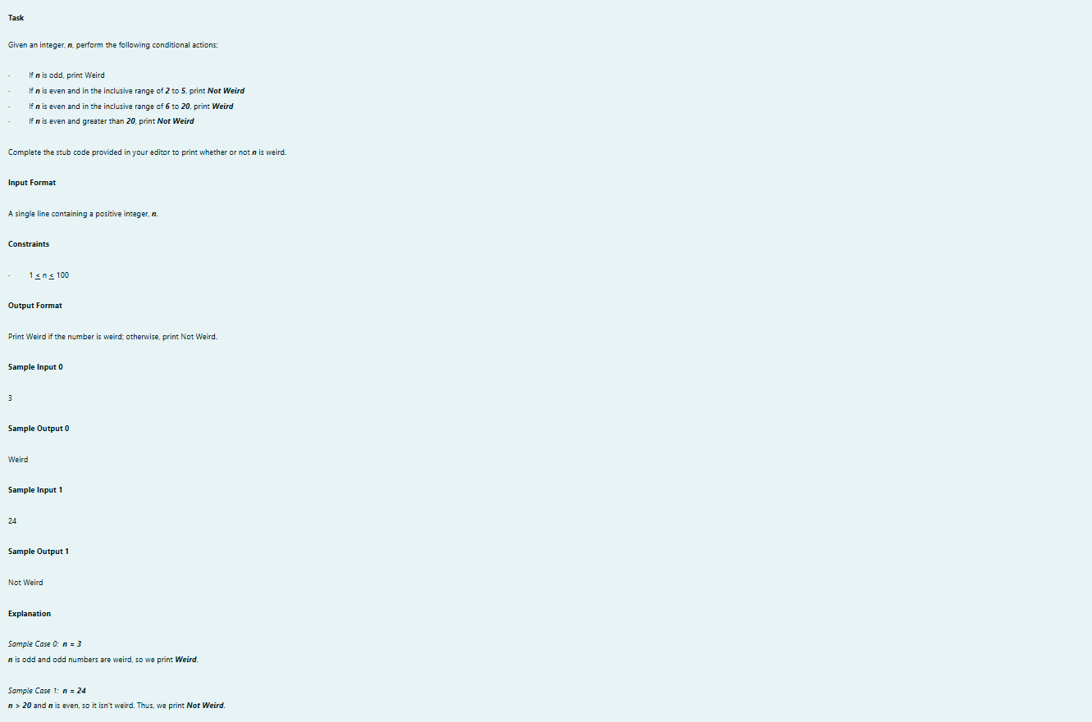

Program:

Output:

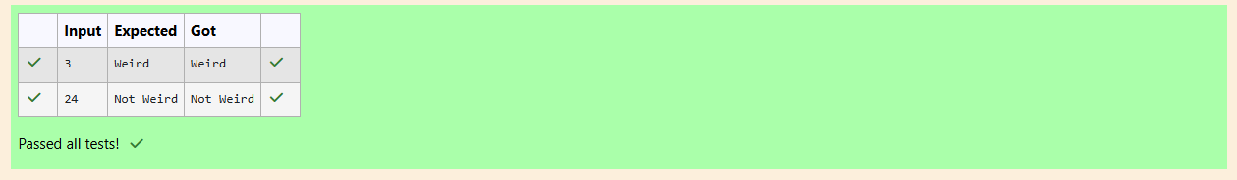

Question:



Program:

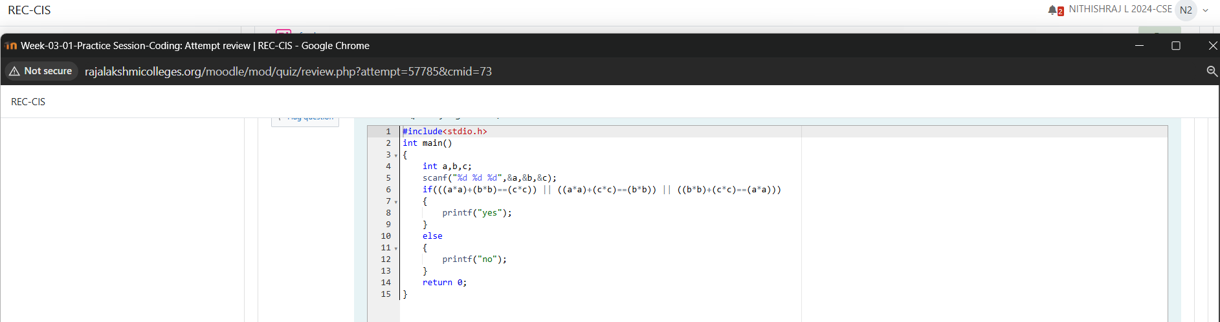

Output:

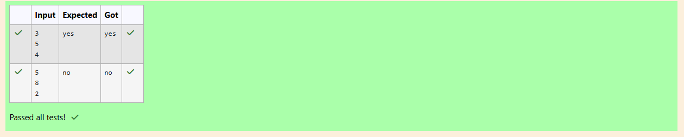

Week-03-02-Practice Session-Coding

Question:

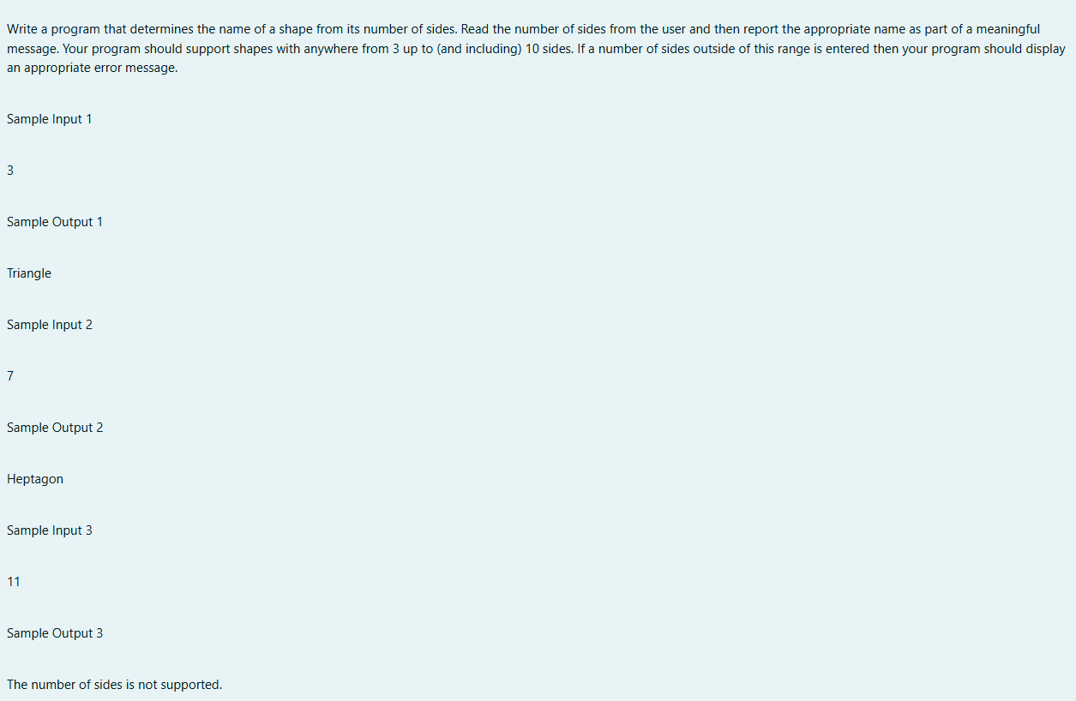

Program:

Output:

Question

Program

Output

Question:

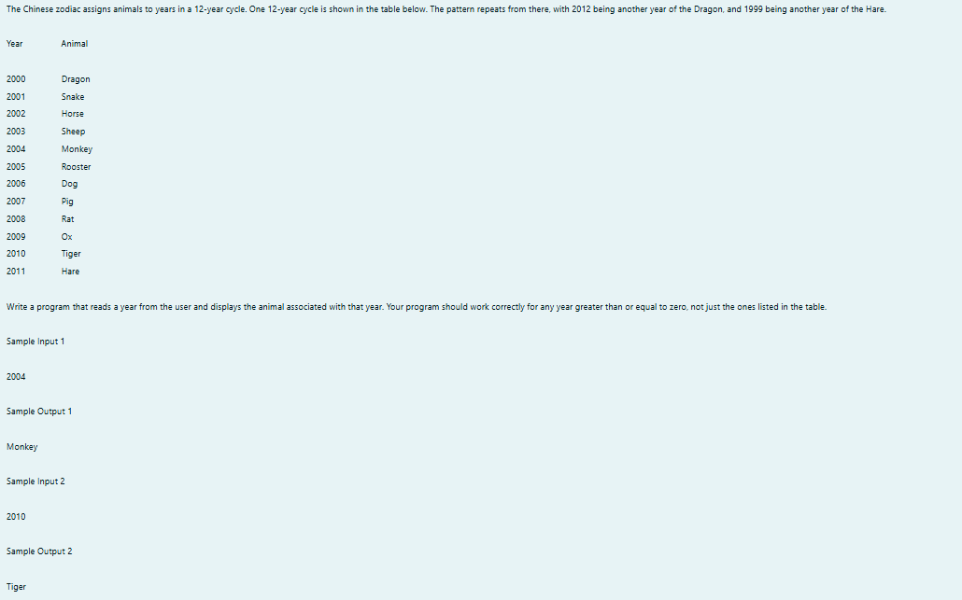

Program:

Output:

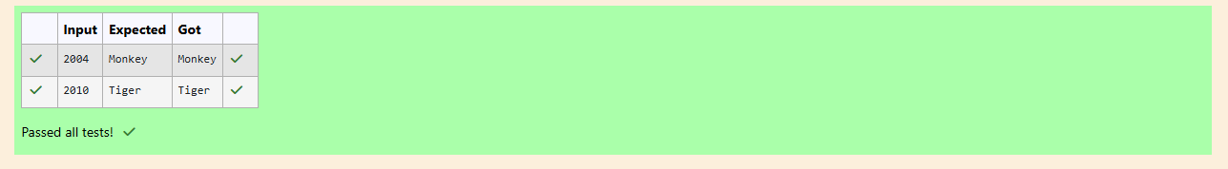

Question:

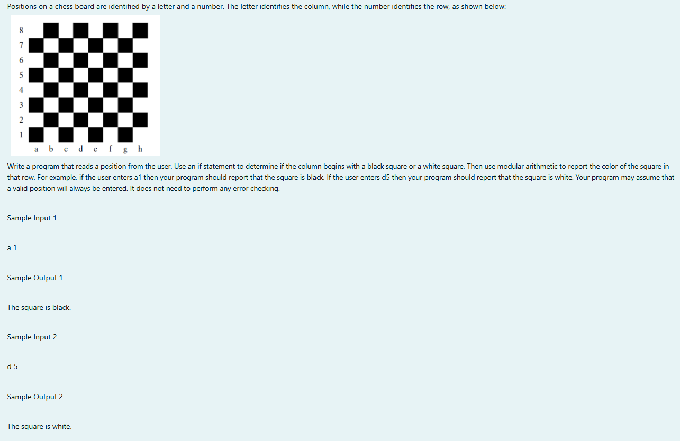

Program:

Output:

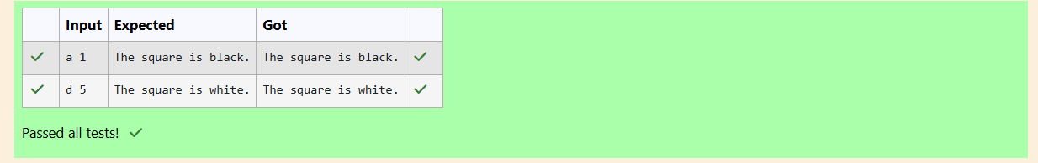

Week-03-03-Practice Session-Coding

Question:

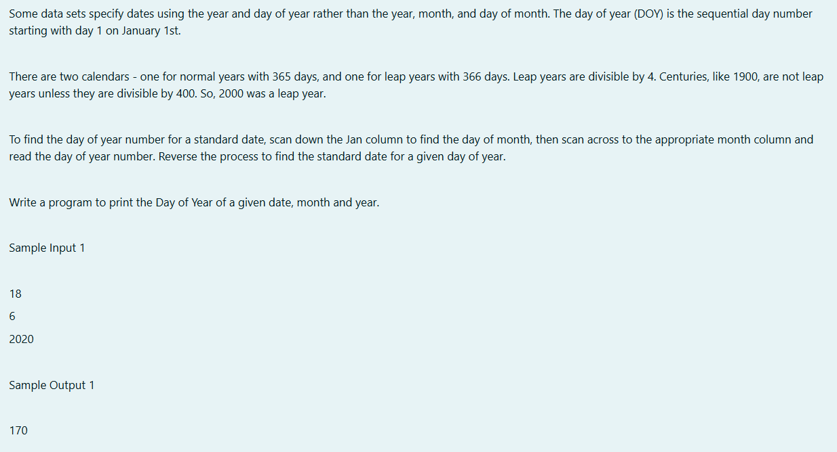

Output:

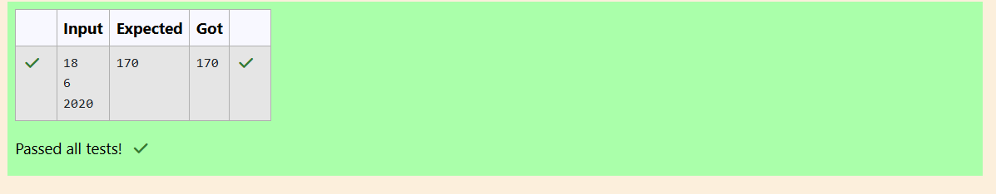

Question:

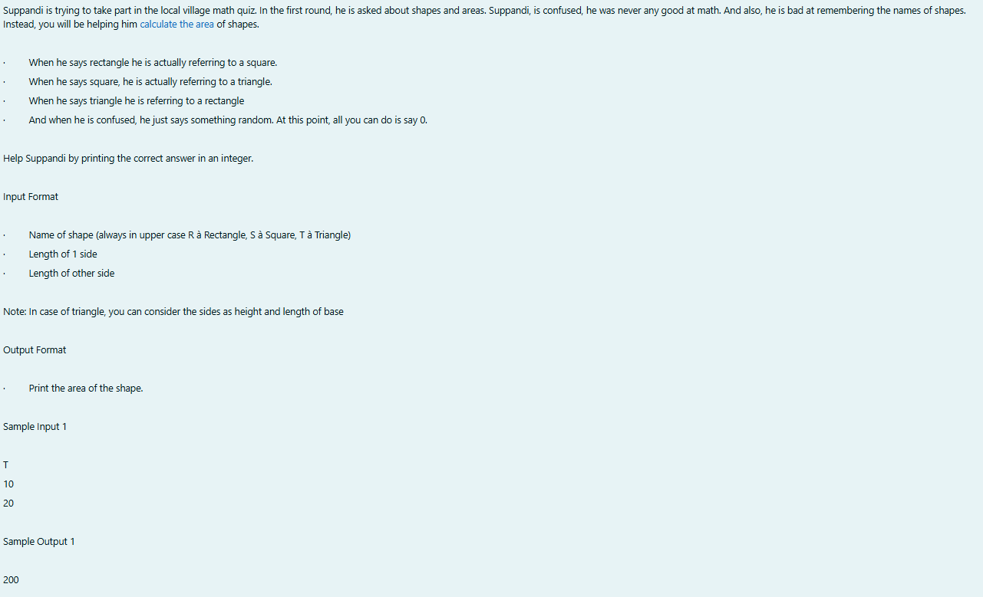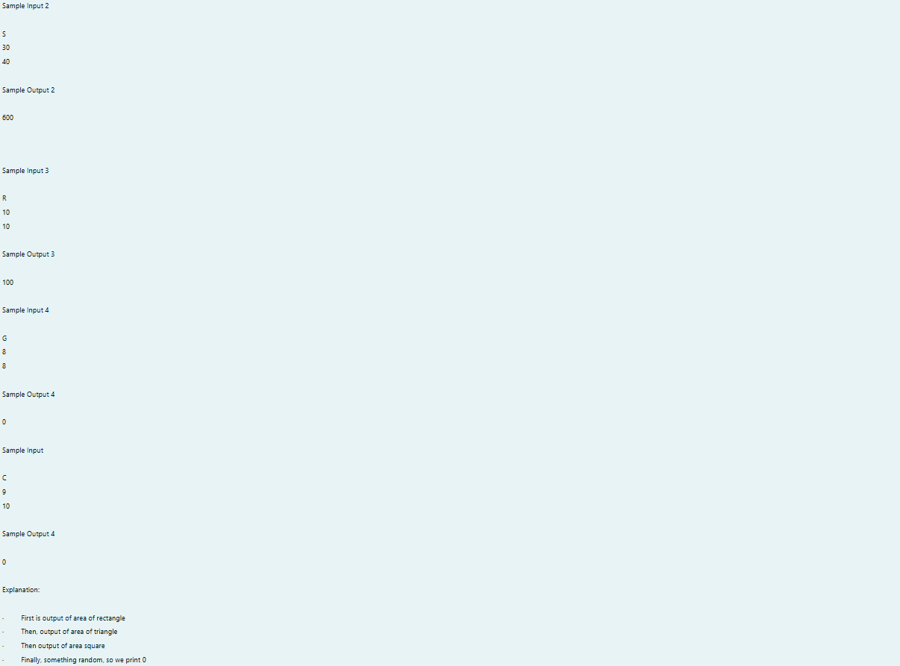

Output:

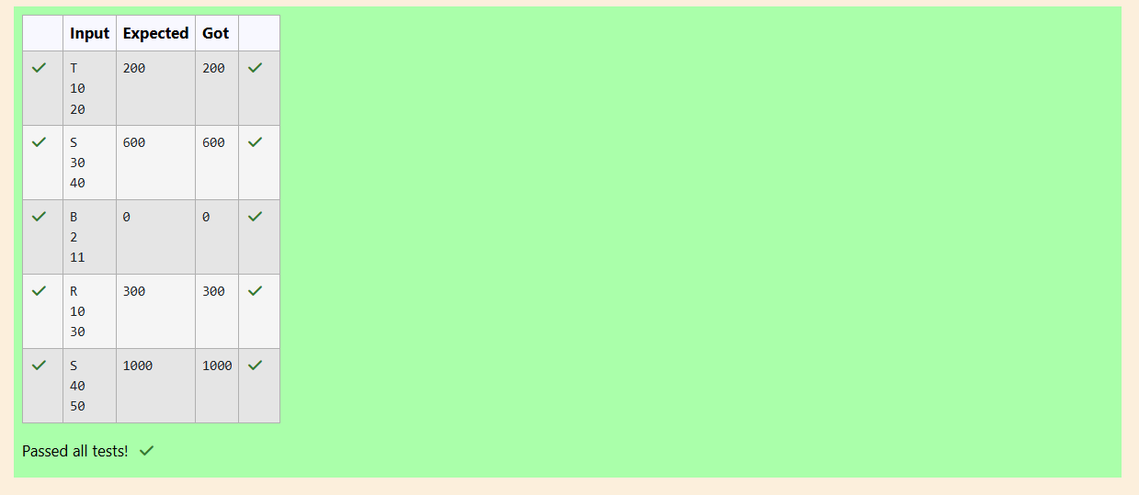

Question:

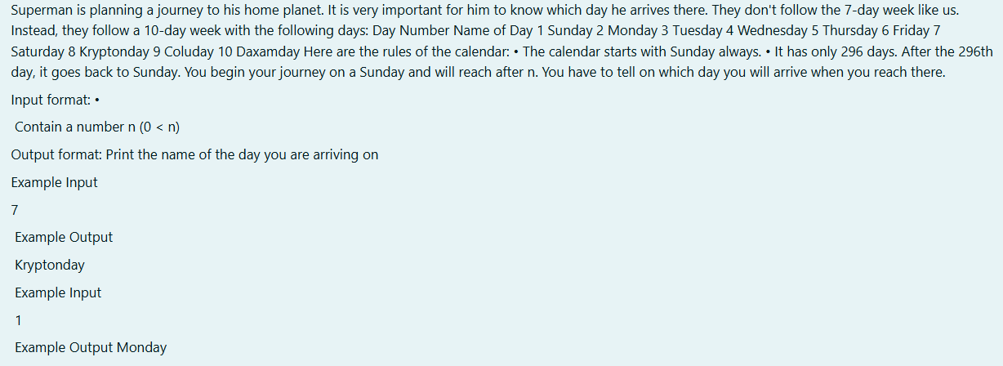

Output:

