Week-04-01-Practice Session-Coding

Question:

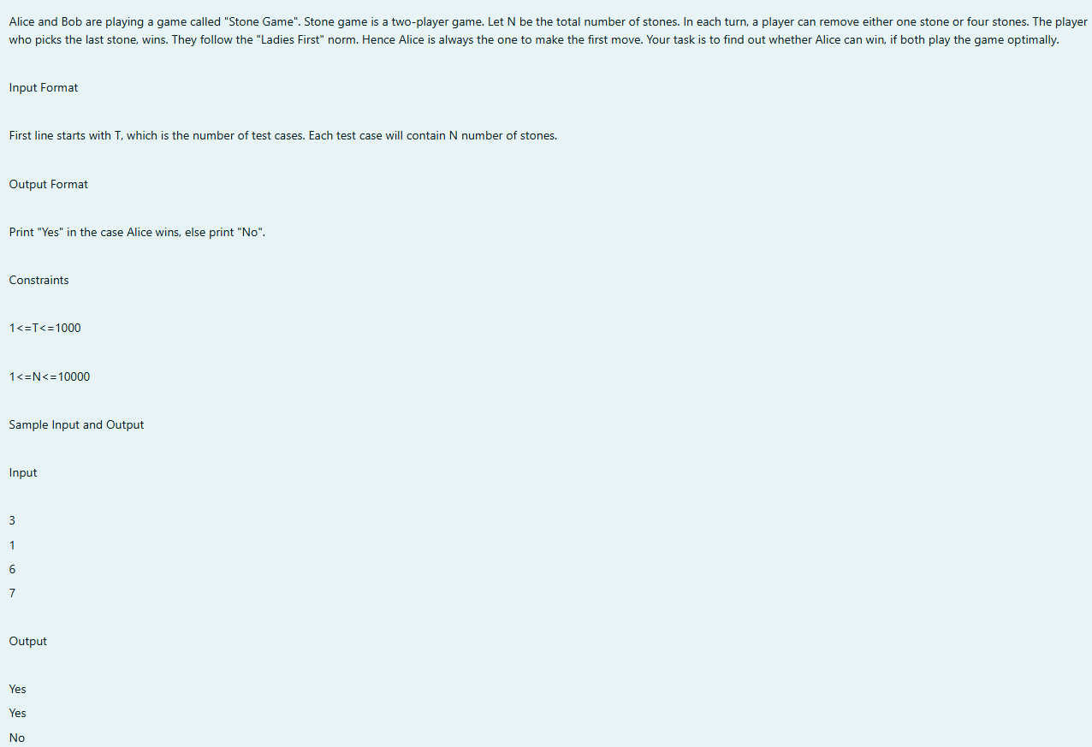

Output:

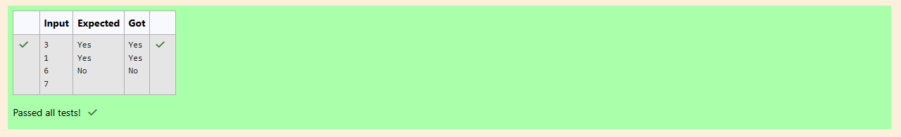

Question:

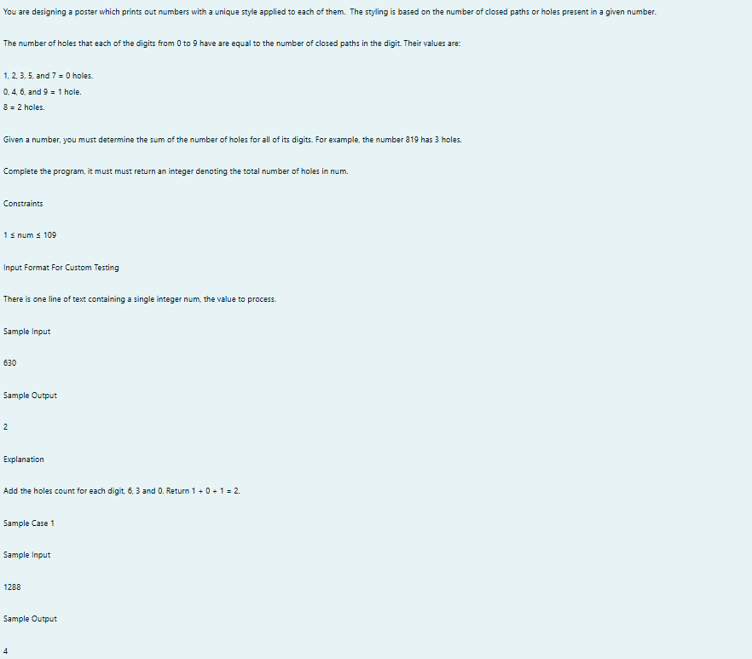

Output: 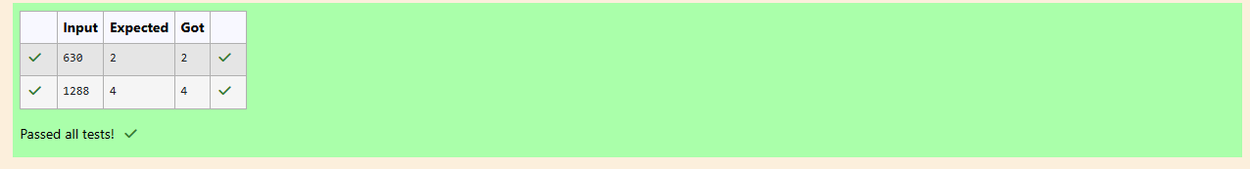

Question:

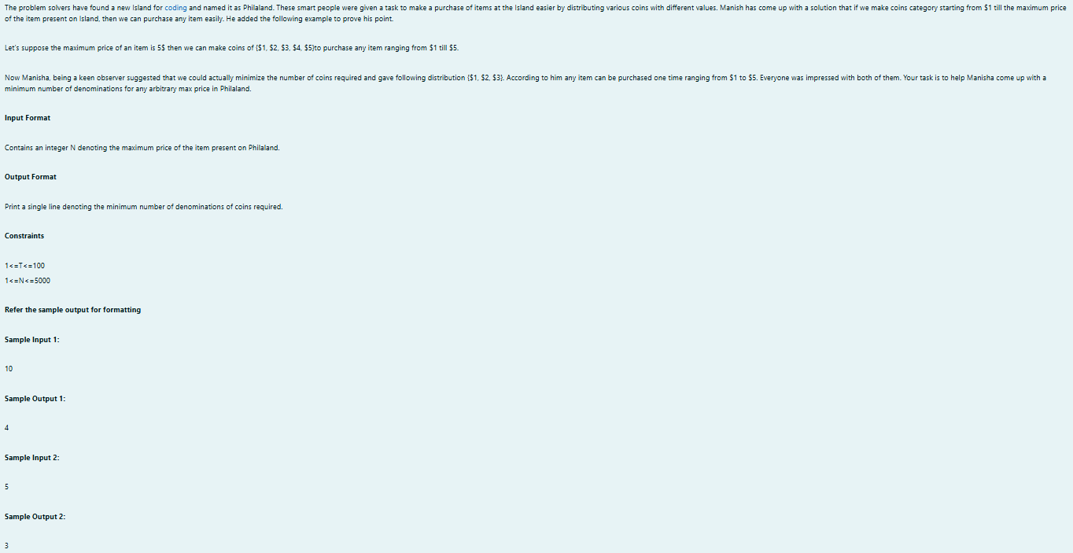

Program:

Output:

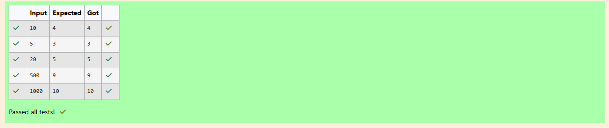

Week-04-02-Practice Session-Coding

Question: 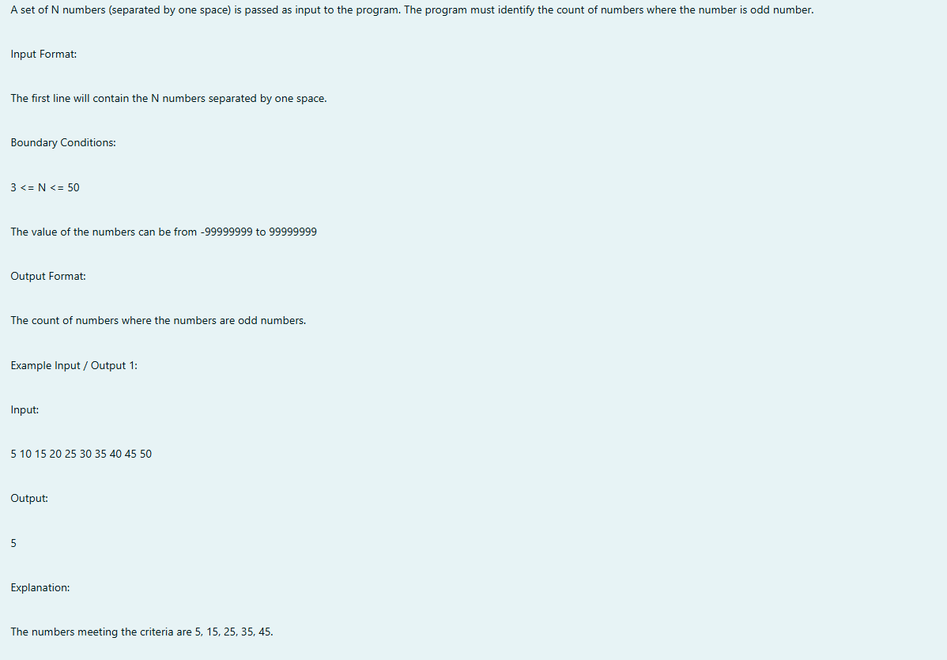

PPP

Program:

Output:

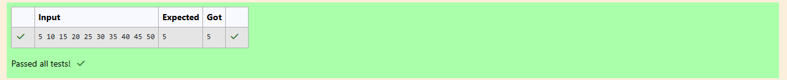

Question:

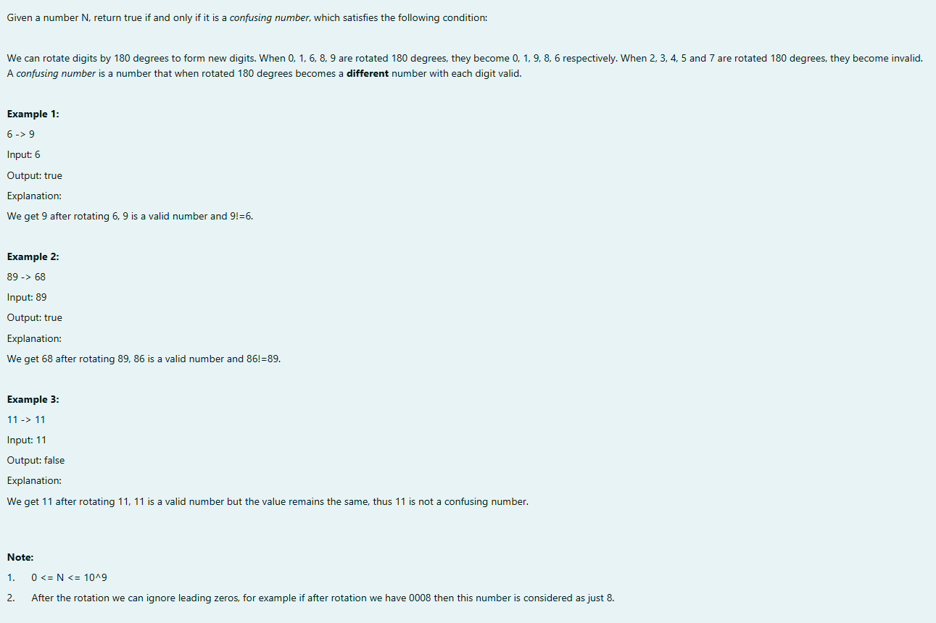

Output:

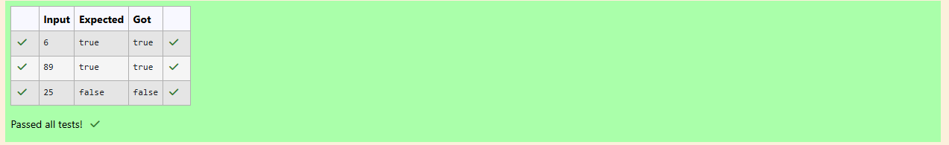

Question:

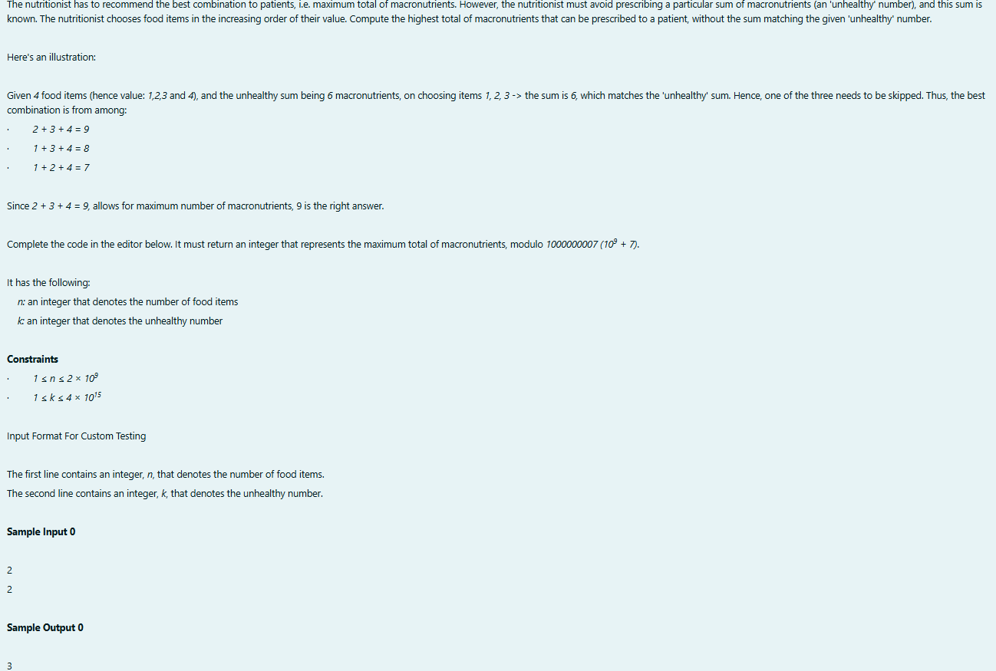 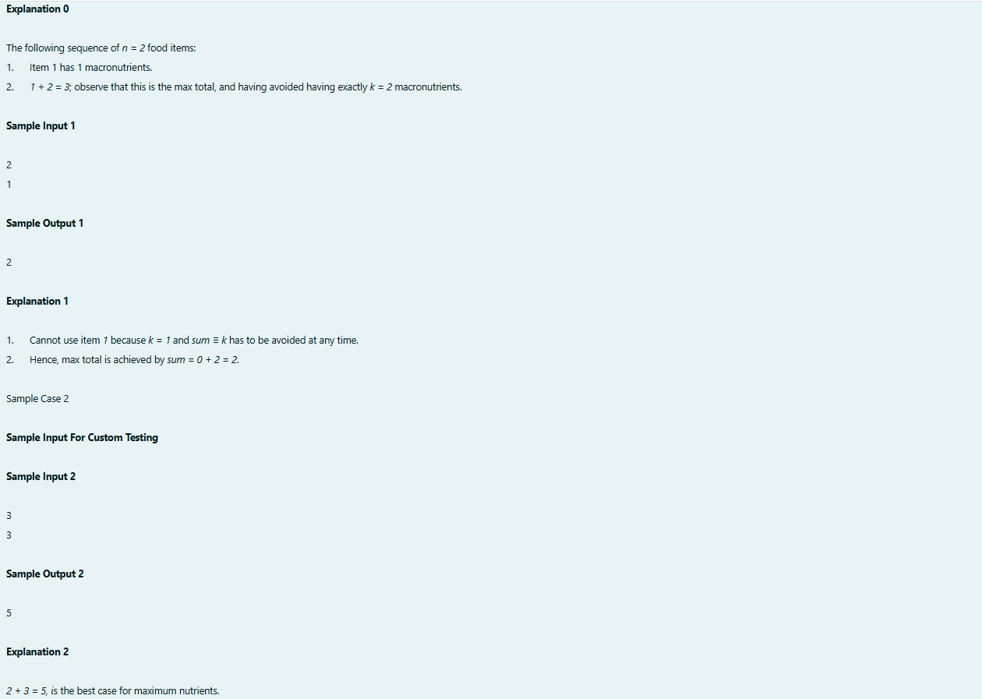

Program:

Output:

