Week-05-01-Practice Session-Coding

Question:

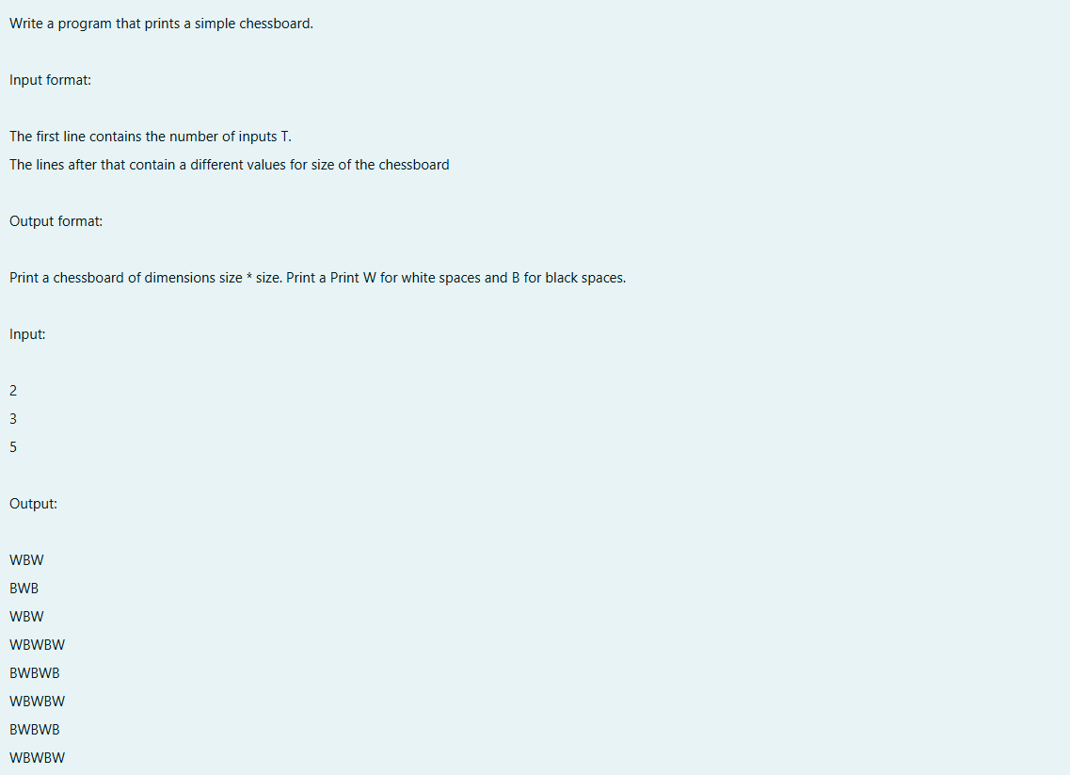

Program:

Output:

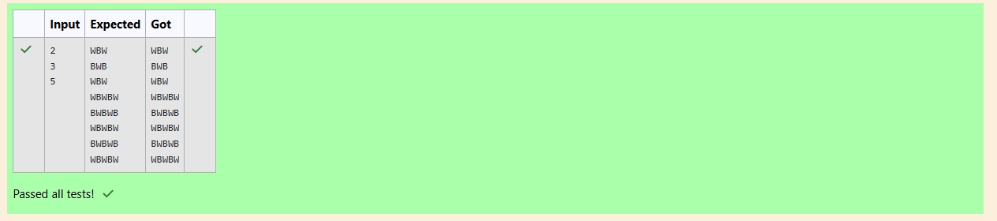

Question:

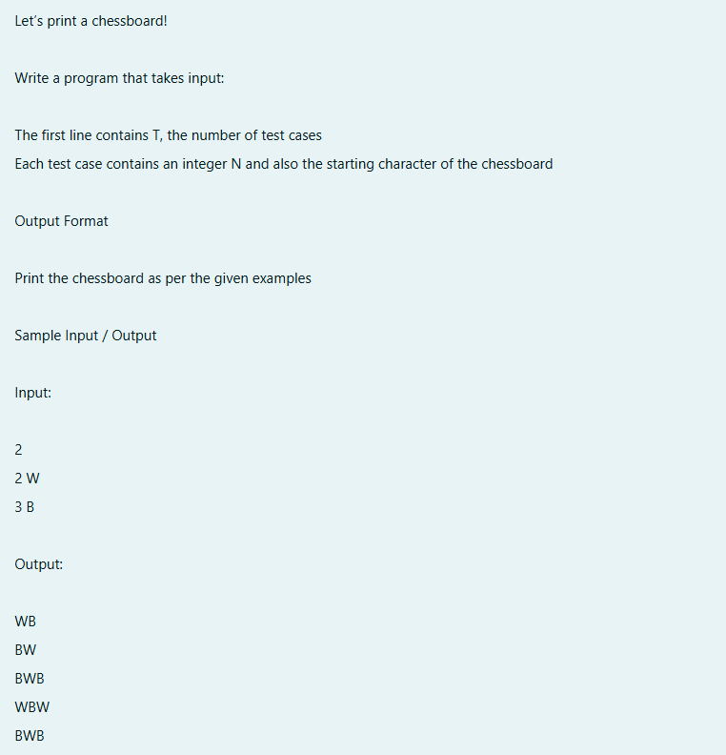

Output:

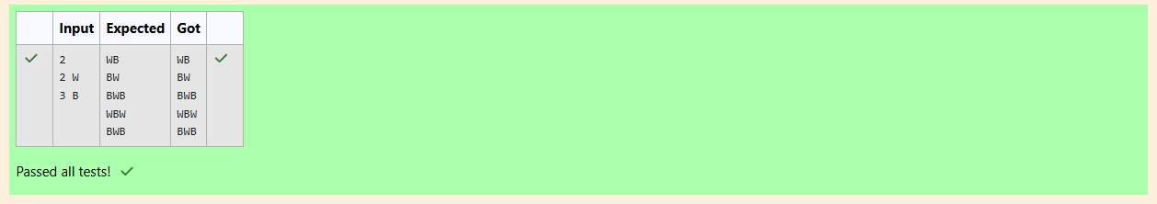

Question:

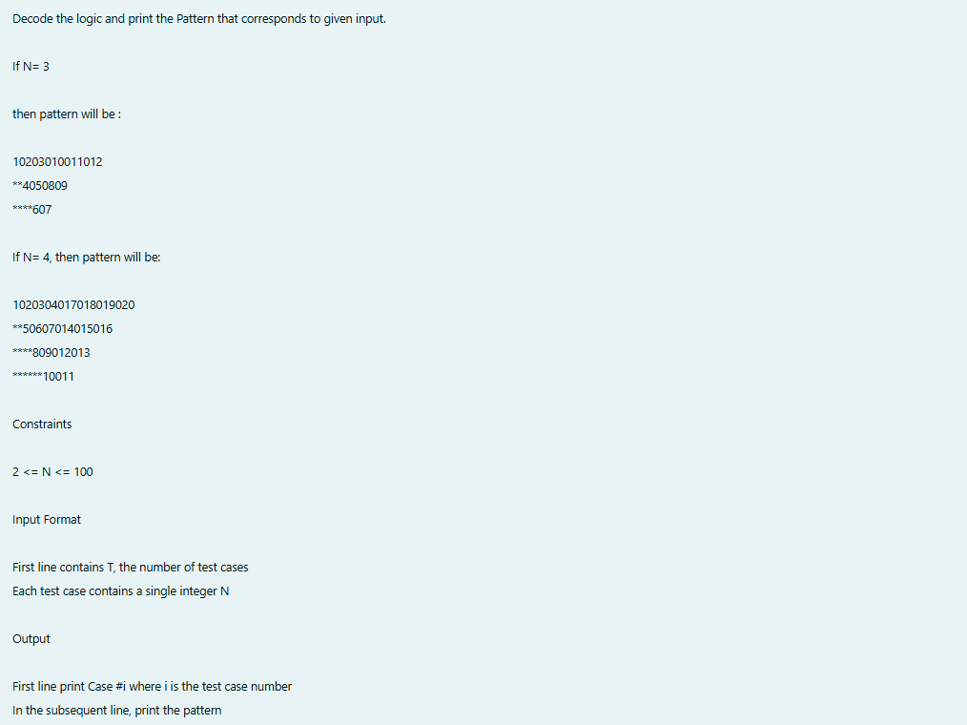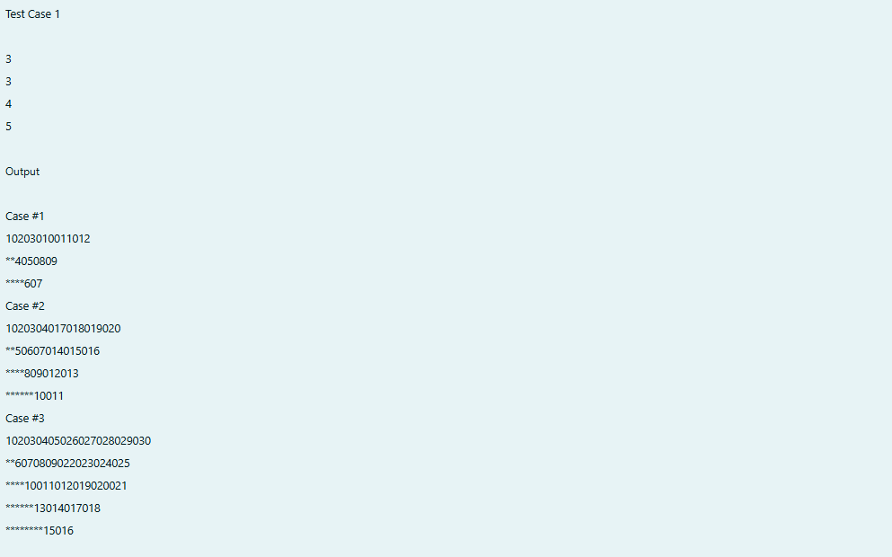

Output:

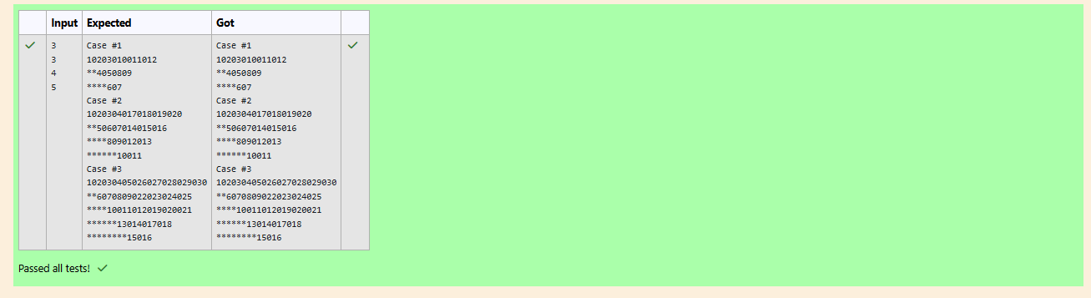

Week-05-02-Practice Session-Coding

Question:

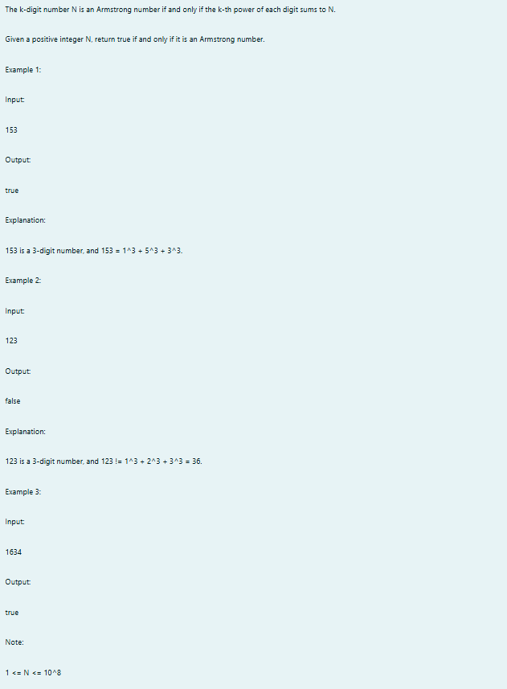

Program:

Output:

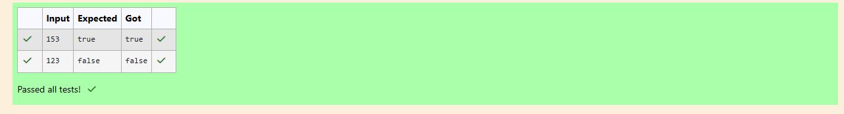

Question:

C:\Users\Nthish\Pictures\Screenshots\Screenshot 2025-01-12 183036.png

Program:

Output:

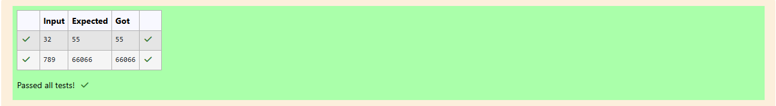

Question:

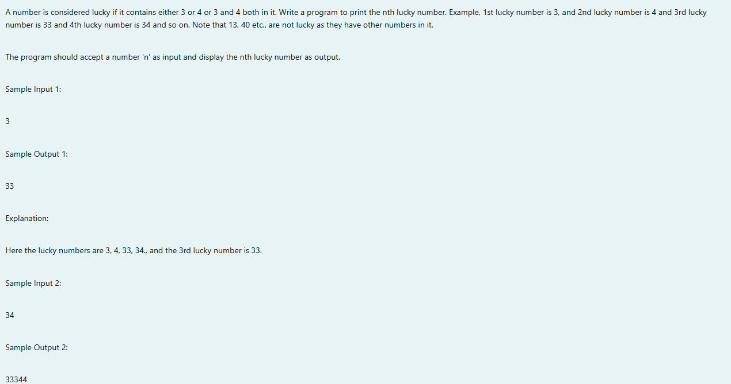

Program:

Output:

