Week-07-01-Practice Session-Coding

Question:

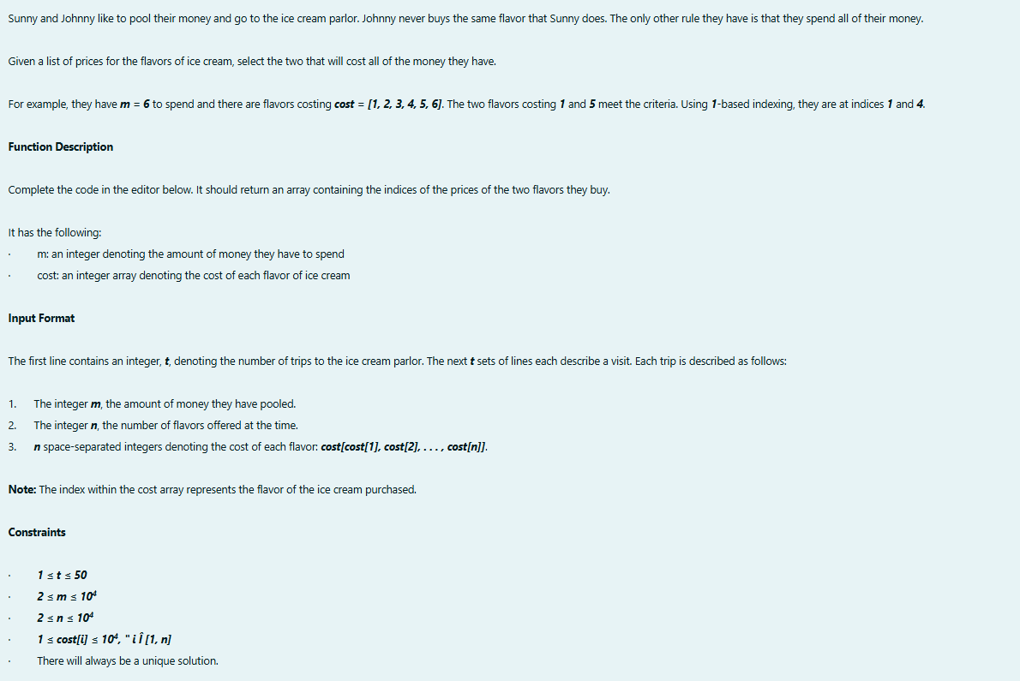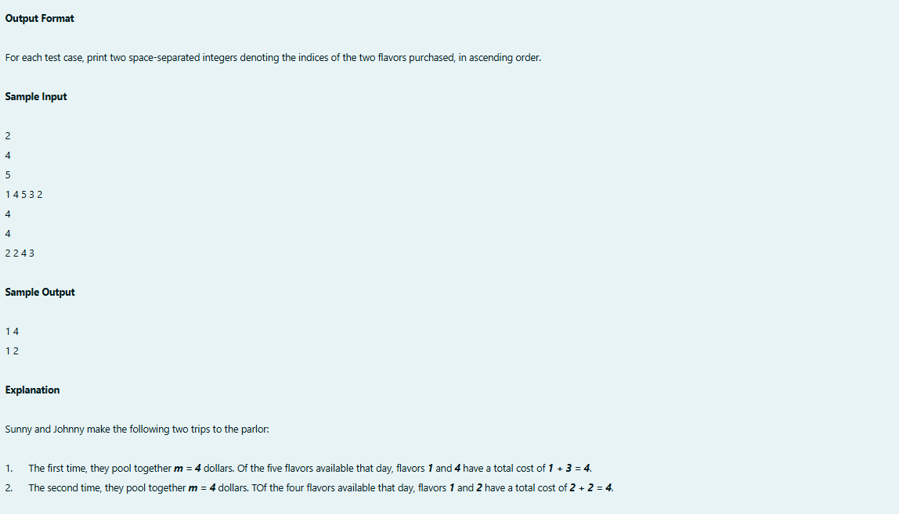

Program:

Output:

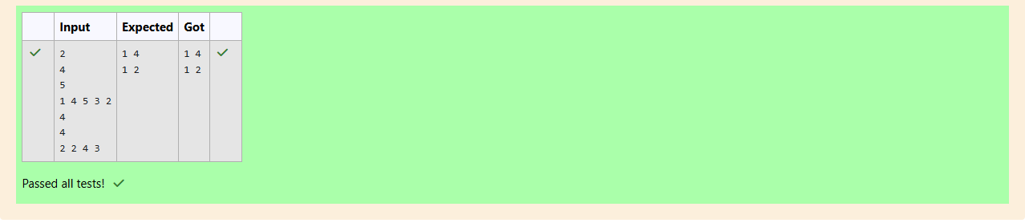

Question:

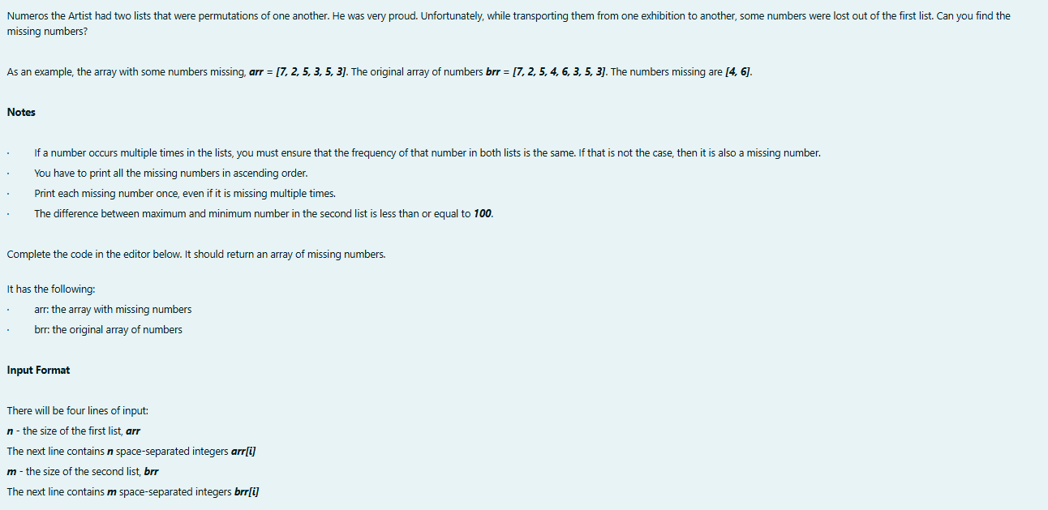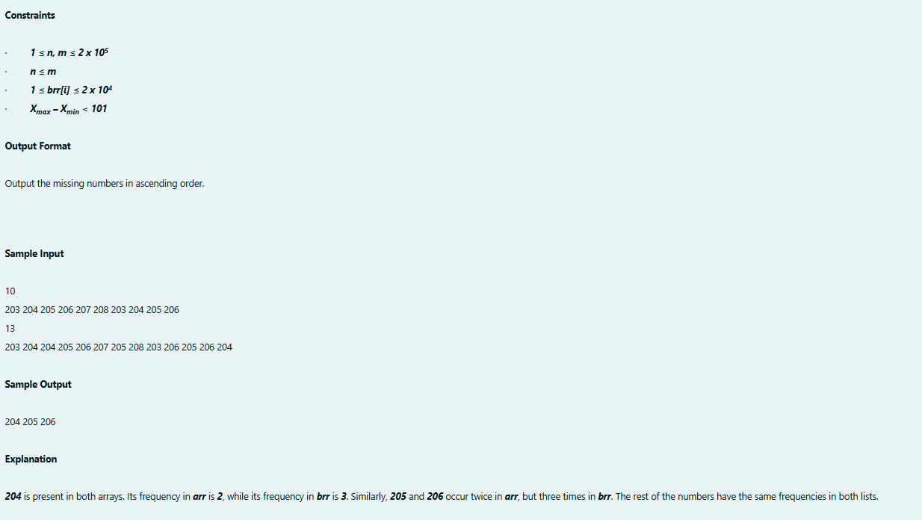

Program:

Output:  
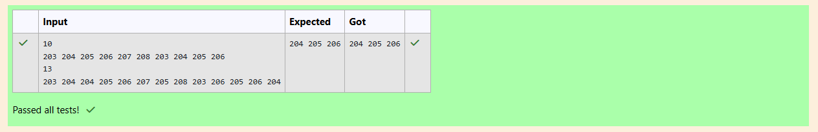

Question:

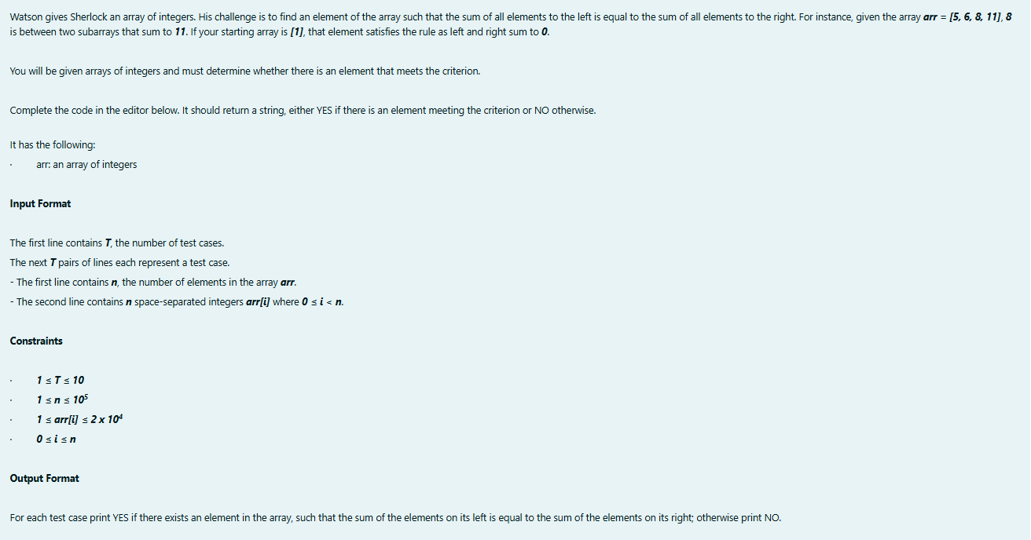 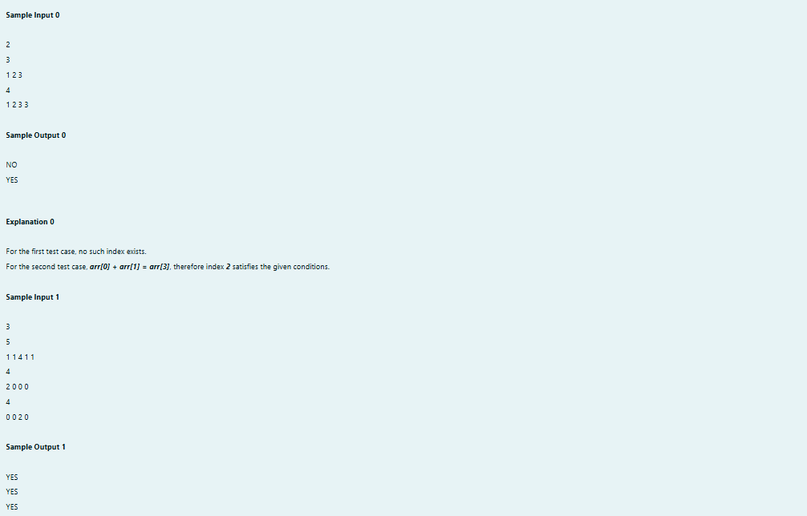

Program:

Output:  
