Week-08-Coding

Question:

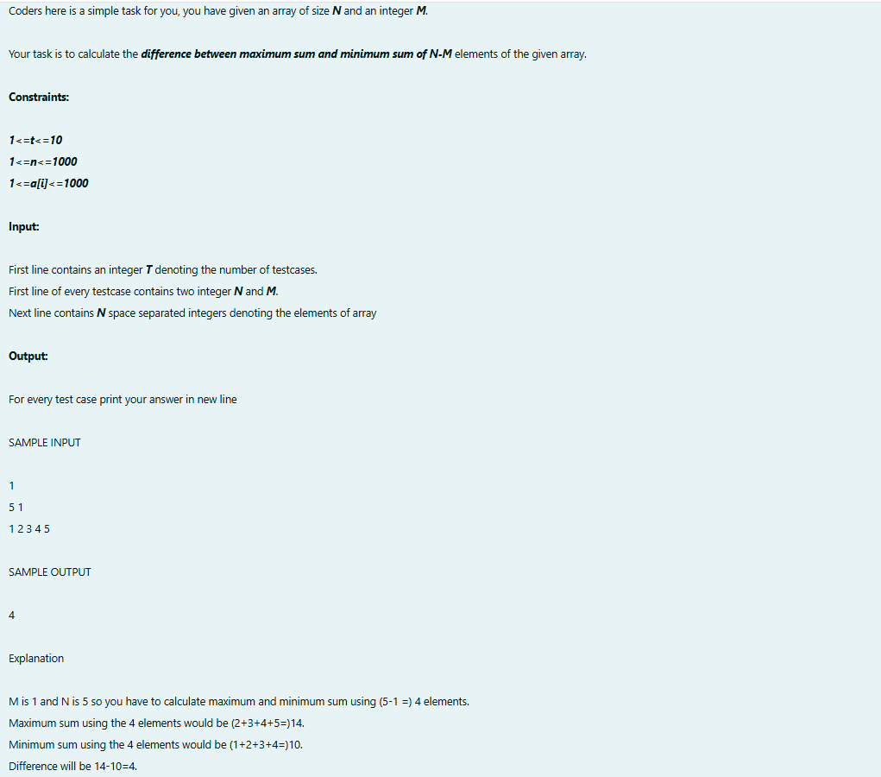

Output:  
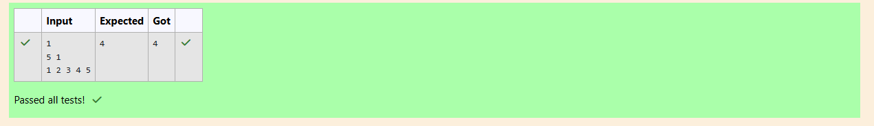

Question:  
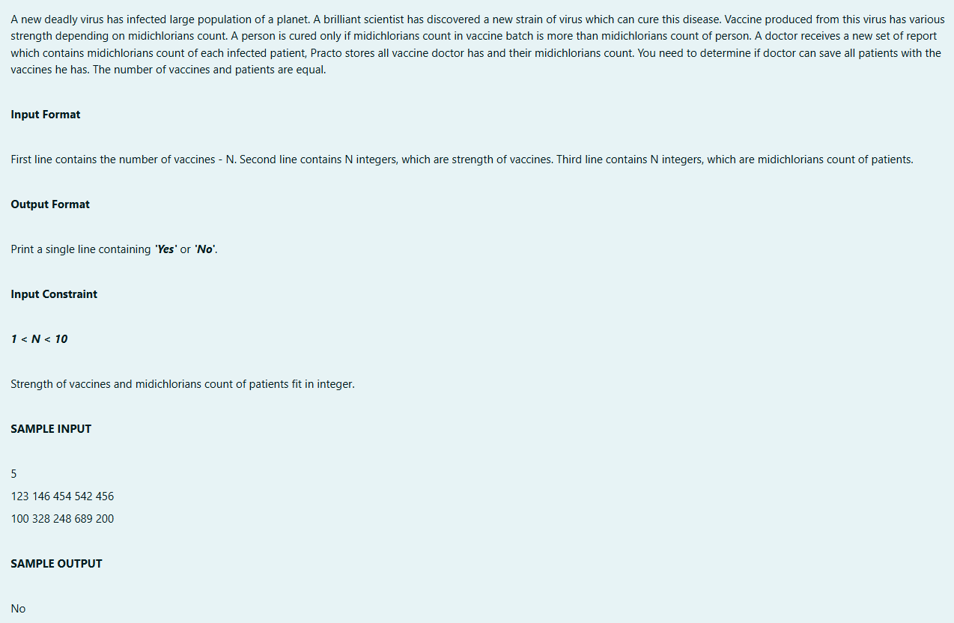

Program:

Output:

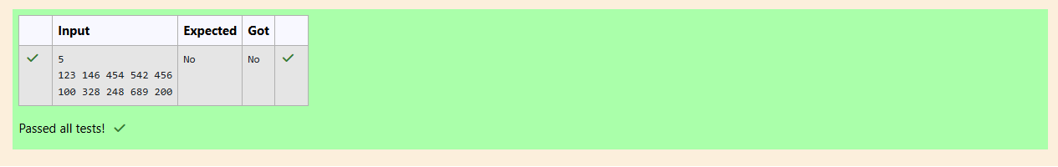

Question:

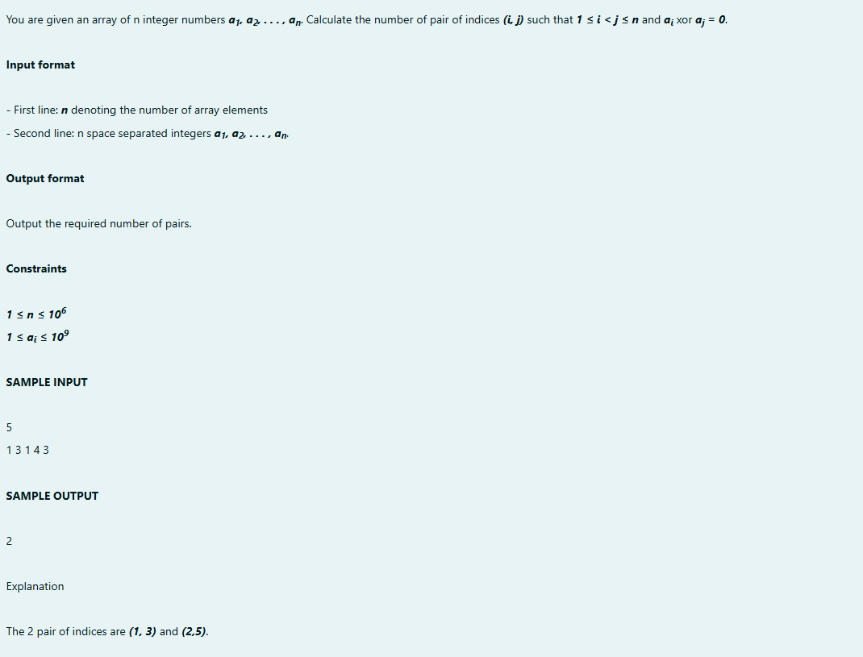

Program:

Output:

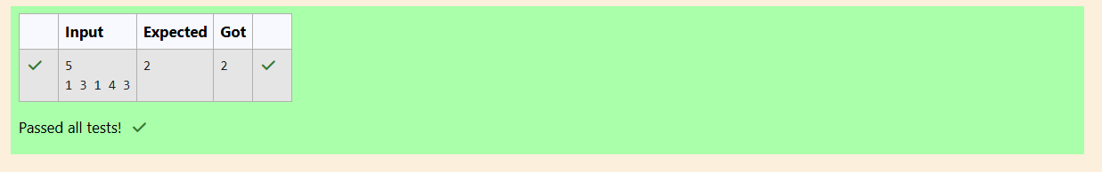

Question:

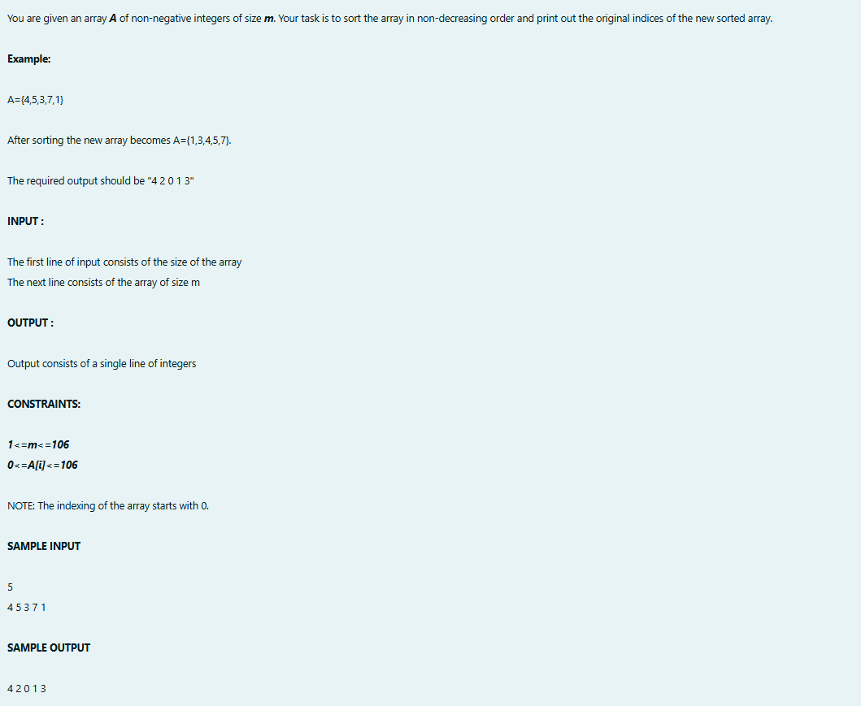

Program:

Output:

