Week-10-Coding

Question:

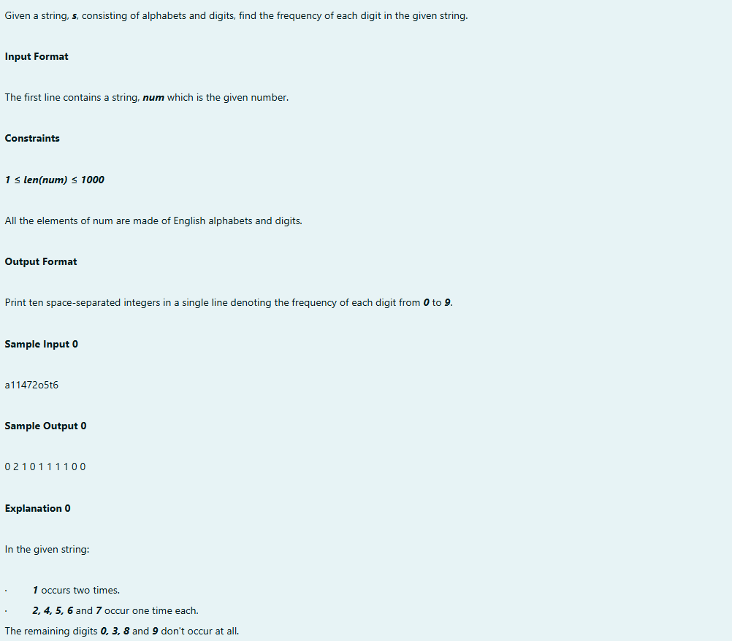

Output:

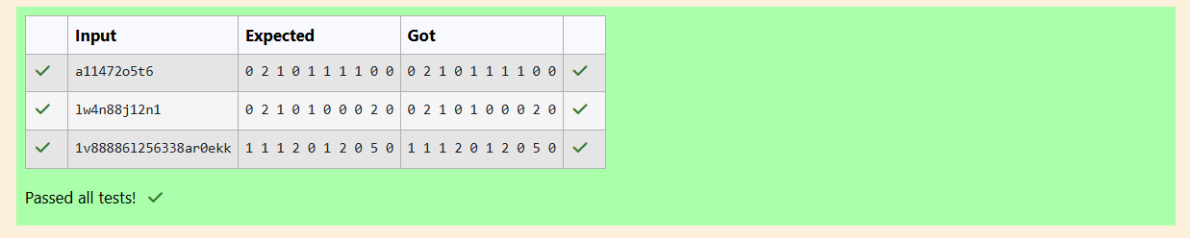

Question:

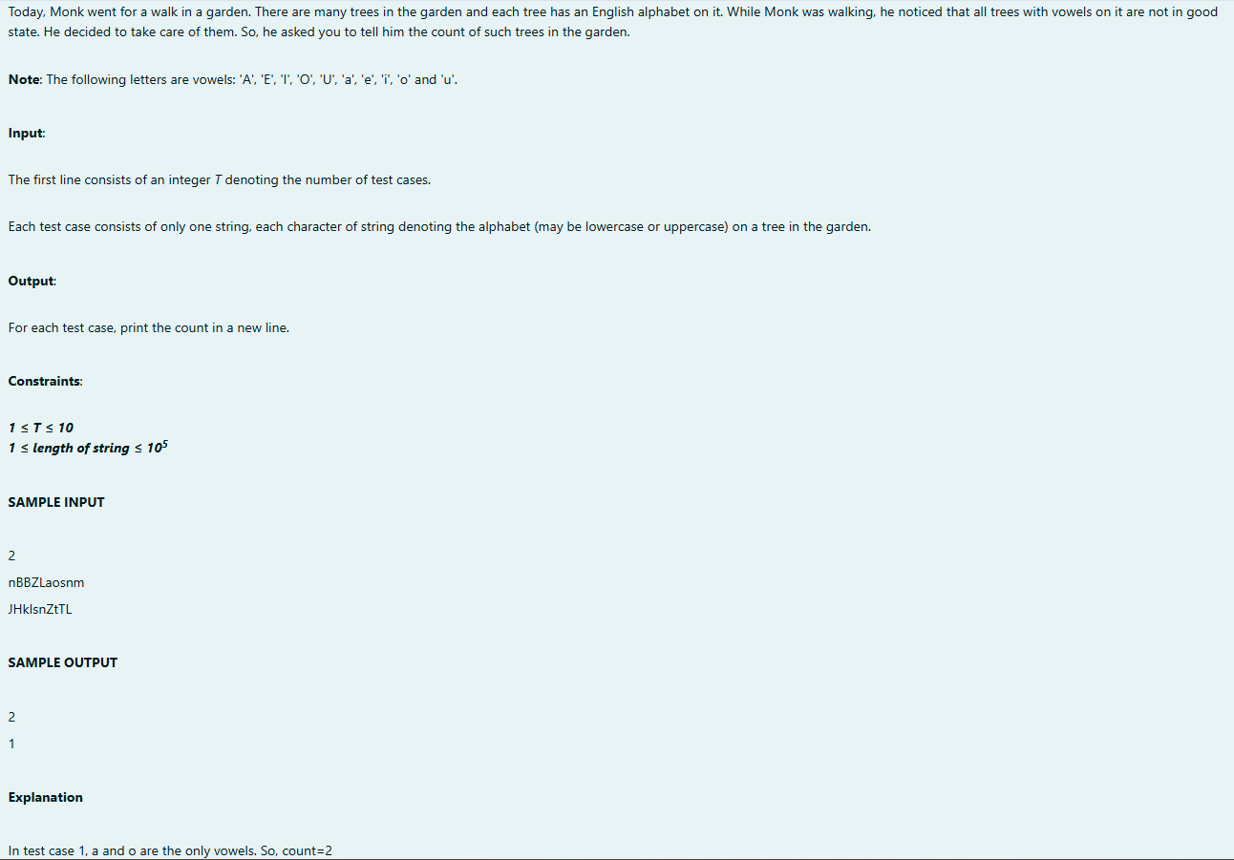

Output: 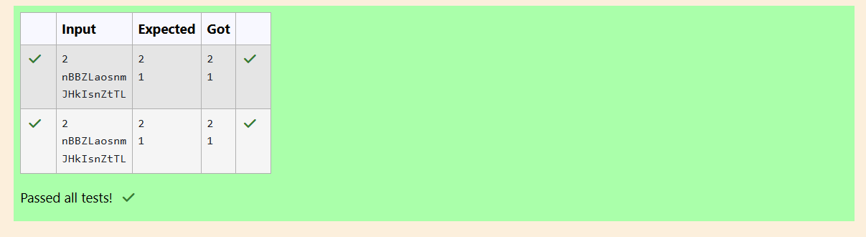

Question:

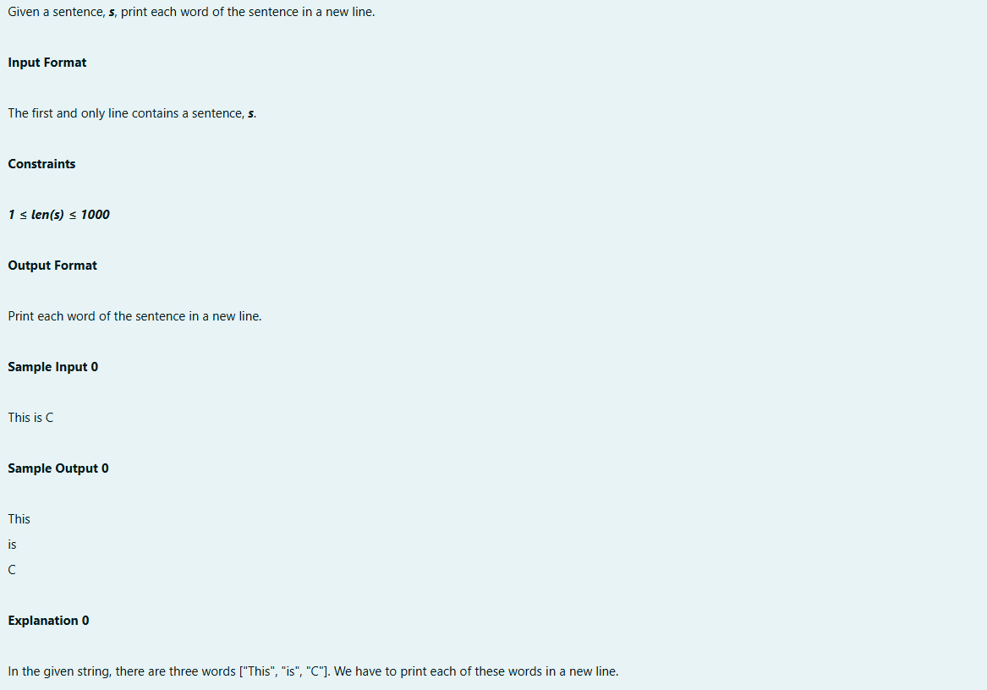

Program:

O

Output: 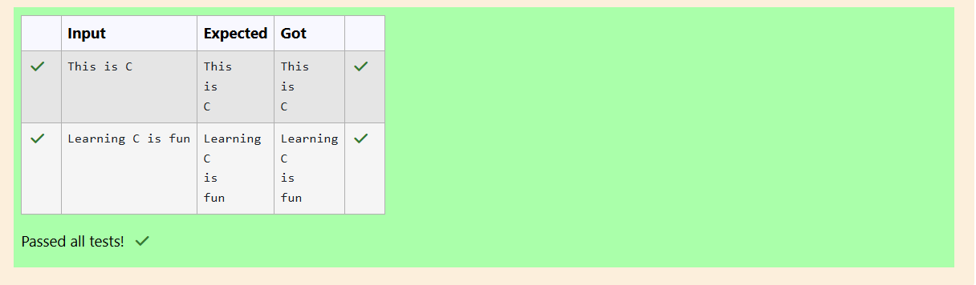

Question:

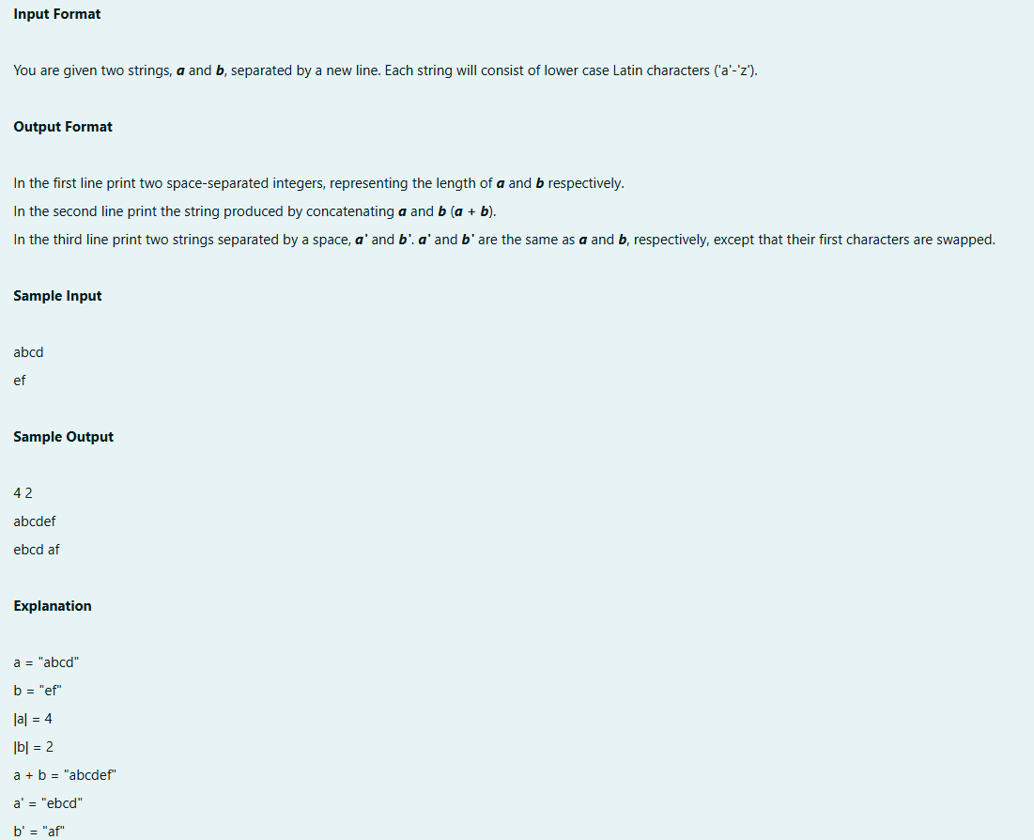

Program:

Output:  
