Week-14-Coding

Question:

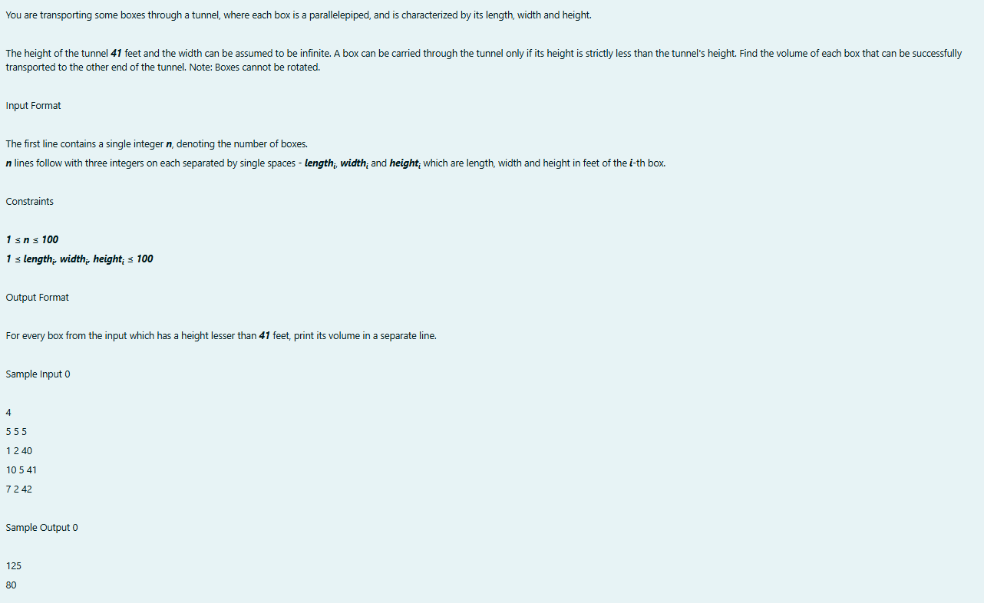

Program:

Output:

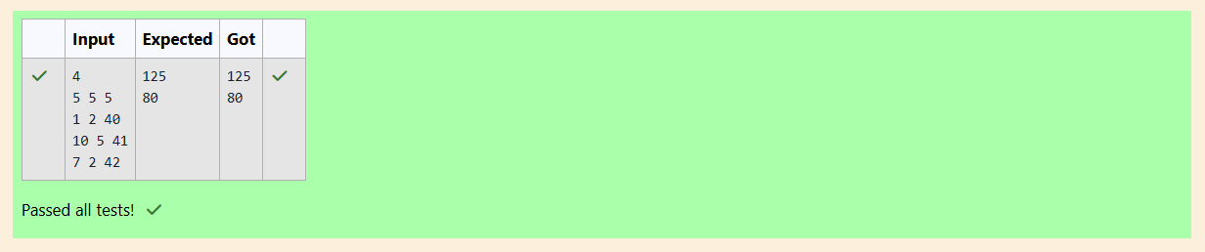

Question:

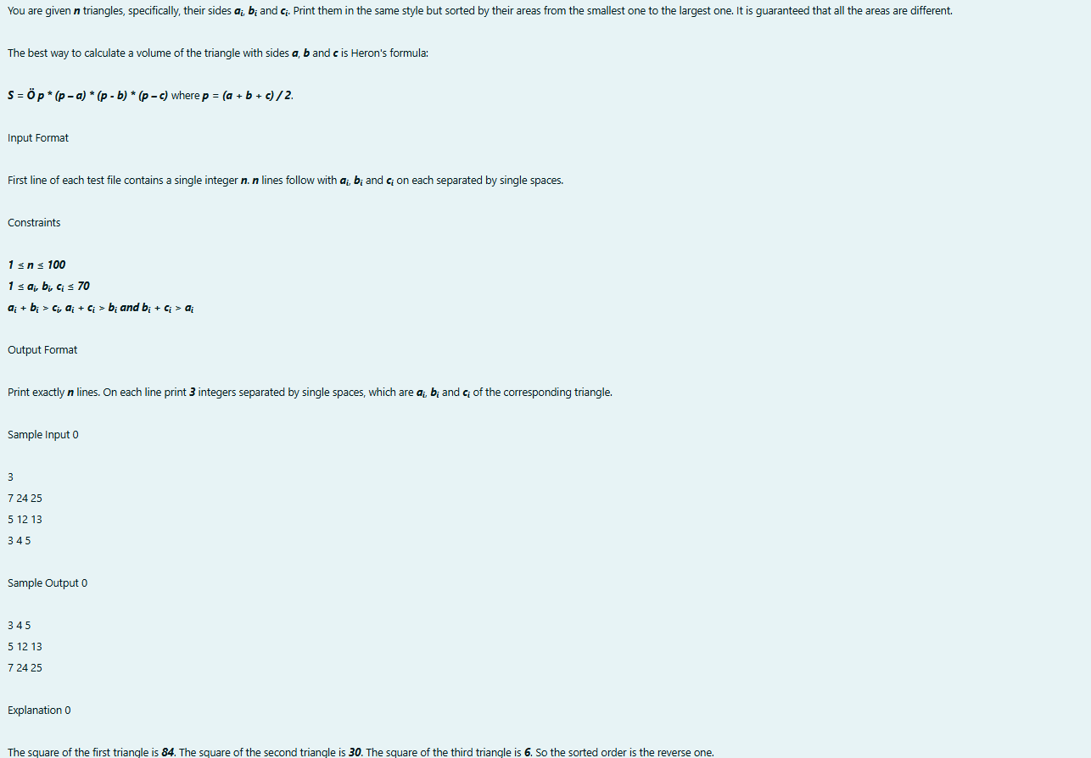

Program:

Output:

