Week-15-Coding

Question:

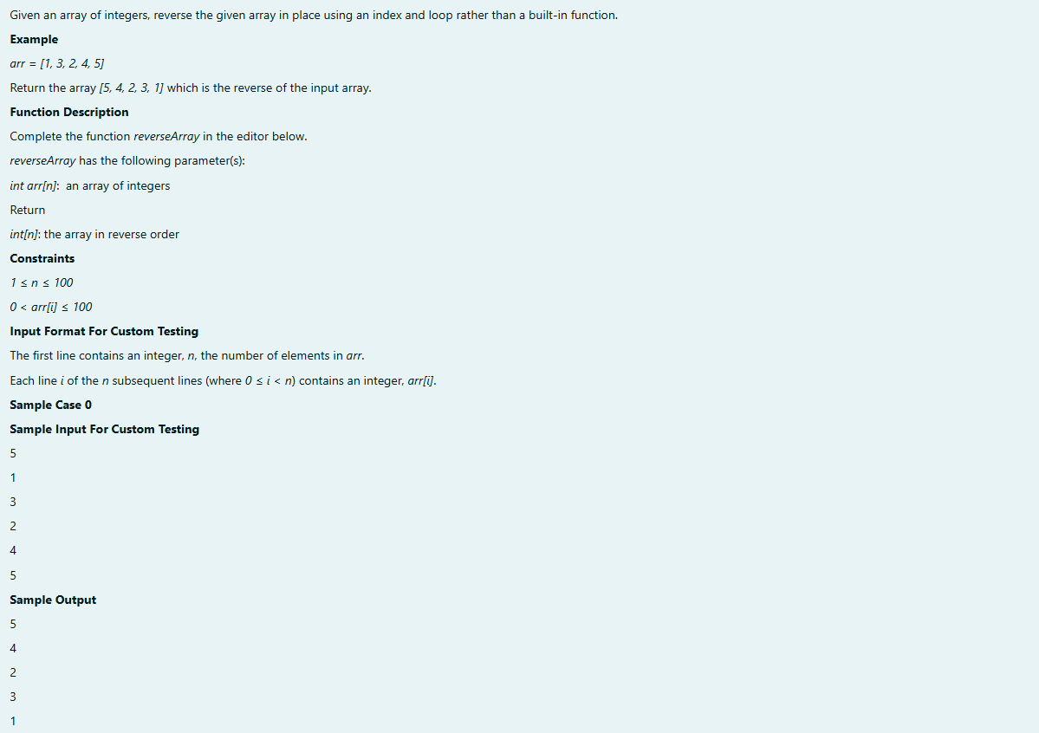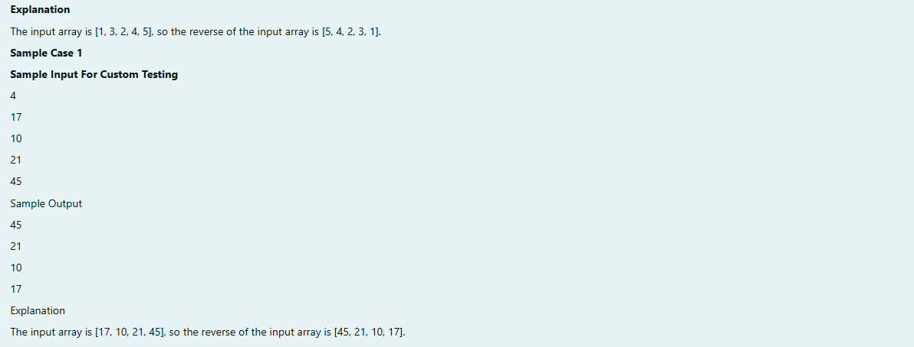

Program:

Output:

Question:

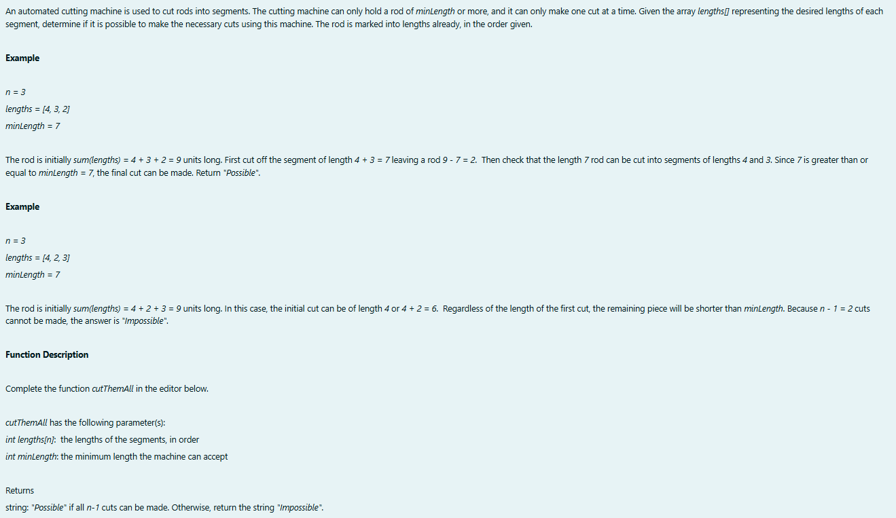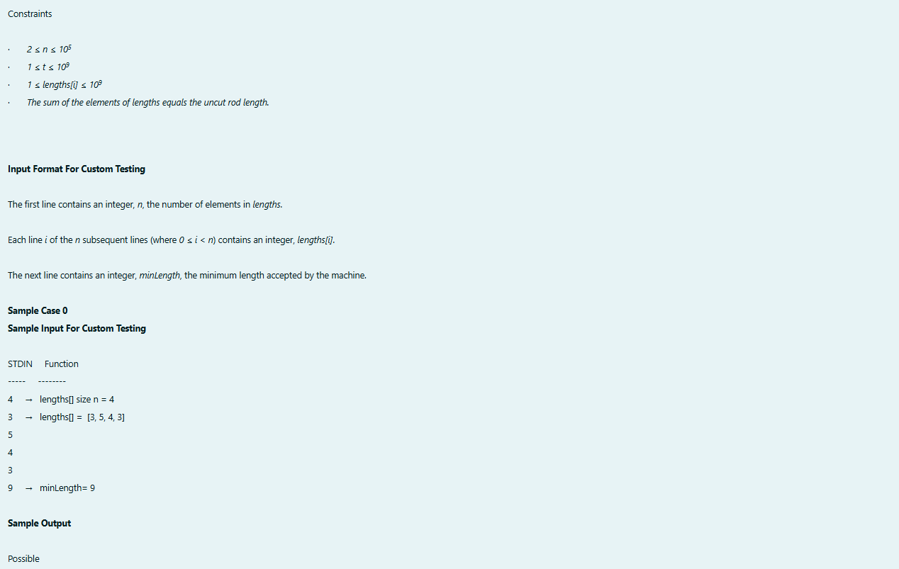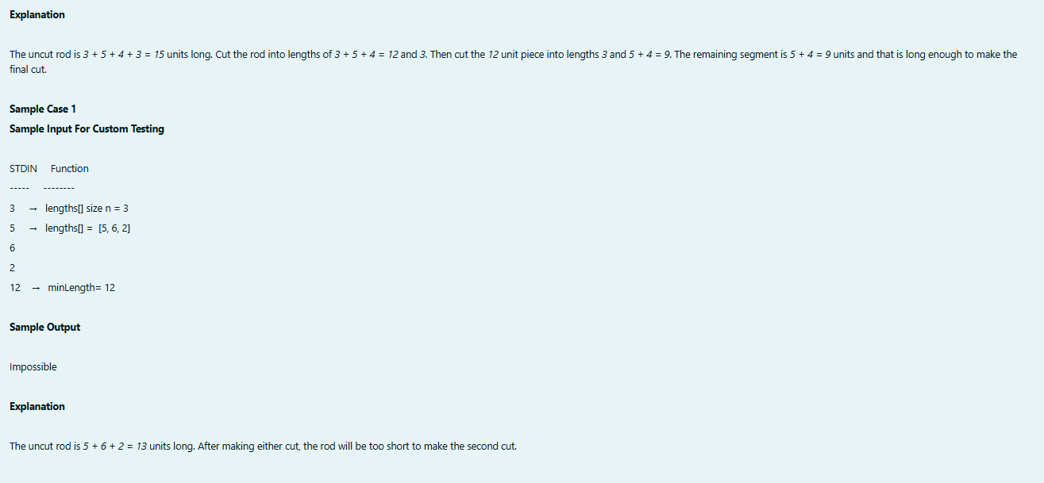

Program:

Output:

