**Experiment No.: 9**

**Aim:**

Shell script to display your name.

**Procedure**

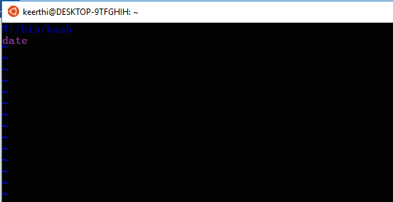

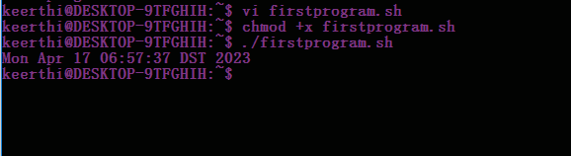

**Experiment No.:10**

**Aim:** Shell script to display your name.

**Procedure**

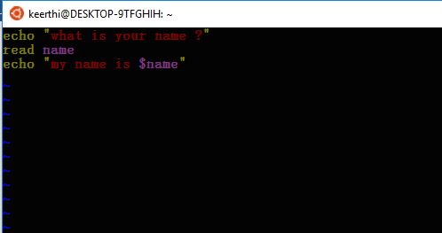

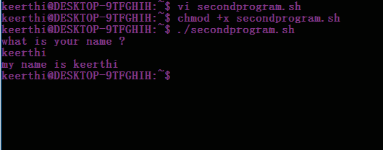

**Experiment No.:11**

**Aim:** Shell script to display date, pwd, ls commands.

**Procedure**

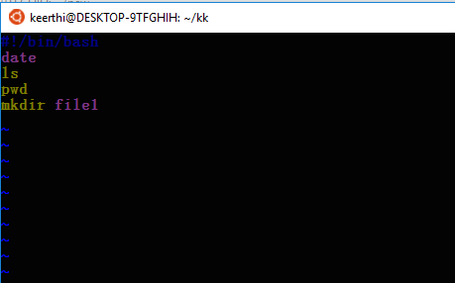

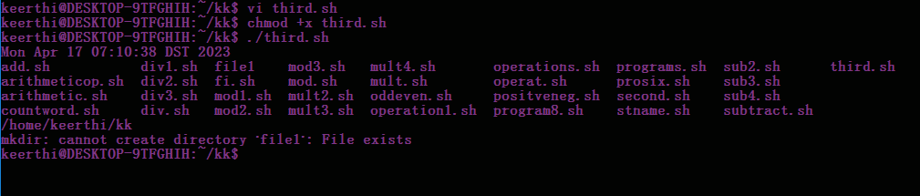

**Experiment No.: 12**

**Aim:** Shell script to demonstrate variables.

**Procedure**

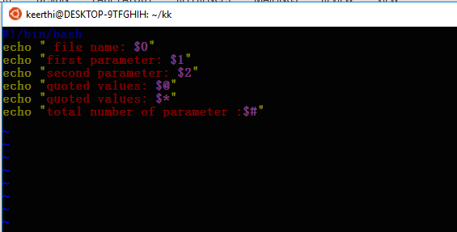

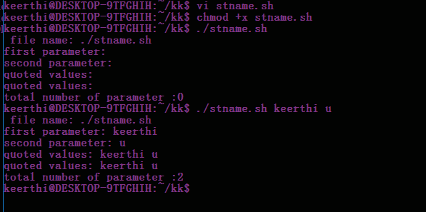

**Experiment No.: 14**

**Aim:** Shell script to count words and lines in a file.

**Procedure**

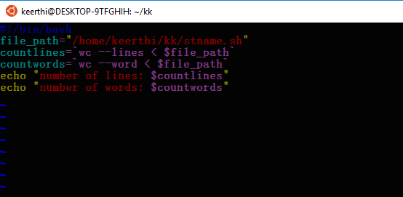

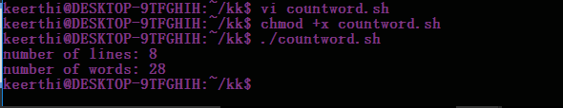

**Experiment No.: 15**

**Aim:** Shell script to display array index.

**Procedure**

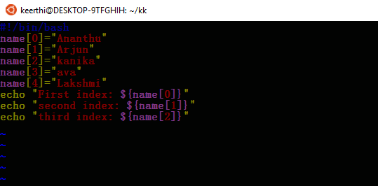

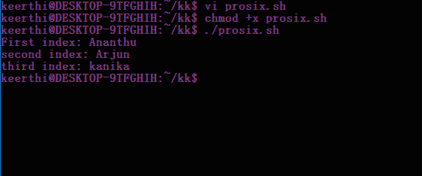

**Experiment No.: 16**

**Aim:** Shell script to demonstrate Arithmetic operations.

**Procedure**

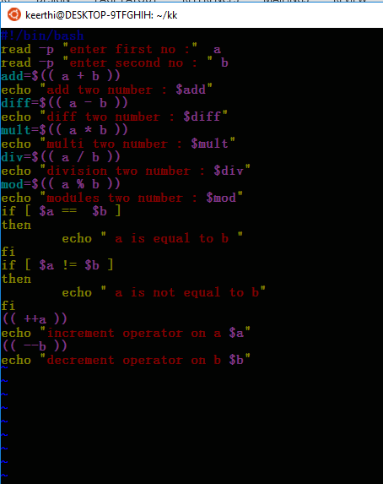

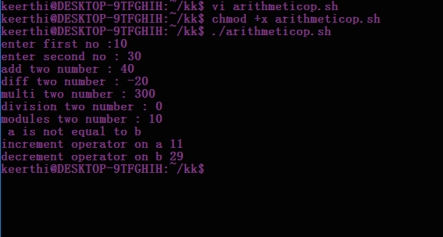

**Experiment No.: 17**

**Aim:** Shell script to demonstrate Relational operations.

**Procedure**

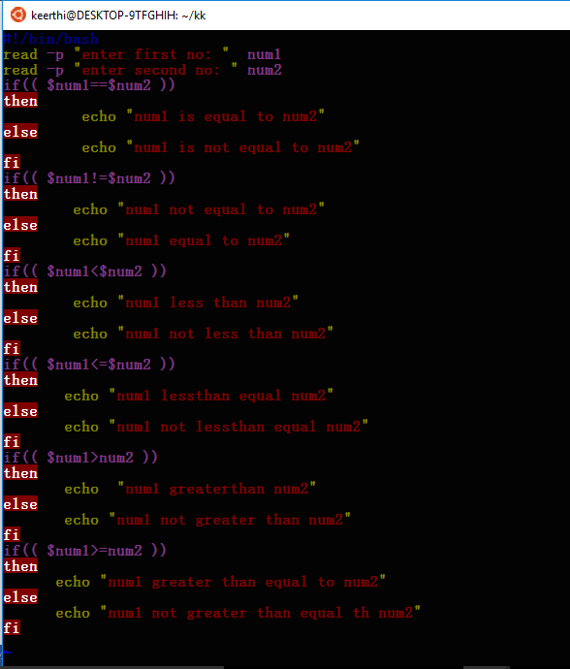

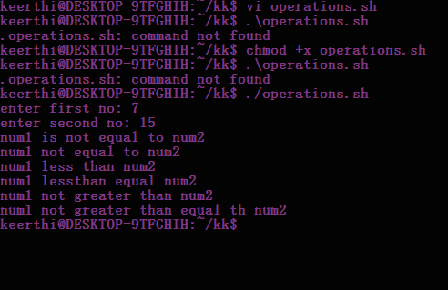

**Experiment No.: 18**

**Aim:** Shell script to check whether a number is odd or even.

**Procedure**

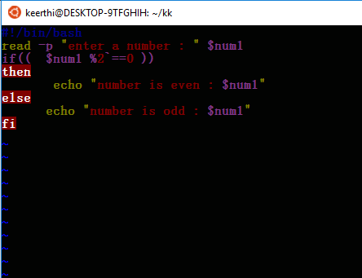

**Experiment No.: 20**

**Aim:**

**Shell script to find the greatest of three numbers .**

**Procedure**

1:largest no

read -p "enter the first no " a

read -p "enter the second no" b

read -p "enter the third no" c

if(( $a > $b & $a > $b ))

then

echo " greatest no is &a"

elif(( $b > $a && $b > $c ))

then

echo "greatest no is $b"

else

echo "greatest no is $c"

fi

3:bitwiswe operator

#!/bin/bash

read -p " enter a : " a

read -p " enter b : " b

bitwiseAND=$(( a&b ))

echo " bitwise AND of a and b is $bitwiseAND"

bitwiseOR=$(( a|b ))

echo " bitwise OR of and b is $bitwiseOR "

bitwiseXOR=$(( a^b ))

echo " bitwise XOR of a and b are $bitwiseXOR"

bitwiseComplements=$(( ~a ))

echo " bitwise Complement of and b are $bitwiseComplement"

leftshift=$(( a<<1 ))

echo " lefthift of a is $leftshift

rightshift=$(( b>>1 ))

echo " right shift of b is $rightshift

2:stringoperator

#!/bin/bash

read -p "enter your first string :" a

read -p "enter second string :" b

if [ $a = $b ]

then

echo "$a = $b : a is equal to b"

else

echo " $a = $b : a is not equal to b"

fi

if [ $a != $b ]

then

echo "$a != $b : a is not equal to b "

else

echo " $a != $b : a is equal to b "

fi

if [ -z $a ]

then

echo " -z $a : string length is zero"

else

echo " -z $a : string length not zero"

fi

if [ -n $a ]

then

echo " -n $a : string length not true"

#!/bin/bash

4:fileoperation

#!/bin/bash

read -p " enter the name: " filename

if [ -e $filename ]

then

echo " file exist "

else

echo " file doesnot exist "

fi

if [ -s $filename ]

then

echo " given file is not empty "

else

echo "the given file is empty "

fi

if [ -r $filename ]

then

echo " the given file has read acess "

else

echo "file is does not acess "

fi

if [ -w $filename ]

then

echo " the given file write acess "

else

echo "the given file is not write acess"

fi

if [ -x $filename ]

then

echo " the given file has exicute acess "

else

echo "the given file does not acess"

fi

5:equalnumber

#!/bin/bash

a=10

b=20

if [ $a == $b ]

then

echo " a is equal to b "

fi

if [ $a != $b ]

then

echo " a is not equal to b "

fi