**Experiment No.: 1 DATE:28/10/2022**

**Aim:**

To find the area of a rectangle

**CO1:**

Understands basic of python programming language including input or output function operators. Basic and collection data types.

**Procedure**

**Length=int(input('Enter the length:')) #Area of a rectangle**

**Breadth=int(input('enter the breadth'))**

**Area=Breadth*Length**

**print ('area of rectangle is:',area) #print area**

**Output Screenshot**

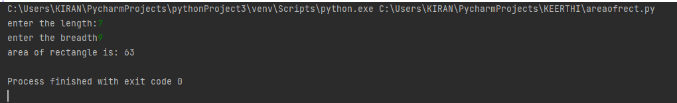

**Result**

The program was executed and the result was successfully obtained. Thus CO1 was obtained.

**Experiment No.: 2 DATE:28/10/2022**

**Aim:**

To find area and perimeter of circle

**CO1:**

Understands basic of python programming language including input or output function operators. Basic and collection data types.

**Procedure:**

pi=3.14 #initialiseing value of pi

r=float(input('enter the radius:'))

Area=pi*r*r #area of circle

Perimeter=2*pi*r #perimeter of circle

print('Area of circle',area)

print('Perimeter of a circle',perimeter)

**Output Screenshot:**

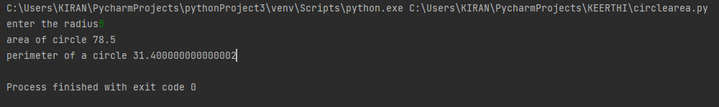

**Result:**

The program was executed and the result was successfully obtained. Thus CO1 was obtained.

**Experiment No.: 3 DATE:28/10/2022**

**Aim:**

To find the temperature convert to celcius

**CO1:**

Understands basic of python programming language including input or output function operators. Basic and collection data types.

**Procedure:**

**celcius=float(input('enter the celcius'))#tempareture in celcius to fahrenheit**

**fahrenheit=(celcius*9/5)+32**

**print("fahrenheit is",fahrenheit)**

**Output Screenshot:**

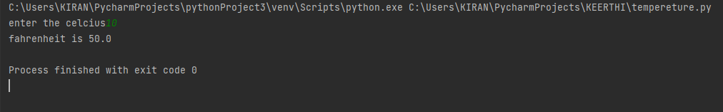

**Result**

The program was executed and the result was successfully obtained. Thus CO1 was obtained.

**Experiment No.: 4 DATE:28/10/2022**

**Aim:**

To convert kilometre to miles

**CO1:**

Understands basic of python programming language including input or output function operators. Basic and collection data types.

**Procedure:**

kilometer=float(input('enter the kilometer:')) #convert kilometer to miles

cf=0.621371 #conversion factor

miles=kilometer*cf

print("%0.2f kilometr is equal to\n %2f miles"%(kilometer,miles))

**Output Screenshot:**

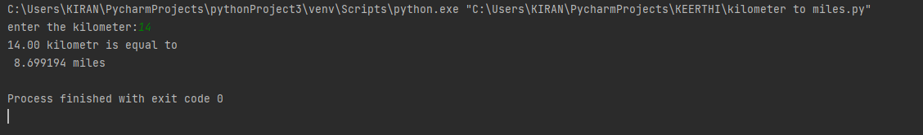

**Result:**

The program was executed and the result was successfully obtained. Thus CO1 was obtained.

**Experiment No.: 5 DATE:28/10/2022**

**Aim:**

To swap two variable

**CO1:**

Understands basic of python programming language including input or output function operators. Basic and collection data types.

**Procedure:**

y=int(input('enter first no:'))#swapping two variables

x=int(input("enter second no:"))

print("before swapping ",y,x)

y=y+x

x=y-x

y=y-x

print("after swapping",y,x)

**Output Screenshot:**

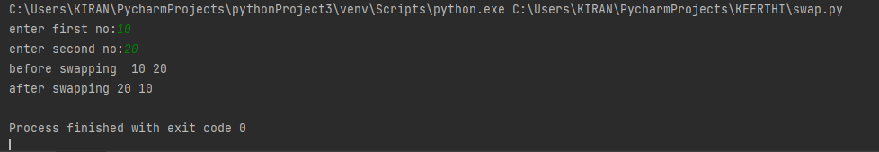

**Result:**

The program was executed and the result was successfully obtained. Thus CO1 was obtained.

**Experiment No.: 6 DATE:28/10/2022**

**Aim:**

To Enter the name ,mark of five subject calculate total percentage.

**CO1:**

Understands basic of python programming language including input or output function operators. Basic and collection data types.

**Procedure:**

name=str(input('enter the student name:')) #total mark and percentage of five subject

sub1=float(input("enter the mark of c programming"))

sub2=float(input("enter the mark of data structure"))

sub3=float(input("enter the mark of web programming"))

sub4=float(input("enter the mark of software engineering"))

sub5=float(input("enter the mark of python"))

maximum_mark=1500

total=sub1+sub2+sub3+sub4+sub5 #calculate total and percentage

percentage=(total/1500)*100

print("total mark:",total) #print total mark

print("percentage is:",percentage) #mark percentage

**Output Screenshot:**

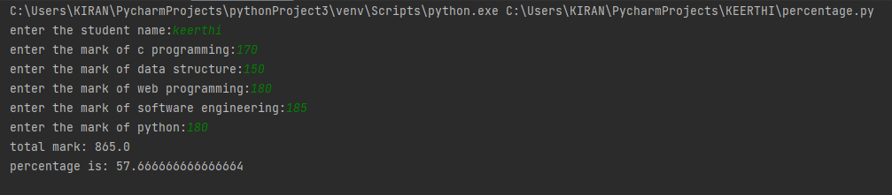

**Result:**

The program was executed and the result was successfully obtained. Thus CO1 was obtained.

**Experiment No.: 7 DATE:28/10/2022**

**Aim:**

To the Enter the distance in feet converted to inches

**CO1:**

Understands basic of python programming language including input or output function operators. Basic and collection data types.

**Procedure:**

feet=int(input("enter the distance"))#distance feet and convert into inches

inch=12*feet

print("the distance in inches",inch)

**Output Screenshot:**

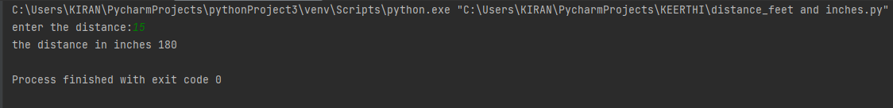

**Result:**

The program was executed and the result was successfully obtained. Thus CO1 was obtained.

**Experiment No.: 8 DATE:28/10/2022**

**Aim:**

To the Enter the radius and height of a cylinder and calculate the volume of a cylinder

**CO1:**

Understands basic of python programming language including input or output function operators. Basic and collection data types.

**Procedure:**

rad=float(input("enter the radius:")) #volume of cylinder

height=float(input("enter the height:"))

pi=3.14 # initialising pi value

vol=pi*rad*rad*height

print("volume of cylinder \t",vol) #print volume

**Output Screenshot:**

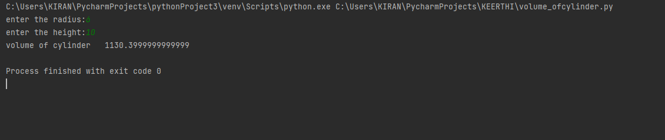

**Result:**

The program was executed and the result was successfully obtained. Thus CO1 was obtained.

**Experiment No.: 9 DATE:28/10/2022**

**Aim:**

To generate simple calculator

**CO2:**

Implement decision making,looping constructs and function

**Procedure:**

print("1.ADD")#simple calculator

print("2.SUBTRACT")

print("3.MULTIPLY")

print("4.DIVIDE")

choice=input("enter the your choice: \t")

if choice =='1':

num1=int(input("\nenter the first number:"))#input two values

num2=int(input("\nenter the second number:"))

print("\nThe result is:\t",(num1+num2))#addition

elif choice =='2':

num1 = int(input("\nenter the first number"))

num2 = int(input("\nenter the second number"))

print("The result is:\t", (num1 - num2))#subtraction

elif choice =='3':

num1 = int(input("\nenter the first number"))

num2 = int(input("\nenter the second number"))

print("The result is:\t", (num1*num2))#multiplication

elif choice =='4':

num1 = int(input("\nenter the first number"))

num2 = int(input("\nenter the second number"))

print("The result is:\t",(num1 / num2))#divion of two numbers

else:

print("default ")

**Output Screenshot:**

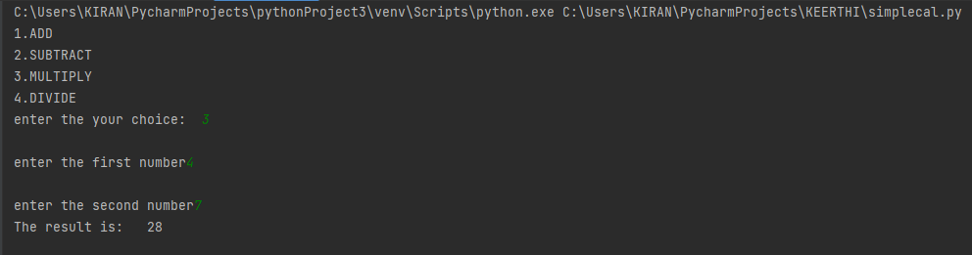

**Result:**

The program was executed and the result was successfully obtained. Thus CO2 was obtained.

**Experiment No.: 10 DATE:28/10/2022**

**Aim:**

To find the volume of cone

**CO1:**

Understands basic of python programming language including input or output function operators. Basic and collection data types.

**Procedure:**

#python program to find volume of cone

rad=float(input("enter the radius of cone:"))

height=float(input("enter the height of cone:"))

pi=3.14

vol=pi*rad*rad*height/3#calculate the volume

print(" volume of cone is:",vol)

**Output Screenshot:**

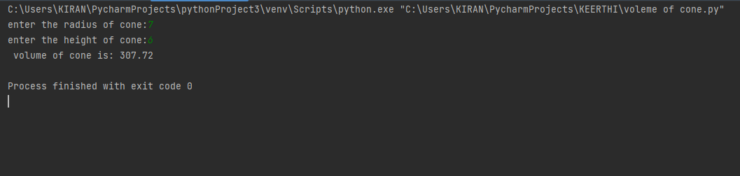

**Result:**

The program was executed and the result was successfully obtained. Thus CO1 was obtained.

**Experiment No.: 11 DATE:8/11/2022**

**Aim:**

To create a string from given string where first and last character are change.

**CO1:**

Understands basic of python programming language including input or output function operators. Basic and collection data types.

**Procedure:**

str=input("enter a string:")

a=str[-1]

b=str[0]

c=str[1:-1]

print(a+b+c)

**Output Screenshot:**

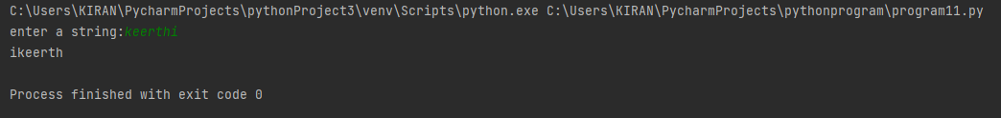

**Result:**

The program was executed and the result was successfully obtained. Thus CO1 was obtained.

**Experiment No.: 12 DATE:8/11/2022**

**Aim:**

To find the biggest of 3 number using max() function

**CO1:**

Understands basic of python programming language including input or output function operators. Basic and collection data types.

**Procedure:**

a=int(input("enter first number:"))

b=int(input("enter 2nd number:"))

c=int(input("enter 3rd number:"))

d=max(a,b,c)

print("largest number is",d)

**Output Screenshot:**

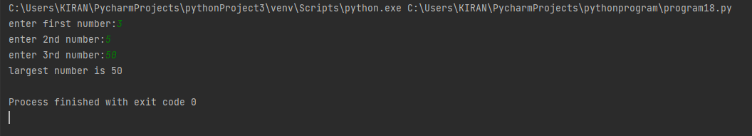

**Result:**

The program was executed and the result was successfully obtained. Thus CO1 was obtained.

**Experiment No.: 13 DATE:8/11/2022**

**Aim:**

To accept a file name from user .print extention of the file

**CO1:**

Understands basic of python programming language including input or output function operators. Basic and collection data types.

**Procedure:**

file1=input("enter a filename:")

x=file1.split('.')

print(x)

print(x[1])

**Output Screenshot:**

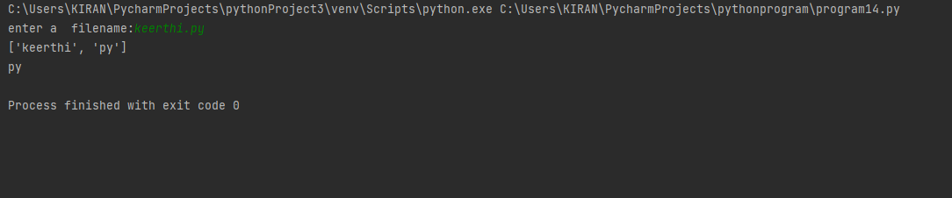

**Result:**

The program was executed and the result was successfully obtained. Thus CO1 was obtained

**Experiment No.: 14 DATE:8/11/2022**

**Aim:**

To create a list of colour from comma separated colour name enter by user display first and last

colour

**CO1:**

Understands basic of python programming language including input or output function operators. Basic and collection data types.

**Procedure:**

colour=input("enter colour:")

print(colour)

colour_list=colour.split(',')

print(colour_list)

print(colour_list[0])

print(colour_list[-1])

**Output Screenshot:**

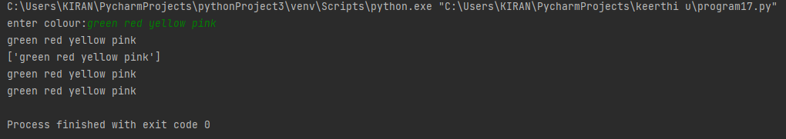

**Result:**

The program was executed and the result was successfully obtained. Thus CO1 was obtained

**Experiment No.: 15 DATE:8/11/2022**

**Aim:**

To accept an in integer n and compute n+nn+nnn

**CO1:**

Understands basic of python programming language including input or output function operators. Basic and collection data types.

**Procedure:**

n=int(input("enter a number:"))

print( n+n*n+n*n*n)

**Output Screenshot:**



**Result:**

The program was executed and the result was successfully obtained. Thus CO1 was obtained

**Experiment No.: 16 DATE:8/11/2022**

**Aim:**

To check whether a number a number is odd or even

**CO1:**

Understands basic of python programming language including input or output function operators. Basic and collection data types.

**Procedure:**

num=int(input("enter a number:"))

if num % 2 ==0:

print("even number")

else:

print("odd number")

**Output Screenshot:**

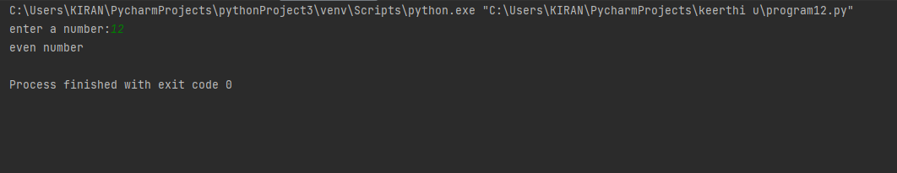

**Result:**

The program was executed and the result was successfully obtained. Thus CO1 was obtained

**Experiment No.: 17 DATE:8/11/2022**

**Aim:**

To check whether a number is negative ,positive or zero

**CO1:**

Understands basic of python programming language including input or output function operators. Basic and collection data types.

**Procedure:**

x=int(input("enter a number:"))

if x > 0:

print("number is positive")

elif x < 0:

print("number is negative")

else:

print("number is zero")

**Output Screenshot:**

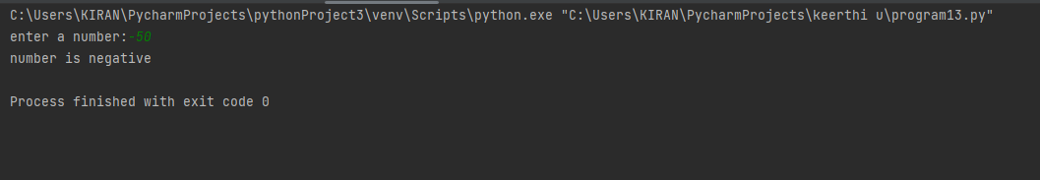

**Result:**

The program was executed and the result was successfully obtained. Thus CO1 was obtained

**Experiment No.: 18 DATE:8/11/2022**

**Aim:**

Create a single string separated with space from two strings by swapping character at position

one

**CO1:**

Understands basic of python programming language including input or output function operators. Basic and collection data types.

**Procedure:**

str1=input("enter 1st string:")

str2=input("enter 2nd string:")

string1=str2[0]+str1[1:]

string2=str1[0]+str2[1:]

print(string1+ " " +string2)

**Output Screenshot:**

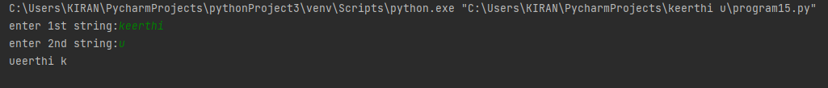

**Result:**

The program was executed and the result was successfully obtained. Thus CO1 was obtained

**Experiment No.: 19 DATE:8/11/2022**

**Aim:**

To checkwhether a number is Armstrong or Not.

**CO1:**

Understands basic of python programming language including input or output function operators. Basic and collection data types.

**Procedure:**

n=int(input("enter a nuber"))

sum = 0

temp = n

while n != 0:

rec = n % 10

sum = sum + rec * rec * rec

n = n // 10

if temp == sum:

print("armstrong no")

else:

printf("not an armstrong ")

**Output Screenshot:**

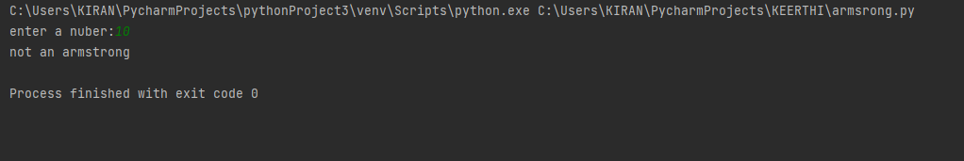

**Result:**

The program was executed and the result was successfully obtained. Thus CO1 was obtained

**Experiment No.: 20 DATE:8/11/2022**

**Aim:**

To check factorial of a number

**CO1:**

Understands basic of python programming language including input or output function operators. Basic and collection data types.

**Procedure:**

num=int(input("enter a number:"))

i=1

fact=1

while i <= num:

fact=fact*i

i=i+1

print(fact)

**Output Screenshot:**

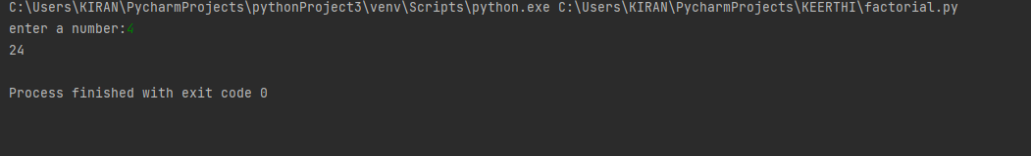

**Result:**

The program was executed and the result was successfully obtained. Thus CO1 was obtained

**Experiment No.: 21 DATE:8/11/2022**

**Aim:**

To find the number is palindrome or not

**CO2:**

Implement decision making ,looping construct and function

**Procedure:**

n=int(input("enter a nuber:"))

temp = n

rev=0

while(n>0):

rem = n % 10

rev = rev * 10 + rem

n = n // 10

if temp == rev:

print("palindrome")

else:

print("not a palindrom")

**Output Screenshot:**

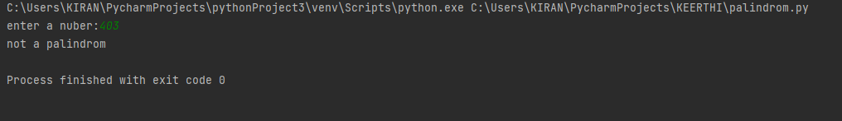

**Result:**

The program was executed and the result was successfully obtained. Thus CO2 was obtained

**Experiment No.: 22 DATE:8/11/2022**

**Aim:**

To find reverse of a number

**CO2:**

Implement decision making ,looping construct and function

**Procedure:**

n=int(input("enter a number"))

rev_num=0

while num !=0:

digit=num != 0:

digit=num%10

reversed_num=reversed_num*10+digit

num//=10

print("reversed number:"+str(reversed_num))

**Output Screenshot:**

**Result:**

The program was executed and the result was successfully obtained. Thus CO1 was obtained

**Experiment No.: 23 DATE:8/11/2022**

**Aim:**

Write a program to print certain pattern (type1)

**CO2:**

Implement decision making ,looping construct and function

**Procedure:**

n = int(input('Enter number of rows : '))

i = 1

while i <= n:

j = 1

while j <= i:

print("*", end=" ")

j += 1

print()

i += 1

Output Screenshot:

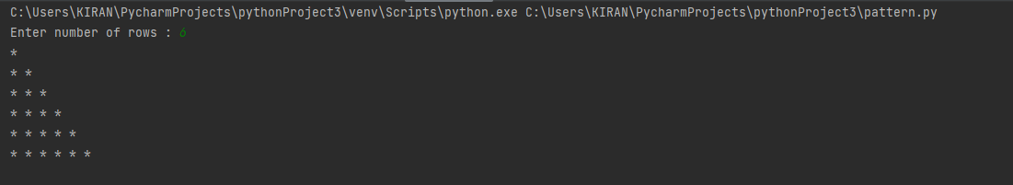

**Result:**

The program was executed and the result was successfully obtained. Thus CO2 was obtained

**Experiment No.: 24 DATE:8/11/2022**

**Aim:**

Write a program to print certain pattern (type2)

**CO2:**

Implement decision making ,looping construct and function

**Procedure:**

n = int(input('Enter number of rows : '))

i = 1

while i <= n:

j = n

while j >= i:

print("*", end=" ")

j -= 1

print()

i += 1

**Output Screenshot:**

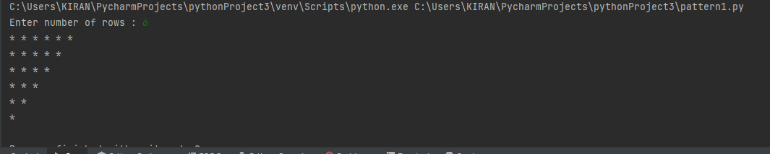

**Result:**

The program was executed and the result was successfully obtained. Thus CO2 was obtained