**Experiment No.: 1 DATE: 28/10/2022**

**Aim:**

Program to find the area of a rectangle.

**CO1:**

Understands basic of python programming language including input or output function operators. Basic and collection data types.

**Procedure :**

Length= int(input('Enter the length:')) #Area of a rectangle

Breadth= int(input('enter the breadth'))

Area=Breadth*Length

print ('area of rectangle is:',area) #print area

**Output Screenshot**

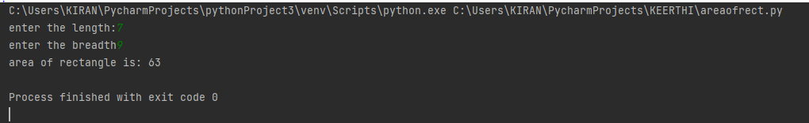

**Result**

The program was executed and the result was successfully obtained. Thus CO1 was obtained.

**Experiment No.: 2 DATE:28/10/2022**

**Aim:**

To find area and perimeter of circle

**CO1:**

Understands basic of python programming language including input or output function operators. Basic and collection data types.

**Procedure:**

pi=3.14 #initialiseing value of pi

r=float(input('enter the radius:'))

Area=pi*r*r #area of circle

Perimeter=2*pi*r #perimeter of circle

print('Area of circle',area)

print('Perimeter of a circle',perimeter)

**Output Screenshot:**

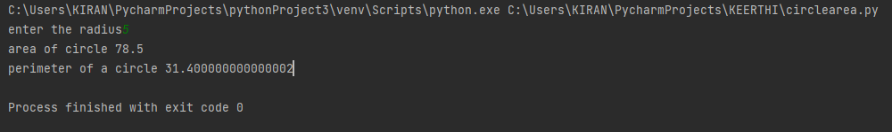

**Result:**

The program was executed and the result was successfully obtained. Thus CO1 was obtained.

**Experiment No.: 3 DATE:28/10/2022**

**Aim:**

Convert the tempareture to Celsius to fahrenheit

**CO1:**

Understands basic of python programming language including input or output function operators. Basic and collection data types.

**Procedure:**

celcius=float(input('enter the celcius'))#tempareture in celcius to fahrenheit

fahrenheit=(celcius*9/5)+32

print("fahrenheit is",fahrenheit)

**Output Screenshot:**

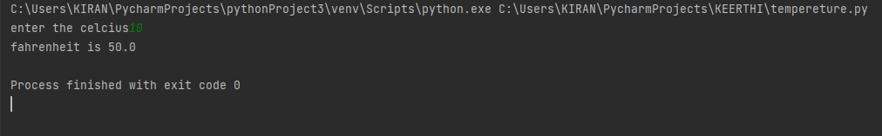

**Result**

The program was executed and the result was successfully obtained. Thus CO1 was obtained.

**Experiment No.: 4 DATE:28/10/2022**

**Aim:**

Convert kilometre to miles

**CO1:**

Understands basic of python programming language including input or output function operators. Basic and collection data types.

**Procedure:**

kilometer=float(input('enter the kilometer:')) #convert kilometer to miles

cf=0.621371 #conversion factor

miles=kilometer*cf

print("%0.2f kilometr is equal to\n %2f miles"%(kilometer,miles))

**Output Screenshot:**

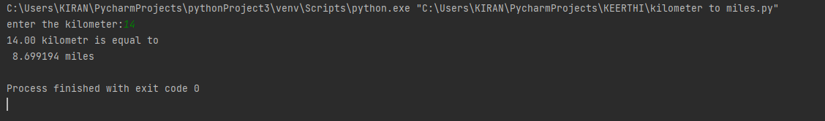

**Result:**

The program was executed and the result was successfully obtained. Thus CO1 was obtained.

**Experiment No.: 5 DATE:28/10/2022**

**Aim:**

To swap two numbers

**CO1:**

Understands basic of python programming language including input or output function operators. Basic and collection data types.

**Procedure:**

y=int(input('enter first no:'))#swapping two variables

x=int(input("enter second no:"))

print("before swapping ",y,x)

y=y+x

x=y-x

y=y-x

print("after swapping",y,x)

**Output Screenshot:**

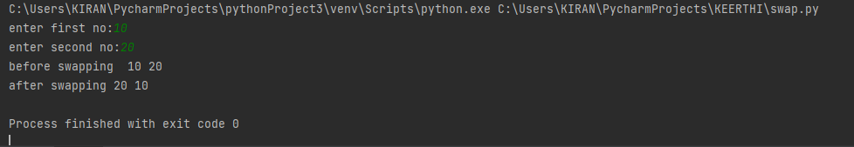

**Result:**

The program was executed and the result was successfully obtained. Thus CO1 was obtained.

**Experiment No.: 6 DATE:28/10/2022**

**Aim:**

Program to enter the name of a student and enter the marks of 3 subjects to find the total and percentage of the student

**CO1:**

Understands basic of python programming language including input or output function operators. Basic and collection data types.

**Procedure:**

name=str(input('enter the student name:')) #total mark and percentage of five subject

sub1=float(input("enter the mark of c programming"))

sub2=float(input("enter the mark of data structure"))

sub3=float(input("enter the mark of web programming"))

sub4=float(input("enter the mark of software engineering"))

sub5=float(input("enter the mark of python"))

maximum_mark=1500

total=sub1+sub2+sub3+sub4+sub5 #calculate total and percentage

percentage=(total/1500)*100

print("total mark:",total) #print total mark

print("percentage is:",percentage) #mark percentage

**Output Screenshot:**

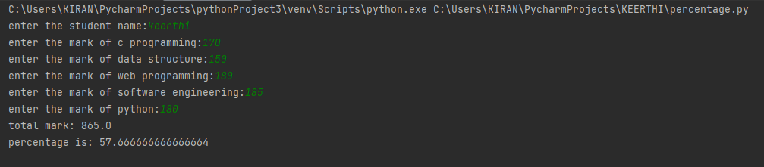

**Result:**

The program was executed and the result was successfully obtained. Thus CO1 was obtained.

**Experiment No.: 7 DATE:28/10/2022**

**Aim:**

Program to enter the distance in foot

**CO1:**

Understands basic of python programming language including input or output function operators. Basic and collection data types.

**Procedure:**

feet=int(input("enter the distance"))#distance feet and convert into inches

inch=12*feet

print("the distance in inches",inch)

**Output Screenshot:**

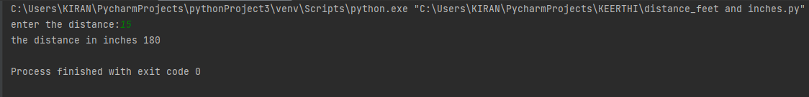

**Result:**

The program was executed and the result was successfully obtained. Thus CO1 was obtained.

**Experiment No.: 8 DATE: 28/10/2022**

**Aim:**

Enter the radios and  height of a cylinder & calculate volume

**CO1:**

Understands basic of python programming language including input or output function operators. Basic and collection data types.

**Procedure:**

rad=float(input("enter the radius:")) #volume of cylinder

height=float(input("enter the height:"))

pi=3.14 # initialising pi value

vol=pi*rad*rad*height

print("volume of cylinder \t",vol) #print volume

**Output Screenshot:**

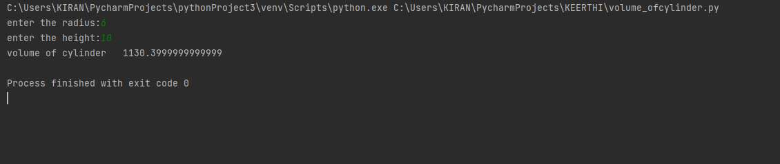

**Result:**

The program was executed and the result was successfully obtained. Thus CO1 was obtained.

**Experiment No.: 9 DATE:28/10/2022**

**Aim:**

print simple calculator

**CO2:**

Implement decision making,looping constructs and function

**Procedure:**

x=int(input("enter the value of x:"))

y=int(input("enter the value of y:"))

a=x+y

b=x-y

c=x*y

r=x/y

print("sum of two number",a)

print("Difference of two number",b)

print("Product of two number",c)

print("Quotient of two number",r

**Output Screenshot:**

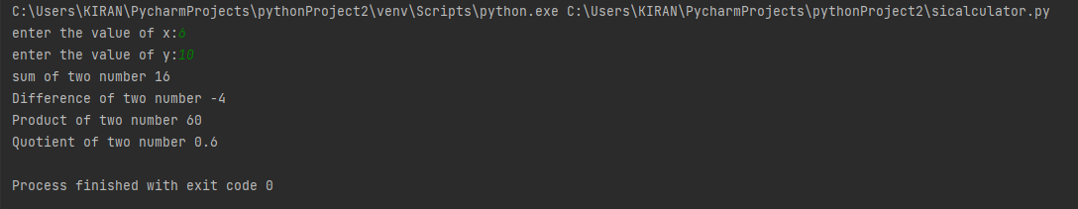

**Result:**

The program was executed and the result was successfully obtained. Thus CO2 was obtained.

**Experiment No.: 10 DATE:28/10/2022**

**Aim:**

To find the volume of cone

**CO1:**

Understands basic of python programming language including input or output function operators. Basic and collection data types.

**Procedure:**

#python program to find volume of cone

rad=float(input("enter the radius of cone:"))

height=float(input("enter the height of cone:"))

pi=3.14

vol=pi*rad*rad*height/3#calculate the volume

print(" volume of cone is:",vol)

**Output Screenshot:**

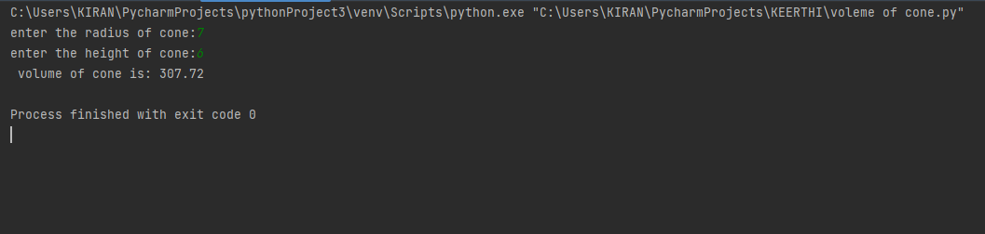

**Result:**

The program was executed and the result was successfully obtained. Thus CO1 was obtained.

**Experiment No.: 11 DATE:31/10/2022**

**Aim:**

To create a string from given string where first and last character are change.

**CO1:**

Understands basic of python programming language including input or output function operators. Basic and collection data types.

**Procedure:**

str=input("enter a string:")

a=str[-1]

b=str[0]

c=str[1:-1]

print(a+b+c)

**Output Screenshot:**

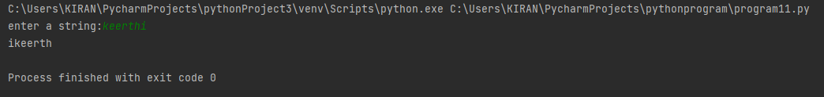

**Result:**

The program was executed and the result was successfully obtained. Thus CO1 was obtained.

**Experiment No.: 12 DATE:31/10/2022**

**Aim:**

To find the biggest of 3 number using max() function

**CO1:**

Understands basic of python programming language including input or output function operators. Basic and collection data types.

**Procedure:**

a=int(input("enter first number:"))

b=int(input("enter 2nd number:"))

c=int(input("enter 3rd number:"))

d=max(a,b,c)

print("largest number is",d)

**Output Screenshot:**

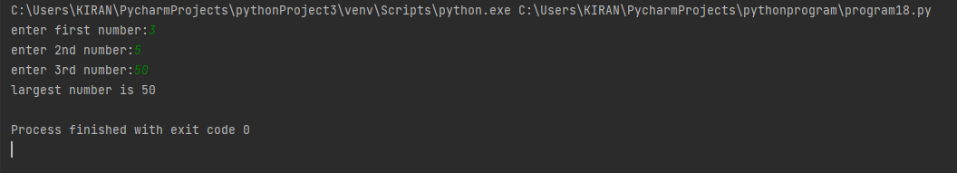

**Result:**

The program was executed and the result was successfully obtained. Thus CO1 was obtained.

**Experiment No.: 13 DATE:8/11/2022**

**Aim:**

Create a string from a given string where first and last character exchange

**CO1:**

Understands basic of python programming language including input or output function operators. Basic and collection data types.

**Procedure:**

file1=input("enter a filename:")

x=file1.split('.')

print(x)

print(x[1])

**Output Screenshot:**

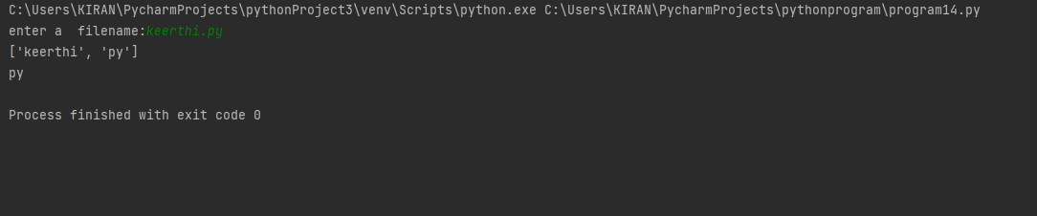

**Result:**

The program was executed and the result was successfully obtained. Thus CO1 was obtained

**Experiment No.: 14 DATE:31/10/2022**

**Aim:**

To create a list of colour from comma separated colour name enter by user display first and last

colour

**CO1:**

Understands basic of python programming language including input or output function operators. Basic and collection data types.

**Procedure:**

colour=input("enter colour:")

print(colour)

colour_list=colour.split(',')

print(colour_list)

print(colour_list[0])

print(colour_list[-1])

**Output Screenshot:**

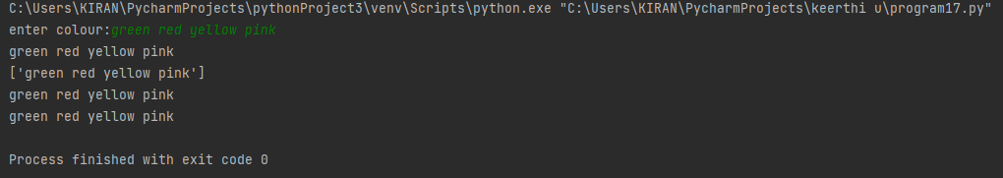

**Result:**

The program was executed and the result was successfully obtained. Thus CO1 was obtained

**Experiment No.: 15 DATE:31/10/2022**

**Aim:**

Accept an integer n and complete n+nn+nnn

**CO1:**

Understands basic of python programming language including input or output function operators. Basic and collection data types.

**Procedure:**

n=int(input("enter a number:"))

print( n+n*n+n*n*n)

**Output Screenshot:**



**Result:**

The program was executed and the result was successfully obtained. Thus CO1 was obtained

**Experiment No.: 16 DATE:31/10/2022**

**Aim:**

To check whether a number a number is odd or even

**CO1:**

Understands basic of python programming language including input or output function operators. Basic and collection data types.

**Procedure:**

num=int(input("enter a number:"))

if num % 2 ==0:

print("even number")

else:

print("odd number")

**Output Screenshot:**

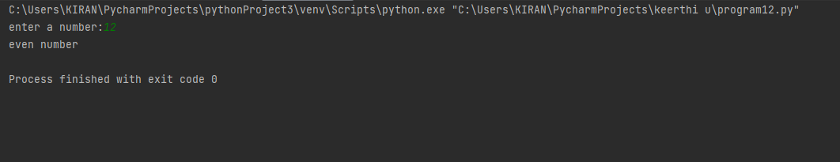

**Result:**

The program was executed and the result was successfully obtained. Thus CO1 was obtained

**Experiment No.: 17 DATE:31/10/2022**

**Aim:**

Check whether a number is positive,negative  or zero

**CO1:**

Understands basic of python programming language including input or output function operators. Basic and collection data types.

**Procedure:**

x=int(input("enter a number:"))

if x > 0:

print("number is positive")

elif x < 0:

print("number is negative")

else:

print("number is zero")

**Output Screenshot:**

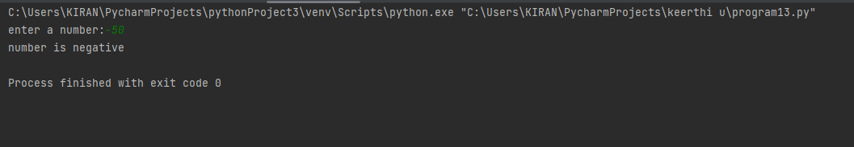

**Result:**

The program was executed and the result was successfully obtained. Thus CO1 was obtained

**Experiment No.: 18 DATE:31/10/2022**

**Aim:**

Create a single string separated with space from two strings by swapping the character at position one

**CO1:**

Understands basic of python programming language including input or output function operators. Basic and collection data types.

**Procedure:**

str1=input("enter 1st string:")

str2=input("enter 2nd string:")

string1=str2[0]+str1[1:]

string2=str1[0]+str2[1:]

print(string1+ " " +string2)

**Output Screenshot:**

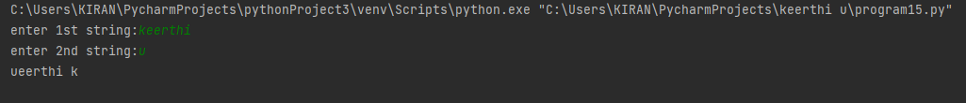

**Result:**

The program was executed and the result was successfully obtained. Thus CO1 was obtained

**Experiment No.: 19 DATE:4/11/2022**

**Aim:**

Simple calculator(using elif)

**CO1:**

Understands basic of python programming language including input or output function operators. Basic and collection data types.

**Procedure:**

print("1.ADD")#simple calculator

print("2.SUBTRACT")

print("3.MULTIPLY")

print("4.DIVIDE")

choice=input("enter the your choice: \t")

if choice =='1':

num1=int(input("\nenter the first number:"))#input two values

num2=int(input("\nenter the second number:"))

print("\nThe result is:\t",(num1+num2))#addition

elif choice =='2':

num1 = int(input("\nenter the first number"))

num2 = int(input("\nenter the second number"))

print("The result is:\t", (num1 - num2))#subtraction

elif choice =='3':

num1 = int(input("\nenter the first number"))

num2 = int(input("\nenter the second number"))

print("The result is:\t", (num1*num2))#multiplication

elif choice =='4':

num1 = int(input("\nenter the first number"))

num2 = int(input("\nenter the second number"))

print("The result is:\t",(num1 / num2))#divion of two numbers

else:

print("default ")

**Output Screenshot:**

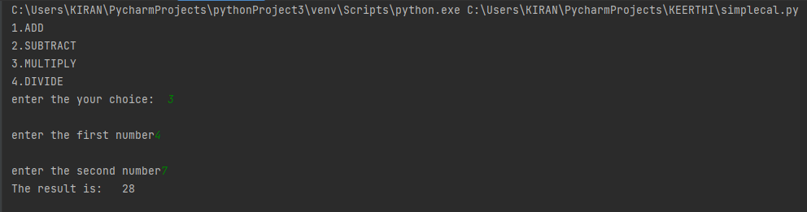

**Result:**

The program was executed and the result was successfully obtained. Thus CO1 was obtained

**Experiment No.: 20 DATE:4/11/2022**

**Aim:**

To check factorial of a number

**CO1:**

Understands basic of python programming language including input or output function operators. Basic and collection data types.

**Procedure:**

num=int(input("enter a number:"))

i=1

fact=1

while i <= num:

fact=fact*i

i=i+1

print(fact)

**Output Screenshot:**

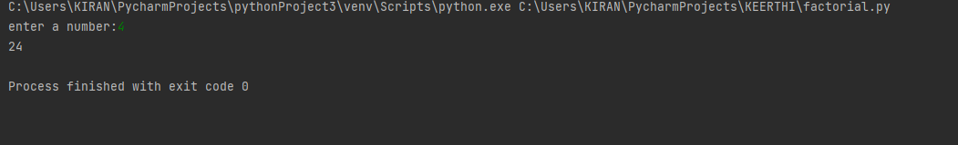

**Result:**

The program was executed and the result was successfully obtained. Thus CO1 was obtained

**Experiment No.: 21 DATE:4/11/2022**

**Aim:**

To find sum of odd and even number in a limit

**CO2:**

Implement decision making ,looping construct and function

**Procedure:**

a=int(input("Enter the limit:"))

i=1

sum1=0

sum2=0

while i<a:

if i%2==0:

sum1=sum1+i

else:

sum2=sum2+i

i=i+1

print("sum of even nos:",sum1)

print("sum of odd nos:",sum2)

**Output Screenshot:**

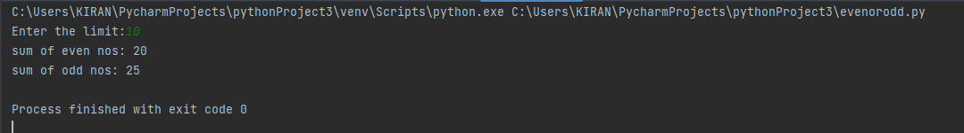

**Result:**

The program was executed and the result was successfully obtained. Thus CO2 was obtained

**Experiment No.: 22 DATE:4/11/2022**

**Aim:**

To find reverse of a number

**CO2:**

Implement decision making ,looping construct and function

**Procedure:**

n=int(input("enter a number"))

rev_num=0

while num !=0:

digit=num != 0:

digit=num%10

reversed_num=reversed_num*10+digit

num//=10

print("reversed number:"+str(reversed_num))

**Output Screenshot:**

**Result:**

The program was executed and the result was successfully obtained. Thus CO1 was obtained

**Experiment No.: 23 DATE:8/11/2022**

**Aim:**

To find palindrome or not

**CO2:**

Implement decision making ,looping construct and function

**Procedure:**

n=int(input("enter a nuber:"))

temp = n

rev=0

while(n>0):

rem = n % 10

rev = rev * 10 + rem

n = n // 10

if temp == rev:

print("palindrome")

else:

print("not a palindrom")

**Output Screenshot:**

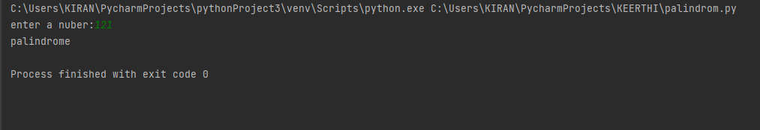

**Result:**

The program was executed and the result was successfully obtained. Thus CO2 was obtained

**Experiment No.: 24 DATE:4/11/2022**

**Aim:**

Sum of digits

**CO2:**

Implement decision making ,looping construct and function

**Procedure:**

total = 0

# creating a list

list1 = [11, 5, 17, 18, 23]

for ele in range(0, len(list1)):

total = total + list1[ele]

# printing total value

print("Sum of all elements in given list: ", total)

**Output Screenshot:**

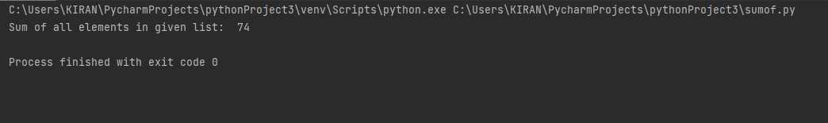

**Result:**

The program was executed and the result was successfully obtained. Thus CO1 was obtained

**Experiment No.: 25 DATE:4/11/2022**

**Aim:**

To checkwhether a number is Armstrong or Not.

**CO1:**

Understands basic of python programming language including input or output function operators. Basic and collection data types.

**Procedure:**

n=int(input("enter a nuber"))

sum = 0

temp = n

while n != 0:

rec = n % 10

sum = sum + rec * rec * rec

n = n // 10

if temp == sum:

print("armstrong no")

else:

printf("not an armstrong ")

**Output Screenshot:**

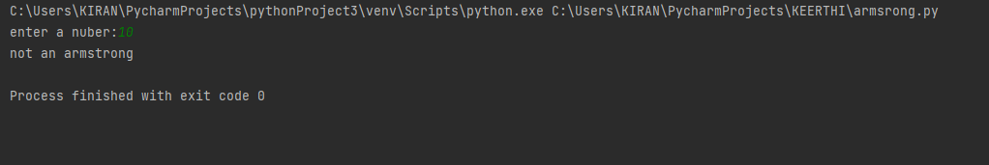

**Result:**

The program was executed and the result was successfully obtained. Thus CO1 was obtained

**Experiment No.: 26 DATE: 4/11/2022**

**Aim:**

To check whether a number is prime or not

**CO2:**

Implement decision making ,looping construct and function

**Procedure:**

num = int(input("Enter a number:"))

n = 0

i = 2

while i <= num / 2:

if num % i == 0:

n = 1

break

i = i + 1

if n == 0:

print("The entered number is a PRIME number")

else:

print("The entered number is not a PRIME number")

**Output Screenshot:**

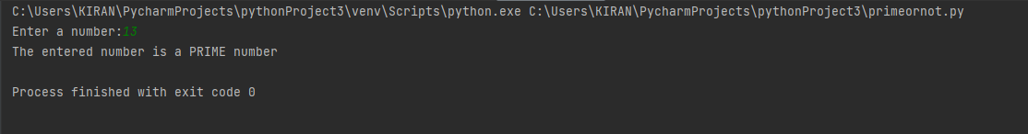

**Result:**

The program was executed and the result was successfully obtained. Thus CO2 obtained

**Experiment No.: 27 DATE:4/11/2022**

**Aim:**

To print Fibonacci series

**CO2:**

Implement decision making ,looping construct and function

**Procedure:**

list=int(input("enter a limit:"))

n1=0

n2=1

count=0

print("fibonacci series is :")

while count<list:

print(n1)

N=n1+n2

n1=n2

n2=N

count=count+1

**Output Screenshot:**

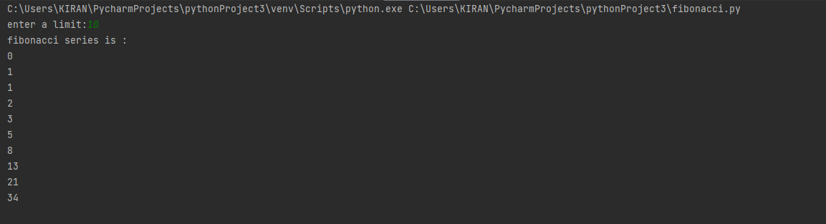

**Result:**

The program was executed and the result was successfully obtained. Thus CO2 was obtained

**Experiment No.: 28 DATE:4/11/2022**

**Aim:**

To check whether a number is Armstrong or not within a range

**CO2:**

Implement decision making ,looping construct and function

**Procedure:**

min=int(input("Enter the starting limit:"))

max=int(input("Enter the ending limit:"))

print("Armstrong numbers are:")

i=min

while i<=max:

temp=i

sum=0

while temp > 0:

digit = temp % 10

sum += digit ** 3

temp //= 10

if(i==sum):

print(i)

i =i + 1

**Output Screenshot:**

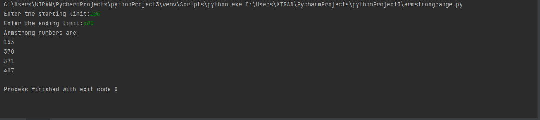

**Result:**

The program was executed and the result was successfully obtained. Thus CO2 was obtained

**Experiment No.: 29 DATE:4/11/2022**

**Aim:**

Display future leap year from current year to a final year entered by user

**CO2:**

Implement decision making ,looping construct and function

**Procedure:**

print("Enter start year:")

startYear = int(input())

print("Enter last year:")

endYear = int(input())

print("List of leap years:")

for year in range(startYear, endYear):

if (0 == year % 4) and (0!= year % 100) or (0 == year % 400):

print(year)

**Output Screenshot:**

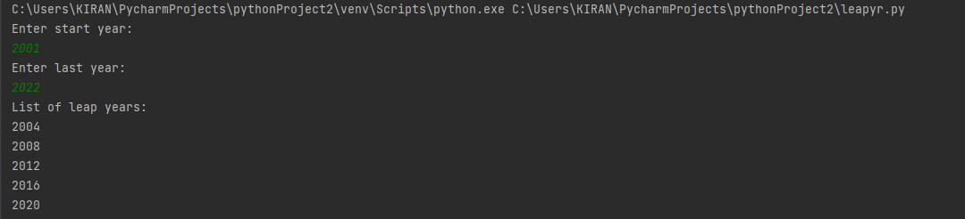

**Result:**

The program was executed and the result was successfully obtained. Thus CO2 was obtained

**Experiment No.: 30(a) DATE:8/11/2022**

**Aim:**

Generate positive list of number from a given word

**CO2:**

Implement decision making ,looping construct and function

**Procedure:**

list1=[-3,-2,-1,0,1,2,3]

list2=[i for i in list1 if i>= 0]

print("list is",list1)

print("new list is",list2)

**Output Screenshot:**

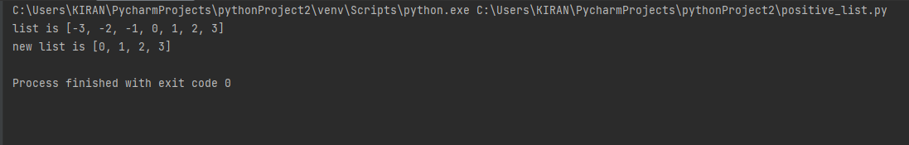

**Result:**

The program was executed and the result was successfully obtained. Thus CO2 was obtained

**Experiment No.: 30 (b) DATE:8/11/2022**

**Aim:**

To find square of n natural number

**CO1:**

Understands basic of python programming language including input or output function operators. Basic and collection data types

**Procedure:**

list1=int(input("Enter the limit:"))

square=[i*i for i in range(list1)]

print(square)

**Output Screenshot:**

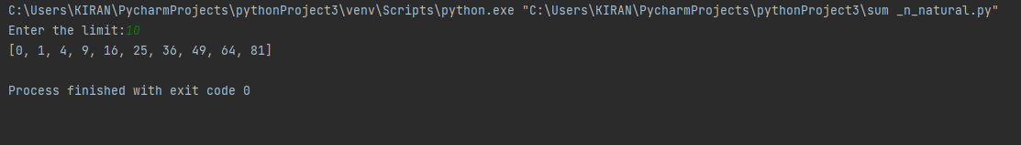

**Result:**

The program was executed and the result was successfully obtained. Thus CO2 was obtained

**Experiment No.: 30(c) DATE:8/11/2022**

**Aim:**

List of vowel selected from given word

**CO2:**

Implement decision making ,looping construct and function

**Procedure:**

elem= input("Enter the elements : ")

vowels =['a','e','i','o','u']

list1=[]

for x in elem:

if x in vowels :

list1.append(x)

print("Vowels present in given statement : ",list1)

**Output Screenshot:**

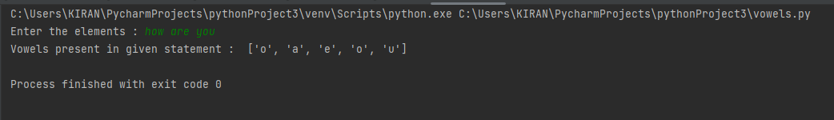

**Result:**

The program was executed and the result was successfully obtained. Thus CO2 was obtained

**Experiment No.: 31 DATE:8/11/2022**

**Aim:**

Count occurrence of each word in a line of text

**CO2:**

Implement decision making ,looping construct and function

**Procedure:**

n=input("enter the string").split(' ')

list1=list

set=set(list1)

newlist=list(set)

for i in newlist:

count=0

for j in list1:

if i==j:

count=count+1

print("occurance of ",i,count)

**Output Screenshot:**

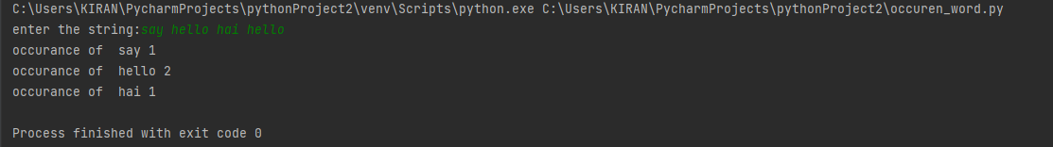

**Result:**

The program was executed and the result was successfully obtained. Thus CO2 was obtained

**Experiment No.: 35 DATE:8/11/2022**

**Aim:**

Get a string from an input string where all occurrences of first character replaced with

‘$’, except first character.

**CO2:**

Implement decision making ,looping construct and function

**Procedure:**

str =(input("enter a string:"))

# replacing character a with $ sign

str = str.replace('a', '$')

print("Modified string : ")

print(str)

**Output Screenshot:**

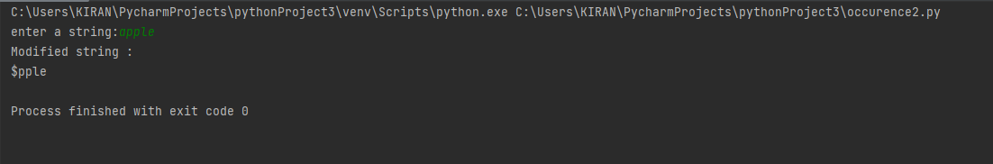

**Result:**

The program was executed and the result was successfully obtained. Thus CO2 was obtained

**Experiment No.: 40 DATE:8/11/2022**

**Aim:**

Accept a list of words and return length of longest word.

**CO2:**

Implement decision making ,looping construct and function

**Procedure:**

sen = input("Enter few words: ")

longest = max(sen.split(), key=len)

print("Longest word is: ", longest)

print("And its length is: ", len(longest))

**Output Screenshot:**

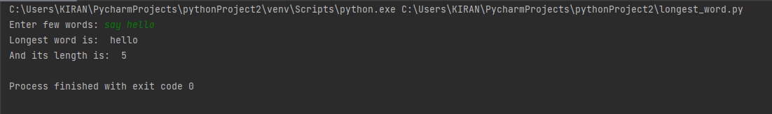

**Result:**

The program was executed and the result was successfully obtained. Thus CO2 was obtained

**Experiment No.: 41 DATE:8/11/2022**

**Aim:**

Write a program to print certain pattern (type1)

**CO2:**

Implement decision making ,looping construct and function

-**Procedure:**

n = int(input('Enter number of rows : '))

i = 1

while i <= n:

j = 1

while j <= i:

print("*", end=" ")

j += 1

print()

i += 1

Output Screenshot:

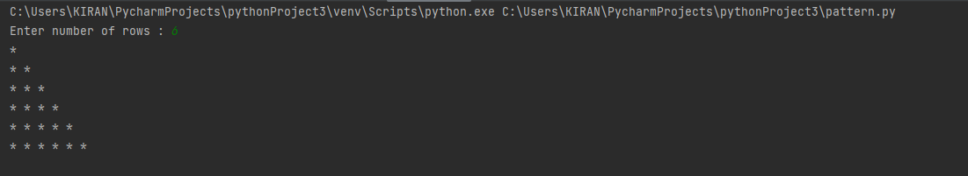

**Result:**

The program was executed and the result was successfully obtained. Thus CO2 obtained

**Experiment No.:42 DATE:8/11/2022**

**Aim:**

Write a program to print certain pattern (type2)

**CO2:**

Implement decision making ,looping construct and function

**Procedure:**

n = int(input('Enter number of rows : '))

i = 1

while i <= n:

j = n

while j >= i:

print("*", end=" ")

j -= 1

print()

i += 1

**Output Screenshot:**

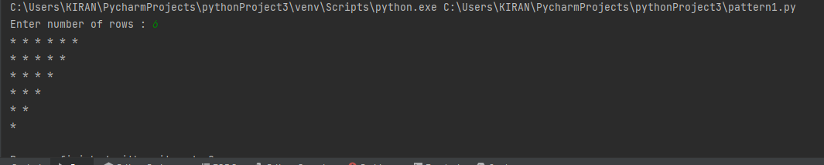

**Result:**

The program was executed and the result was successfully obtained. Thus CO2 was obtained

**Experiment No.: 43 DATE:8/11/2022**

**Aim:**

Write a program to print certain pattern (type3)

**CO2:**

Implement decision making ,looping construct and function

**Procedure:**

n = int(input('Enter the number of rows: '))

i = 1

while i < n:

print("* " * i)

i += 1

i = n

while i >= 1:

print("* " * i)

i -= 1

**Output Screenshot:**

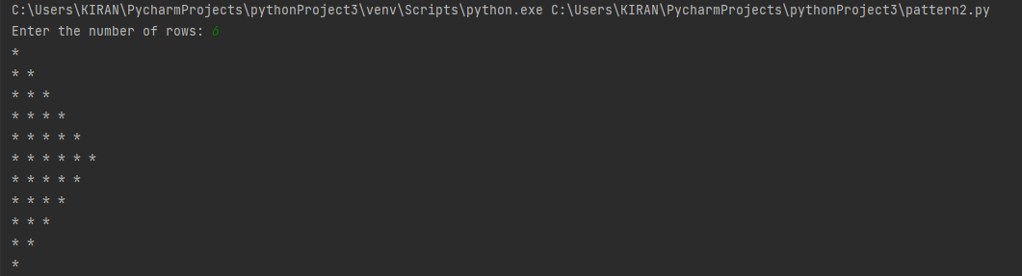

**Result:**

The program was executed and the result was successfully obtained. Thus CO2 was obtained

**Experiment No.: 44 DATE:8/11/2022**

**Aim:**

To print out all color from color list1 not contain colourlist2

**CO2:**

Implement decision making ,looping construct and function

**Procedure:**

colour1=input("\nenter the first set colors:").split(",")

colour2=input("\nenter the next set colors:").split(",")

set1=set(colour1)

set2=set(colour2)

x=set1.difference(set2)

y=set2.difference(set1)

mylist=list(x)

mylist1=list(y)

mylist2=mylist1+mylist

print(mylist2)

**Output Screenshot:**

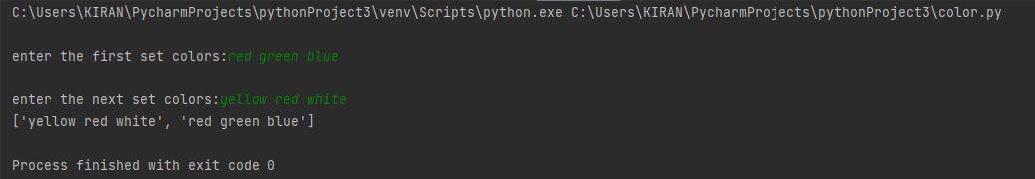

**Result:**

The program was executed and the result was successfully obtained. Thus CO2 was obtained

**Experiment No.: 45 DATE:8/11/2022**

**Aim:**

Generate all factors of a number

**CO2:**

Implement decision making ,looping construct and function

**Procedure:**

**Output Screenshot:**

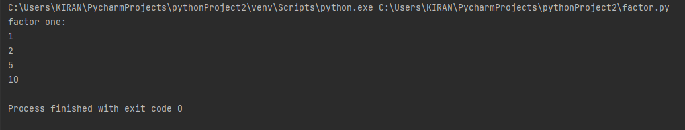

**Result:**

The program was executed and the result was successfully obtained. Thus CO2 was obtained

**Experiment No.: 46 DATE:8/11/2022**

**Aim:**

Generate all factorial of number (for loop)

**CO2:**

Implement decision making ,looping construct and function

**Procedure:**

**Output Screenshot:**



**Result:**

The program was executed and the result was successfully obtained. Thus CO2 was obtained

**Experiment No.: 47 DATE:8/11/2022**

**Aim:**

To find Fibonacci series(for loop)

**CO2:**

Implement decision making ,looping construct and function

**Procedure:**

n = int(input("fibi upto : "))

n1 = 0

n2 = 1

count = 0

if n <= 0:

print("Please enter a positive integer")

else:

for i in range(0,n):

print(n1)

n3 = n1 + n2

n1 = n2

n2 = n3

count = count +1

**Output Screenshot:**

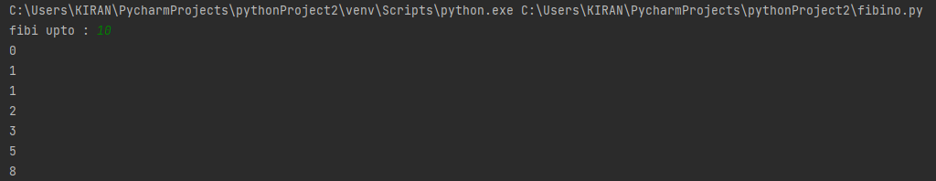

**Result:**

The program was executed and the result was successfully obtained. Thus CO2 was obtained

**Experiment No.: 48 DATE:8/11/2022**

**Aim:**

Find Armstrong or not

**CO2:**

Implement decision making ,looping construct and function

**Procedure:**

num = int(input("Enter a number: "))

length = len(str(num))

sum = 0

temp = num

for i in range(0,temp):

rem = temp % 10

sum = sum + rem ** length

temp = temp//10

if num == sum:

print(num ,"is an Armstrong number")

else:

print(num ,"is not an Armstrong number")

**Output Screenshot:**

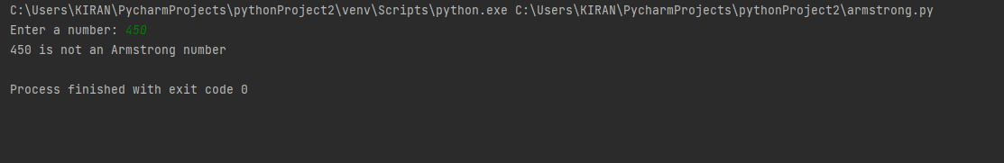

**Result:**

The program was executed and the result was successfully obtained. Thus CO2 was obtained

**Experiment No.: 49 DATE:8/11/2022**

**Aim:**

Find palindrome or not

**CO2:**

Implement decision making ,looping construct and function

**Procedure:**

num = input('Enter the number: ')

i = 0

length = len(num)

for i in range(length):

if num[i] != num[-1 - i]:

print(num, 'is not a Palindrome')

break

else:

print(num, 'is a Palindrome')

**Output Screenshot:**

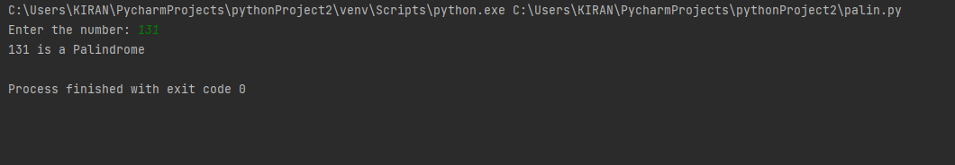

**Result:**

The program was executed and the result was successfully obtained. Thus CO2 was obtained

**Experiment No.: 50 DATE:8/11/2022**

**Aim:**

To find reverse of a number

**CO2:**

Implement decision making ,looping construct and function

**Procedure:**

num = input("Enter a number :")

reverse = ''

for i in range(len(num), 0, -1):

reverse = reverse + num[i-1]

print('The reverse number is =', reverse)

**Output Screenshot:**

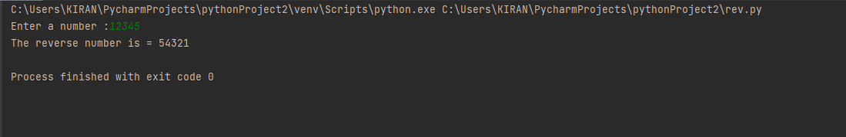

**Result:**

The program was executed and the result was successfully obtained. Thus CO2 was obtained

**Experiment No.: DATE:8/11/2022**

**Aim:**

Write a Python program to generate a random color hex, a random alphabetical string, random value between two integers (inclusive) and a random multiple of 7 between 0 and 70.

**CO2:**

design modules and packages -built in and user defined packages

**Procedure:**

import random

import string

print("generate a random color box:")

print("#{:6x}".format(random.randint(0,0xffffff)))

print(" generate a random alphabetical string:")

max_length=255

s=" "

for i in range(random.randint(1,max_length)):

s+=random.choice(string.ascii_letters)

print(s)

print("generate a random multiple of 7 between two integers,inclusive")

print(random.randint(0,10))

print(random.randint(-7, 7))

print(random.randint(1,1))

print("generate a random multiple of 7 between 0 and 70:")

print(random.randint(0,10)*7)

**Output Screenshot:**

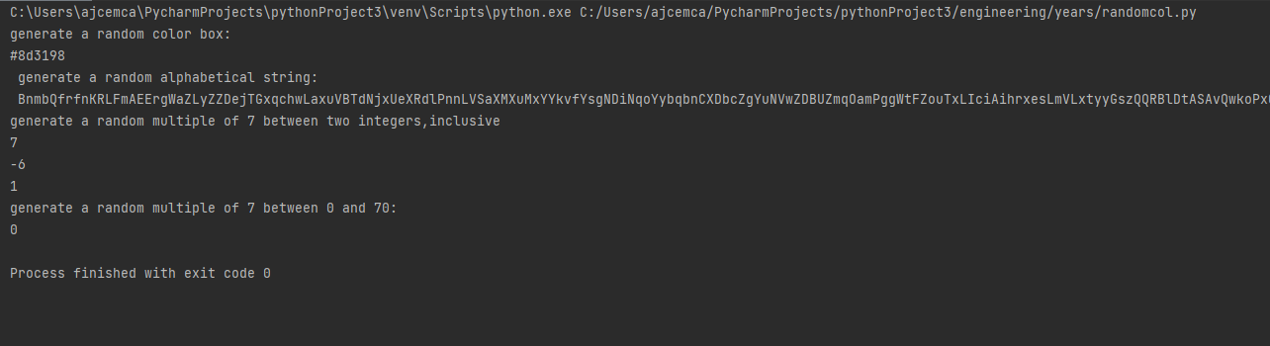

**Result:**

The program was executed and the result was successfully obtained. Thus CO3 was obtained