**FINANCE DOMAIN**

BANK LOAN DATA ANALYSIS

***TOTAL LOAN APPLICATIONS:***

1. Calculate total number of loan applications received during a specific period

select count(*) as total_applications from bank_loan_data;



1. Month to date total loan applications received

select count(*) as mtd_total_applications from bank_loan_data where month(issue_date)=12 and year(issue_date)=2021;

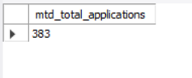

1. Month to month total loan applications received

select count(*) as mtm_total_applications from bank_loan_data where month(issue_date)=11 and year(issue_date)=2021;

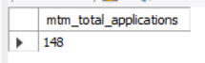

***TOTAL FUNDED AMOUNT:***

1)Total loan amount funded to the customers

select sum(loan_amount) as total_funded_amount from bank_loan_data;



2)Month to date total amount funded to the customers

select sum(loan_amount) as mtd_ttl_funded_amt from bank_loan_data where year(issue_date)= 2021 and month(issue_date)= 12;

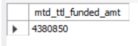

3)Month over month total amount funded to the customers

select sum(loan_amount) as mtd_ttl_funded_amt from bank_loan_data where year(issue_date)= 2021 and month(issue_date)= 11;

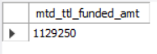

***TOTAL AMOUNT RECEIVED:***

1)Total amount received from borrowers

select sum(total_payment) as total_amount_received from bank_loan_data;

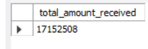

2)Month to date total amount received from borrowers

select sum(total_payment) as mtd_amount_received

from bank_loan_data where year(last_payment_date)=2021

and month(last_payment_date)=12;

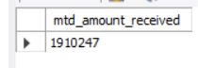

3)Month over month total amount received from borrowers

select sum(total_payment) as mtd_amount_received from bank_loan_data where year(last_payment_date)=2021 and

month(last_payment_date)=11;

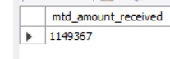

***AVERAGE INTEREST RATE:***

1)Average interest rate

select round(avg(int_rate)*100,4) as avg_interest from bank_loan_data;



2)Month to Date average interest rate

select round(avg(int_rate)*100,4) as mtd_avg_rate

from bank_loan_data where year(issue_date)=2021

and month(issue_date)=12;

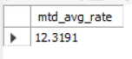

3)Month over Month average interest rate

select round(avg(int_rate)*100,4) as mtd_avg_rate

from bank_loan_data where year(issue_date)=2021

and month(issue_date)=11;

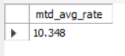

***AVERAGE DEBT-TO-INCOME:***

1)average debt to income

select round(avg(dti)*100, 3) as average_dti from

bank_loan_data;

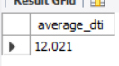

2)Month to Date average debt to income

select round(avg(dti)*100, 3) as average_dti from

bank_loan_data where year(issue_date)=2021 and

month(issue_date)=12;

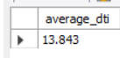

3)Month over Month average debt to income

select round(avg(dti)*100, 3) as average_dti from

bank_loan_data where year(issue_date)=2021 and

month(issue_date)=11;



***GOOD LOAN RELATED ANALYSIS:***

1)Good Loan Application Percentage

Select concat(round

(count(case when loan_status= 'Fully Paid' or loan_status= 'Current' then id end) *100 /

count(*), 2), '%') as

good_loan_percent

from bank_loan_data;

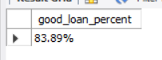

2)Good Loan Applications

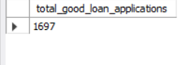

3)Good Loan Funded Amount

select sum(loan_amount) as good_loan_funded_amount

from bank_loan_data

where loan_status='Fully Paid' or loan_status='Current';

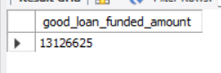

4)Good Loan Total Received Amount

select sum(total_payment) as good_loan_received_amount

from bank_loan_data

where loan_status='Fully Paid' or loan_status='Current';

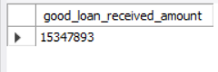

***BAD LOAN RELATED ANALYSIS:***

1)Bad Loan Application Percentage

select

concat(round(

count(case when loan_status='Charged Off' then id end)*100 /

count(id), 2),

'%')

as bad_loan_application_percent

from bank_loan_data;

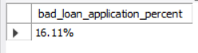

2)Bad Loan Applications

select count(id) as bad_loan_applications

from bank_loan_data

where loan_status='Charged Off';

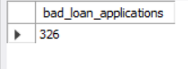

3)Bad Loan Funded Amount

select sum(loan_amount) as bad_loan_funded_amount

from bank_loan_data

where loan_status='Charged Off';

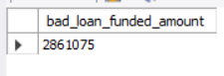

4)Bad Loan Total Received Amount

select sum(total_payment) as bad_loan_funded_amount

from bank_loan_data

where loan_status='Charged Off';

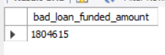

***GRID VIEW:*** View all the details in grid view based on loan status total applications, total funded amount, total received amount, month to date funded amount,

Month to date received amount, average interest rate, average debt to income ratio.

select loan_status,

count(id) as total_applications,

sum(loan_amount) as total_funded_amount,

sum(total_payment) as total_received_amount,

sum(case when year(issue_date)=2021 and month(issue_date)=12 then

loan_amount end) as mtd_funded_amount,

sum(case when year(issue_date)=2021 and month(issue_date)=12 then

total_payment end) as mtd_received_amount,

round(avg(int_rate)*100,2) as average_interest_rate,

round(avg(dti)*100,2) as average_debt_to_income_ratio

from bank_loan_datas

group by loan_status;

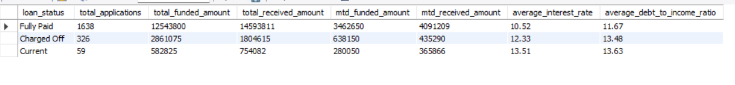

***FOR CHART ANALYSIS:***

Calculate total applications, total funded amount, total received amount for the following:

1. Monthly trends by issue date

select

month(issue_date) as month_number,

monthname(issue_date) as month_name,

count(id) as total_applications,

sum(loan_amount) as total_funded_amount,

sum(total_payment) as total_received_amount

from bank_loan_data

group by month(issue_date), monthname(issue_date)

order by month(issue_date) ;

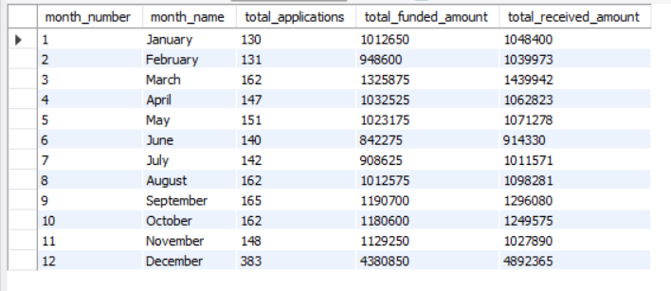

2)Regional analysis by state

select

address_state as state,

count(id) as total_applications,

sum(loan_amount) as total_funded_amount,

sum(total_payment) as total_received_amount

from bank_loan_data

group by address_state

order by address_state ;

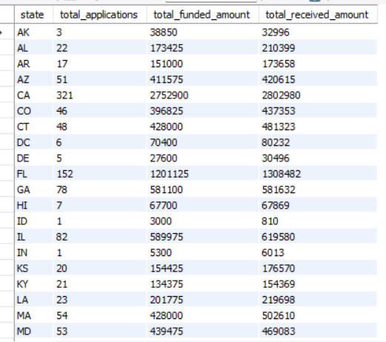

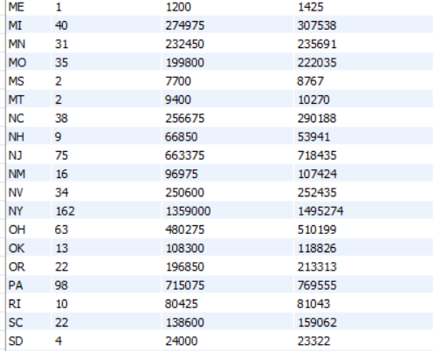

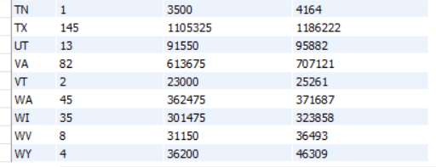

3)Total term analysis

select

term as loan_term,

count(id) as total_applications,

sum(loan_amount) as total_funded_amount,

sum(total_payment) as total_received_amount

from bank_loan_data

group by term

order by term;

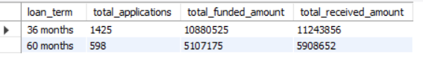

4)Emp length analysis

select

emp_length as employee_length,

count(id) as total_applications,

sum(loan_amount) as total_funded_amount,

sum(total_payment) as total_received_amount

from bank_loan_data

group by emp_length

order by emp_length;

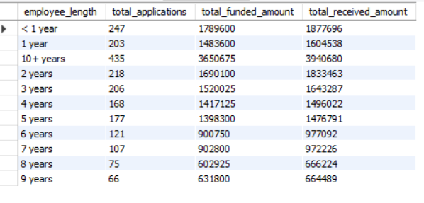

5)Loan purpose

select

purpose as loan_purpose,

count(id) as total_applications,

sum(loan_amount) as total_funded_amount,

sum(total_payment) as total_received_amount

from bank_loan_data

group by purpose

order by purpose;

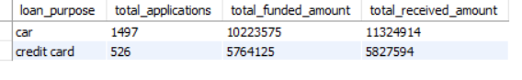

6)Home ownership analysis

select

home_ownership,

count(id) as total_applications,

sum(loan_amount) as total_funded_amount,

sum(total_payment) as total_received_amount

from bank_loan_data

group by home_ownership

order by home_ownership;

