**REPORT**

**ABSTRACT:**

High blood cholesterol is a risk factor for heart disease, which is the number one killer of people of different regions around the world. Researchers began to look a little more closely at the effects of carbs on cholesterol and found that processed carbs may play a role in raising levels. Highly processed carbs tend to have a high-glycemic index, which means they cause blood sugars to rise rapidly. All carbs are converted into glucose which is also known as blood sugar in the body and carbs can be used immediately for energy or stored for later use.

Carbohydrate consumption from refined carbohydrates that are high in sugar and low in fiber is associated with lower levels of HDL and higher levels of LDL and triglycerides, which is associated with an increased risk for heart disease. Very high carbohydrate intakes of more than 60 percent of total calories ,along with excess sugar consumption are associated with an increase in triglycerides.

The body uses cholesterol as the starting point to make estrogen, testosterone, vitamin D, and other vital compounds. Cholesterol in the bloodstream, specifically the bad LDL cholesterol, is what’s most important in determining health risk. Inflammation is the true cause of heart disease. And what causes inflammation.

**INTRODUCTION:**

Carbohydrates linked with cholesterol is a major problem which is causing health risk to the people of the different regions around the world . It is important to understand that increase in carbohydrates leads to fluctuations in blood sugar levels leading to heart risks due to cholesterol increase. Experiments are conducted on people with different metabolisms by subjecting them to have two different carbohydrates in their diet for several weeks and checking the cholesterol levels

Study is performed so that the fluctuations in cholesterol levels due to carbohydrates is observed to know how it effects in relative to a persons metabolism and intake of food. It is important as the study will give how the carbohydrates intake can make a impact on people’s health and increase the risks of having included in their diets. This data set is a form of study to determine the statistical data of impact on carbohydrates around the world. The research questions are the cholesterol levels varying taking two different carbohydrates, as the study is conducted for several weeks, are the cholesterol levels varying in different people differently, analysis focusing on people , carbohydrates and weeks, construct a plot which will help you understand the effect of carbohydrates on people .

**METHODOLOGY AND STUDY AREA**:

The dataset contains two different carbohydrates ,people group A, B,C ,study is performed for 5 weeks for carbohydrates-1 i.e., 50 and 10 weeks for carbohydrates-2 i.e., 90,repetitions are performed ,cholesterols based on the two carbohydrates given to people. Performed GLM on the data set ,taking all the observations with 4 different levels of people A,B,C,D and 2 carbohydrate levels 50 and 90.

**ANOVA:**

**H0 : There is no effect of carbohydrates on people.**

**H1: There is a significant effect of carbohydrates on people.**

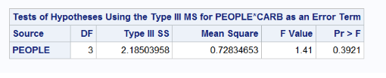

**Pr >F< 0.05 which indicates that the null hypothesis is rejected as 0.39>0.05**

**Scatterplot:**

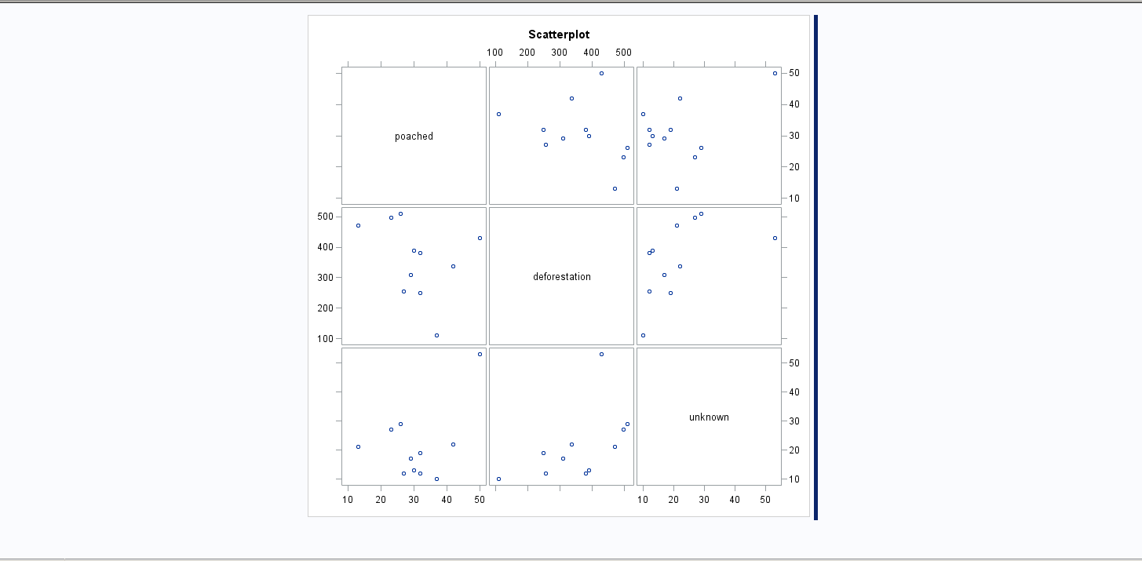

**GLM:**

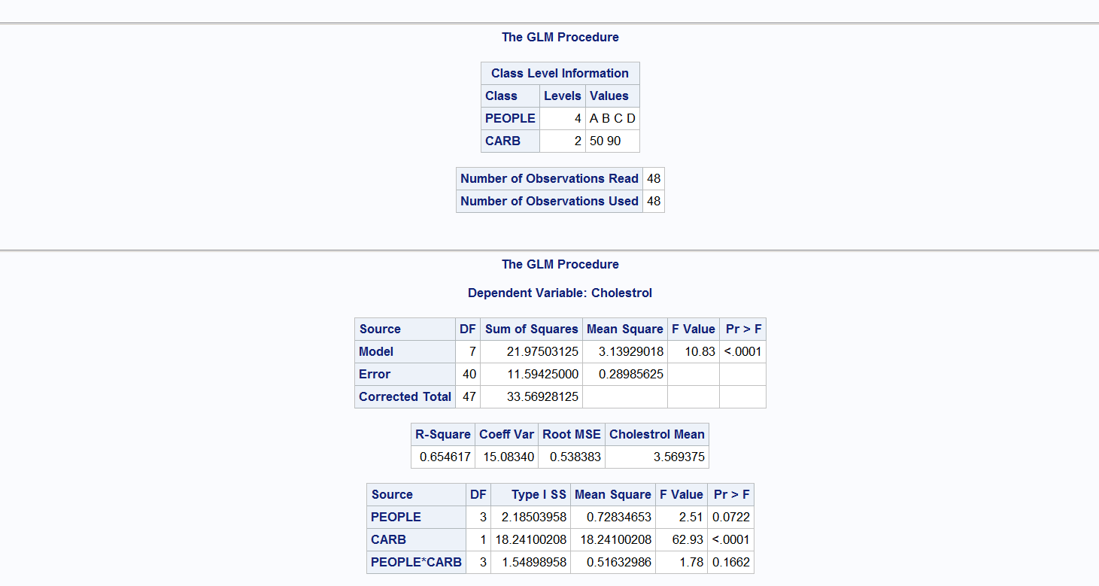





**Interaction plot:**

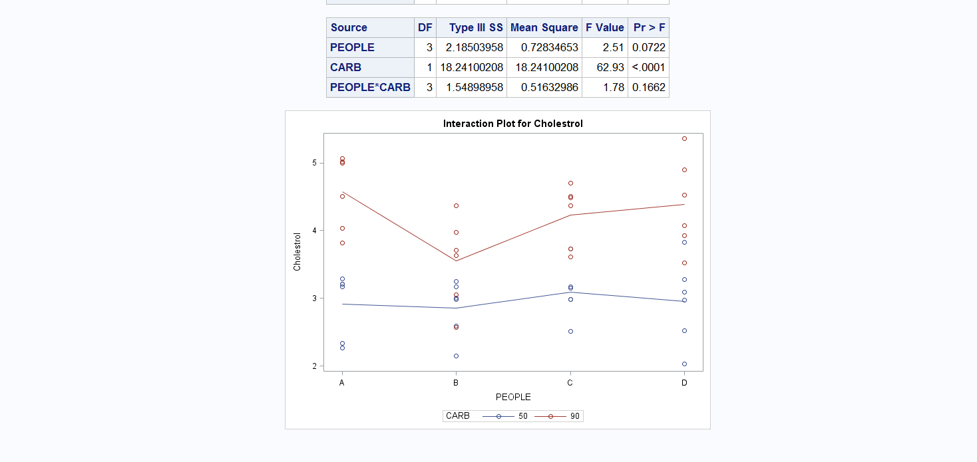

**GLM with LSMeans and tukey:**

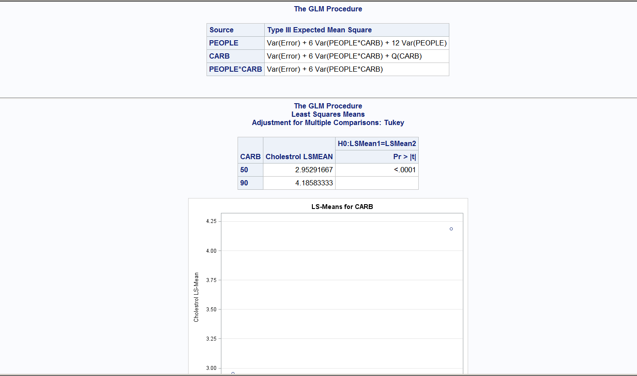

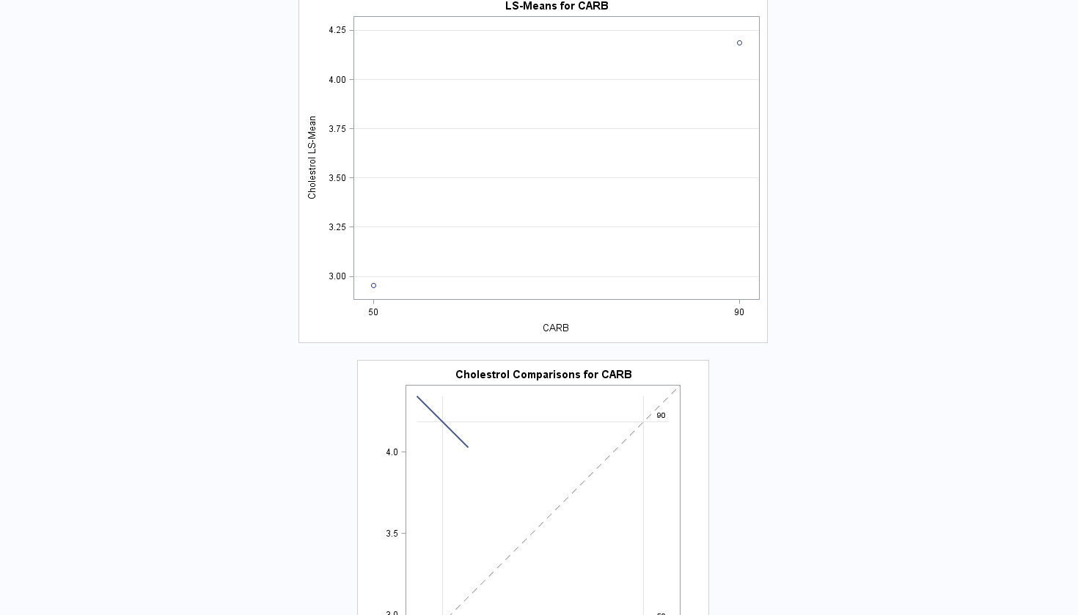

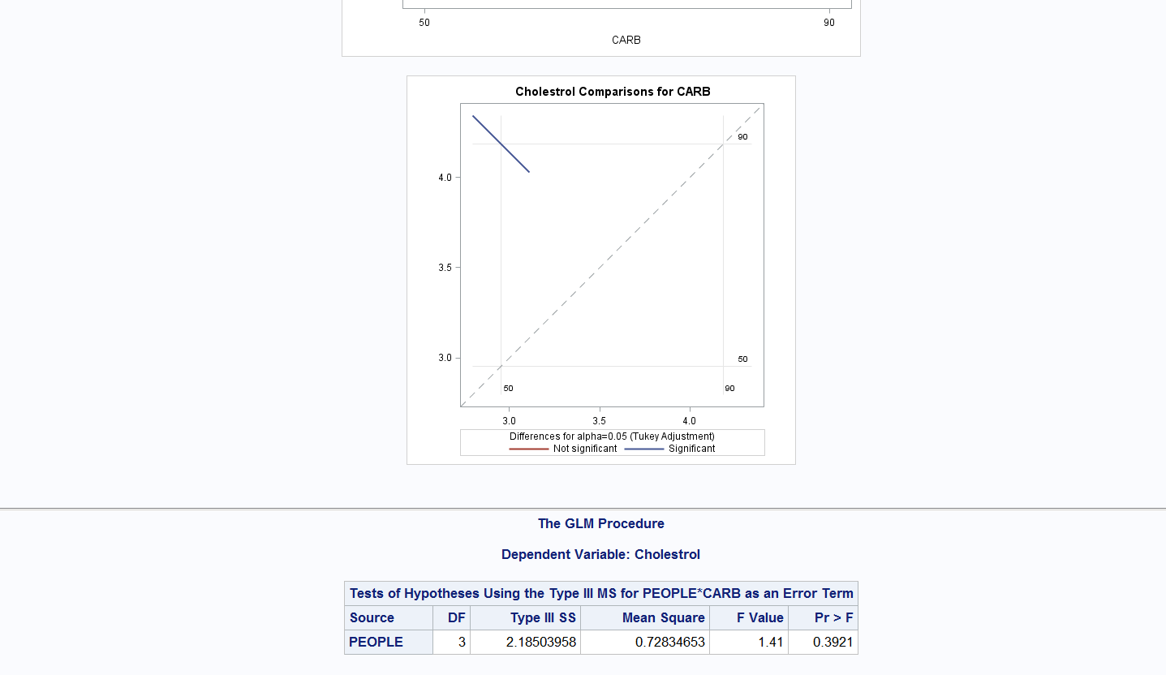

**Conclusion:**

**There is significant effect of carbohydrates on people indicated from the analysis. The interactive plot shows that the carbohydrate 50 is stable where as carbohydrate 90 is fluctuating. While performing the analysis ,the health risk from excess cholesterol can be decreased by reducing the intake of carbohydrates.**

**References:**

**1.**[**https://www.dietdoctor.com/carbs-affect-cholesterol**](https://www.dietdoctor.com/carbs-affect-cholesterol)

**research by Dr. Jason Fung, MD.**

**2.**[**https://www.livestrong.com/article/294152-carbohydrates-and-cholesterol-levels/**](https://www.livestrong.com/article/294152-carbohydrates-and-cholesterol-levels/) **A cited literature work on how the carbohydrates have effect on cholesterol.**