**PREDICTIVE MAINTENANCE**

**ABSTRACT:**

Predictive Maintenance (PdM) is maintenance that screens the presentation and condition of equipment during ordinary movement to reduce the likelihood of disillusionment. In any case called condition-based maintenance, predictive maintenance has been utilized in the mechanical world since the 1990s. In any case, in reality, predictive maintenance is significantly more prepared, in spite of the way that its arrangement of encounters isn’t officially detailed. As exhibited by Control Engineering, ”The beginning of Predictive maintenance (PdM) may have been the place where a specialist from the outset put his ear to the handle of a screwdriver, arrived at the opposite culmination to a machine, and expressed that it seemed like a heading was turning sour.

The goal of judicious upkeep is the ability to at first anticipate when gear frustration could occur (considering explicit factors), followed by hindering the failure through reliably reserved and therapeutic help. Predictive maintenance (PdM) is a huge utilization of the Internet of Things (IoT) inspected in various associations, especially in the collecting industry. PdM uses data, generally sensor data, to update upkeep works out. In this paper, review progress is made in the turn of events and uses of PdM. It is being characterized that the current exploration dependent on their qualities and industry 4.0 difficulties.

Then, a few applications for PdM are being examined, and investigated the capability of enormous scope arranged PdM. The paper is being closed by talking about future work headings featuring some advanced applications. The point of this review paper is to be valuable for analysts to get experiences into this significant territory, and propel the advancement of commonsense arrangements towards sending. In this paper a few graphs are represented utilizing the tool so called Cite Space. Those graphs illustrate Scientometrics concentrate over the “Internet of Things as Predictive Maintenance”.

**INTRODUCTION:**

In the beginning availability of IoT, regarding hypothesis the practice, is as of now under discussion. Looking to the couple of quantities of reference clinics in Rwanda that have not yet embraced another innovation of virtual patient’s well being observing because of the accessible assets, emergency clinics do consistently have a long line of individuals searching for diagnostics and treatment. To fulfill the patients through compelling medical care administrations conveyance, clinical gear plays a major effect not exclusively to patients, yet in addition to the center business achievement. Likewise, there is a developing requirement for maintenance management programs to limit unscheduled vacations.

The internet of things have tremendous potential in both the private and mechanical conditions. The term Industrial Internet of Things (IIoT) is being utilized for these applications. Prior to assessment discusses the qualities of strategies that adequately use the possible results offered by IIoT. The relevance of PdM is moreover extending in the sensible field [4]. In any case, it is difficult for associations to grasp the market of PdM providers and commitments. Which providers are accessible and what do they offer [1]? Assessment unequivocally considering the credits of electronic strategies for upkeep organizations is lacking. In an intelligent discussion of PdM strategies, it is basic to consider their different designs to all the almost certain perceive how they work before long.

Oil and the gas companies are taking advantages through applying PdM solutions. Actual review of oil and gas creation gear expects staff to go into unsafe climate to inspect the hardware, which now and again isn’t achievable. IoT-based predictive maintenance permits oil and gas organizations to recognize likely disappointments and increment the creation of exceptionally basic resources. Railroad organizations have literally applied IoT-based predictive maintenance to guarantee the rails and the moving stocks are suffering from proper condition.

As an example, BNSF railroad sent power identifiers, smart vision cameras, and acoustic sensors to recognize surrenders in cargo vehicle slowing down capacities, over the top grating in haggles, rail bends and straight-aways harms. Information assembled through sensors which is handed-off over to the cloud for examination and/or go through Machine Learning calculations to uncover unfortunate information designs that lead to breakages. The arrangement assists with improving well being, dependability and speed of the moving stock, just as decrease train delays brought about by gear glitches.

**SYSTEM REQUIREMENTS**

**SOFTWARE REQUIREMENTS:**

* Monitoring infrastructure
* IOT Platform
* Data Preprocessing Tools like KNIME or Alteryx

**HARDWARE REQUIREMENTS :**

* 4 processors.
* 32 GB of RAM.
* 300 GB of hard disk space.

**SYSTEM ARCHITECTURE :**

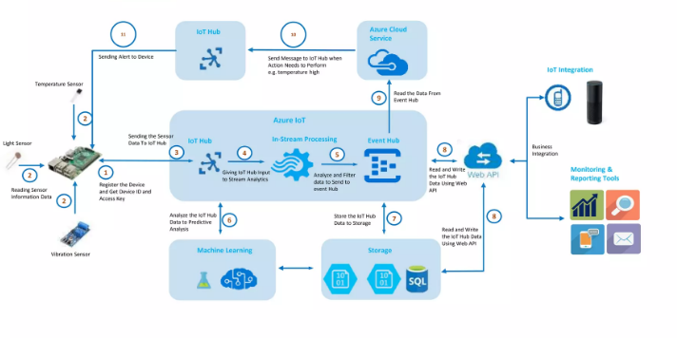

**ARCHITECTURE:**