1.

<!DOCTYPE html>

<html lang="en">

<head>

<meta charset="UTF-8">

<meta name="description" content="A sample webpage showing head tag usage">

<meta name="author" content="Student Name">

<meta name="viewport" content="width=device-width, initial-scale=1.0">

<title>Sample Web Page</title>

<link rel="stylesheet" href="styles.css">

<style>

body {

font-family: Arial, sans-serif;

background-color: #f0f8ff;

}

</style>

<script>

console.log("Page Loaded Successfully!");

</script>

</head>

<body>

<header>

<h1>Welcome to My Web Page</h1>

</header>

<main>

<p>This page demonstrates the use of head section tags.</p>

</main>

<footer>

<p>&copy; 2025 Student Name. All rights reserved.</p>

</footer>

</body>

</html>

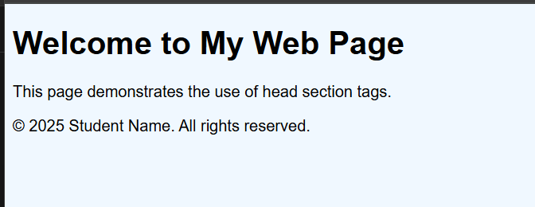

2. <html>

<head>

<title>Nearest Odd Number</title>

<script>

function findNearestOdd() {

let num = parseInt(prompt("Enter a number:"));

let nearestOdd;

if (num % 2 === 0) {

nearestOdd = num + 1; // or num - 1

} else {

nearestOdd = num;

}

alert("The nearest odd number is: " + nearestOdd);

}

</script>

</head>

<body>

<h1>Nearest Odd Number Finder</h1>

<button onclick="findNearestOdd()">Find Nearest Odd</button>

</body>

</html>

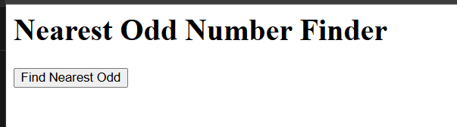index.html

3

<!DOCTYPE html>

<html>

<head>

<title>Relative Positioning Example</title>

<link rel="stylesheet" type="text/css" href="style.css">

</head>

<body>

<div class="parent">

<h1 class="child">Welcome to CSS Positioning</h1>

<p>This paragraph remains normally positioned.</p>

</div>

</body>

</html>

style.css

.parent {

border: 2px solid blue;

padding: 20px;

width: 400px;

height: 200px;

position: relative;

}

.child {

position: relative;

top: 30px; /* Move the h1 element 30px down */

left: 20px; /* Move the h1 element 20px to the right */

color: darkgreen;

}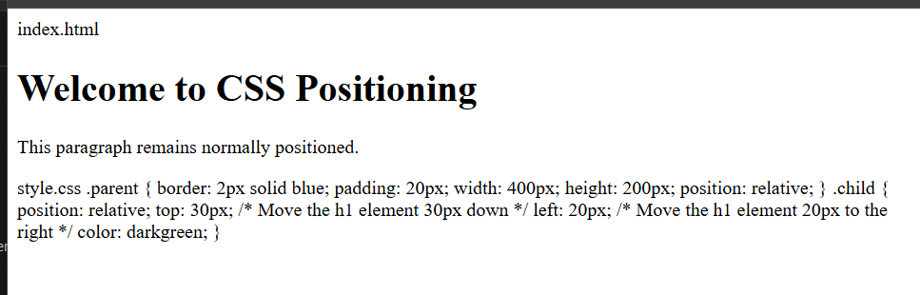

4

import java.io.*;

import javax.servlet.*;

import javax.servlet.http.*;

public class StudentRegistrationServlet extends HttpServlet {

public void doGet(HttpServletRequest request, HttpServletResponse response)

throws ServletException, IOException {

response.setContentType("text/html");

PrintWriter out = response.getWriter();

// HTML Form

String name = request.getParameter("name");

String regno = request.getParameter("regno");

String course = request.getParameter("course");

String email = request.getParameter("email");

if (name == null || regno == null || course == null || email == null) {

out.println("<html><body>");

out.println("<h2>Student Registration Form</h2>");

out.println("<form method='get'>");

out.println("Name: <input type='text' name='name'><br><br>");

out.println("Registration Number: <input type='text' name='regno'><br><br>");

out.println("Course: <input type='text' name='course'><br><br>");

out.println("Email: <input type='text' name='email'><br><br>");

out.println("<input type='submit' value='Register'>");

out.println("</form>");

out.println("</body></html>");

} else {

out.println("<html><body>");

out.println("<h2>Student Registration Details</h2>");

out.println("<p><strong>Name:</strong> " + name + "</p>");

out.println("<p><strong>Registration Number:</strong> " + regno + "</p>");

out.println("<p><strong>Course:</strong> " + course + "</p>");

out.println("<p><strong>Email:</strong> " + email + "</p>");

out.println("</body></html>");

}

}

}

5.

<!DOCTYPE html>

<html>

<head>

<title>Employee Registration Form</title>

<link rel="stylesheet" type="text/css" href="style.css">

</head>

<body>

<div class="container">

<h2>Employee Registration Form</h2>

<form>

<label for="name">Employee Name:</label>

<input type="text" id="name" name="name" required><br><br>

<label for="id">Employee ID:</label>

<input type="text" id="id" name="id" required><br><br>

<label for="address">Address:</label><br>

<textarea id="address" name="address" rows="4" cols="30" required></textarea><br><br>

<label for="dept">Department:</label>

<input type="text" id="dept" name="dept" required><br><br>

<label for="mobile">Mobile Number:</label>

<input type="text" id="mobile" name="mobile" required><br><br>

<label for="city">City:</label>

<select id="city" name="city" required>

<option value="">--Select City--</option>

<option value="Chennai">Chennai</option>

<option value="Bangalore">Bangalore</option>

<option value="Hyderabad">Hyderabad</option>

<option value="Mumbai">Mumbai</option>

</select><br><br>

<input type="submit" value="Register">

</form>

</div>

</body>

</html>

style.css

body {

font-family: Arial, sans-serif;

background-color: #f0f8ff;

}

.container {

background-color: white;

padding: 20px;

margin: 50px auto;

width: 400px;

border: 2px solid #ccc;

border-radius: 10px;

}

h2 {

text-align: center;

color: darkblue;

}

label {

font-weight: bold;

}

input[type="text"], textarea, select {

width: 100%;

padding: 8px;

margin: 5px 0 15px 0;

border: 1px solid #ccc;

border-radius: 5px;

}

input[type="submit"] {

background-color: darkblue;

color: white;

padding: 10px;

width: 100%;

border: none;

border-radius: 5px;

cursor: pointer;

}

input[type="submit"]:hover {

background-color: navy;

}

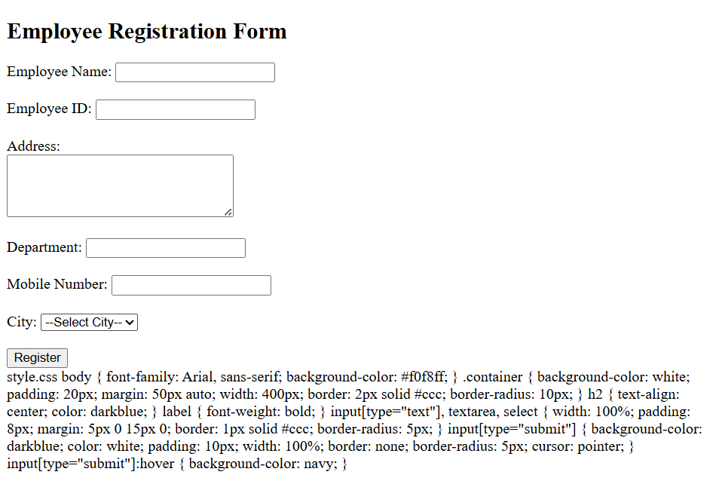

6

<!DOCTYPE html>

<html>

<head>

<title>Class Selector Example</title>

<link rel="stylesheet" type="text/css" href="styles.css">

</head>

<body>

<h1 class="main-heading">Welcome to Web Development</h1>

<p class="intro-para">This paragraph is styled using a class selector. It introduces the topic.</p>

<p class="content-para">This is another paragraph with different styling using another class.</p>

<button class="btn-primary">Click Me!</button>

<button class="btn-secondary">Submit</button>

</body>

</html>

styles.css

body {

font-family: Arial, sans-serif;

background-color: #f5f5f5;

}

.main-heading {

color: darkgreen;

text-align: center;

margin-top: 20px;

}

.intro-para {

color: navy;

font-size: 18px;

padding: 10px;

background-color: #e0f7fa;

margin: 20px;

}

.content-para {

color: maroon;

font-size: 16px;

padding: 10px;

background-color: #ffe0b2;

margin: 20px;

}

.btn-primary {

background-color: royalblue;

color: white;

padding: 10px 20px;

border: none;

margin: 10px;

border-radius: 5px;

cursor: pointer;

}

.btn-secondary {

background-color: darkorange;

color: white;

padding: 10px 20px;

border: none;

margin: 10px;

border-radius: 5px;

cursor: pointer;

}

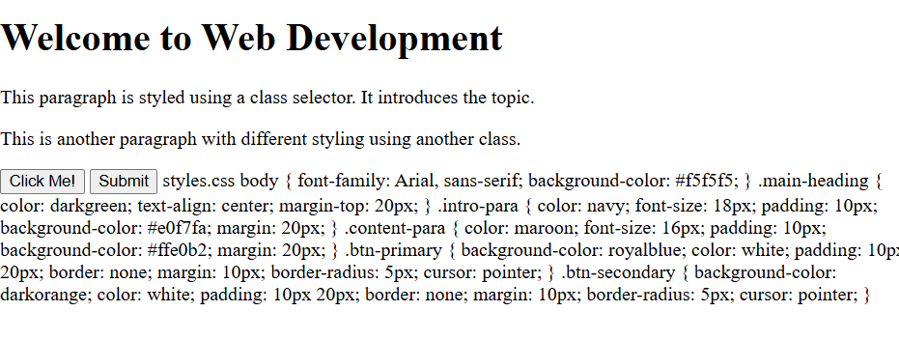

7.<!DOCTYPE html>

<html>

<head>

<title>Float Positioning Example</title>

<link rel="stylesheet" type="text/css" href="style.css">

</head>

<body>

<div class="box-left">

<h2>Left Box</h2>

<p>This box floats to the left side.</p>

</div>

<div class="box-right">

<h2>Right Box</h2>

<p>This box floats to the right side.</p>

</div>

</body>

</html>

style.css

body {

font-family: Arial, sans-serif;

margin: 20px;

}

.box-left {

width: 45%;

float: left;

background-color: #add8e6;

padding: 20px;

margin-right: 5%;

}

.box-right {

width: 45%;

float: left;

background-color: #f08080;

padding: 20px;

}

/* Clear floats after the floated elements */

body::after {

content: "";

display: table;

clear: both;

}

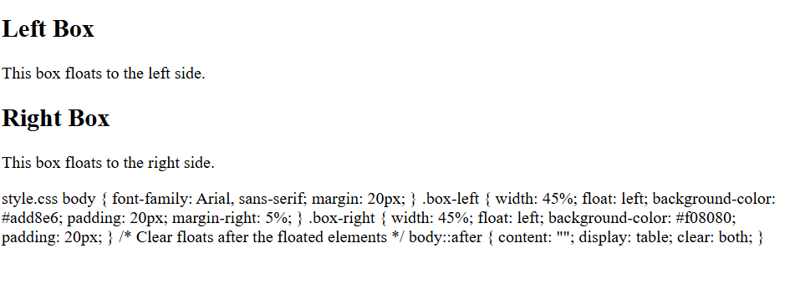

8

<!DOCTYPE html>

<html>

<head>

<title>JavaScript Number Operations</title>

</head>

<body>

<h1>JavaScript Number Operations</h1>

<script>

var num = 1234.56789;

// Find exponential value

var exponentialValue = num.toExponential(2);

// Limit decimal places

var fixedDecimal = num.toFixed(3);

// Convert number to string

var numberToString = num.toString();

// Return negative infinity

var negativeInfinity = Number.NEGATIVE_INFINITY;

// Display outputs

document.write("<h3>Exponential Value (2 digits): " + exponentialValue + "</h3>");

document.write("<h3>Fixed Decimal (3 places): " + fixedDecimal + "</h3>");

document.write("<h3>Number to String: " + numberToString + "</h3>");

document.write("<h3>Negative Infinity: " + negativeInfinity + "</h3>");

</script>

</body>

</html>

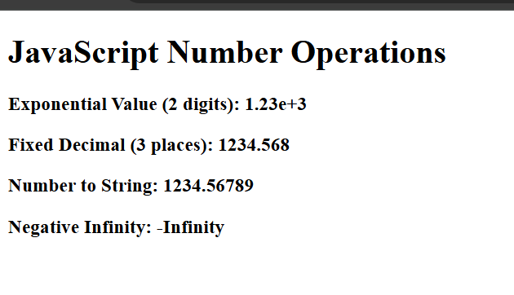

9

**email_validation.html**

<!DOCTYPE html>

<html>

<head>

<title>Email Validation</title>

<script>

function validateEmail() {

var email = document.getElementById("email").value;

var pattern = /^[^\s@]+@[^\s@]+\.[^\s@]+$/;

if (pattern.test(email)) {

alert("Valid Email Address!");

return true;

} else {

alert("Invalid Email Address! Please enter a valid email.");

return false;

}

}

</script>

</head>

<body>

<h2>Email Validation Form</h2>

<form onsubmit="return validateEmail()">

<label for="email">Enter your Email:</label><br><br>

<input type="text" id="email" name="email" required><br><br>

<input type="submit" value="Submit">

</form>

</body>

</html>

**Output:**

A web form appears with a field to enter an email.

On clicking "Submit":

If the email is in a correct format (e.g., abc@example.com), a message "Valid Email Address!" is shown.

If the email is not valid (missing @, .com, etc.), a message "Invalid Email Address!" appears.

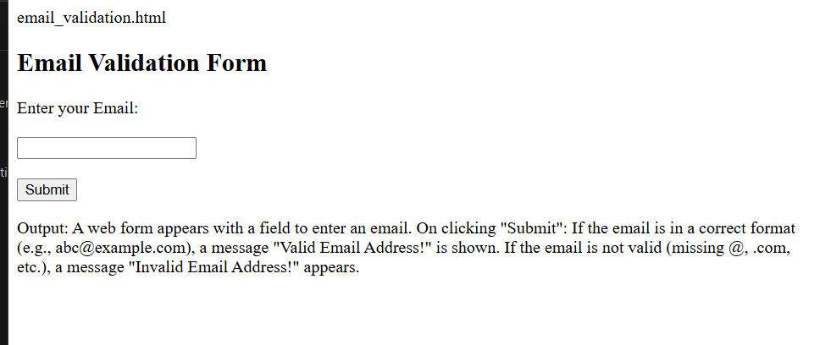

10

<!DOCTYPE html>

<html lang="en">

<head>

<meta charset="UTF-8">

<meta name="viewport" content="width=device-width, initial-scale=1.0">

<title>Background GIF with CSS</title>

<style>

body {

margin: 0;

padding: 0;

height: 100vh;

}

.background-container {

background-image: url('your-gif.gif'); /* Use the path to your GIF file */

background-size: cover; /* Make the background cover the entire screen */

background-position: center;

height: 100vh;

width: 100%;

transition: opacity 2s ease-in-out; /* Smooth transition for opacity */

opacity: 0.7; /* Initial transparency */

}

/* On hover, change the transparency */

.background-container:hover {

opacity: 1; /* Full opacity on hover */

}

</style>

</head>

<body>

<div class="background-container">

<!-- You can add content here if you wish -->

<h1 style="color: white; text-align: center; padding-top: 40%;">Welcome to the Animated Background!</h1>

</div>

</body>

</html>