1. **Write a program to print all the composite numbers between a and b?**

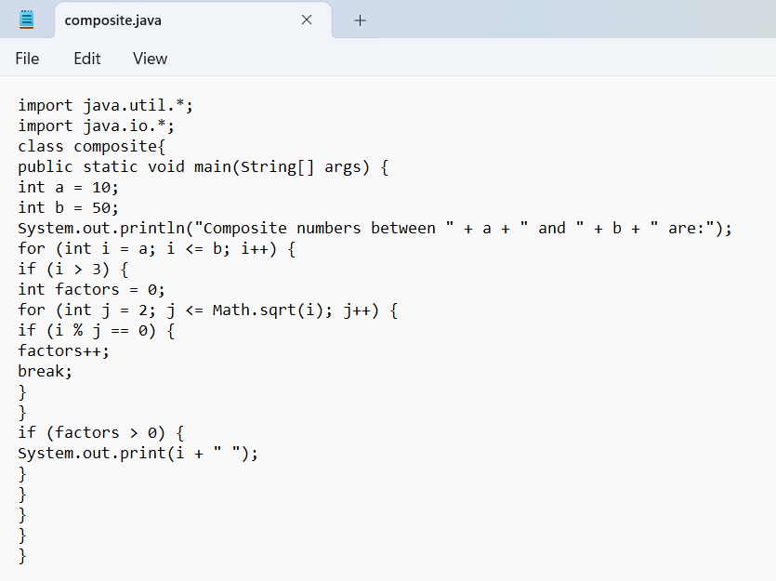

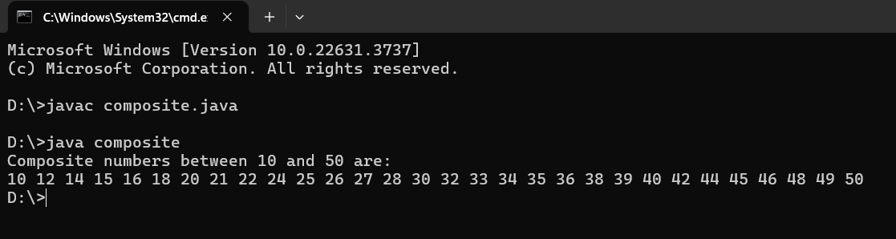

**2.Find the factorial of n using while loop**

**Sample Input: N = 4**

**Sample Output:4**

**Factorial = 24**

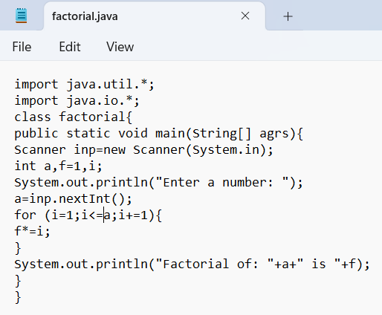

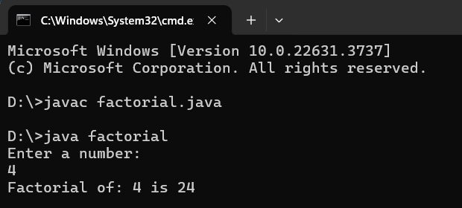

**3.** **Find the number of factors for the given number**

**Sample Input: Given number: 100**

**Sample Output: Number of factors = 9**

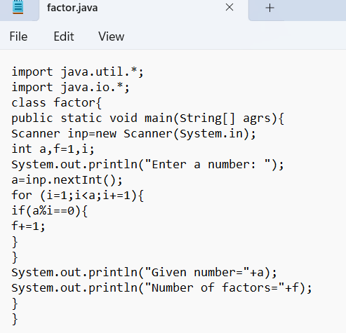

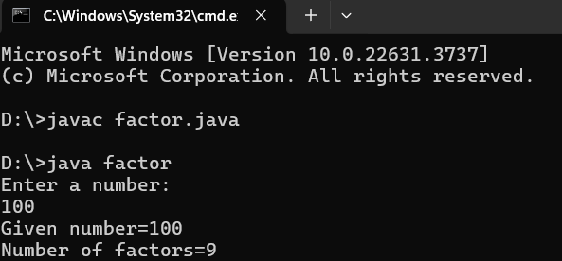

**4.** **Write a program to find the square root of a perfect square number (print both the positive and negative values)**

**Sample Input: Enter the number: 6561**

**Sample Output: Square Root: 81, -81**

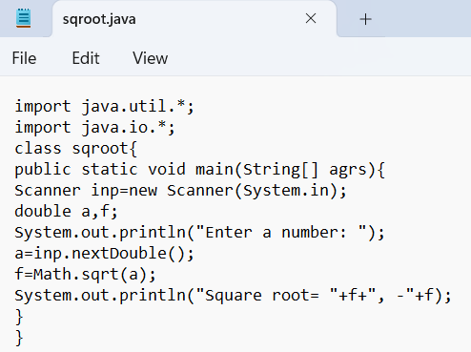

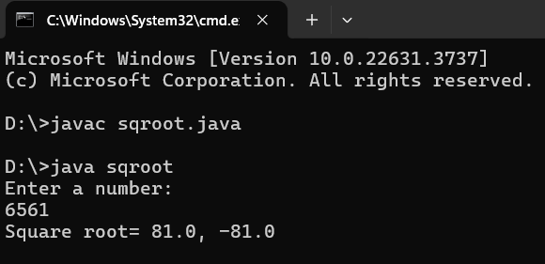

**5.** **Write a java code for perfect number for 4 digits.**

