Earthquake prediction model using python

AI_PHASE5: Development 3

**Contents**

**1.**Project Overview

**2.**Problem Statement and approach to solution

**3.**Metrics

**4.**Dataset

**5.**Exploratory Data Analysis and Data processing

**6.**Model implementation

**7.**Improvement and evaluation

**8.**Prediction and web application

**9.** Importing Libraries and Dataset

**10.**Improvement and conclusion

**11.**Acknowledgement

**Project Overview**

Countless dollars and entire scientific careers have been dedicated to predicting where and when the next big earthquake will strike. But unlike weather forecasting, which has significantly improved with the use of better satellites and more powerful mathematical models, earthquake prediction has been marred by repeated failure due to highly uncertain conditions of earth and its surroundings. Now, with the help of artificial intelligence, a growing number of scientists say changes in the way they can analyze massive amounts of seismic data can help them better understand earthquakes, anticipate how they will behave, and provide quicker and more accurate early warnings. This helps in hazzard assessments for many builders and real estate business for infrastructure planning from business perspective. Also many lives can be saved through early warning. This project aims a simple solution to above problem by predicting or forecasting likely places to have earthquake in next 7 days. For user-friendly part, this project has a web application that extracts live data updated every minute by USGS.gov and predicts next likely place world wide to get hit by an earthquake, hence a realtime solution is provided.

**Problem Statement and approach to solution**

Anticipating seismic tremors is a pivotal issue in Earth science because of their overwhelming and huge scope outcomes. The goal of this project is to predict where likely in the world and on what dates the earthquake will happen. Application and impact of the project​ includes potential to improve earthquake hazard assessments that could spare lives and billions of dollars in infrastructure and planning. Given geological locations, magnitude and other factors in dataset from <https://earthquake.usgs.gov/earthquakes/feed/v1.0/csv.php> for 30 days past which is updated every minute, we predict or forecast 7 days time in future that is yet to come, the places where quake would likely happen. Since this is event series problem type, proposed solution in this project follows considering binary classification of earthquake occurance with training period includes fixed rolling window moving averages of past days while for which its labels, a fixed window size shifted ahead in time. The model will be trained with Adaboost classifier (RandomForestClassifier and DecisionTreeClassifier) and compared with XGBoost based on AUC ROC score and recall score due to the nature of problem (i.e binary classification). Model with better AUC score and recall will be considered for web app that uses Google maps api to predict places where earthquake might occur.

**Metrics**

The problem addressed above is about binary classification, Earthquake occur = 1 and Earthquake not occur = 0 and with these prediction we try to locate co-cordinates corrosponding to the predictions and display it on the google maps api web app. More suitable metrics for binary clsssification problems are ROC (Reciever operator characteristics), AUC (Area Under Curve), Confusion matrix for Precision, recall, accuracy and sensitivity. One important thing about choosing metrics and model is what exactly we need from predictions and what not. To be precise, we need to minimize or get less False negative predictions since we dont want our model to predict as 0 or no earthquake occured at particular location when in reality it had actually happend as this is more dangerous than the prediction case in which prediction is true/1 or earthquake occured but in reality it did not because its always better safe than sorry!!!. Hence apart from roc_auc score, I have considered Recall as well for evaluation and model selection with higher auc_roc score and recall, where recall = (TP/TP+FN).

**Dataset**

Real time data that updates every minute on <https://earthquake.usgs.gov/earthquakes/feed/v1.0/csv.php> for past 30 days. Below is the feature description of the dataset with 22 features and 14150 samples at the time of training.

Time ---------------------- Time when the event occurred. Times are reported in milliseconds since the epoch

Latitude ------------------- Decimal degrees latitude. Negative values for southern latitudes.

Longitude ------------------ Decimal degrees longitude. Negative values for western longitudes.

Depth ---------------------- Depth of the event in kilometers.

Mag ------------------------ Magnitude of event occured.

magType -------------------- The method or algorithm used to calculate the preferred magnitude

nst ------------------------ The total number of seismic stations used to determine earthquake location.

Gap ------------------------ The largest azimuthal gap between azimuthally adjacent stations (in degrees).

Dmin ----------------------- Horizontal distance from the epicenter to the nearest station (in degrees).

Rms ------------------------ The root-mean-square (RMS) travel time residual, in sec, using all weights.

Net ------------------------- The ID of a data source contributor for event occured.

Id -------------------------- A unique identifier for the event.

Types ----------------------- A comma-separated list of product types associated to this event.

Place ----------------------- named geographic region near to the event.

Type ------------------------ Type of seismic event.

locationSource -------------- The network that originally authored the reported location of this event.

magSource ------------------- Network that originally authored the reported magnitude for this event.

horizontalError ------------- Uncertainty of reported location of the event in kilometers.

depthError ------------------ The depth error, three principal errors on a vertical line.

magError -------------------- Uncertainty of reported magnitude of the event.

magNst ---------------------- The total number of seismic stations to calculate the magnitude of earthquake.

Status ---------------------- Indicates whether the event has been reviewed by a human.

**Exploratory Data Analysis and Data preprocessing**

**Data Info**:

Null values Input to model from dataset has many important features to consider as time,latitude & longitude,depth of quake,magnitude,place, rest other features are error and non supporting features for classification, below shows the null value counts for some features and what to do with that.

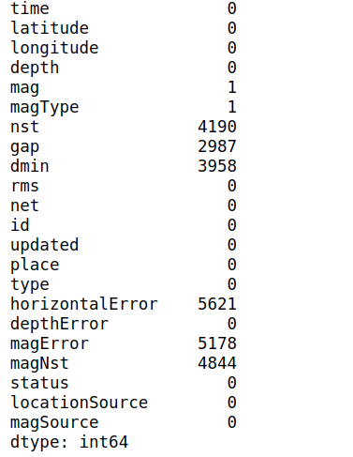

We can see lots of null values of certain features, but as part of prediction most of the features that address ‘error’ in measurement have missing values, thus for feature selection we consider only certain features in final dataframe, hence I choose simply drop or ignore the null values.

Apart from features in dataset we focus on, I have done some feature Engineering based on some considerations on my model as follows:

Set rolling window size for future prediction based on past values with fixed window size in past

I have created 6 new features based on rolling window size on average depth and average magnitude.

A final outcome ‘mag_outcome’ has been defined as target values and the output is considered as shifted values from set rolling window of past days eg: ‘7’. New features include : avg_depth, magnitude_avg for 22,15,7 days rolling window period for training.

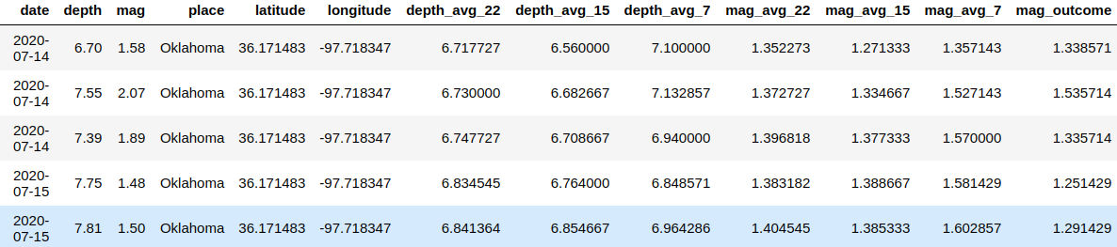

After feature engineering and dealing with null values, the model has imbalance class distribution

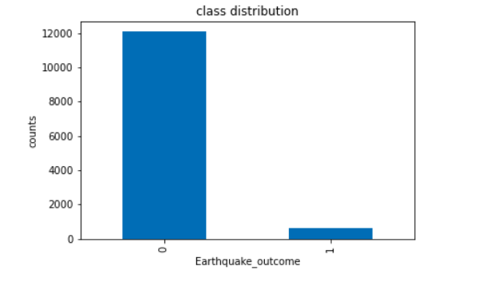

Accuracy is not the metric to use when working with an imbalanced dataset. We have seen that it is misleading.There are metrics that have been designed to tell you a more truthful story when working with imbalanced classes. Such as collect more data, change metrics, resampling data, cross-validation dataset etc. For the project I have considered the metrics for treating this imbalance nature with-

Confusion Matrix: A breakdown of predictions into a table showing correct predictions (the diagonal) and the types of incorrect predictions made (what classes incorrect predictions were assigned).

Recall: A measure of a classifiers completeness

ROC Curves: Like precision and recall, accuracy is divided into sensitivity and specificity and models can be chosen based on the balance thresholds of these values.

Moreover the reason for choosing this metrics not only helps me improve class imbalance comfirmation bias but also due to my nature of problem to be solved of earthquake prediction False negative must be penalized more.

Lets analyse places with top 20 higher & lower number of magnitude mean

Top 20 places where lowest magnitude mean quake experienced in past 30 days.

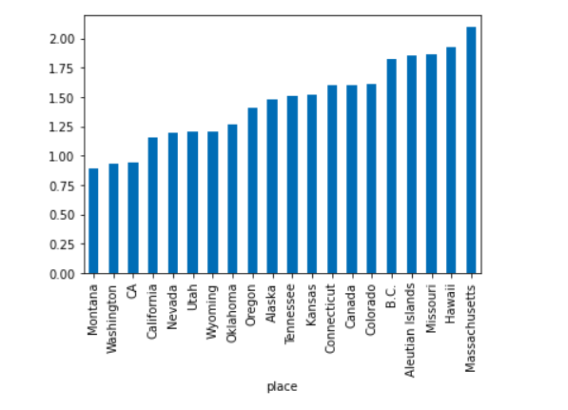

Top 20 places where highes magnitude mean quake experienced in past 30 days.

Finally for mag_outcome feature we created based on 7 days rolling window period in future as target, I have converted it to class as 1 or 0 based on magnitude outcome > 2.5

Rest of the part is best explained in project walkthrough notebooks Data/ETL_USGS_EarthQuake.ipybn or Data/ETL_USGS_EarthQuake.html. Finally the cleaned data for prediction is stored in database file Data/Earthquakedata.db using sql engine.

Note : only for project walkthrough purpose cleaned data is stored in database but for realtime analysis, in Webapp/main.py flask app, we extract data on the go without storing. This make sures we get realtime data any day when web app is requested by any user.

**Model implementation and methodology**

After preprocessing with removing null values, and feature engineering as discussed above, I performed Boosting algorithms for classification problem.

Adaboost classifier with estimator as DecisionTreeClassifier

Adaboosr classifier with estimator as RandomForestClassifier

Finally I tried Xgboost algorithm.

For all the above algorithms,

DecisionTreeClassifier

Max_depth =[2,6,7], n_estimators = [200,500,700] and used gridsearch CV for best estimator as nodes are expanded until all leaves are pure or until all leaves contain less than min_samples_split = 2 samples which helps for classification with various types of features in dataset.

RandomForestCLassifer

Same parameters were used for randomforest as well to compare the algorithms used with gridsearchCV along with another hyperparamter max_features= [‘auto’,’sqrt’,’log2’] that will let select features based on log(featues), sqrt(features) etc.

XgboostClassifier

I did not use grid Search CV here since, it took me more very long to train, hence I tried max_depth same as above algorithms with best fit, i.e 6, learning_rate=0.03 and gbtree as booster

Model selection was based on Evaluation on roc_auc score and recall and hyperparameter tunning. A better walkthrough is mentioned with great detail in models/Earthquake-predictor-ML-workflow.ipybn or models/Earthquake-predictor-ML-workflow.html.

Max_depth hyperparameter along with n_estimator was important as this indicates how deep the tree can be. The deeper the tree, the more splits it has and it captures more information about the data due eqarthquake data being only for past 30 days and features such as rolling window time period of magnitude.

Max_features hyperparameter is used since it ensures how many features to take in account for classification. Due to features such as maginutude and depth of quake for 22,15,and 7 days, this hyperparameter takes care of how many to pay attention to. GridSearchCV will take care of what features to take depending on sqrt(num_features),log(num_features),auto(num_features).

**Improvement and evaluation**

I have used gridsearch CV for improving model and hyperparameter tunning on Adaboost classifier with base estimators as DecisionTreeClassifier and RandomForestClassifier.

Using the same hyper parameters I trained XGBoost. As mentioned above, metrics for evaluation is roc_auc score and recall

RandomForesClassifier adaboost

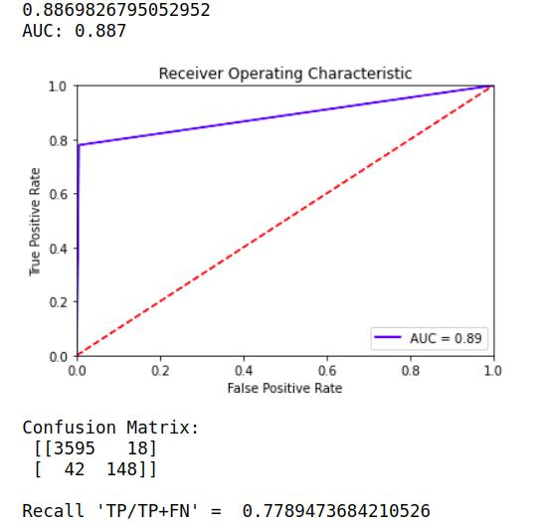

* With adaboost decision tree classifier and hyper parameter tunning, we get area under curve (score) = 0.8867
* higher the auc score, better is the model since it is better at distinguishing postive and negative classes.
* Make a note here that we get from confusion matrix, False negative = 42and Recall score =0.7789. We need this value apart from auc score that we will analyze later when we have tested with diffferent models below

I got Best estimator with max_depth = 6 and for n_estimators = 500 after running gridSearchcv.

model selection is based on metrics score after comaparing all the algorithm score

RandomForesClassifier adaboost

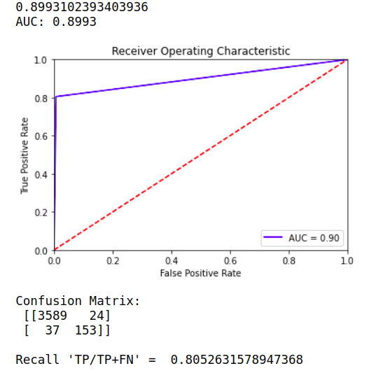

Below is the auc score for adaboost RandomForest classifier with 0.916 which is slightly lower than Decision tree classifier

Moreover when we look at confusion matrix, False Negative=38 and `Recall score = 0.8’ can be observed which is slightly higher than recall score of decision tree. Thus performs better than decision tree adabooost

Random forest gets best estimator with max_depth = 7 and max_feature = sqrt(features)

Model selection is based on metrics score after comaparing all the algorithm score

XGBoost model

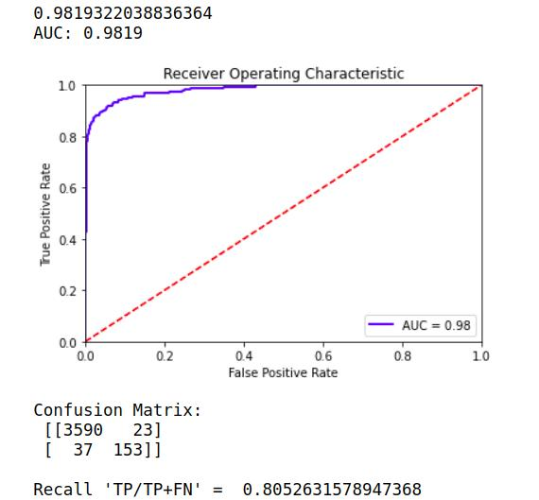

I have also tested with xgboost model below with similar parameters as I got above, since grid search CV was taking lot of time for xgboost.

With Estimators = 500 , and learning rate =0.03 as we can see this significantly gives higher AUC score of almost 0.98 and also False negative = 37 which is similar Random Forest adaboost but xgboost has higher True positive and less False Positve compared to Random forest adaboost. i.e Recall score = 0.805 which is similar adaboost Random Forrest tree. But XGboost is really good at classifying positive and negative classes and also better aur_roc_score = 0.98193. We can see above that xgboost algorithm has higher auc score (0.9819) than adaboost decision tree and random forest, as it is evident from the ROC curve.

Since Xgboost model having higher recall & auc_score than other alorithms, it can be considered more robust as it has ability to handle class imbalance with recall score, and deal good with False negative values and penalize it which is important for our task. i.e reduce False Negative values. Hence we consider xgboost for prediction of live data and deployment in the application.

* For more insights go : models/Earthquake-predictor-ML-workflow.ipybn or models/Earthquake-predictor-ML-workflow.html.

**Prediction and Web-application**

Select specific features such as data,place,long,lat and give earthquake probablity from prediction at that place and date as quake probability

With taking only 7 days rolling period data from predict dataframe since this outcome value is NaN and we need to predict next 7 days period.

Prediction for a particular day

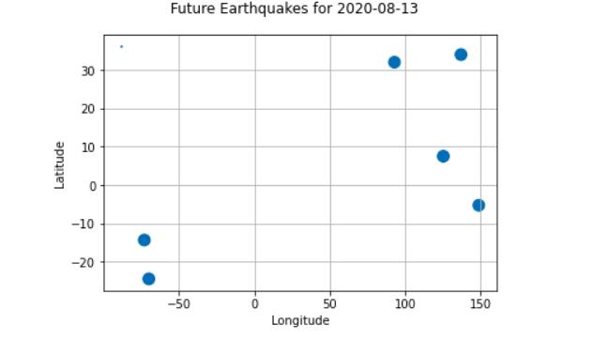

**Web App:**Now its time to deploy the model on web application with flask and I have chosen it to deploy on <https://www.pythonanywhere.com/> which is a free hosting cloud platform for web flask applications.

Main Idea of Application will be predicting or forecasting these earthquake sites on given day all over the world.

The user has option to change the date using a slider and look at predicted places all over the world where earthquake is likely to happen. App.

Application uses google maps api, hence the coordinates we get from the prediction of our model needs to be converted to api format. This has been done and can be viewed Webapp/main.py

**Importing Libraries and Dataset**

Python libraries make it very easy for us to handle the data and perform typical and complex tasks with a single line of code.

**Pandas** – This library helps to load the data frame in a 2D array format and has multiple functions to perform analysis tasks in one go.

**Matplotlib/Seaborn** – This library is used to draw visualizations.

**Python**

**Input1**

Import pandas as pd

Import matplotlib.pyplot as plt

Import seaborn as sb

Import warnings

Warnings.filterwarnings(‘ignore’)

Now, let’s load the dataset into the panda’s data frame for easy analysis.

Df = pd.read_csv(‘dataset.csv’)

Df.head()

**Output1**

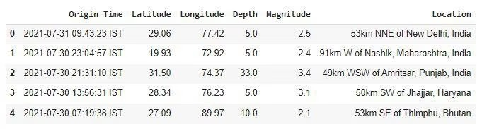

The dataset we are using here contains data for the following columns:

* Origin time of the Earthquake
* Latitude and the longitude of the location.
* Depth – This means how much depth below the earth’s level the earthquake started.
* The magnitude of the earthquake
* Location

**Input 2**

Df.shape

**Output 2**

(2719, 6)

Now let’s see which data is present in which type of data format.

**Input 3**

Df.info()

**Output 3**

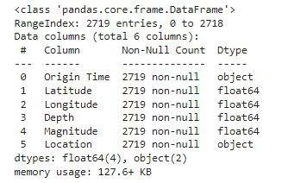

Looking at the descriptive statistical measures also gives us some idea regarding the distribution of the data.

**Input 4**

Df.describe()

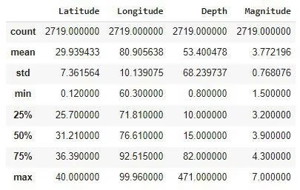**Output 4**

From the above description of the dataset, we can conclude that:

* The maximum magnitude of the Earthquake is 7.
* The maximum depth at which the earthquake started is 471 km below the ground.

**Feature Engineering**

Feature Engineering helps to derive some valuable features from the existing ones. These extra features sometimes help in increasing the performance of the model significantly and certainly help to gain deeper insights into the data.

**Input**

Splitted = df[‘Origin Time’].str.split(‘ ‘, n=1, Expand=True)

Df[‘Date’] = splitted[0]

Df[‘Time’] = splitted[1].str[:-4]

Df.drop(‘Origin Time’, axis=1,inplace=True)

Df.head()

**Output**

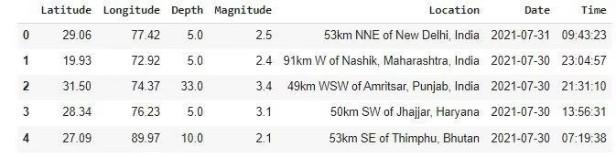

Now, let’s divide the date column into the day, month, and year columns respectively**.**

**Input**

Splitted = df[‘Date’].str.split(‘-‘, expand=True)

Df[‘day’] = splitted[2].astype(‘int’)

Df[‘month’] = splitted[1].astype(‘int’)

Df[‘year’] = splitted[0].astype(‘int’)

Df.drop(‘Date’, axis=1, Inplace=True)

Df.head()

**Output**

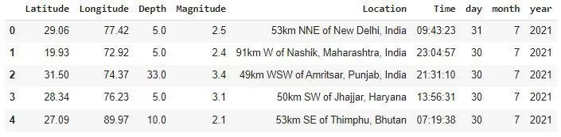

**Exploratory Data Analysis**

EDA is an approach to analyzing the data using visual techniques. It is used to discover trends, and patterns, or to check assumptions with the help of statistical summaries and graphical representations.

**Input**

Plt.figure(figsize=(10, 5))

X = df.groupby(‘year’).mean()[‘Depth’]

x.plot.bar()

plt.show()

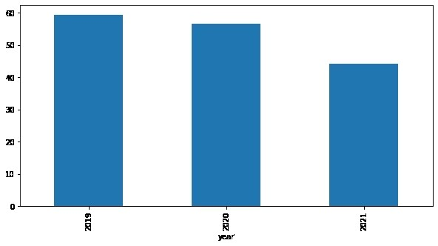**output**

The depth from which earthquakes are starting is reducing with every passing year.

**Input**

Plt.figure(figsize=(10, 5))

Sb.lineplot(data=df, X=’month’, Y=’Magnitude’)

Plt.show()

**Output**

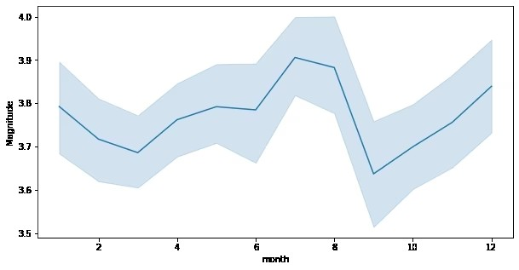Here we can observe that the changes of an earthquake with higher magnitude are more observed during the season of monsoon.

**Input**

Plt.subplots(figsize=(15, 5))

Plt.subplot(1, 2, 1)

Sb.distplot(df[‘Depth’])

Plt.subplot(1, 2, 2)

Sb.boxplot(df[‘Depth’])

Plt.show()

**Output**

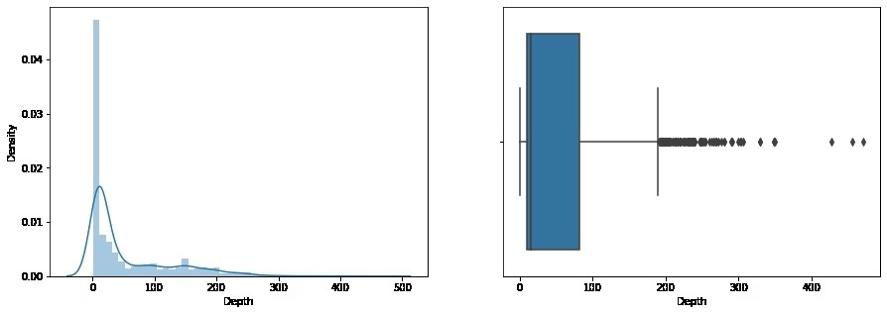

From the distribution graph, it is visible that there are some outliers that can be confirmed by using the boxplot. But the main point to observe here is that the distribution of the depth at which the earthquake rises is left-skewed.

**Input**

Plt.subplots(figsize=(15, 5))

Plt.subplot(1, 2, 1)

Sb.distplot(df[‘Magnitude’])

Plt.subplot(1, 2, 2)

Sb.boxplot(df[‘Magnitude’])

Plt.show()

**Output** 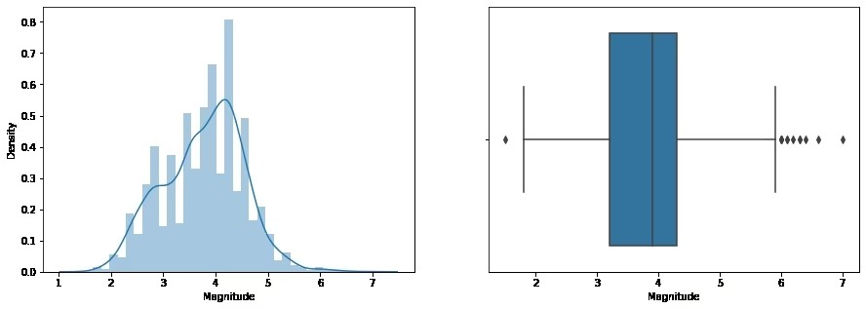

As we know that many natural phenomena follow a normal distribution and here we can observe that the magnitude of the earthquake also follows a normal distribution.

**Input**

Plt.figure(figsize=(10, 8))

Sb.scatterplot(data=df, X=’Latitude’, Y=’Longitude’,Hue=’Magnitude’)

Plt.show()

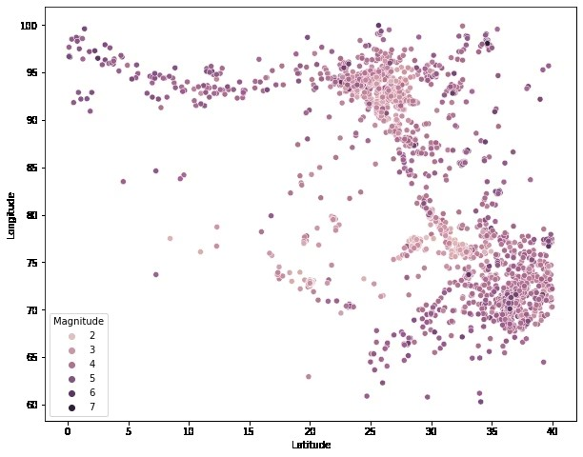 **Output**

Now by using Plotly let’s plot the latitude and the longitude data on the map to visualize which areas are more prone to earthquakes.

**Input**

Import plotly.express as px

Import pandas as pd

Fig = px.scatter_geo(df, lat=’Latitude’,Lon=’Longitude’,Color=”Magnitude”,Fitbounds=’locations’,

Scope=’asia’)

Fig.show()

**Output**

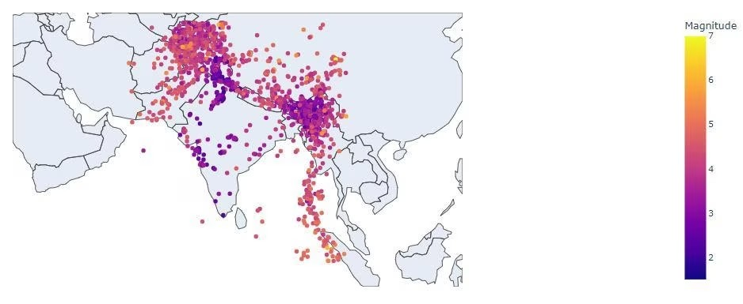

**Improvement and conclusion**

Though XGboost model has given Higher roc_auc and better recall, I believe any work given always has some scope for improvement and in here we could also use RNN or LSTM for time series or rather event series forecasting. LSTMs have hidden memory cells that help in remembering and handeling time series or event series data well. Moreover for xgboost I have just used hyper parameters from already tuned Adaboost models, but we can also tune xgboost hyper parameter and find best parameters using GridSearchCV or RandomSearch.

*Some final thoughts*

So far the model looks good with xgboost as chosen model for predictions in web app haveing higher auc score and higher recall_score as I have explained under XGBoost result section why auc and recall score are chosen.

Our main Aim is to predict wether earthquake will happen or not at a given day and place. So we definitely would not like the model with higher False Neagtive values , since its more dangerous to predict as no earthquake while in reality earthquake happend than predicting earthquake will happen given in reality it did not. We can allow False positive more than False negative

After seeing these comparision on auc_roc score, confusion matrix, and recall score, since all the above algorithm have given similar result with slightly different recall scores, Xgboost with FN=37 but with higher auc_score 0f 0.98 performs over-all better. Hence for webapplication deployment, I have chosen Xgboost as it also faster than adaboost.

Hence with all the mentioned implementation, the web application was successfully deployed and necessary project walktrhough can be accessed from Data and models directory.