**ASSESSMENT OF MARGINAL WORKERS IN TAMILNADU - A SOCIOECONOMIC ANALYSIS**

**INTRODUCTION:**

The analysis of the topic comprises examining the age, sexual orientation, and population demographics based on industry classification of workers who are marginalized in Tamil Nadu. The main goal is to complete an economic and social analysis and provide examples of how marginal employees are distributed across various demographic groups. The goals of this project have been outlined, a data analysis plan has been developed, useful visualization types have been identified, and Python and data visualization libraries are being used for the analysis.

**DESCRIPTION:**

This stage focuses on prepping the provided CSV file in order to prepare it for other operations including analysis, exploratory data analysis, and dataset visualization. Using the "IBM Cognos Tool" to visualize the data is part of phase 3 of the study "ASSESSMENT OF MARGINAL WORKERS IN TAMILNADU - A SOCIOECONOMIC ANALYSIS". This document includes a bar chart, pie chart, line chart, and heatmap among other charts.

**IBM COGNOS:**

A set of business intelligence and performance management tools called IBM Cognos is intended to assist companies in deriving insights from their data. For reporting, analysis, scorecarding, and event and metric monitoring, it provides a number of tools. IBM Cognos helps businesses make smart decisions and boost performance with capabilities like interactive dashboards, ad hoc reporting, and advanced analytics. It is renowned for its intuitive user interface and strong ability to convert unprocessed data into insightful knowledge for strategic planning and decision-making.

1. BAR CHART

Information gained:

* Age group Total has the highest total Industrial Category - A - Cultivators - Persons due to Industrial Category - B - Persons 2853.
* Industrial Category - A - Cultivators - Persons is unusually high when Age group is Total.
* Over all age groups, the sum of Industrial Category - A - Cultivators - Persons is almost 514 thousand.
* Industrial Category - A - Cultivators - Persons ranges from 160, when Age group is Age not stated, to nearly 257 thousand, when Age group is Total.

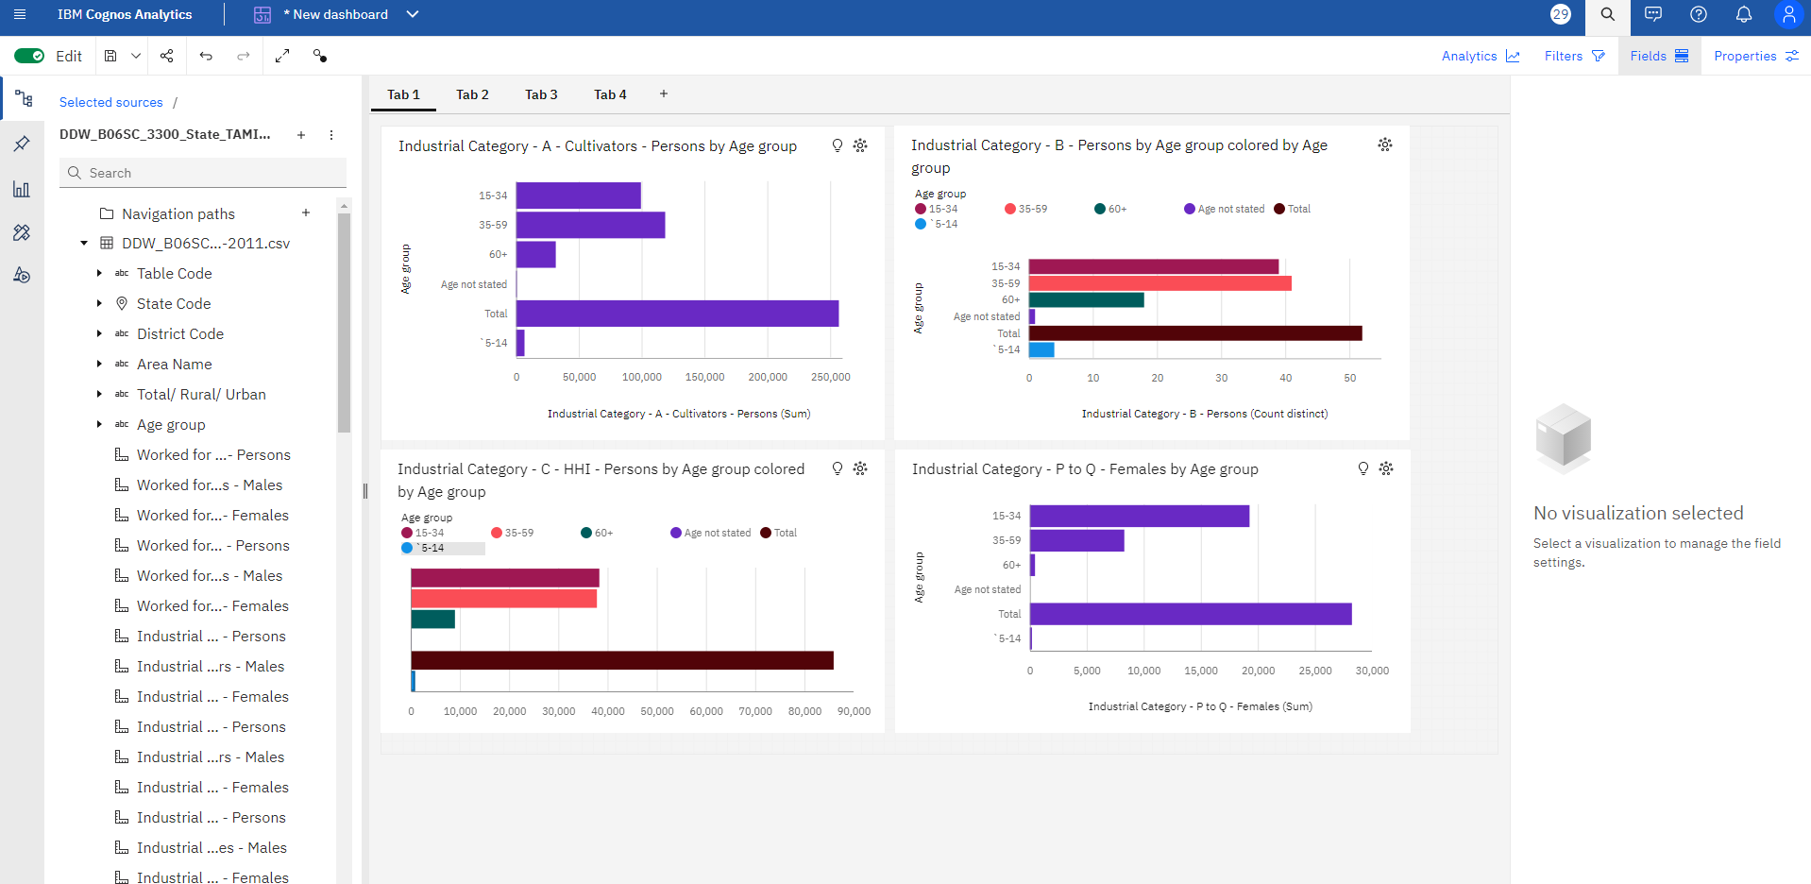

1. PIECHART

Information gained:

* Age group Total has the highest total Industrial Category - A - Cultivators - Persons due to Industrial Category - B - Persons 2853.
* Over all age groups, the sum of Industrial Category - B - Females is nearly eight thousand.
* Age group Total has the highest total Industrial Category - D & E - Females due to Industrial Category - B - Persons 2853.
* Industrial Category - B - Persons 0 has the highest Industrial Category - J - Non HHI - Persons at 32, out of which Age group 15-34 contributed the most at 12.