Chapter - I

**Fashion Haven**

**Introduction**

We started Fashion Haven because we wanted to see changes in the fashion industry. There are many emerging designers who do know how to market their clothing so we are here to help. Also, there are many fashionistas who wants to buy designer clothing but can't afford to purchase them. Fashion Haven is the place tat will put designers with fashion trendy buyers.  
  
 Fashion Haven is a premier online marketplace to find unique and one of a kind Designer Inspired pieces. We work directly with emerging designers around the world to bring you the best selection of high-quality, one of a kind inspired pieces the industry has to offer.  
  
 Our mission is to empower designers worldwide with the tools to enter a global market and to make buyer around the world feel and look good.Fashion Haven is not just an online store, we are a community that merges fashion lovers worldwide.

Fashion Heaven Inc (”We”) are committed to protecting and respecting your privacy.This notice together with our terms of use, sets out the basis on which any personal data we collect from you, or that you provide to us, will be processed by us.Please read the following carefully to understand our views and practices regarding your personal data and how we will treat it.It includes information you provide when you register to use our site, to enter our database, subscribe to our services, attend our events, participate in discussion boards or other social media functions on our site, enter a competition, promotion or survey and when you report a problem with our site.

**Purpose of fashion haven**

* Fashion is not just about clothing; it is also about the way we carry ourselves and the way we present ourselves to the world.
* It is a form of self-expression that can tell the world who we are and what we believe in. We can use fashion to express our individuality and our unique personalities.
* There are no rules or set standards when it comes to fashion. You can dress however you want, as long as you feel comfortable and confident in what you are wearing.
* You don’t have to follow the latest trends or wear the latest designer clothes to be fashionable. There is no one definition of fashion; it is different for everyone.

* The world of fashion is constantly changing and evolving. What is considered fashionable today might be out of style tomorrow.

* Trends come and go, but some styles are timeless and always come back in fashion.
* Fashion can be expensive, but it doesn’t have to be. You can find affordable clothing and accessories at many stores and online retailers.
* There are also many ways to save money on fashion, such as shopping at consignment stores, thrift stores, and online retailers.
* The way we dress and the clothes we wear play an important role in our lives.

CHAPTER-II

1.**Empathy map**

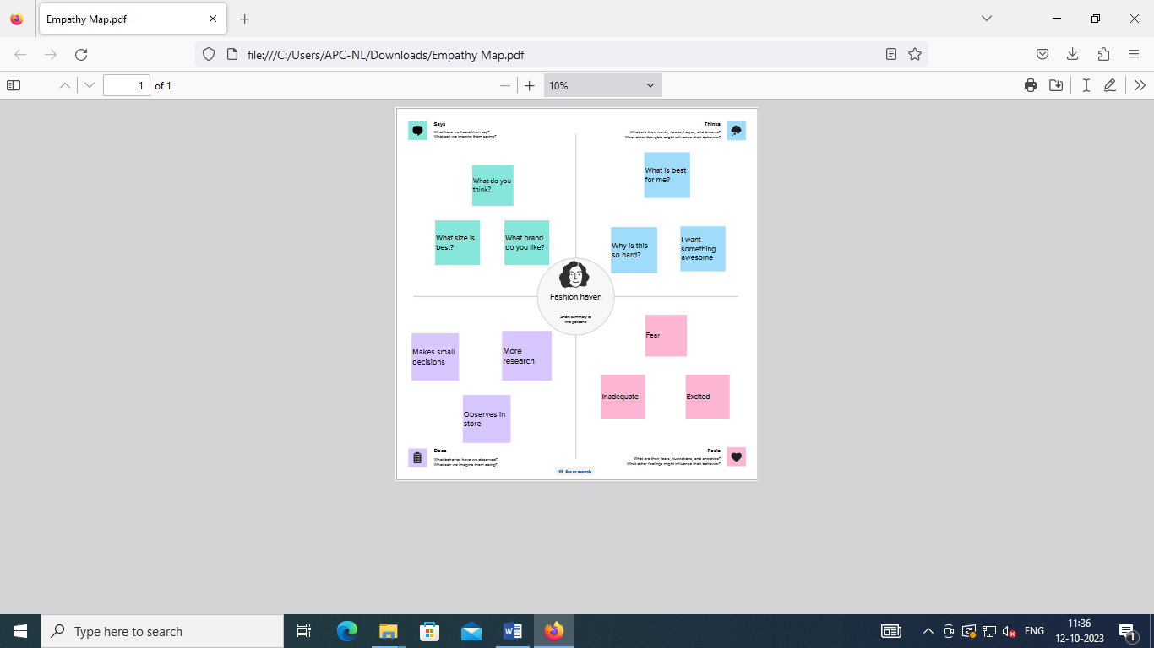

2**.Brainstorming**

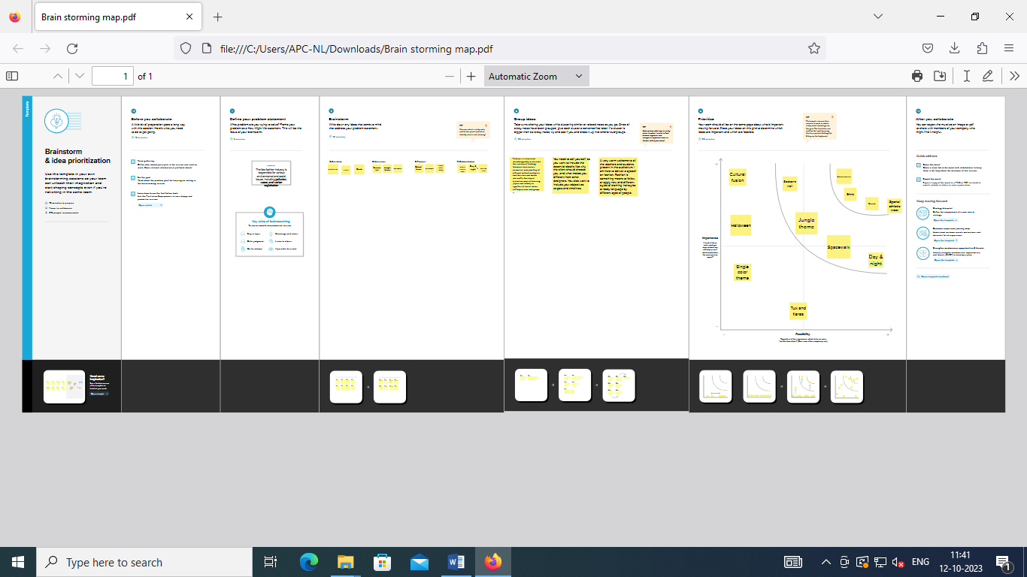

Chapter-III

**1.Profit and loss account**

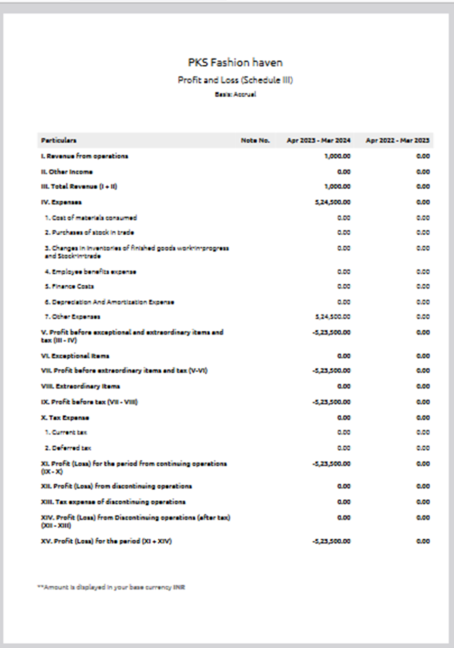

2.**Balance sheet**

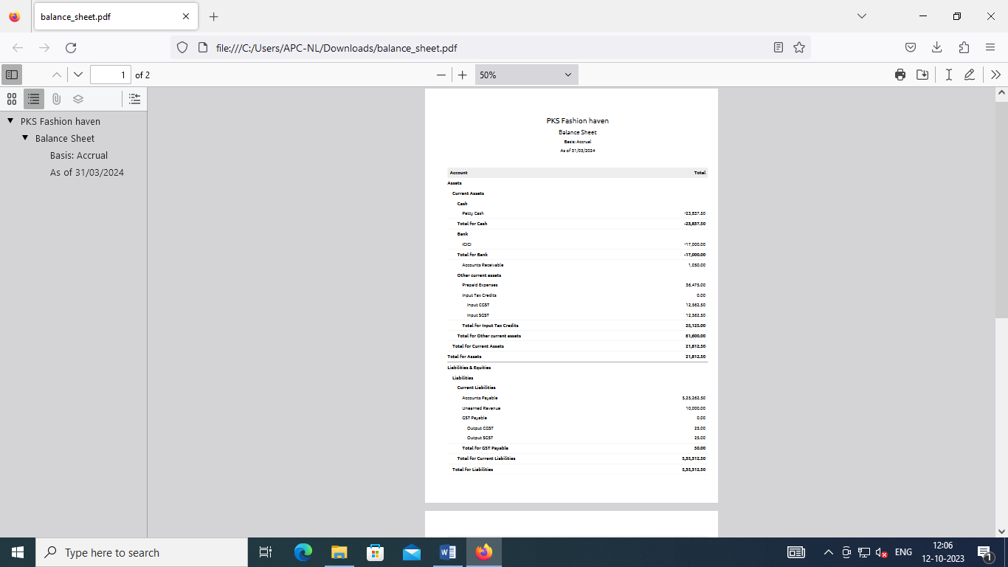

Chapter-IV

**Advantages of fashion haven**

* wearing different designer clothes or dresses ins insert a feeling of self-confidence. And also feel confident and independent in your choice.

* Confidence like models wearing different designer outfits and also catwalks in front of many people only those who can wear designer outfits who were more confident.
* The most fashion-conscious people on earth. A teenager’s lifestyle is heavily influenced by fashion and image.
* Fashion is significant to them because it shows the world who they are or who they want to be. Teenagers have different personalities, so there are clothes in different styles, sizes, colors, and materials.
* As people grow up, their sense of themselves is shaped by the clothes they wear. Fashion is a way for teens to express themselves, connect to their peers, and gain social status.
* Teenagers express themselves through their clothes and hairstyles. The clothes a teenager wears are a way of individuating themselves and demonstrating how they wish to be perceived.
* The retailer does not replenish its stock—instead, it replaces items that sell out with new items.
* Consumers know to purchase an item they like when they see it, no matter the price because it's not likely to be available for long.
* Fashion trends can influence individuals to develop their unique style. Individuals can experiment with various styles and convey themselves creatively.
* Confidence: Following fashion trends can enhance one's self-confidence because it fosters a sense of belonging and social acceptance.

**Disadvantages of fashion haven**

* Fashion trends can create social pressure to conform, leading to a lack of individuality and self-expression.
* Body Image Concerns: Some trends may not be inclusive of all body types, leading to body image issues and self-esteem issues.
* The fashion industry is second only to the oil industry in terms of its pollution contributions.
* And when you look at the whole apparel supply chain—from raw materials extraction to manufacturing to distribution to waste disposal—the industry accounts for 10% of global carbon emissions.
* Fashion is also one of the worst offenders when it comes to human rights abuses and the exploitation of workers, especially women and children.
* The International Labor Organization, there are ~40 million garment workers worldwide, and 80% of them are women between the ages of 18 and 35. Many of them make less than minimum wage and work insanely long hours.
* In some places, female garment workers don’t even have access clean sanitation and hygiene facilities.
* Further, the rising popularity of fast fashion has made it easier for consumers to buy clothing and accessories that are trendy, but also cheap.
* But while the clothes themselves might be inexpensive, the environmental and social cost of fast fashion is anything but.

**Chapter-V**

**Applications**

A little good news amid all the gloom. Technology is paving the way to a more[sustainable future for fashion](https://www.worldfashionexchange.com/blog/what-is-sustainable-fashion-why-fashion-brands-need-to-be-more-sustainable/)! Here’s few ways to get started:

* Ensure all the factories you work with have strict policies around worker hygiene and safety.
* Use 3D design solutions to test samples for fit, design and quality before manufacturing physical pieces to minimize waste.
* Use less resource-intensive sustainable materials that are not as harmful for the environment.
* Make use of analytics and production intelligence to forecast demand and avoid overproduction.
* Increase transparency in your supply chain by using production tracking software such as PLM and [ERP](https://www.worldfashionexchange.com/apparel-erp-software.html) to establish accountability.
* Encourage customers to resell or rent clothing instead of buying and discarding after one or two uses.
* Collect data about your supply chain to identify where there’s room for improvement and efficiency.

.

* Implement holographic labels and watermarks. These labels on product packaging and tags can make it difficult for counterfeiters to replicate the look of authentic products.
* Trademark important words or design elements, which makes it easier to pursue legal action against those who try to copy you. You can further protect your brand by working with trusted manufacturers who won’t share your design with others or fudge on materials requirements and specs.
* Encourage your consumers to buy authentic items—ideally directly from you! And by “encourage,” I mean through education, incentives, and other tactics designed to get customers excited about buying your products directly.
* Use software programs that can help you detect when someone is using your images or content without permission on the Internet. Teport the offenders as soon as you spot them.

**Chapter-VI**

**Conclusion**

we use clothes as a sign of our identity,as a way of representing ourselves and stand out from the crowd and also influence on how we appear in front of others making them (clothes) a huge part of our non verbal communication.

The impact that fast fashion has on our planet is vast. From extreme climate changes to socially unacceptable work environments, fast fashion is destroying the Earth. It is important to do our individual part to decrease the environmental and social impacts that fast fashion presents

Fashion communication is important for creating a unique brand identity. It helps brands to gather maximum visibility and attract more customers.

We have also highlighted the various opportunities available for entrepreneurs to promote sustainable fashion in India. These opportunities include the use of sustainable materials, innovative production processes, and the development of new business models.

Chapter-VII

**Future scope**

There might be many reasons why one wants to pursue fashion designing, while one can explore outwards, search within yourself, what you are good at? Maybe do you have an good sense of matching colors and patterns, your doodles mostly are ideas for garments, good at styling fabrics, or have a keen sense of an understanding of fabrics and textiles. One can leverage the core strengths in future career.

It is one of the most ambitious career options for all. A [**Fashion Designer**](https://textilelearner.net/11-tips-to-become-a-successful-fashion-designer/) is someone who builds up new ideas based on the latest trends and innovation that are leading the world. Designing concepts and apparel is what they essentially do. The person who dreams up creative concepts and are always up to date about what’s happening in the fashion world, may wish to choose this path.

As the name suggests, a Fashion Illustrator presents drawings and illustrates the ideas of a fashion designer on paper and/or on computers. To pursue career in this, one need to be really good at drawing and illustration. One will get to work closely with designers to bring their ideas and designs to reality.

They manage for makeup, accessories, hair styles, and everything else to make sure the model looks awesome wearing the designs. For this, one need to have an amazing sense of style and should be skill The demand for fashion consultants are increasing nowadays. They are someone who help individuals choose their style based on their image, their personality, and looks. One should know the trends of the industry as well as basics of fashion designing to take on this route.ful with accessorizing to shine in this path.