# Revisional bariatric surgery using robotic-assisted surgery in a national medical center in Mexico

***Gaytán Fuentes Omar Felipe1,2 Edith Barajas Galicia1, Chávez García Geovany1,2, Galván Remigio Isabel1,2, Oviedo Rodolfo3,4,5, Gaytán Fuentes Israel Abraham2,6, Ayala Ventura Gustavo Andrés1,2, Barba Mendoza Jairo Arturo1***

1 Upper Gastrointestinal Robotic Surgery Fellowship, General Surgery Department, “CMN 20 de Noviembre” ISSSTE, Mexico City, México 2 Revenant Clinic, Integral Obesity Clinic, Hospital Ángeles Acoxpa, Mexico City, México 3 University of Houston Tilman J, Fertitta Family College of Medicine, Houston, TX, USA 4 Sam Houston State University College of Osteopathic Medicine, Conroe, TX, USA 5 Nacogdoches Center for Metabolic and Weight Loss Surgery, Nacogdoches, TX, USA 6 Montefiore Medical Center, Albert Einstein College of Medicine, Bronx, NY, USA

### Abstract (300 word limit)

Long-term postoperative complications of metabolic and bariatric surgery (MBS) are more frequent than those of primary surgery. Robotic-assisted procedures offer several advantages over traditional laparoscopy, but there are limited data. A retrospective study of 29 patients who underwent a revisional robotic-assisted Roux-en-Y gastric bypass (RRYGB) in a Tertiary Level Hospital. Variables included were demographics, causes for revision, operative details, complications, and weight loss outcomes up to 54 month post-RRYGB. Causes for conversion were weight loss failure (WLF), weight regain (WR), Gastroesophageal Reflux Disease (GERD), or Joint Pain (JP). We assessed 29 patients. Causes for conversion included WLF (34%), WR (15%), WR with GERD (20%), GERD (24%), and JP (3%). Initial BMI was 53.43 kg/m2 ± 8.75. Mean length of hospital stay (LOS) was 2 days. Total operative time was 126 min. ± 43.45. Excess weight loss at 1 year post surgery was 82.66% (p < 0.0001), with mean BMI of 30.93 kg/m2 (p < 0.001). At 3 years, mean %EWL was 71.26% and a mean BMI 33.81 kg/m2 (p < 0.0001). At 4.5 years, mean %EWL was 59.29% and mean BMI 37.27 kg/m2 (p < 0.0001). One complication (8%) was found (jejunojejunal stenosis). There was no mortality. The initial experience with RRYGB shows acceptable outcomes, including low morbidity, no mortality, excellent weight loss after the revisional surgery, and promising reduction in operative times, with important implications on reduction of the total cost of the procedure.

### Image

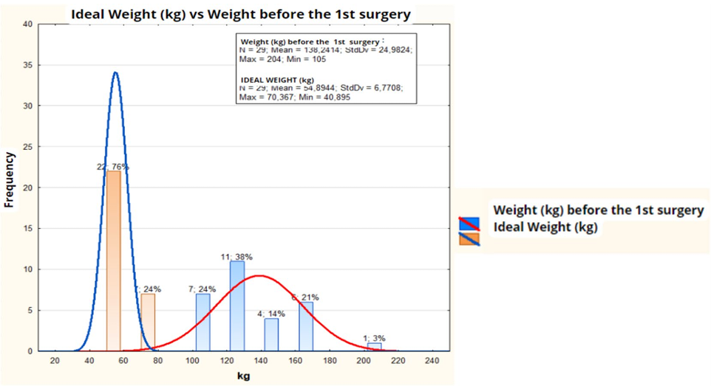

Fig. 1 Comparative analysis of the statistical distributions of Ideal BMI (kg) vs. the distribution of BMI before the first surgery (P < 0.000001)

**Recent Publications (minimum 5)**

1. Campos-Nonato I, Galván-Valencia Ó, Hernández-Barrera L,

Oviedo-Solís C, Barquera S (2023) Prevalencia de obesidad y factores de riesgo asociados en adultos mexicanos: resultados de la Ensanut 2022. Salud Publica Mex 14(65):s238–s247 (Spanish)

2.-Martin MJ, Topart P (2016) Comment on: “conversion of sleeve gastrectomy to Roux-en-Y gastric bypass: an audit of 34 patients” and “weight loss, weight regain, and conversions to Roux-en-Y gastric bypass -10- year results of laparoscopic sleeve gastrectomy.” Surg Obes Relat Dis 12:1646–1654

3. Bindal V, Gonzalez-Heredia R, Elli EF (2015) Outcomes of robot-assisted Roux-en-Y gastric bypass as a reoperative bariatric procedure. Obes Surg 25(10):1810–1815

4. Vilallonga R, Fort JM, Caubet E, Gonzalez O, Balibrea JM, Ciudin A, Armengol M (2015) Robotically assisted single anastomosis

duodenoileal bypass after previous sleeve gastrectomy implementing high valuable technology for complex procedures. J Obes 2015:586419. https://doi.org/10.1155/2015/586419

5. Cirocchi R, Boselli C, Santoro A et al (2013) Current status of robotic bariatric surgery: a systematic review. BMC Surg 13:53

6. Bindal V, Bhatia P, Dudeja U et al (2015) Review of contemporary

role of robotics in bariatric surgery. J Min Access Surg

11(1):16–21

**Photograph**

Biography (150 word limit)

Dr. Omar Felipe Gaytán Fuentes is a distinguished specialist in bariatric and general surgery, graduating from UNAM Faculty of Medicine. He completed his General Surgery residency at Hospital Central Norte de PEMEX and a High Specialty Course in Bariatric Surgery at the National Medical Center 20 de Noviembre ISSSTE. Certified in Robotic Surgery since 2015, he has performed over 250 robotic procedures, focusing on super obesity, bariatric revision/conversion surgeries, and various techniques like gastric sleeve, gastric bypass, and minigastric bypass. Dr. Gaytán Fuentes is a pioneer in bariatric surgery research in Mexico, recognized by UNAM, and also practices general surgery including hernia repairs, gastrointestinal procedures, and treatments for reflux, appendicitis, and gallbladder disease. His expertise spans a wide spectrum of surgical interventions aimed at improving patient health and quality of life.

ganf29@hotmail.com

**Notes/Comments:**

DOI and Reference of the article:

* Gaytán Fuentes OF, Barajas Galicia E, Chávez García G, Galván Remigio I, Oviedo RJ, Gaytán Fuentes IA, Ayala Ventura GA, Barba Mendoza JA. Revisional bariatric surgery using robotic-assisted surgery in a national medical center in Mexico. J Robot Surg. 2024 Jun 8;18(1):247. doi: 10.1007/s11701-024-01980-0. PMID: 38850381.