**A Hybrid Crypto Trend Analysis And Online Graphical Representation Model Using Neural Network**

Bitcoin price prediction has become a significant area of research due to its volatile nature and potential for financial gain. In this study, we employed four distinct algorithms, namely Auto Regressive Integrated Moving Average with Exogenous Variables (ARIMAX), Long Short-Term Memory (LSTM) networks, Facebook Prophet, and XGBoost, to forecast the price of Bitcoin. The analysis utilized historical Bitcoin price data spanning several years. Initially, the data underwent preprocessing steps, including handling missing values and visualizing temporal trends. Subsequently, we engineered features such as rolling means and standard deviations to capture potential patterns. Each algorithm was then applied, and their respective predictions were evaluated using performance metrics like Root Mean Squared Error (RMSE) and Mean Absolute Error (MAE). Our results indicate that LSTM and FB Prophet demonstrated superior predictive capabilities, yielding the highest accuracy percentages. Additionally, we explored the potential of hybrid models by combining forecasts from multiple algorithms, which further enhanced prediction accuracy. Overall, our study contributes to the ongoing efforts to develop robust models for Bitcoin price prediction, thereby aiding investors and stakeholders in making informed decisions in the cryptocurrency market.

**Problem Statement**

The rapid evolution of hybrid cryptocurrencies, blending diverse technologies like blockchain and traditional finance, poses a significant challenge for accurate trend analysis. Existing methods struggle to capture the intricate patterns in these hybrid assets, leading to unreliable predictions. Integrating cryptographic techniques with neural networks offers a promising solution, but current research lacks a comprehensive approach. This study addresses the pressing need for a sophisticated hybrid model that fuses cryptography and neural networks to provide precise, real-time trend analysis for hybrid crypto currencies. Solving this challenge holds the key to empowering investors and traders with informed decision-making capabilities in this complex and dynamic market.

**Applications**

The Hybrid Crypto Trend Analysis application utilizes advanced neural networks combined with cryptographic techniques to offer precise predictions and insights into hybrid cryptocurrencies. This application is invaluable for investors and traders, providing accurate forecasts, aiding in risk management, guiding trading strategies, and supporting data-driven decision-making. Additionally, it serves as a powerful tool for researchers, educators, and algorithm developers, contributing to the advancement of cryptocurrency analysis methods and enhancing overall market understanding. Through real-time monitoring and informed analytics, this application transforms the way stakeholders engage with hybrid cryptocurrencies, enabling them to navigate the market with confidence and efficiency.

**Scope of the project**

The scope of this project encompasses the development of a comprehensive and robust Bitcoin price prediction system using a hybrid model that integrates ARIMAX, LSTM, XG Boost, and Facebook Prophet algorithms. The project will involve extensive data preprocessing and feature engineering, including the conversion of Unix timestamps and the computation of rolling statistics for both momentary and permanent trends. The key objective is to provide accurate and reliable Bitcoin price forecasts, catering to cryptocurrency enthusiasts, traders, and investors. Additionally, the project includes the implementation of an interactive web-based visualization tool to present forecasted prices and trends, offering users an intuitive and accessible means to gain insights into cryptocurrency market dynamics. This project's scope includes the development of a full-fledged system for Bitcoin price prediction and visualization, with the potential for further enhancements and applications in the evolving cryptocurrency landscape.

**Tech Stack**

**Web IDES** Colaboratory

**Language:** Python

**Libraries** Pandas, numpy, matplot, seborn, plotly, sklearn, tensorflow, pmdarima, prophet, Xgboost, statsmodel.

**Algorithms:** ARIMAX, FB Prophet, Xgboost, LSTM.

**Methodology**

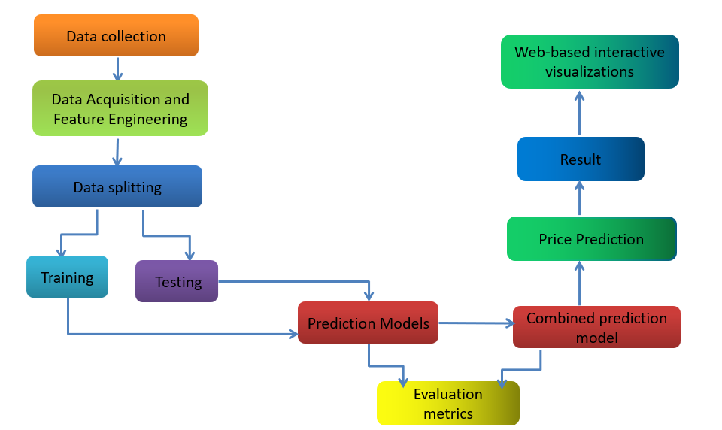

**Data Collection and Preprocessing:** We begin by collecting historical Bitcoin price data from reputable cryptocurrency exchanges, ensuring a comprehensive dataset spanning multiple years to capture diverse market conditions and trends.The collected data includes daily opening, closing, high, and low prices, as well as trading volume and other relevant indicators. To ensure data accuracy and reliability, we meticulously clean and preprocess the dataset, handling missing values, outliers, and inconsistencies through techniques such as interpolation,smoothing,and normalization.

**Feature Engineering:** In preparation for model training, we conduct feature engineering to extract meaningful input variables that can potentially influence Bitcoin prices. These features may include technical indicators such as moving averages, Rolling Statistics [16], Moving Average Convergence Divergence, Lag plots, ACF, PACF [21] and Bollinger Bands, as well as exogenous features such as rolling mean, standard deviation and moving average. By incorporating a diverse range of features, we aim to capture the multifaceted nature of the cryptocurrency market and improve the predictive power of our models.

**Model Selection and Training:** We employ a CPD [5] and diverse set of forecasting models, including both traditional statistical methods and modern machine learning algorithms, to explore different approaches for predicting Bitcoin prices. These models include the Auto Regressive Integrated Moving Average (ARIMA) model [6], which is well-suited for capturing linear dependencies and trends in time series data, as well as advanced machine learning techniques such as Long Short-Term Memory (LSTM) networks, which excel at capturing non-linear relationships and long-term dependencies in sequential data. Additionally, we experiment with ensemble learning methods like XGBoost to leverage the collective wisdom of multiple models and enhance prediction accuracy and FB Prophet model well suitable for time series data.

**Model Evaluation and Validation:** To assess the performance of each forecasting model, we employ rigorous evaluation metrics[20] such as mean squared error (MSE), mean absolute error (MAE), and root mean squared error (RMSE), which provide insights into the accuracy and precision of predictions. We also conduct cross validation experiments to validate the robustness and generalization ability of the models across different time periods and market conditions. By comparing the performance of each model against baseline benchmarks and alternative approaches, we aim to identify the most effective methodologies for Bitcoin price prediction.

**Hyperparameter Tuning & Optimization:** In order to fine-tune the performance of our forecasting models, we conduct extensive hyperparameter tuning and optimization experiments[22], adjusting model parameters, architecture configurations, and training strategies to maximize prediction accuracy and minimize overfitting. This process involves iteratively experimenting with different parameter settings and evaluating their impact on model performance using techniques such as grid search, random search, and Bayesian optimization. By optimizing model hyperparameters, we seek to enhance the stability and reliability of our predictions, enabling more informed decision-making in cryptocurrency trading and investment strategies. Through the systematic application of these methodologies, our study aims to advance the state-of-the-art in Bitcoin price forecasting and provide valuable insights for investors, traders, and researchers seeking to navigate the dynamic and volatilecryptocurrency market. By leveraging a diverse range of data sources, features, and modeling techniques, we strive to develop robust and accurate forecasting models capable of capturing the complex dynamics of Bitcoin prices and empowering stakeholders with actionable insights for risk management and portfolio optimization.

**Lessons Learned**

**ARIMAX (AutoRegressive Integrated Moving Average with Exogenous Variables):** ARIMAX is a time series forecasting model that combines autoregressive (AR) and moving average (MA) components with exogenous variables (X). In this approach, the past values of the variable being forecasted are regressed on past values of the same variable and past values of other time series that may influence it. The model also incorporates information from external factors or predictors, which can improve forecast accuracy. In the provided code, ARIMAX is applied to predict Bitcoin prices using both historical Bitcoin data and engineered features as exogenous variables.

**Prophet:** Prophet is a forecasting tool developed by Facebook's Core Data Science team. It is designed to handle time series data with strong seasonal patterns and multiple seasonality. Prophet decomposes time series data into trend,seasonality, and holiday components and models them separately. It can also handle missing data and outliers gracefully. In the provided code, Prophet is utilized to forecast Bitcoin prices based on historical data, with additional features engineered to enhance prediction accuracy.

**XGBoost (Extreme Gradient Boosting):** XGBoost is an implementation of gradient boosted decision trees designed for speed and performance. It is widely used for supervised learning tasks, including regression and classification, and has gained popularity for its accuracy and efficiency. XGBoost builds a series of decision trees iteratively, each correcting the errors of its predecessor, and combines their predictions to produce a final output.In the provided code, XGBoost is employed to predict Bitcoin prices using engineered features derived from historical data.

**LSTM (Long Short-Term Memory):**

LSTM is a type of recurrent neural network (RNN) architecture designed to model sequential data and handle long-term dependencies.Unlike traditional feed forward neural networks,LSTM networks have feedback connections that allow them to process sequences of data over time. They are particularly effective for time series forecasting tasks due to their ability to retain information over long periods. In the provided code, LSTM is used to forecast Bitcoin prices based on historical data, with the model trained to capture complex patterns and dependencies within the time series.

The hybrid model employed in this study combines the predictive capabilities of ARIMAX, XG BOOST, FB PROPHET and LSTM neural networks to enhance the accuracy of time series forecasting . By leveraging ARIMA's proficiency in capturing linear trends and seasonality alongside LSTM's ability to model complex nonlinear patterns and long-term dependencies, the hybrid model achieves superior performance compared to either model used in isolation. This hybrid approach capitalizes on the complementary strengths of both techniques, resulting in more robust predictions that better capture the intricacies of the underlying data.

**Result**

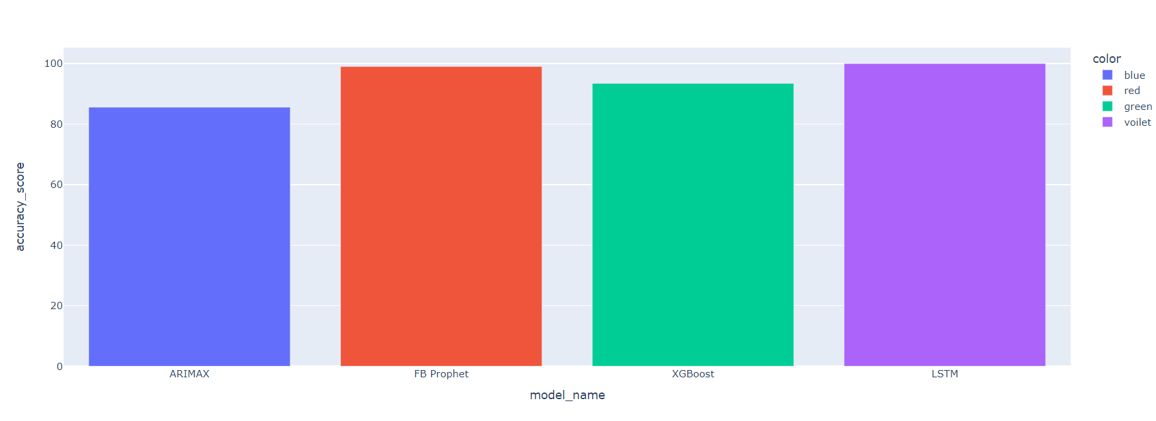

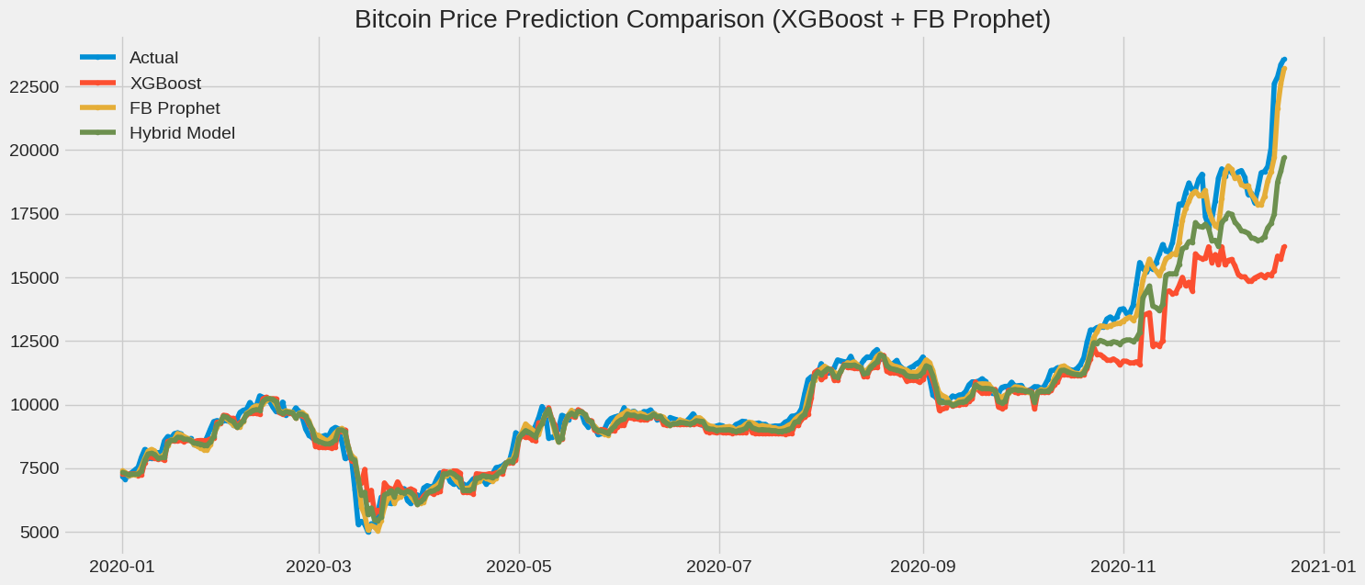

**Conclusion**

In conclusion, we explored the predictive capabilities of various models to forecast Bitcoin prices. We employed ARIMAX, Facebook Prophet, XGBOOST, and LSTM models to predict the prices of Bitcoin. The implementation of a FB Prophet model, LSTM and hybrid model combining FB Prophet and XG Boost algorithms demonstrates promising results in time-series forecasting tasks than other model such as XG BOOST and ARIMAX. XGBOOST also performs effective than ARIMAX and in certain period of time after undergoing various tuning.Through the integration of both linear and nonlinear modeling techniques, the hybrid model effectively captures diverse patterns and trends present in the data, leading to improved forecasting accuracy compared to some individual models such as ARIMAX and XGBOOST. The hybrid approach leverages the strengths of each algorithm, with FB Prophet adept at modeling linear trends and XGBOOST excelling in capturing complex temporal dependencies. By combining these complementary capabilities, the hybrid model achieves enhanced predictive performance, It may be a valuable tool for various applications requiring accurate time-series forecasting after iterative tuning.Furthermore, the experimental evaluation conducted on real-world datasets validates the effectiveness of the Facebook Prophet, a forecasting tool developed by Facebook, demonstrated superior performance among the traditional models with a MAE value of 684.8. Its ability to handle various trends and seasonality in the data contributed to its effectiveness in Bitcoin price prediction. And LSTM, a type of recurrent neural network, exhibited remarkable accuracy in predicting Bitcoin prices with a RMSE value of 947.95. Its capability to capture temporal dependencies and learn intricate patterns in the data contributed to its outstanding performance.Both performed well than other model in different domains and time-series characteristics.The comparative analysis against standalone FB Prophet and LSTM models illustrates that hybrid approach performs lesser than these model with the RMSE value of 886.9 in terms of forecast accuracy and robustness. Notably, the hybrid model may exhibits superior performance in scenarios with both short term fluctuations and long-term trends after various tuning process,it would showcasing its versatility and adaptability to diverse forecasting challenges. Then these findings would underscore the practical significance of adopting hybrid modeling techniques for improving the reliability and precision of time-series predictions in various domains, including finance, energy, and healthcare. Overall, the FB prophet, LSTM and hybrid model combining FB Prophet and XGBOOST represents a promising approach in time-series forecasting, with potential for continued refinement and application in diverse domains, thereby contributing to advancements in predictive analytics and decision-making processes.