MEMBER RETENTION
POWER BI DASHBOARDS
Confluence Dashboard Requirements & Design Reference
Dashboard-focused document aligned to the supplied FRS and approved/working mock-ups

This document is intentionally dashboard-focused. The supplied FRS was used as a reference for terminology, measurement level, retention concepts and business classification context, but the detailed ML/FRS content is not reproduced here.

Table of Contents
- Executive Summary
- Document Overview
- Project Objectives
- Dashboard Requirements
- Data Sources & Integration
- Functional Requirements
- Dashboard Specifications
- User Acceptance Criteria
- Security & Compliance
- Deployment Plan
- Appendices

1. Executive Summary
The Member Retention Power BI reporting solution is intended to provide a consolidated view of retention performance, member activity, FUM movement, churn risk and key retention drivers. The solution combines executive-level dashboard reporting with member-level drill-through capability so users can move from KPI and trend analysis to detailed records.
The supplied mock-ups show an executive Retention Analytics Dashboard, a Member Drill Through Report and a BD4 Retention Modelling Core Metrics view. A Member Behavioral Dashboard and Rollover Dashboard are also identified in the project scope and should be incorporated once their approved designs are available.
The formal FRS remains the source of truth for detailed business rules and formulas. This document focuses on what the Power BI reporting solution is expected to present and how the dashboard experience is structured.

2. Document Overview
Item | Description
Document purpose | Define the dashboard/reporting requirements and design reference for the Member Retention Power BI solution.
Primary audience | Business stakeholders, product/retention teams, BI developers, testers and reporting users.
Primary platform | Microsoft Power BI.
Reporting approach | Executive dashboard + analytical visuals + member-level drill-through.
Business reference | Approved/working FRS, BRS/Key Metrics definitions and dashboard mock-ups.
Status | Draft – design and requirements reference for Confluence.

3. Project Objectives
- Provide a single executive view of member retention performance and related business indicators.
- Show Member Retention Rate and FUM Retention Rate trends over the required reporting period.
- Provide visibility of active members, exits, member movements, FUM inflow/outflow and net cashflow.
- Identify members at risk and present the distribution of High, Medium and Low churn risk.
- Highlight the leading drivers associated with high-risk members.
- Enable users to move from aggregate dashboard analysis to member-level detail.
- Provide a dedicated BD4 view for core retention modelling metrics.
- Maintain consistent filtering, terminology, navigation and visual design across the reporting solution.

4. Dashboard Requirements

4.1 Dashboard Scope
Dashboard / Report | Requirement / Intended Use | Status
Retention Analytics Dashboard | Executive summary of retention, activity, risk and financial movement. | Mock-up available
Member Drill Through Report | Detailed member-level records supporting dashboard drill-through. | Mock-up available
Member Behavioral Dashboard | Analyse behavioural indicators and their relationship to retention/churn. | Scope identified
BD4 Dashboard | Present retention modelling core metrics and trends. | Mock-up available
Rollover Dashboard | Provide rollover-focused analysis and reporting. | Scope identified

4.2 Retention Analytics – Required Business View
- Executive KPI cards for retention, activity, rollover, inactivity and Voice of Customer indicators.
- Monthly retention trend comparison for Member and FUM retention.
- Monthly member movement view covering new members, exited members and net movement.
- Churn risk distribution across High, Medium and Low risk.
- FUM inflow versus outflow and net movement.
- Net cashflow trend by displayed cashflow categories.
- Top drivers of churn for high-risk members.
- Members-at-risk count and percentage of total members.
- Filter-driven analysis across the dashboard.

4.3 Dashboard Filters
Filter | Mock-up behaviour / values
Date | Last 12 Months
Gender | All
Age Group | All
Tenure Band | All
Life Stage | All
Channel | All
Region | All
Account Type | All

5. Data Sources & Integration
The dashboard should consume curated/approved reporting data rather than directly embedding business-rule logic in individual visuals. The exact physical tables, columns and mappings should be maintained in the project data-mapping/data-model artefacts.
Area | Dashboard expectation | FRS / project dependency
Retention metrics | Member and FUM retention values and historical trend. | Use approved retention definitions and calculation logic.
Member / account data | Member-level attributes for drill-through and segmentation. | Measurement level and identifiers to follow approved data model.
Risk / ML output | Risk score, risk band, retention category and churn drivers. | Consume approved ML/business prediction output.
FUM / cashflow | FUM start/end, inflow/outflow and cashflow components. | Use approved financial metric definitions.
Behavioural data | Login/activity/engagement indicators where approved. | Final field availability to be confirmed through data mapping.

5.1 Integration Principles
- Use the approved Gold/curated reporting layer or equivalent consumption-ready dataset.
- Maintain consistent keys for member/account drill-through.
- Ensure dashboard aggregates reconcile with the underlying reporting output.
- Avoid duplicating business definitions independently across multiple reports.
- Document refresh cadence and source ownership in the final implementation documentation.

6. Functional Requirements

6.1 Filtering and Slicing
- Users shall be able to apply the available dashboard filters to analyse the reporting population.
- Filter selections shall update the applicable KPIs and visuals consistently.
- Default filter values shall follow the approved dashboard design.
- Filter behaviour and cascading rules shall be consistent with the final Power BI implementation.

6.2 KPI Reporting
KPI | Expected dashboard presentation
Retention Rate (Member) | Percentage KPI with comparison to reference period and trend.
Retention Rate (FUM) | Percentage KPI with comparison to reference period and trend.
Active Members | Member volume with period comparison.
Net Rollover Ratio | Ratio with period comparison.
Inactivity Exit Rate / Exit Rate | Percentage KPI with period comparison.
NPS (VOC) | Customer sentiment score where applicable.
CSAT Score (VOC) | Customer satisfaction score where applicable.
Members at Risk | Count plus percentage of total population.

6.3 Visual and Analytical Requirements
- Retention Rate Trend shall show Member and FUM retention over time.
- Member Movements shall distinguish new, exited and net movement.
- Churn Risk Distribution shall show High, Medium and Low risk populations.
- Top Churn Drivers shall rank the leading drivers for high-risk members.
- Inflow vs Outflow shall show FUM inflow, outflow and net movement.
- Net Cashflow shall show the approved cashflow categories over time.
- Visual selections should support drill-through where configured.

6.4 Drill-Through Requirements
- Users shall be able to navigate from applicable dashboard data points to member-level details.
- Relevant dashboard filter context shall be passed to the drill-through page.
- The drill-through report shall provide clear navigation back to the dashboard.
- The detail report shall support pagination and member/account-level inspection.

7. Dashboard Specifications

7.1 Retention Analytics Dashboard
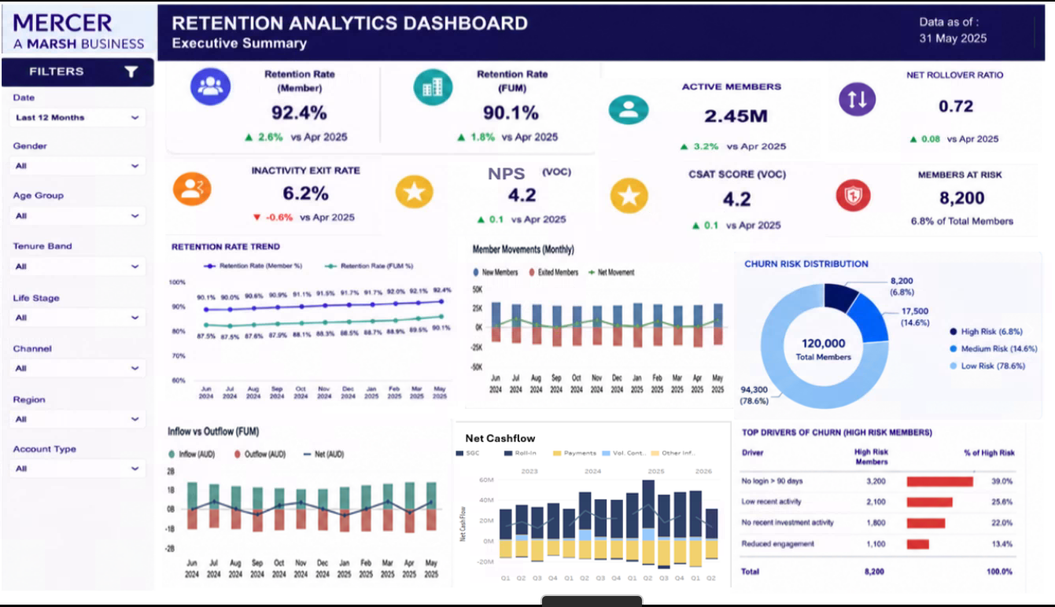
Figure 1 – Retention Analytics Dashboard mock-up

Area | Specification
Header | Dashboard title, executive-summary label and reporting/data-as-of date.
Left filter panel | Date, Gender, Age Group, Tenure Band, Life Stage, Channel, Region and Account Type.
Top KPI area | Retention, activity, rollover, inactivity, NPS, CSAT and members-at-risk indicators.
Middle analytics | Retention trend, member movements and churn-risk distribution.
Lower analytics | FUM inflow/outflow and net cashflow.
Right-side insight area | Top drivers of churn among high-risk members.

7.2 Member Drill Through Report
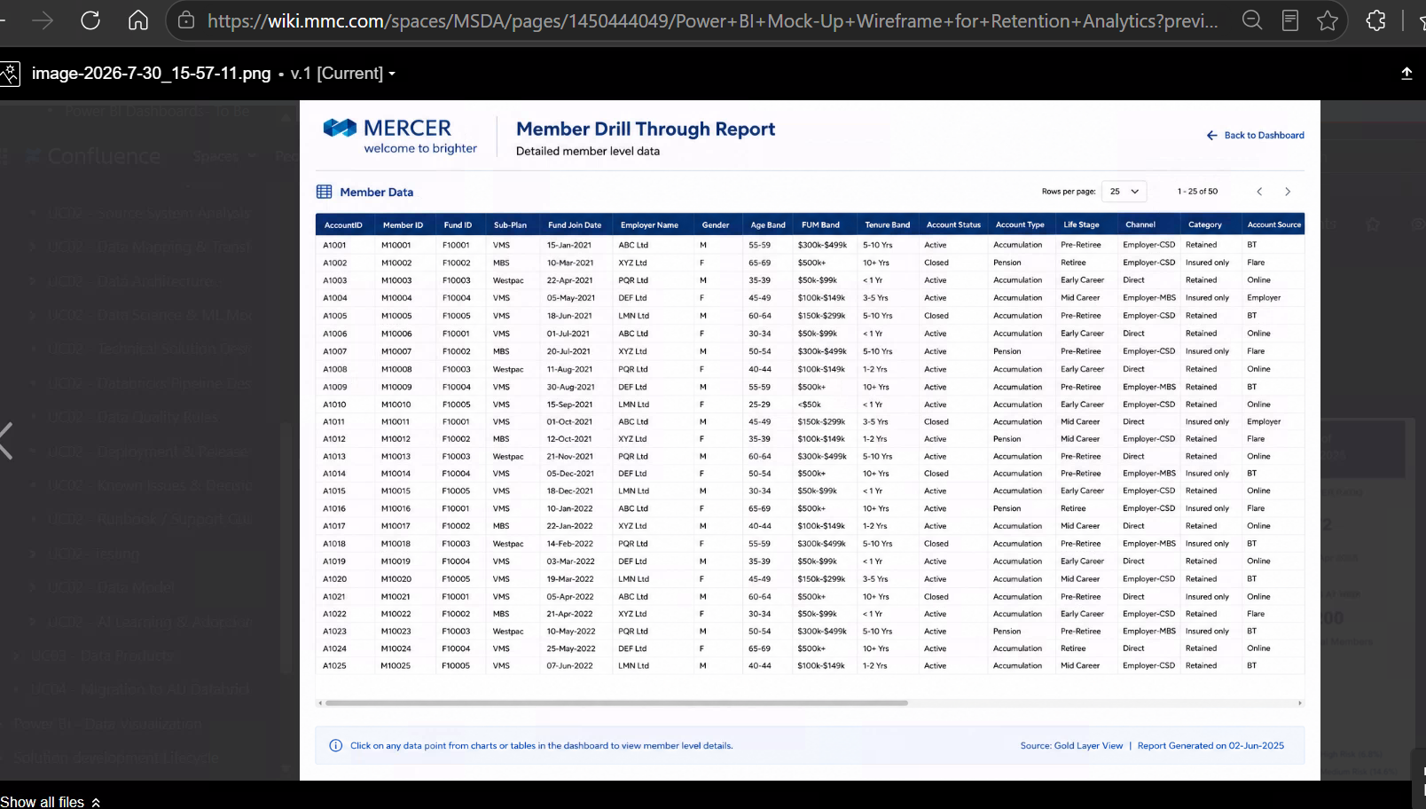
Figure 2 – Member Drill Through Report mock-up

Visible field / element | Expected purpose
Account ID | Account-level identifier.
Member ID | Member-level identifier for traceability.
Fund ID / Sub-Plan | Fund and plan context.
Fund Join Date | Member/account joining information.
Employer Name | Employer context.
Gender / Age Band | Demographic segmentation.
FUM Band / Tenure Band | Financial and tenure segmentation.
Account Status / Account Type | Account classification and status.
Life Stage / Channel | Business segmentation.
Category / Account Source | Additional classification shown in mock-up.
Pagination | Paginated member-level records.
Back to Dashboard | Navigation to originating dashboard.

7.3 BD4 – Retention Modelling Core Metrics
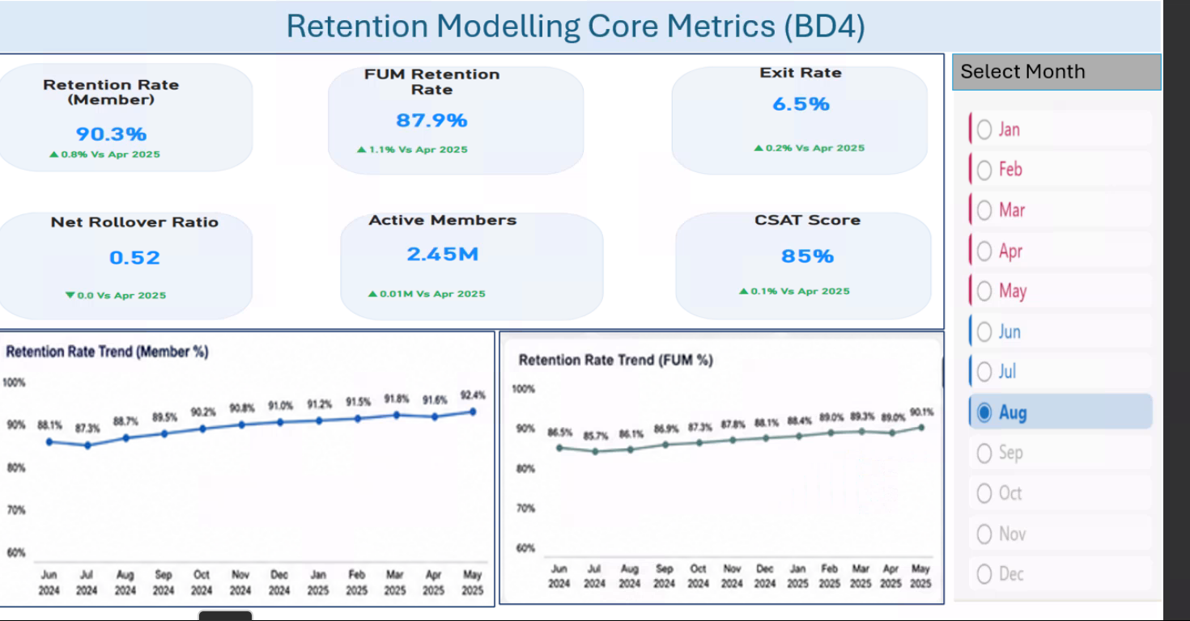
Figure 3 – BD4 Retention Modelling Core Metrics mock-up

- Six core KPI cards are shown: Member Retention Rate, FUM Retention Rate, Exit Rate, Net Rollover Ratio, Active Members and CSAT Score.
- Separate Member Retention and FUM Retention trend visuals are shown.
- A month selector is provided on the right-hand side.
- The final dashboard should use the approved metric definitions from the formal FRS/BRS.

7.4 Member Behavioral Dashboard – Planned Specification
Area | Expected focus
Behavioural indicators | Login/activity, advice usage, insurance, beneficiary and inactivity-related indicators where approved.
Segmentation | Behavioural groups and retention/churn-risk segments.
Relationship analysis | Show how behaviour is associated with retention or churn risk.
Drill-through | Support investigation of members behind behavioural/risk patterns where applicable.

No final Member Behavioral Dashboard mock-up was supplied in the screenshots. The above is therefore a scope-level specification and should be updated when the approved mock-up is available.

7.5 Rollover Dashboard – Planned Specification
The Rollover Dashboard is identified in the Confluence scope. Detailed visual specifications should be added after the approved rollover mock-up and business requirements are available.

8. User Acceptance Criteria
ID | Acceptance criterion
UAC-01 | Dashboard displays the approved retention KPIs and reporting period.
UAC-02 | Dashboard filters update the applicable KPIs and visuals correctly.
UAC-03 | Retention trends display the expected historical periods and values.
UAC-04 | Member movements correctly distinguish new, exited and net movement.
UAC-05 | Churn risk distribution correctly reflects approved risk categories.
UAC-06 | Top churn drivers are displayed using the approved driver output.
UAC-07 | FUM inflow/outflow and cashflow visuals reconcile to approved reporting data.
UAC-08 | Drill-through opens the member-level report with the expected filter context.
UAC-09 | Member-level report displays the approved detail fields and navigation.
UAC-10 | Dashboard results reconcile with the approved source/reporting output.
UAC-11 | BD4 metrics match the approved retention metric definitions.
UAC-12 | Visual formatting, labels and navigation are consistent with the approved design.

9. Security & Compliance
Detailed security and compliance requirements remain subject to project confirmation.
- Data Security: Apply approved corporate data-security controls.
- Access Control: Implement role-based access as defined by the project security model.
- Member-level data: Restrict access according to approved privacy and business rules.
- Compliance: Follow applicable regulatory, privacy and client requirements.
- Audit Trail: Follow approved Power BI/platform monitoring and audit requirements.
No specific security model, role matrix or privacy rule has been assumed in this document.

10. Deployment Plan
Phase | Focus | Status
Phase 1 – Planning & Design | Confirm requirements, mock-ups, data model and dashboard design. | TBC
Phase 2 – Development | Build Power BI semantic model, measures, pages, visuals and drill-through. | TBC
Phase 3 – Testing | Functional testing, data reconciliation, visual validation and UAT. | TBC
Phase 4 – Deployment | Production release, access enablement, monitoring and handover. | TBC

11. Appendices
Appendix | Content
Appendix A – Dashboard Mock-ups | Approved wireframes/mock-ups for each dashboard.
Appendix B – KPI / Metric Reference | Approved KPI definitions and calculation references from the formal FRS/BRS.
Appendix C – Data Dictionary | Approved reporting fields and business descriptions.
Appendix D – Data Mapping | Source-to-reporting-layer mappings.
Appendix E – Technical Architecture | Approved Power BI/data platform architecture.
Appendix F – Glossary | Business and reporting terminology.
Appendix G – Reference Documents | FRS, BRS, Key Metrics Q&A and other approved project references.

11.1 Supplied Dashboard References
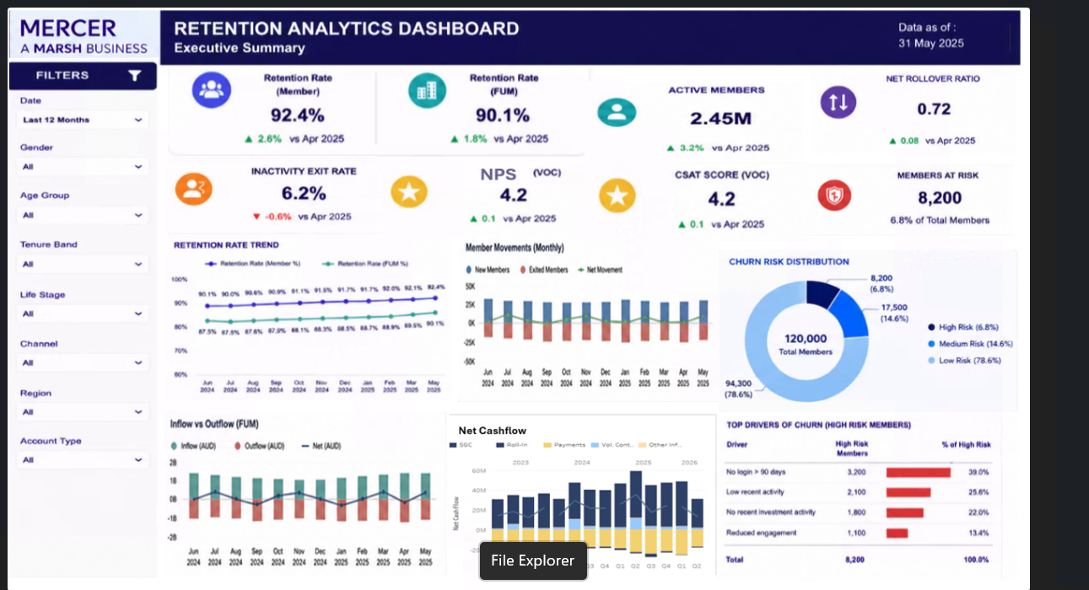
Figure 4 – Alternate supplied Retention Analytics capture

