CS 6362 Software Architectural Design

SUMMER 2013

KWIC SOFTWARE SYSTEM

PHASE I - Interim

USER MANUAL

**Submitted To**

**Dr. LAWRENCE CHUNG**

**Associate Professor,**

**Department of Computer Science – Software Engineering,**

**The University of Texas at Dallas,**

**Richardson, TX-75080**

TEAM MEMBERS

Keerthikumar Ravichandran

Jayabharathi Sundararaj

Swapnil Mirajkar

Team Website

https://utdallas.edu/~kxr123330

Table of contents:

1. What is KWIC?................................................................................................................... 4

1.1 Purpose............................................................................................................................ 4

1.2 Constraints....................................................................................................................... 4

1.3 System Requirements...................................................................................................... 4

2. Input/Output Samples of KWIC......................................................................................... 4

2.1 Start-up Screen................................................................................................................ 4

2.2 Input Screen..................................................................................................................... 5

2.3 Output Screen................................................................................................................. 5

1. WHAT IS KWIC?

The KWIC (Key Word in Context) index system shall accept an ordered set of lines, where each line is an ordered set of words, and each word is an ordered set of characters. Any line shall be **“Circularly Shifted"** by repeatedly removing the first word and appending it at the end of the line. The KWIC index system shall output a listing of all circular shifts of all lines in ascending alphabetical order.

1.1 Purpose

The notion of this user manual is to provide the users a comfortable level of operating the system. This manual provides textual as well as pictorial instructions to operate the KWIC system efficiently.

1.2 Constraints

Special characters are not allowed. Only characters, alphabets and spaces are allowed.

1.3 System Requirements

1. Windows or Unix Operating System.

No other special requirements are needed.

2. Input/ Output Screenshots of KWIC system

2.1 Start Screen

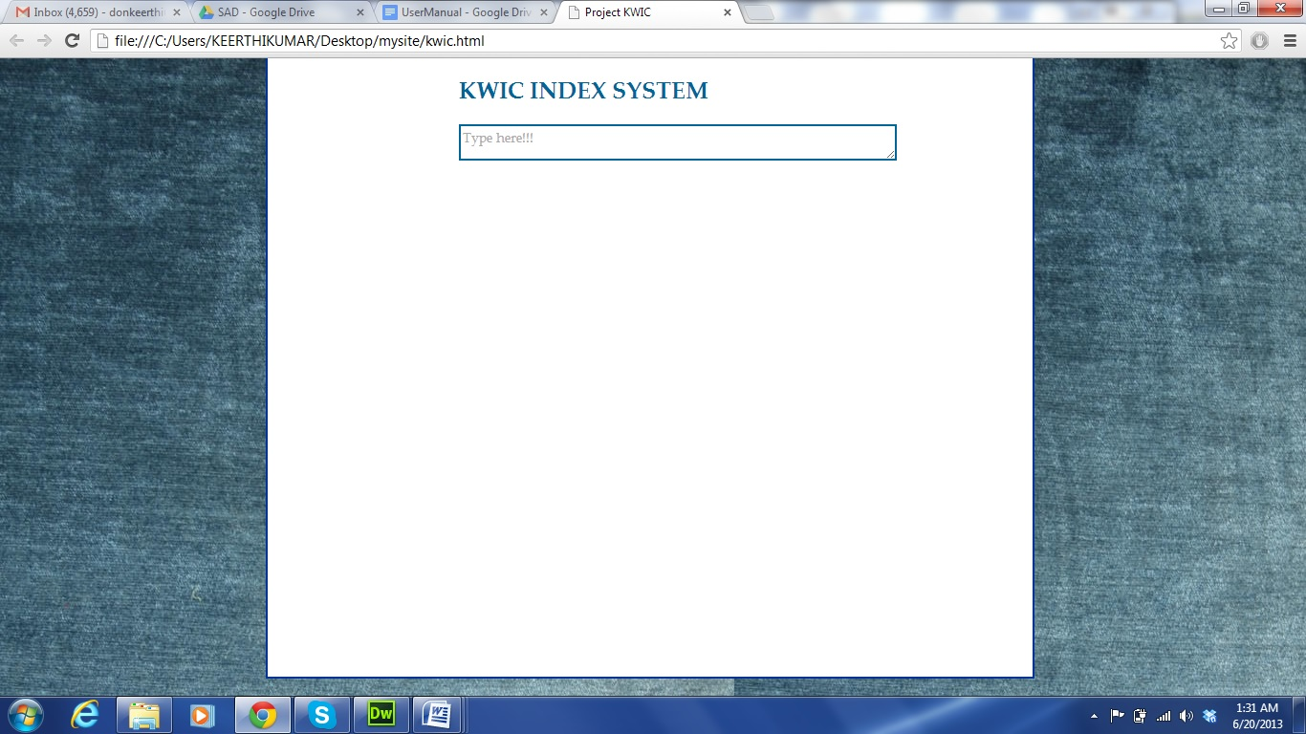

2.2 Input Screen

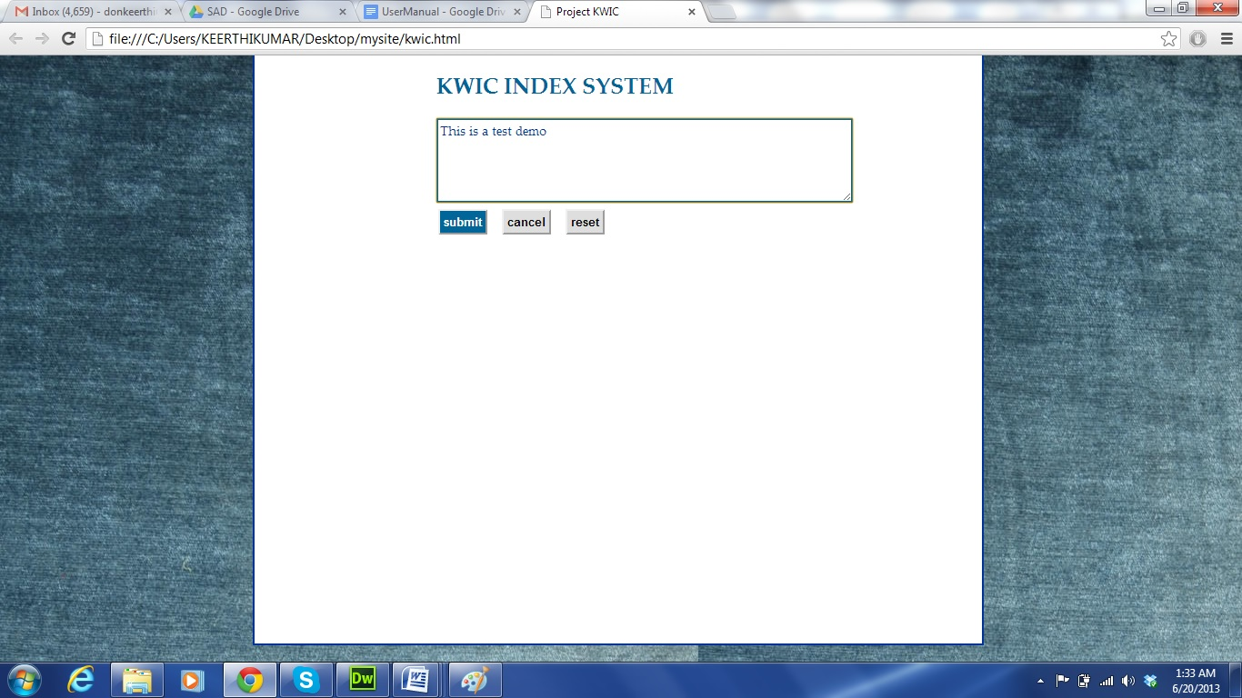

2.3 Output Screen

