**Online Banking System**

-By

Keerthikumar Ravichandran

Jayabharathi Sundararaj

Anvesh Ragi

Rasagna Ramireddy

Prepared for

Object Oriented Analysis and Design

Instructor: Banu Kapoor, Ph.D.

Spring 2013

**Table of Contents**

**1. Introduction**

1.1 Purpose

1.2 Scope

1.3 Overview

**2. General Description**

2.1 Product Perspective

2.2 Assumptions and Dependencies

**3.1 External Interface Requirements**

*3.1.1 Hardware Interfaces*

*3.1.2 Software Interfaces*

*(Proposed or estimated)*

*3.1.3 Communications Interfaces*

*(Proposed or estimated)*

**3.2 Functional Requirements**

*3.2.1 Create Account*

*3.2.2 Login*

*3.2.3 View Balance*

*3.2.4 Make Transfers*

*3.2.5 View Billing Statements*

*3.2.6 Account Alerts/Updates*

*3.2.7 Manage Account*

*3.2.8 Log Out*

**3.3 Use Cases**

*3.3.1 Use Case #1: Create Account*

*3.3.2 Use Case #2: Login*

**3.4 CLASS DIAGRAM**

**5 Non-Functional Requirements**

*3.5.4 Reliability*

*3.5.5 Maintainability*

*3.5.6 Portability*

**4. Analysis Models**

4.1 Sequence Diagrams

4.2 ACTIVITY DIAGRAMS

**5. Change Management Process**

**A. Appendices**

A.1 Appendix 1: References

# **1. Introduction**

## Online Banking System provides is specifically developed for online banking for Balance Enquiry, Funds Transfer to another account, View Transactions, View Updates / Alerts, Mini statements.

## 1.1 Purpose

## The Traditional way of maintaining details of a user in a bank was to enter the details and record them. Every time the user needs to perform some transactions he has to go to bank and perform the necessary actions, which may not be so feasible all the time. It may be a hard-hitting task for the users and the bankers too. The project gives real life understanding of Online Banking System and activities performed by various roles in the supply chain. Here, we provide an automation for banking system through Internet.

## Online Banking System project captures activities performed by different roles in real life banking which provides enhanced techniques for maintaining the required information upto-date, which results in efficiency. The project gives real life understanding of Online Banking System and activities performed by various roles in the supply chain.

## 1.2 Scope

This Project investigates the entry threshold for providing a new transaction service

channel via the real options approach, where the entry threshold is established by using an

Internet banking system designed for the use of normal users (individuals), Industrialists, Entrepreneurs, Educational Institutions (Financial sections), Organizations and Academicians under transaction rate uncertainty.

• Customer must have a valid User Id and password to login to the system

• When an invalid password is entered a warning is given to the user that his account is going to get locked.

• After the valid user logs in he is shown the list of accounts he has with the ban along with the balance.

• On selecting the desired account he is taken to a page which shows the transactions happened in that particular account number.

• User can request for the details of the last ‘n’ number of transactions that he has performed.

• User can make a funds transfer to another account. User is provided with a transaction password which is different from the login password.

• User can transfer funds from his account to any other account with this bank. If the

transaction is successful a notification should appear to the customer, in case it is

unsuccessful, a proper message should be given to the customer as to why it failed.

• User can view his monthly as well as annual statements.

• All users are authenticated to avail the services

## 1.3 Overview

SRS includes two sections General description and Function/ Non Functional requirements along with UML, Use-Case, Class, Sequence and Activity Diagrams.

General description will describe major role of the system components and interconnections.

Function/Non Functional requirements along with UML, Use-Case, Class, Sequence and Activity Diagrams will describe roles & functions of the actors in the form of images.

# **2. General Description**

# Customer must have a valid User Id and password to login to the system. After the valid user logs in he/she is shown the list of accounts he has with the bank along with present balance corresponding account. On selecting the desired account he is taken to a page which shows the present balance in that particular account number, user can request details of the last ‘n’ number of transactions he has performed. User can make a funds transfer to another account. User is provided with a transaction password which is different from the login password. User can transfer funds from his account to any other account with this bank. If the transaction is successful a notification should appear to the customer, in case it is unsuccessful, a proper message should be given to the customer as to why it failed. User can view his monthly as well as annual statements.

## 2.1 Product Perspective

## The client/customer will have client interface in which he can interact with the banking system. It is a web based interface which will be the web page of the banking application. Starting a page is displayed, which is login page where the user can enter the login details. If the login particulars are valid then the user is taken to a home page where he has the entire transaction list that he can perform with the bank. All the above activities come under the client interface.

## He will also have a login page where he can enter the login particulars so that he can perform all his actions.

## 2.2 Assumptions and Dependencies

# • Every user should be comfortable of working with computer and net browsing.

• He should be aware of the banking system.

## 3.1 External Interface Requirements

### 3.1.1 Hardware Interfaces

(Proposed or estimated)

Client Side (IE)

Processor Ram Disc Space

Internet Explorer

Pentium II at

500 MHz 64 MB 1 GB

Server Side

Application server V5.0

Pentium III at 1 GHz 512 MB 2 GB

SQL 2005 Pentium III at (Database server)

1 GHz 512 MB 1GB (Excluding data size)

### 3.1.2 Software Interfaces

### (Proposed or estimated)

User on Internet: Web Browser, Operating System (any) Application Server: IIS/APACHE

Data Base Server: SQL2005

Network: Internet

Development Tools: DOTNET SQLSERVER

### 3.1.3 Communications Interfaces

### (Proposed or estimated)

• Client/Customer on Internet will be using HTTP/HTTPS protocol.

• Client/Customer on Intranet will be using TCP/IP protocol.

• A Web Browser such as IE 6.0 and above or equivalent.

## 3.2 Functional Requirements

The functional requirements describe the services provided by the system to the users. It also refers to what the user needs to do on the internet banking system. The various functional requirements of the internet banking system are described below.

### 3.2.1 Create Account

3.2.1.1 Introduction

The create account functionality allows the users to create an online account with the bank. The users enter their personal information, username and password to create a new account. The users can access the online banking system using this username and password.

3.2.1.2 Inputs

First name, Last name, Email, Phone number, Address, Username, Password and Security Questions and Answers.

3.2.1.3 Outputs

The system will check if the entries are valid and if so, the users will be directed to the login page.

3.2.1.4 Pre- Conditions

The user must hold a current account with the bank.

3.2.1.5 Post- Conditions

The user will enter the login page, enters the username and password and will be directed to the main page.

### 3.2.2 Login

3.2.2.1 Introduction

The users should have a valid username and password to access the system. The username and password are created for the first time in the Login page and is then stored in the system’s database. The user might be a customer or an admin to access the system.

3.2.2.2 Inputs

Username and Password

3.2.2.3 Outputs

The system will state whether the inputs are correct or not. If the inputs are correct, then it is directed to the homepage or else displays an error message.

3.2.2.4 Pre- Conditions

The user must have a valid username and password which he has created for the first time in the registration form. The user will be directed to the main page or will be displayed an alert message based on the inputs given.

3.2.2.5 Post- Conditions

The user will enter the main page and access the options from the menu.

### 3.2.3 View Balance

3.2.3.1 Introduction

The View balance allows the users to view their up to date account balance, either checking or savings.

3.2.3.2 Inputs

No inputs

3.2.3.3 Outputs

The system will show the current balance of the checking and savings account.

3.2.3.4 Pre- Conditions

The Customer must be a valid customer and signed in the system.

3.2.3.5 Post- Conditions

The customer views other options in menu or clicks ‘logout’ button.

### 3.2.4 Make Transfers

3.2.4.1 Introduction

Transfers allows the customer to transfer funds between his own accounts (i.e between checking and savings) or to an account of same bank or a different bank. The customer may also request the transfer to take place immediately or at a future date.

3.2.4.2 Inputs

Amount to be transferred, Recipient’s account number or email address, Type of account from which the money is to be transferred (Checking or savings).

3.2.4.3 Outputs

The system will display the transfer details that have been made.

3.2.4.4 Pre- Conditions

The user must be a valid user and signed in the system.

3.2.4.5 Post- Conditions

The user views other options in menu or clicks ‘logout’ button.

### 3.2.5 View Billing Statements/ Transactions

3.2.5.1 Introduction

Billing statements allows the users to view their statements for the previous months for both checking and savings account. Transactions allows user to view transaction history.

3.2.5.2 Inputs

No inputs

3.2.5.3 Outputs

The system will display the billing statements and transaction history for the month and account selected.

3.2.5.4 Pre- Conditions

The user must be a valid user and signed in the system.

3.2.1.5 Post- Conditions

The user views other options in menu or clicks ‘logout’ button.

### 3.2.6 Account Alerts/Updates

3.2.6.1 Introduction

Account Alerts/Updates allows the customer to activate mobile and email alerts for various activities in the account such as overdraft protection, Irregular credit card activity, Online Banking ID changed, Online Banking Sign-in error, etc.

3.2.6.2 Inputs

No inputs

3.2.6.3 Outputs

The system will display the various alerts and updates that can be activated for both checking and savings account.

3.2.6.4 Pre- Conditions

The user must be a valid user and signed in the system.

3.2.6.5 Post- Conditions

The user views other options in menu or clicks ‘logout’ button.

### 3.2.7 Manage Account

3.2.7.1 Introduction

This allows the customer to change password and the secure contact information. Within this feature, the customer can also change the online profile personal information that is retained by the internet banking system only.

3.2.7.2 Inputs

In the change password function a customer should enter a new password. In the update profile, the customer should change information that he/she wants to change.

3.2.7.3 Outputs

The system will show the user has been logged out successfully.

3.2.7.4 Pre- Conditions

The user must be a valid user and signed in the system.

3.2.7.5 Post- Conditions

The user views other options in menu or clicks ‘logout’ button.

### 3.2.8 Log Out

3.2.8.1 Introduction

This function is used when a logged in user finishes his/her job and wants to be logged out therefore, that no one can abuse his/her username.

3.2.8.2 Inputs

No inputs

3.2.8.3 Outputs

The system will show the user has been logged out successfully.

3.2.8.4 Pre- Conditions

The user must be a valid user and signed in the system.

3.2.8.5 Post- Conditions

The user will enter the main page.

## 3.3 Use Cases

### 3.3.1 Use Case #1: Create Account

The create account functionality allows the users to create an online account with the bank. The users enter their personal information, username and password to create a new account.

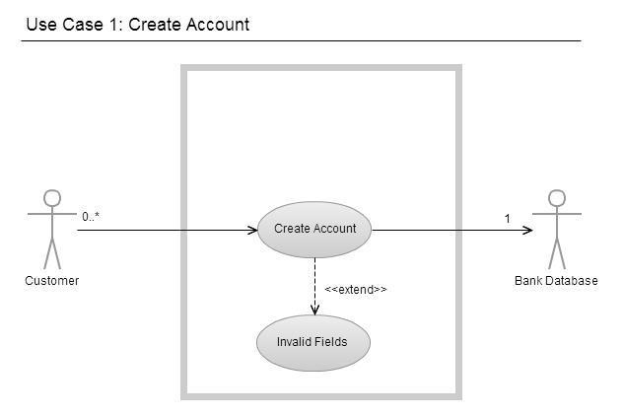

### 3.3.2 Use Case #2: Login

### The users should have a valid username and password to access the system. The username and password are created for the first time in the Login page and is then stored in the system’s database.

**3.3.3 Use Case #3: View Balance**

The View balance allows the users to view their up to date account balance, either checking or savings.

## 

**3.3.4 Use Case #4: Make Transfers**

Transfers allows the customer to transfer funds between his own accounts (i.e between checking and savings) or to an account of same bank or a different bank.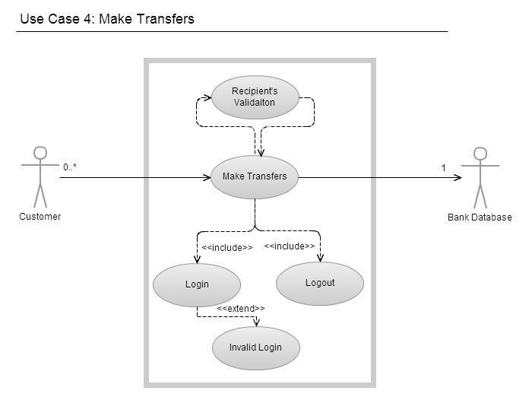

**3.3.5 Use Case #5: View Transactions**

Transactions allows the users to view their current and previous months transactions for both checking and savings account.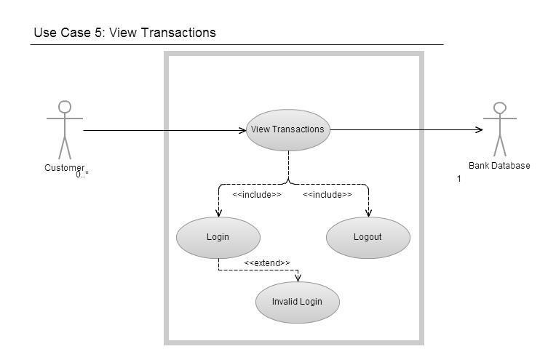

**3.3.6 Use Case #6: Account Alerts/Updates**

Account Alerts/Updates allows the customer to activate mobile and email alerts for various activities in the account such as overdraft protection, Irregular credit card activity, Online Banking ID changed, Online Banking Sign-in error, etc.

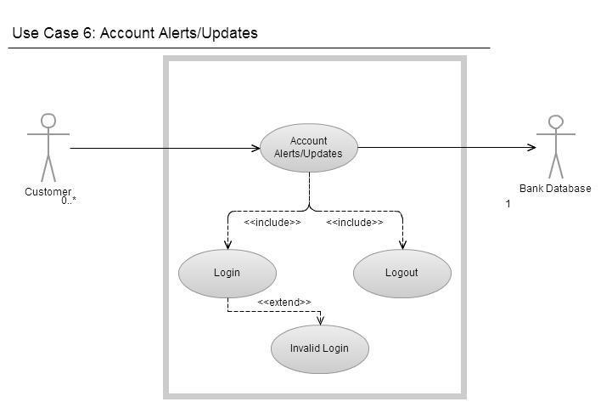

**3.3.7 Use Case #7: Manage Account**

This allows the customer to change password and the secure contact information. Within this feature, the customer can also change the online profile personal information that is retained by the internet banking system only. 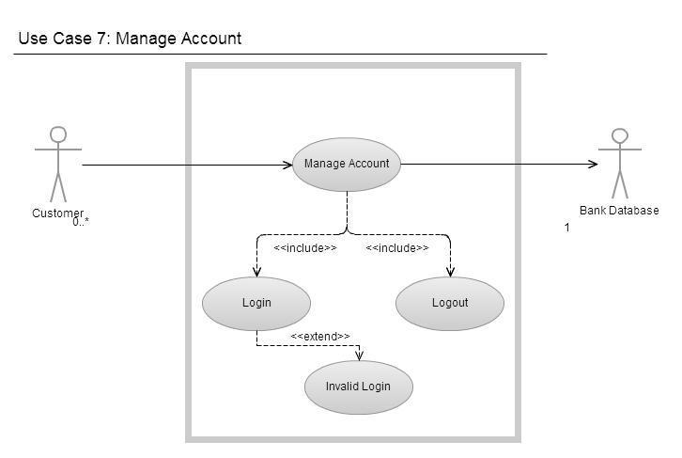

**3.3.8 Use Case #8: Logout**

This function is used when a logged in user finishes his/her job and wants to be logged out therefore, that no one can abuse his/her username.

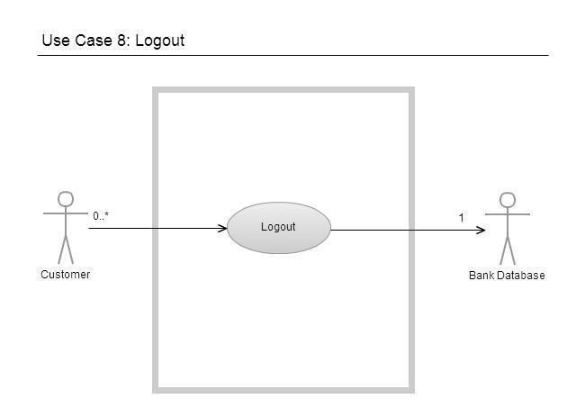

### 3.4 Class Diagram:

### The below class diagram shows that the customer can have more than one account and that relationship goes to one to many relationship. The transaction functions always depends on the web service, which means it’s a web based.

### 

## 3.5 Non-Functional Requirements

**3.5 NON-FUNCTIONAL REQUIREMENTS**

Non-functional requirements are requirements that are not directly concerned with the specific functions delivered by the system. They may relate to emergent system properties such as reliability, response time and store occupancy. They may specify system performance,security, availability, and other emergent properties. This means that they are often more critical than individual functional requirements. System users can usually find ways to work around a system function that doesn’t really meet their needs. However, failing to meet a nonfunctional requirement can mean that the whole system is unusable. Non-functional requirements needed in this internet banking system are identified as performance requirements, safety requirements, security requirements and Reliability etc.

**3.5.1 PERFORMANCE REQUIREMENTS**

**Increase Customer Satisfaction**

Internet banking system must allow customers to access banking services 24 hours a day, 365 days a year with minimum downtime period for backup and maintenance.

**Expand Product Offerings**

The new services allows bank to capture a larger percentage of their customers’ asset base. The internet banking system will provide facilities for bank to offer new services and products onto its homepage.

**Reduce Overall Costs**

It will help to reduce a bank’s costs in two fundamental ways: it minimize the cost of processing transactions and reduces the number of branches required to service an equivalent number of customer.

**3.5.2 SAFETY REQUIREMENTS**

**Backup, recovery & business continuity**

Banks should ensure adequate backup of data as may be required by their operations. Banks should also have, well documented and tested business continuity plans that address all aspects of the bank’s business.

1. Both data and software should be backed up periodically, the frequency of back up depending on the recovery needs of the application. The backup may be incremental or complete. Automating the backup procedures is preferred to obviate operator errors and missed back-ups.

2. Recovery and business continuity measures, based on criticality of the systems, should be in place and a documented plan with the organization and assignment of responsibilities of the key decision making personnel should exist.

3. An off-site backup is necessary for recovery from major failures / disasters to ensure business continuity. Depending on criticality, different technologies based on back up, hot sites, warm sites or cold sites should be available for business continuity. The business continuity plan should be frequently tested.

**3.5.3 SECURITY REQUIREMENTS**

Transactions should be private and secure. Therefore, we have applied the very latest in technology when creating the Internet Banking security architecture. The best way to understand the security architecture within the Internet Banking is to take it one step at a time. These security features are described briefly below. Account ID and Password (PIN) Protection User Account ID and Password (PIN) protection occurs at the first level within the Internet Banking System. To access Internet Banking, users are required to enter an Account ID and password. Without these, access to the Internet Banking System is denied. Special password characters may be imposed by the Bank to provide a greater degree of security. The following characters may be used as required :!@#$%^&*()_+-=[]{}|\;:’”,<.> /? To further increase the level of security, the bank may impose a periodic change of passwords. If the Password Change option is imposed, a warning message will be displayed when logging-onto Internet Banking. Auto Timeout Screen Blanking. Although we recommend users never leave a PC unattended and financial information displayed while logged into Internet Banking, a built-in security feature minimizes the risk in such a situation. Users are required to acknowledge the message (Continue) presented in order to remain active in the Internet Banking session. The auto timeout feature warns users every 30 seconds prior to a pending timeout. If allowed to timeout, the Internet Banking session is halted and users are presented once again with the logon screen. Sign-off Button When an end-user is finished with Internet Banking, they should click the Sign-off button before going anywhere else on the Web. This ends the Internet Banking session. Failed logon Attempts as an added security feature, the Internet Banking System is denied access after a predetermined number of failed logon attempts. If users have been locked out due to exceeding the predetermined number of logon attempts, the users must contact the Bank in order to be reinitialized. Encryption In addition to password protection, we ensures server authentication by using the latest techniques of data encryption. Data encryption is a way of translating data into a form that is unintelligible without a deciphering mechanism.

### 3.5.4 Reliability

Internet banking renders location and time irrelevant, and empowers customers with greater control of their accounts. Banks achieve cost and efficiency gains in a large number of operational areas.

### 

### 3.5.5 Maintainability

* The aptitude of a system to undergo repair and evolution.
* The ease with which a software system or component can be modified to correct faults, improve performance, or other attributes, or adapt to a changed environment.
* The ease with which a hardware system or component can be retained in, or restored to a state in which it can perform its required functions.

### 3.5.6 Portability

Portability in high level computer programming is the usability of the same software in different environments. The pre-requirement for portability is the generalized abstraction between the application logic and system interfaces. When software with the same functionality is produced for several computing platforms, portability is the key for development cost reduction.

## 

## 4.1 Sequence Diagrams

## 4.1.1 Login

## The below sequence diagram represents the login action of customer.

**4.1.2 View Balance**

This diagram represents the customer action of viewing the balance.

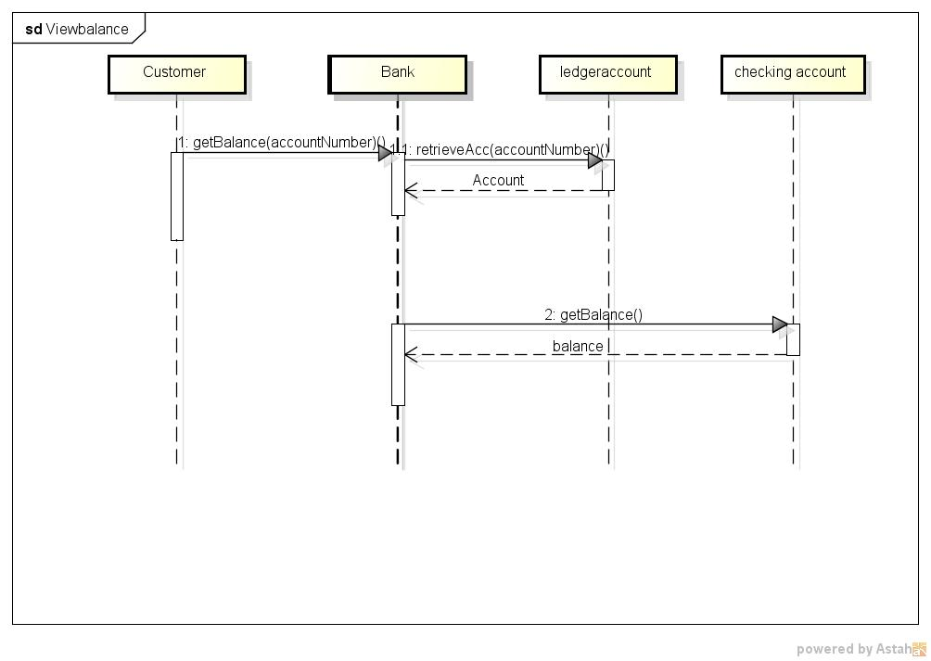

**4.1.3 Make Transfers**

The below diagram show the action of transferring money between the accounts in same bank and different banks.

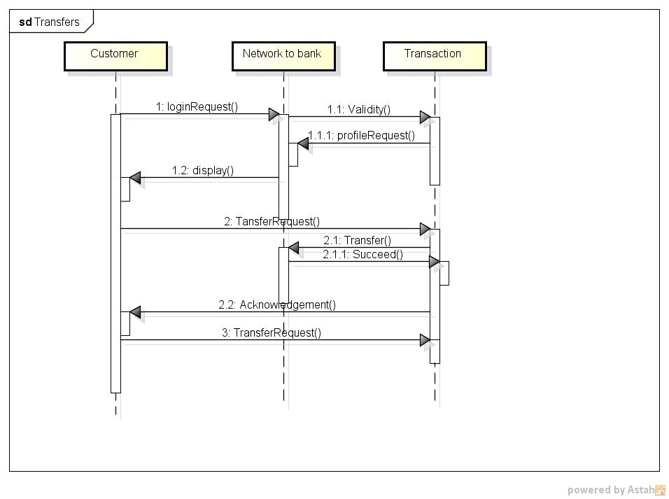

**4.1.4 View Transactions**

This diagram describes the action of view the transactions made by customers.

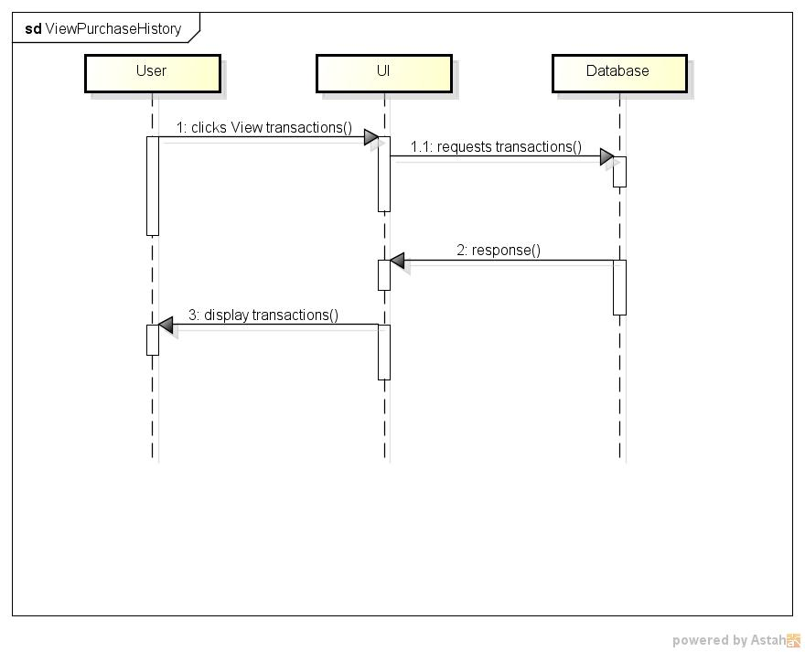

## 4.1.5 Email Alerts/Notifications

This describes the action of sending email alerts to the customer about the transactions or important updates.



## 4.1.6 Manage Accounts

This diagram represents the action of managing account such as change password etc.

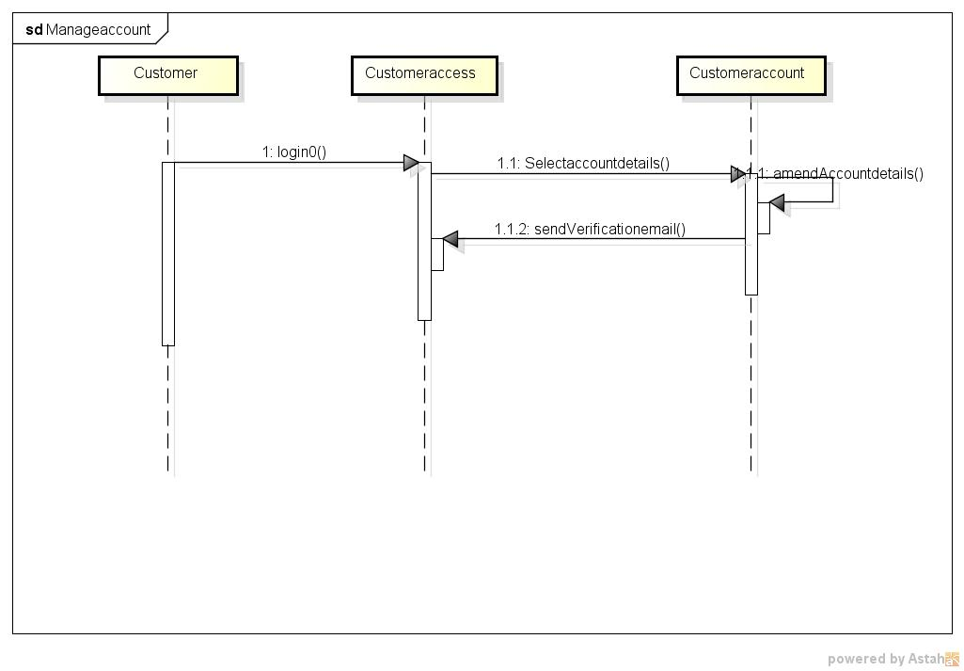

**4.1.7 Logout**

This sequence diagram explains the customer’s logout action

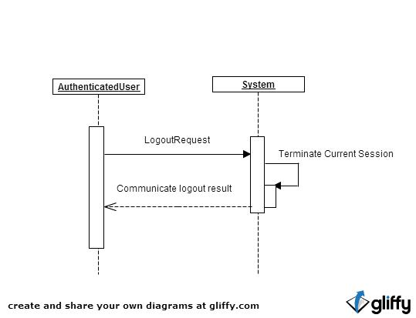

## 

## 

## 

## 

## 

## 

## 

## 

## 4.2 Activity Diagrams

**4.2.1 Create Account**

The user create a new account by providing his personal details such as name, username, password, etc. Using the username and password he logs into the system.

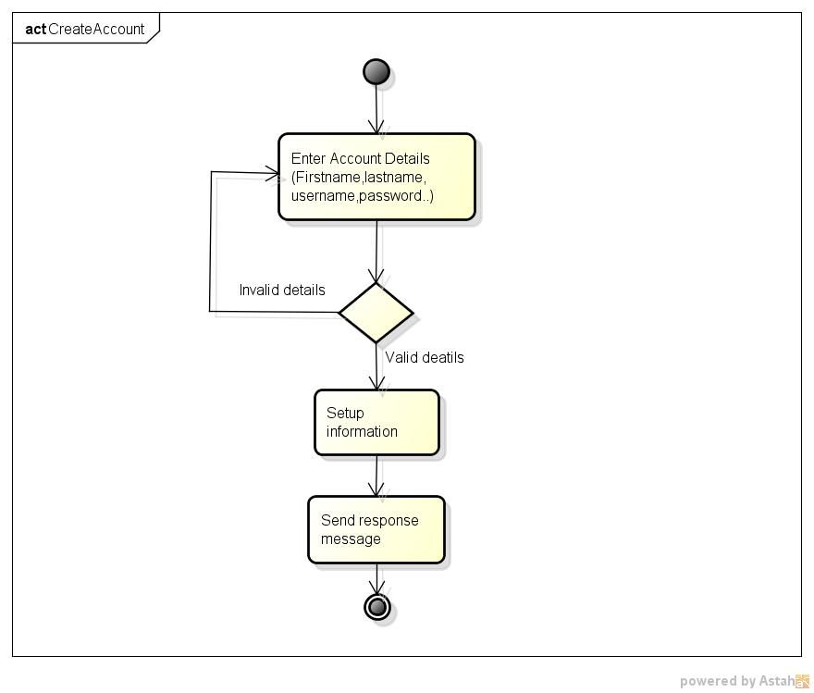

# **4.2.2 Login**

The user using his username and password which was created using account creation logs into the system and makes activities.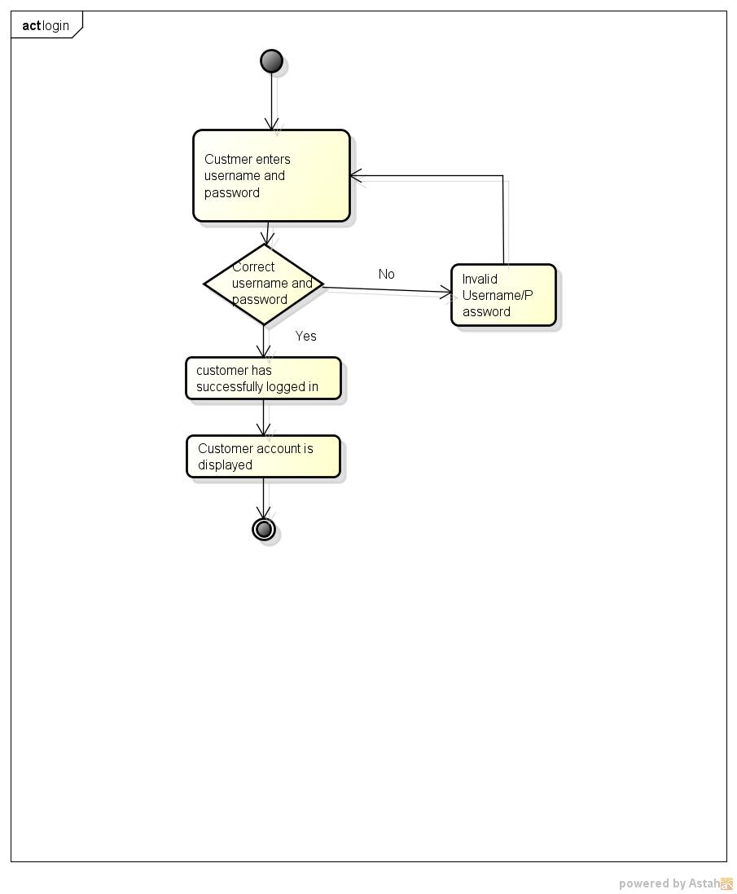

# **4.2.3 View Balance**

The user logs into the system and views his current balance from both checking and savings account.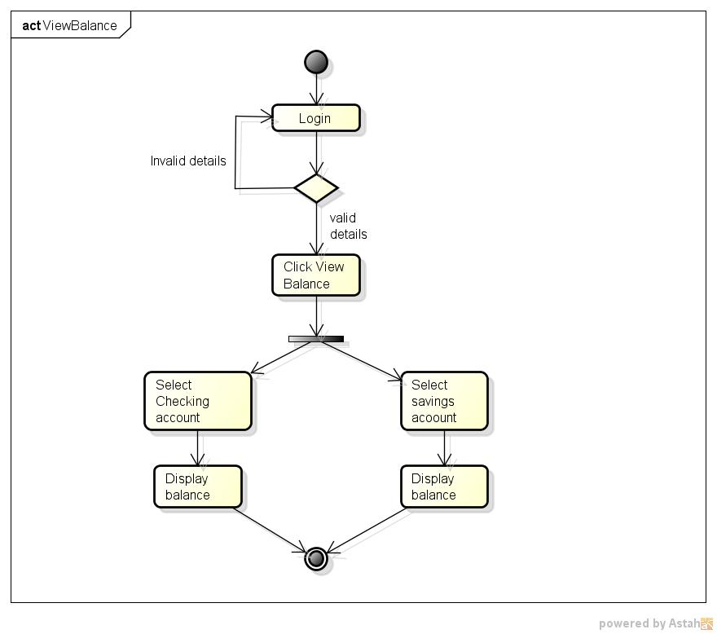

# **4.2.4 Make Transfers**

The user can transfer money from his account to another account. The system checks for available balance in the account, if the amount to be transferred is present in the account,then the transfer is made.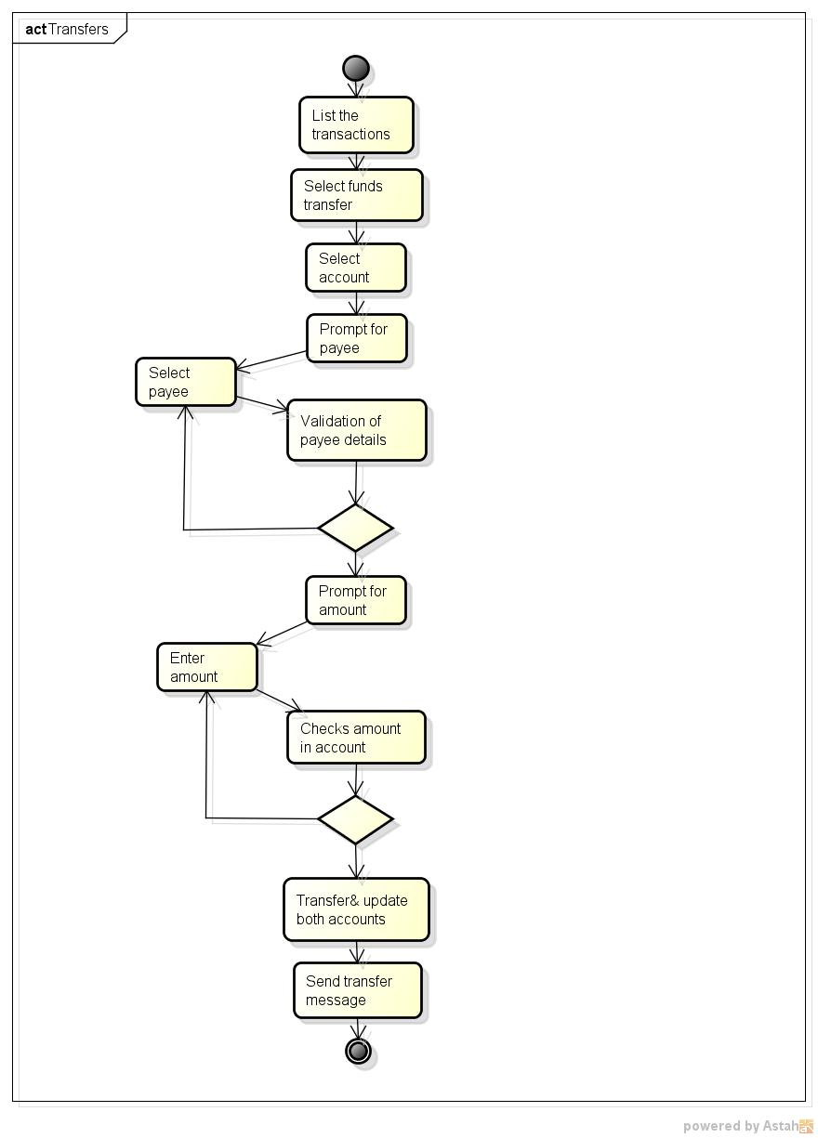

# **4.2.5 View Transactions/ Billing Statements**

The user can view his transaction history or the billing statements for the desired month.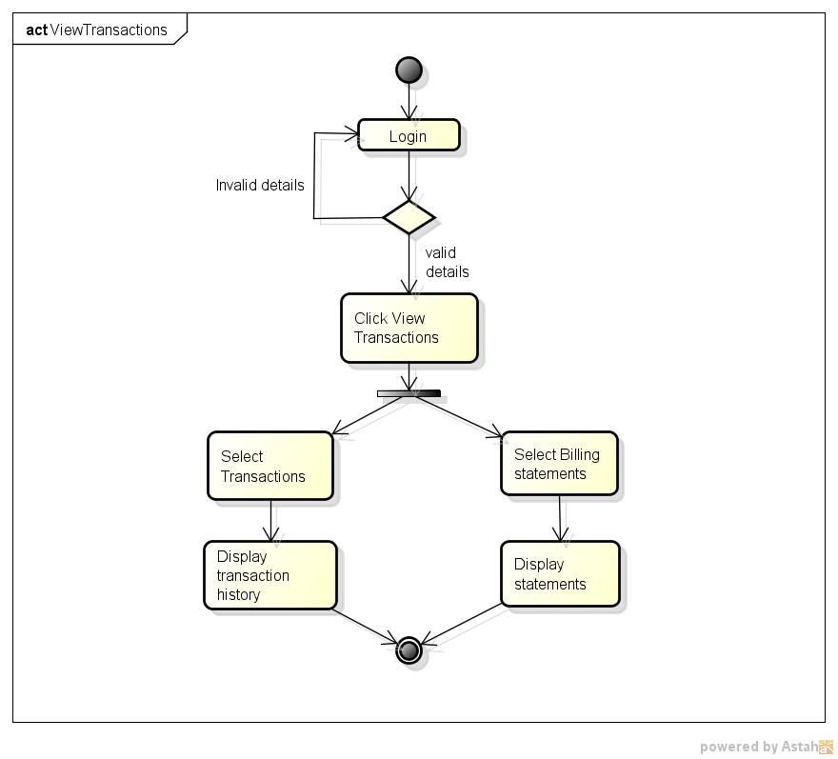

# **4.2.6 Manage Account**

The user can make changes in his account such as changing his billing address, changing password and all other personal information.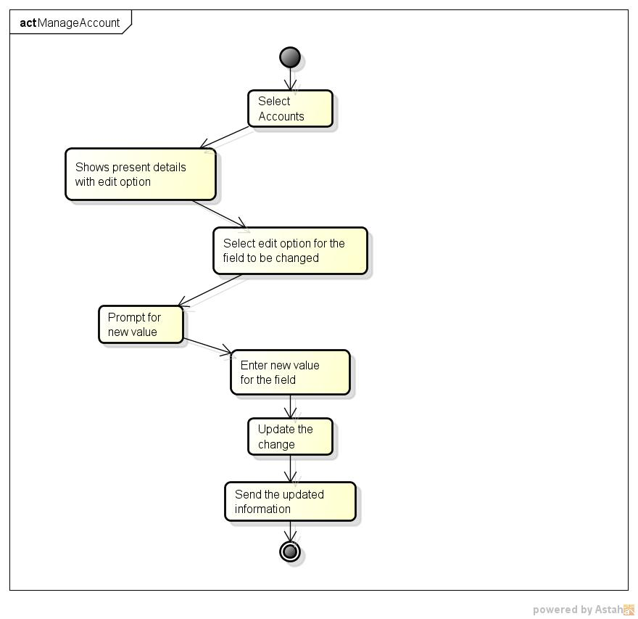

# 

# **4.2.7 Account Alerts/ Updates**

The user can subscribe for email alerts which sends notification emails for alerts such as illegal card usage, low balance, overdraft protection, etc.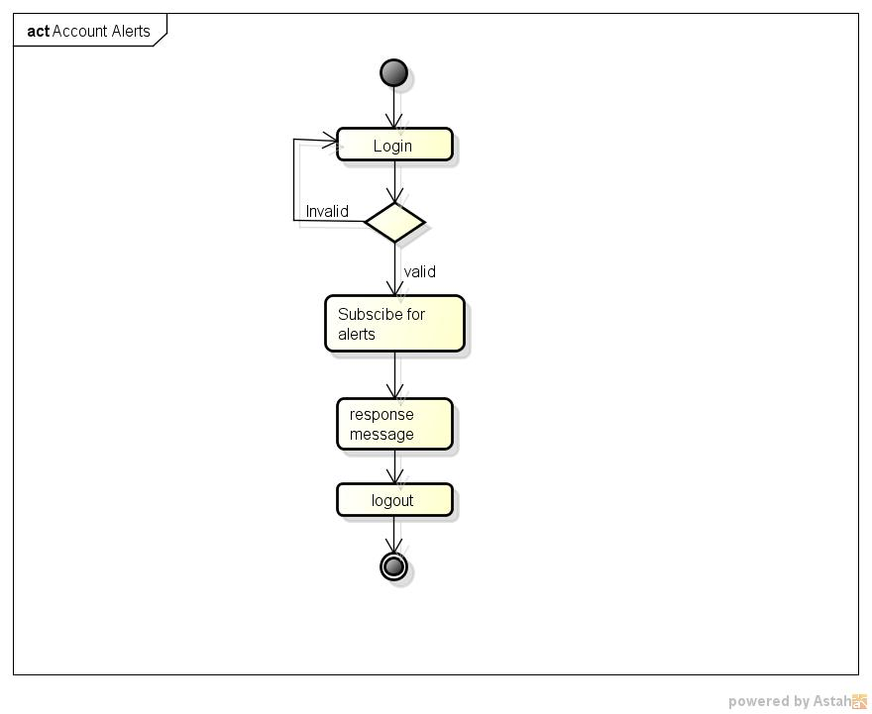

# **4.2.8 LogOut**

The user logs out of the system when all his activities inside the system are completed.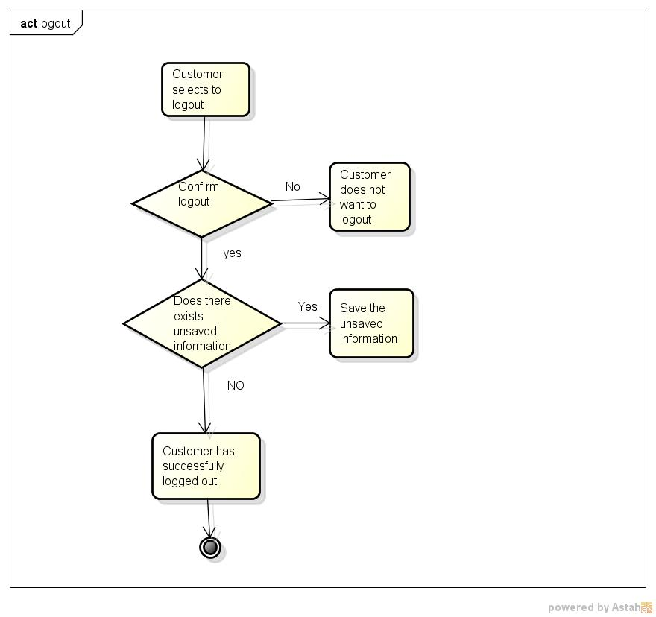

# **5. Change Management Process**

Google Docs is used to store the document and shared among the group members to check in the file and edit the document with changes and then to check out after successful edition.

# **A. Appendices**

## A.1 Appendix 1: References

• Sathye. M.(1999) “Adoption of Internet banking. The International journal of Bank Marketing.

Vol.17. pp. 324-334.

• Barry Williams.(2008).www.databaseanswers.org/data_models/online_banking/facts.htm

• Bank Of America website(www.bankofamerica.com)

• Google search engine(www.google.com--> Online Banking)