AWS EC2 Direct Root Login via SSH
Ubuntu • MobaXterm • Root Password Authentication

Practical step-by-step documentation

This document contains the corresponding steps and commands used to configure and verify direct root login on an AWS Ubuntu EC2 instance.

Security note: Direct root login with an SSH password is suitable for a controlled lab demonstration, but it is not recommended for a public production server. After the lab, restore safer SSH settings and use the normal Ubuntu user with sudo.

Step 1 – Open the EC2 instance connection page
In the AWS EC2 console, open the running Linux instance and select Connect. The connection page shows the instance information, SSH client details, public address, and the default Ubuntu username.
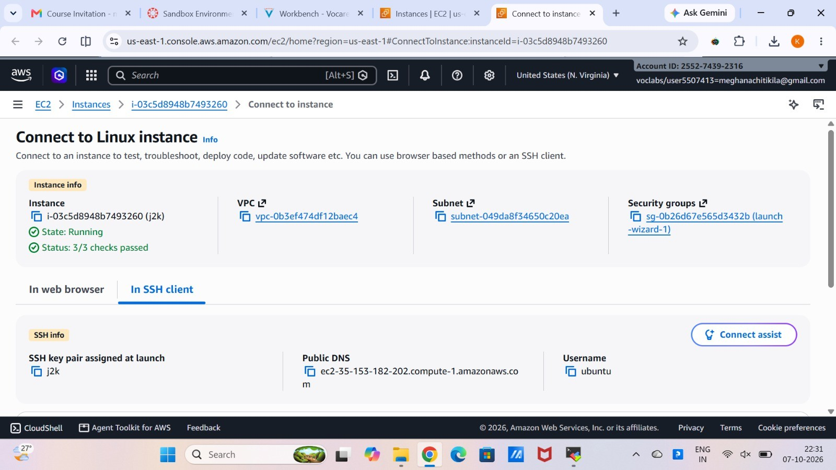

What this step demonstrates: Purpose: Identify the running EC2 instance and obtain the SSH connection details.
Tip: Keep the EC2 instance running and note its current public IPv4 address before opening the SSH session.

Step 2 – Create an SSH session in MobaXterm
Open MobaXterm and choose Session → SSH. Enter the EC2 public host, port 22, and the initial username
ubuntu. Select the private key (.pem) downloaded when the EC2 instance was created.
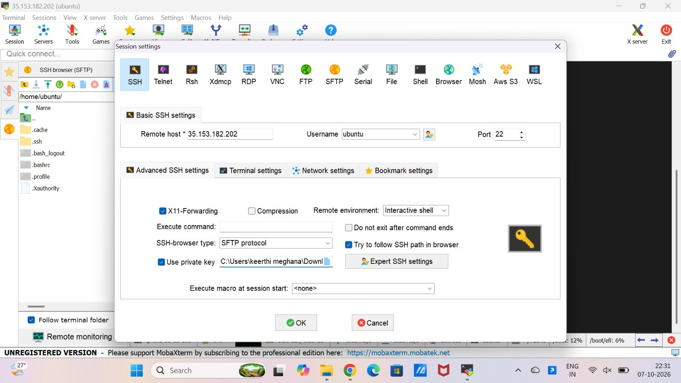

What this step demonstrates: Purpose: Establish the initial secure SSH connection to the Ubuntu server.

Step 3 – Verify the Ubuntu SSH login
After connecting, verify that the terminal opens as the Ubuntu user. A prompt similar to ubuntu@ip-…:~$
confirms that the SSH connection is working.
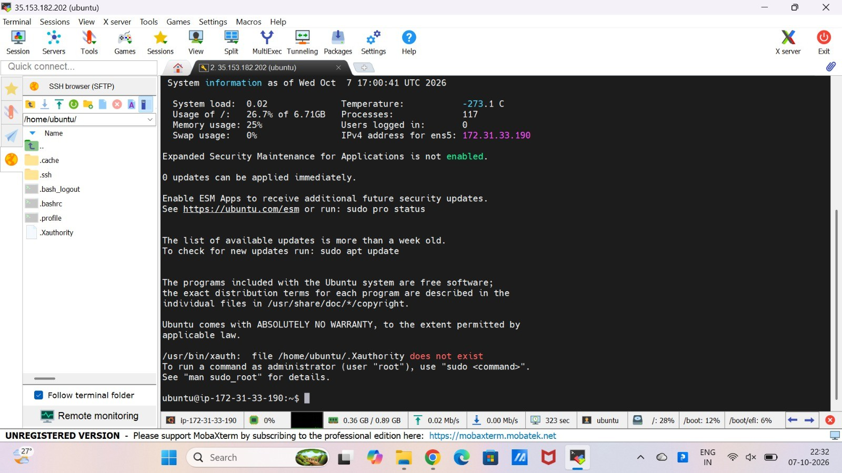

What this step demonstrates: Purpose: Confirm successful access before changing SSH configuration.

Step 4 – Open the SSH server configuration
From the Ubuntu session, open the SSH server configuration with:

sudo nano /etc/ssh/sshd_config

Locate the settings related to root login and password authentication.
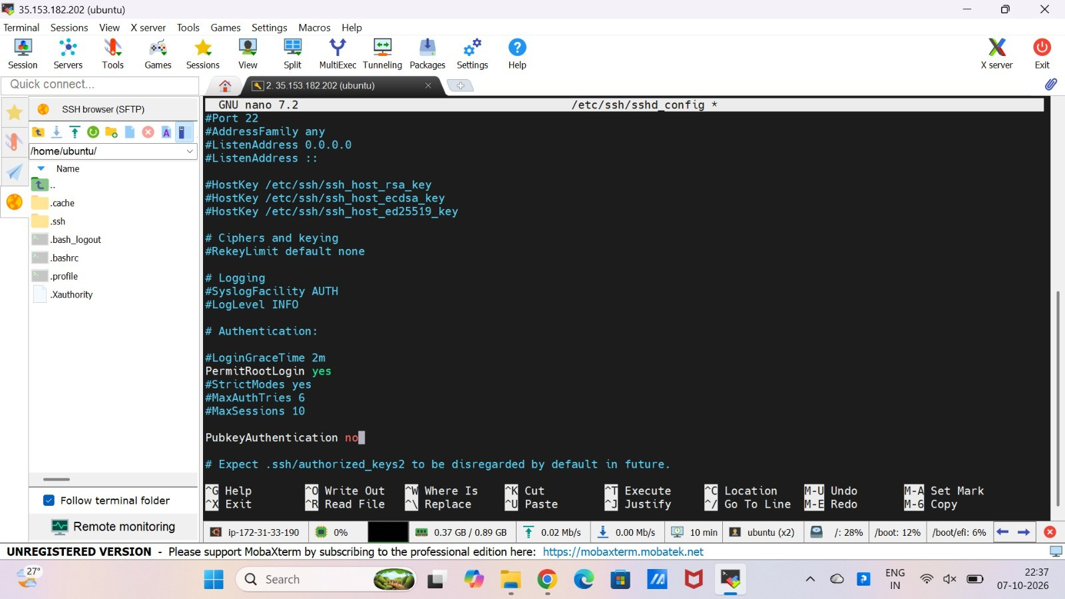

What this step demonstrates: Purpose: Configure the SSH daemon to permit the required root/password login.

Step 5 – Configure root and password authentication
In /etc/ssh/sshd_config, set the required options to allow direct root login and password authentication:

PermitRootLogin yes PasswordAuthentication yes

Save the file with Ctrl+O, press Enter, and exit with Ctrl+X.
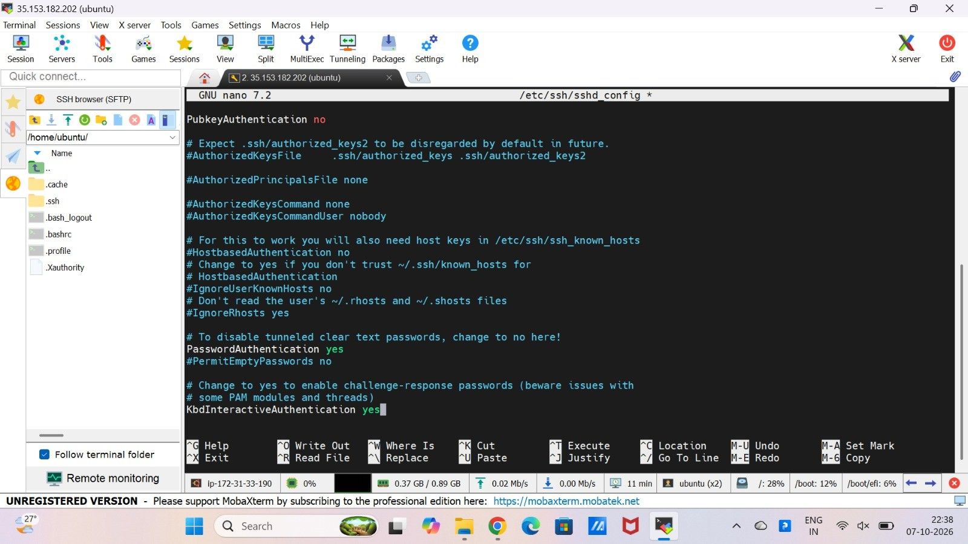

What this step demonstrates: Note: For a public AWS server, direct root/password SSH access is less secure and should normally be disabled after the lab/demo.

Step 6 – Return to the terminal
After saving the SSH configuration, return to the terminal. The Ubuntu session remains available and can be used to perform the remaining configuration commands.
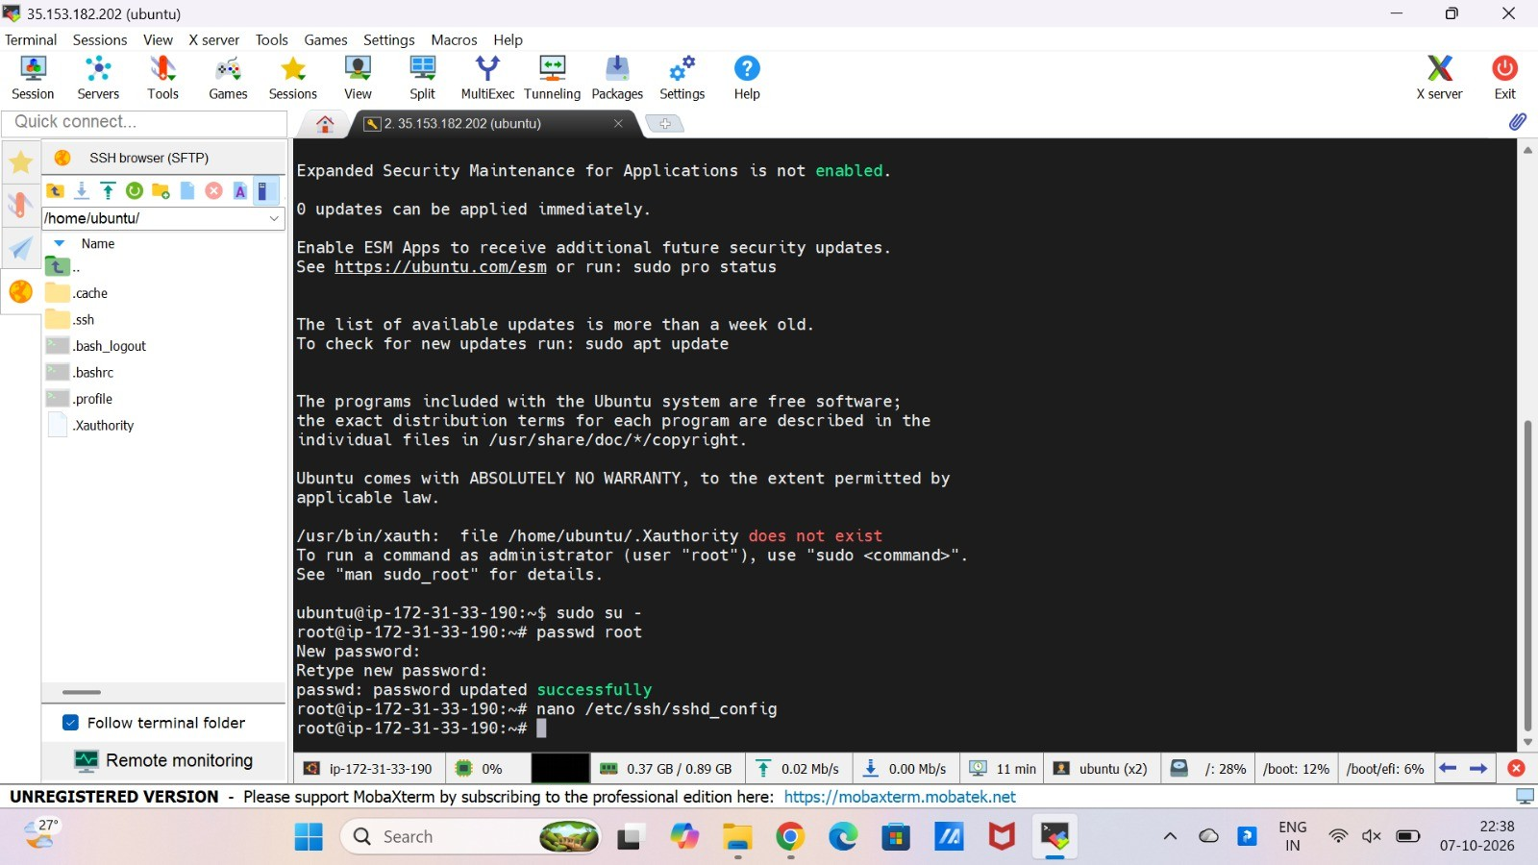

What this step demonstrates: Purpose: Continue the setup without closing the working SSH session.

Step 7 – Set a password for the root account and validate SSH
Switch to the root shell and set the root password using:

sudo su - passwd root

Then validate the SSH configuration with sshd -t. If there is no output, the syntax check passed. Restart SSH with systemctl restart ssh.
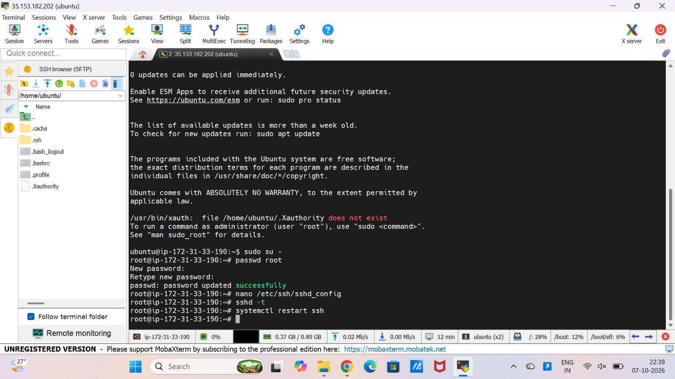

What this step demonstrates: Purpose: Create the root password and apply the SSH configuration safely.
Important: Never store the actual root password or the private-key file in Git/GitHub.

Step 8 – Create a new MobaXterm root SSH session
Create a new SSH session in MobaXterm using the same EC2 public host, username root, and port 22. For a password-login test, leave Use private key unchecked so MobaXterm can request the root password.
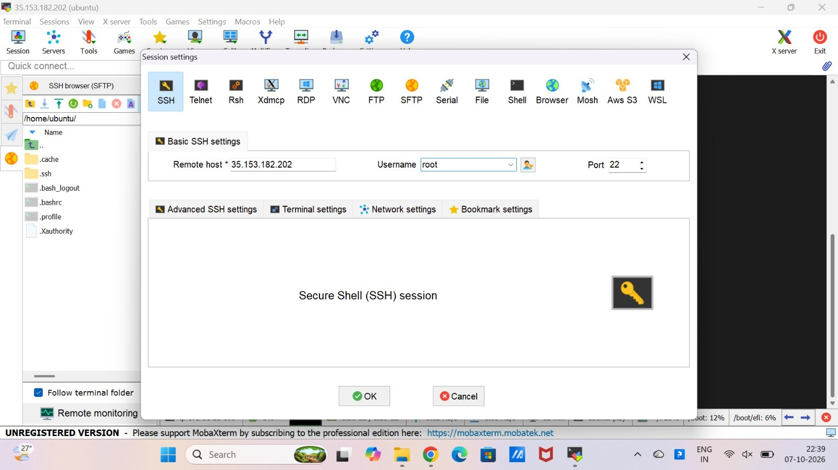

What this step demonstrates: Purpose: Test direct root authentication instead of using sudo/sudo su after login.

Step 9 – Enter the root password
When MobaXterm displays a password prompt, enter the password created with passwd root. Successful authentication should open a root shell.
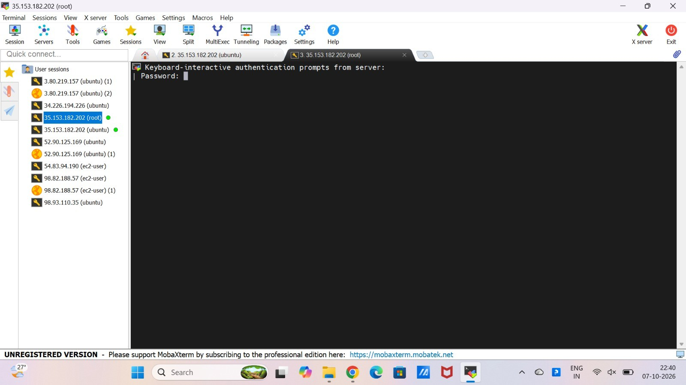

What this step demonstrates: Purpose: Authenticate directly as root using the configured password.
Expected result: The session should open as root and show a prompt ending in #.

Step 10 – Verify the EC2 instance details
The AWS EC2 console can be used to verify that the same running instance is being accessed. Check the instance ID and public IPv4 address before documenting the result.
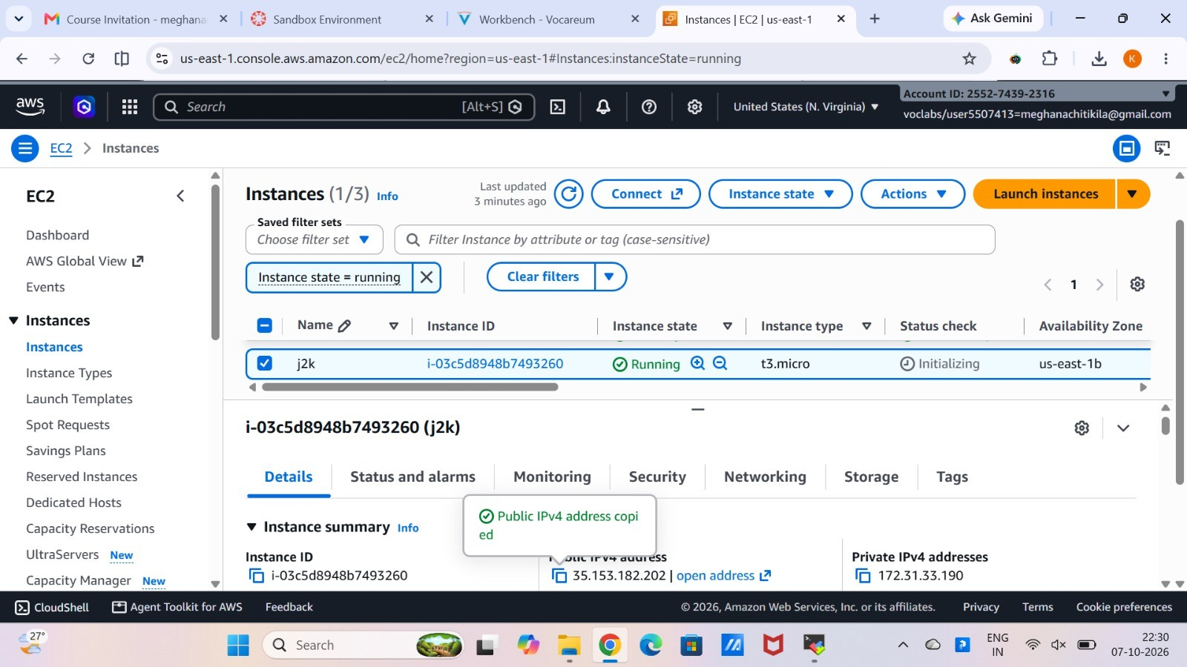

What this step demonstrates: Purpose: Confirm that the SSH session corresponds to the intended EC2 instance.

Step 11 – Confirm the root shell
The successful MobaXterm session shows a prompt similar to root@ip-…:~#. The # prompt and the username root indicate that the session is directly logged in as root.
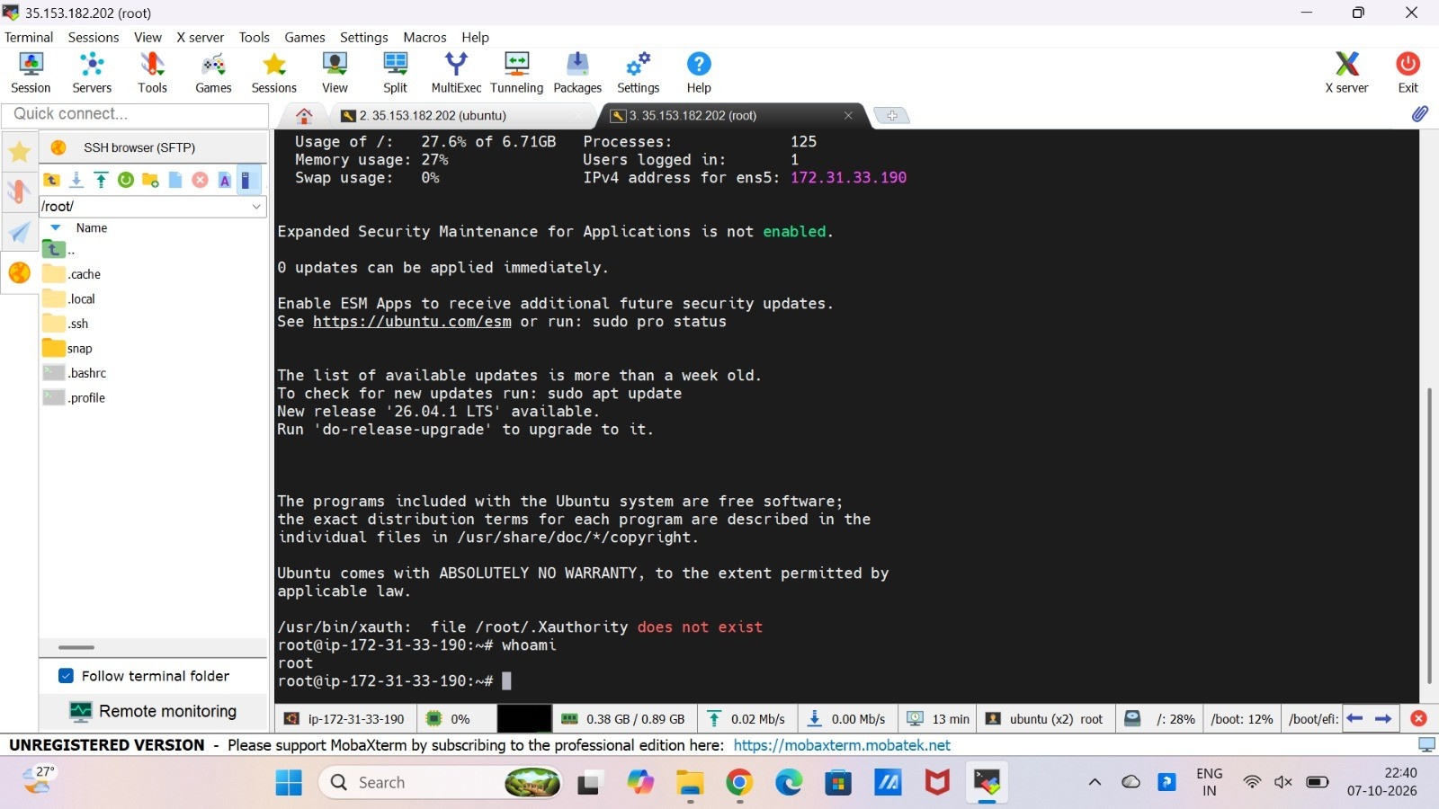

What this step demonstrates: Optional verification command: whoami should return root.

Step 12 – Final verification
The final screenshot documents the completed direct root login. The server is accessible through MobaXterm as the root user without first logging in as ubuntu and running sudo su.
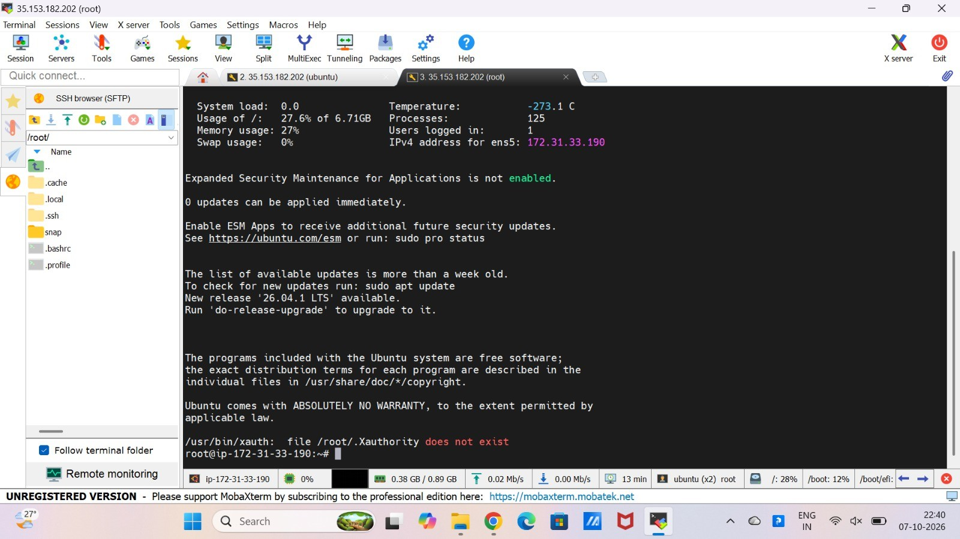

What this step demonstrates: Result: Direct root + password SSH login completed for the lab task.

