**H&R BLOC.K**

**FILING OPTIONS & PRODUCTS TAX INFORMATION & TOOLS Q**



**OVERVIEW BECOME A FRANCHISEE SELL YOUR BUSINESS LOCATIONS FOR SALE**

## Converting your tax business to an H&R Block franchise can make a lot of sense - and dollars.



You've built a successful tax business. We can help you expand it. There are many benefits to joining our team. For starters, you have the backing of an indu stry-leadingbrand withmore than 60 years of experience. But there are more perks to converting to an H&R Block franchise. A lot more, including a competitive purchase price for your tax business when you come aboard. Learn why an H&R Block franchise opportunity may be right for you.

**EXPAND YOUR BUSINESS** >



## Join now. Sell later.

Are you looking to create a long-ter m exit strategy that will allow you to retire within the next 10 years? We specialize in creating personalized plans that can protect the value of your business while you benefit from a competitive buyout package.

**LEARNMORE** >

## When it's time to retire, leave your business, clients, and staff in good hands.

The decision to sell your business is not easy. There is a lot to consider. What will happento your clients and employees? How do you maximize the value of your business? Togeth er, we will create a plan that works best for you. See why hundreds of tax business owners have sold their business to H&R Block.

**SELL YOUR BUSINESS** >

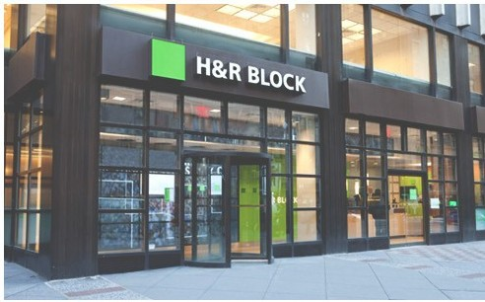





**GROWTH AND EXPANSION**

"I converted my businessbecause I wanted to grow and expand. Each year I have been able to attract and retain hundreds of new clients because of their products and services. I enjoy the best of two worlds; the rewards of running my own business and the support of a nationwide industry leader."

' **HanwookJo** - **3 Locations** < >

**REQUEST MORE INFORMATION**

Request more information about joining H&R Block or to sell your business.

**COMPANY INFO**

Learn about the history, values, and vision of the H&R Block brand.

***cclark***

*2017-05-22 15:50:51*

--------------------------------------------

Wrap an <h1> tag around this heading.

***cclark***

*2017-05-23 13:34:49*

--------------------------------------------

Text should float over image using CSS andHTML. Avoid embedding text within an image since search engines will not be able to crawl this text.

***cclark***

*2017-05-23 13:34:53*

--------------------------------------------

Content should be wrapped in a <p> tag. It should not be embedded within an image.

***cclark***

*2017-05-22 15:51:57*

--------------------------------------------

Optimize buttons by wrapping link text and URL within an <a> tag. Do not embed text into the button.

***cclark***

*2017-05-22 15:51:55*

--------------------------------------------

Optimize buttons by wrapping link text and URL within an <a> tag. Do not embed text into the button.

***cclark***

*2017-05-22 15:57:55*

--------------------------------------------

Wrap an <h2> around this heading.

***cclark***

*2017-05-22 15:57:59*

--------------------------------------------

Wrap an <h2> around this heading.

***cclark***

*2017-05-22 15:58:02*

--------------------------------------------

Wrap an <h2> around this heading.

***cclark***

*2017-05-22 15:58:08*

--------------------------------------------

Wrap an <h2> around this heading.

***cclark***

*2017-05-22 16:01:03*

--------------------------------------------

Hidden content (not exposed upon initial render) may not be valued as much by Google. Ideally, it's recommended to expose all content rather than to hide it through arrows. However, this specific content block is not a high priority to expose.

***cclark***

*2017-05-22 16:05:12*

--------------------------------------------

Wrap an <h3> around this heading.

***cclark***

*2017-05-22 16:05:16*

--------------------------------------------

Wrap an <h3> around this heading.

***cclark***

*2017-05-22 17:10:12*

--------------------------------------------

Update text to be more descriptive like: "Join a long-term exit strategy"

***cclark***

*2017-05-22 17:10:40*

--------------------------------------------

Optimize buttons by wrapping link text and URL within an <a> tag. Do not embed text into the button.

***cclark***

*2017-05-22 17:10:39*

--------------------------------------------

Optimize buttons by wrapping link text and URL within an <a> tag. Do not embed text into the button.

***cclark***

*2017-05-22 17:36:30*

--------------------------------------------

Avoid using words like "Learn More." Instead update anchor text to be: "Learn More About H&R Block" or "Learn More About Our Company"

**Contact Us Learn More**

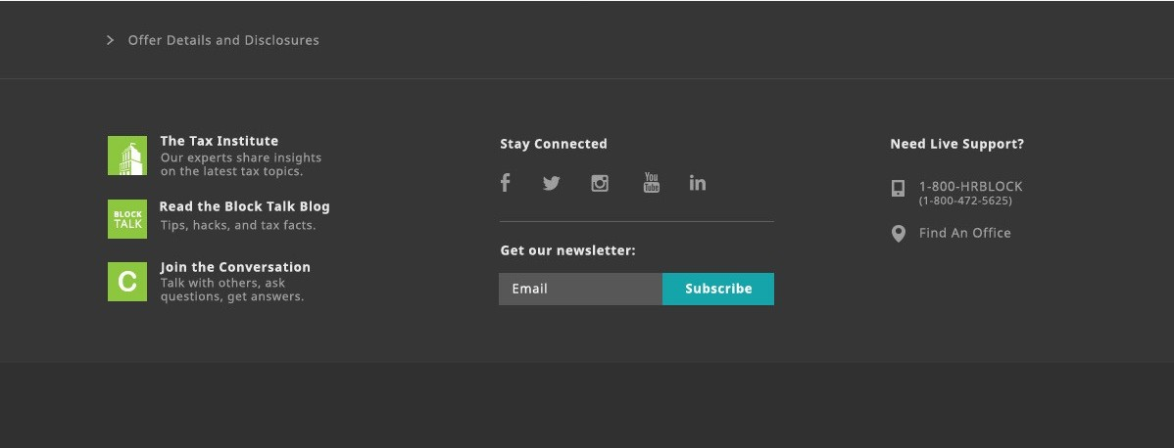

**H&R BLOC.K**

**FILING OPTIONS & PRODUCTS TAX INFORMATION & TOOLS Q**

The Value of Our Brand



**OVERVIEW**

**BECOME A FRANCHISEE**

**SELL YOUR BUSINESS**

**LOCATIONS FOR SALE**

There's one name you can trust to help expand your business.

Joining our team comes with the backing of a well-known and respected brand. We have the experience, systems, and support teams that will help you grow your business. We work with you so that you, your employees, and your clients all benefit from becoming an H&R Block franchise.

**OVER 60 YEARS OF EXPERIENCE BRAND STRENGTH**

Since 1955, we've prepared more than 650million tax returns and have annual revenues exceeding $3 billion. With H&R Block, you have the resources of a large corporation, but the personalized service of a small firm.

**IBM WATSON PARTNERSHIP**

We lead the way in technology and innovation. Our partnership with IBMWatson gives Tax Professionals the added power of data.Imagine having the ability to provide your clients with every credit and deduction possible. The combined insights of Tax Professionals and Watson mean added value to our clients.

What's in a name? A lot. H&R Block is one of the most recognized and respected brands around the world. Our name represents strength, expertise and stability.

**I T' S YOUR BUSINESS**

You remain in charge of your business and make all the decisions. You continue to set your own pricing, hours of operation, hire andtrain your staff and more. Our franchisees enjoy their independence, while benefiting from our support. On average, our franchisees have been with us for over 20 years and own three or more locations.

Support and Training

**GROWTH PROGRAMS**

•

We can help you grow your business. Our year-round marketing and advertising is designed to drive

clients intoyour location. You may even receive annual advertising dollars to spend in your local market to help grow your business. We'll also help you buy a competitor by paying up to 70% of the purchase price.

••• **LOCAL SUPPORT TEAM**

,,,

With H&R Block, you're never on your own. We have a strong field management team that will provide personalized service and the resources you need. Plus you'll have a team of professionals that provide free, individualized public relations and marketing assistance.They'll help you promote your business wit hin your local community.

**THE TAX INSTITUTE**

Have a tough or unusual tax situation? The H&R Block Tax I n stit ut e is comprised of highly experienced tax attorneys, CPAs, enrolled agents, and others. They are available to help research, analyze, and resolve difficult tax questions. They also publish original analysis on tax topics in the industry press.

**BEST IN CLASS TRAINING**

We have over 250 year-round continuing education tax courses and business management classes offered online. Many of the courses are offered in Spanish.

**rn FINANCIAL ASSISTANCE**

H&R Block will invest in your business to help you achieve your goals. We provide financial assistance

with off season support, bad debt relief, and capital for future growth.

Superior Product s and Services

**H&R BLOCK GUARANTEE**

If the IRS audits your clients, H&R Block will assist you in answering their questions.

**REFUND ANTICIPATION CHECKS**

An added service that provides

**H&R BLOCK EMERALD PREPAID M ASTERCARD®**

Millions of our clients love this rewards card.

**PEACE OF MI ND® EXTENDED SERVICE PLAN**

**H&R BLOCK EMERALD ADVANCE"' LINE OF CREDIT**

Your clients can repeatedly use this year-round line of credit for all those unexpected emergencies.

**TAX IDENTITY SHIELD**

We created Tax Identity Shield® as a tool

convenience for your clients. A worry free guarantee thatis availableto your clients that ensures any additional taxes assessed because of an error wilI be paid by H&R Block.



Frequently Asked Quest ion s

to help better protect those concerned about identity theft andtax fraud.

**Q What qualities does H&R Block look for in a prospective franchisee?** +

**Q What type of training do you offer new franchisees?** +

**Q How much field support will I receive to establish and operate my franchise?** +

**Q How much advertising, marketing and public relations support can I expect?** +

**Q Can I expand my franchise to include multiple offices?** +

**Q Can I purchase an existing H&R Block franchise location?** +

**REQUEST MORE INFORMATION**

Request more information about joining H&R Block or to sell your business.

**COMPANY INFO**

Learn about the history, values.and vision of the H&R Block brand.

***cclark***

*2017-05-22 17:20:42*

--------------------------------------------

Wrap an <h2> around this heading.

***cclark***

*2017-05-22 17:20:45*

--------------------------------------------

Wrap an <h2> around this heading.

***cclark***

*2017-05-22 17:20:48*

--------------------------------------------

Wrap an <h2> around this heading.

***cclark***

*2017-05-22 17:20:51*

--------------------------------------------

Wrap an <h2> around this heading.

***cclark***

*2017-05-22 17:20:55*

--------------------------------------------

Wrap an <h2> around this heading.

***cclark***

*2017-05-22 17:22:01*

--------------------------------------------

Wrap an <h3> tag around this heading.

***cclark***

*2017-05-22 17:22:04*

--------------------------------------------

Wrap an <h3> tag around this heading.

***cclark***

*2017-05-22 17:22:24*

--------------------------------------------

Wrap an <h3> tag around this heading.

***cclark***

*2017-05-22 17:22:22*

--------------------------------------------

Wrap an <h3> tag around this heading.

***cclark***

*2017-05-22 17:22:21*

--------------------------------------------

Wrap an <h3> tag around this heading.

***cclark***

*2017-05-22 17:22:19*

--------------------------------------------

Wrap an <h3> tag around this heading.

***cclark***

*2017-05-22 17:22:39*

--------------------------------------------

Wrap an <h3> tag around this heading.

***cclark***

*2017-05-22 17:22:36*

--------------------------------------------

Wrap an <h3> tag around this heading.

***cclark***

*2017-05-22 17:22:34*

--------------------------------------------

Wrap an <h3> tag around this heading.

***cclark***

*2017-05-22 17:22:32*

--------------------------------------------

Wrap an <h3> tag around this heading.

***cclark***

*2017-05-22 17:22:30*

--------------------------------------------

Wrap an <h3> tag around this heading.

***cclark***

*2017-05-22 17:22:56*

--------------------------------------------

Wrap an <h3> tag around this heading.

***cclark***

*2017-05-22 17:22:53*

--------------------------------------------

Wrap an <h3> tag around this heading.

***cclark***

*2017-05-22 17:22:52*

--------------------------------------------

Wrap an <h3> tag around this heading.

***cclark***

*2017-05-22 17:22:50*

--------------------------------------------

Wrap an <h3> tag around this heading.

***cclark***

*2017-05-22 17:22:48*

--------------------------------------------

Wrap an <h3> tag around this heading.

***cclark***

*2017-05-22 17:22:44*

--------------------------------------------

Wrap an <h3> tag around this heading.

***cclark***

*2017-05-22 17:23:43*

--------------------------------------------

Wrap <h3> tags around Questions.

***cclark***

*2017-05-22 17:36:17*

--------------------------------------------

Avoid using words like "Learn More." Instead update anchor text to be: "Learn More About H&R Block" or "Learn More About Our Company"

***cclark***

*2017-05-22 17:36:44*

--------------------------------------------

Optimize buttons by wrapping link text and URL within an <a> tag. Do not embed text into the button.

***cclark***

*2017-05-22 17:36:43*

--------------------------------------------

Optimize buttons by wrapping link text and URL within an <a> tag. Do not embed text into the button.

**Contact Us Learn More**

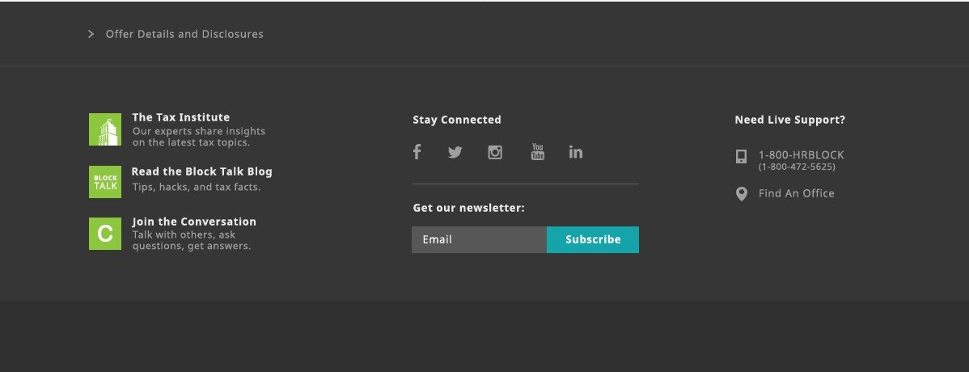

**H&R BLOC.K**

**FILING OPTIONS & PRODUCTS TAX INFORMATION & TOOLS** Q



**OVERVIEW BECOME A FRANCHISEE SELL YOUR BUSINESS LOCATIONS FOR SALE**

Are you ready to retire or

looking to create an exit strategy?

H&R Block offers competitive buyout packages and will work withyouto develop **a** plan that meets your retirement timeline. We encourage you to stay involved in the business until you are readyto retire. We'll work with you to retain your staff so clients continue to receive the same great service from the team they know and trust.

When the t ime is right, H&R Block is the right choice.

The decision to sell your business is a difficult one. We understand the importance of a smooth transition for you, your employees, and your clients. Here are just some of the benefits of selling your business to H&R Block.

J oin Now, Sell Later

H&R Block offers both a short-term and long-term exit strategy for those who plan on retiring in the future.

These options not only give you the freedom to decide when you want to retire, they also come with the following benefits.

**RECEIVE AN UPFRONT CASH PAYMENT**

**WE OFFER GENEROUS BUYOUT PACKAGES**

**FLEXIBLE TRANSITION PERIOD THAT IN CLUDES CO-BRAND ING**

**YOUR STAFF WILL CONTINUE TO BE YOUR STAFF, EVEN AFTER THEY JOIN THE H&R BLOCK FAMILY**

**WE WILL DEAL DIRECTLY WITH YOU, NO NEED TO PAY BROKER FEES**

**WE ARE A QUALIFIED BUYER WITH A SOLIDREPUTATION**

**LONG-TERMSUCCESSIONPLAN NING**

Flex ib le succession plan that puts the control in your hands.

**FLEXIBILITY**

You decide when you retire. And you don't need to decide right now. There is no set tim eframe. It can be 4 years, 7 years, or even 10 years from now.

**CONTROL**

A purchase price is negotiated now sothere are no surprises when you decide to sell. As your businessgrows over the years, so does the purchase price.

**CASH NOW**

You'll receive a substantial upfr ont cash payment now, even th ough you may wait to sell years from now.

**YOU RUN THE SHOW**

When you join our team, you continue to manage the business and make business decisions. This includes setting your own pricing and hiring your own staff.

**MAXIMIZE THE VALUE OF YOUR BUSINESS**

You can continue to grow your business and create an **exit** strategy down the road. As your business grows, so does the purchase price.



Frequently Asked Questions About Selling Your Business

**Q Why should I sell to H&R Block?** +

**Q What type of firm isH&R Block looking for?** +

**Q If I sell to H&R Block, how will it affect my clients and my staff?** +

**Q How does H&R Block value my firm?** +

**Q When is the best time to sell my business?** +

**Q How do I get started if I am interested in learning more?** +

**REQUEST MORE INFORMATION**

Request more information about joining H&R Block or to sell your business.

**COMPANY INFO**

Learn about the history, values, and vision of the H&R Block brand.

***cclark***

*2017-05-22 17:24:03*

--------------------------------------------

Wrap an <h2> around this heading.

***cclark***

*2017-05-22 17:24:10*

--------------------------------------------

Wrap an <h2> around this heading.

***cclark***

*2017-05-22 17:24:18*

--------------------------------------------

Wrap an <h2> around this heading.

***cclark***

*2017-05-22 17:24:22*

--------------------------------------------

Wrap an <h2> around this heading.

***cclark***

*2017-05-22 17:24:51*

--------------------------------------------

Wrap <h3> tags around Questions.

***cclark***

*2017-05-22 17:25:05*

--------------------------------------------

Wrap an <h3> tag around this heading.

***cclark***

*2017-05-22 17:25:08*

--------------------------------------------

Wrap an <h3> tag around this heading.

***cclark***

*2017-05-22 17:33:01*

--------------------------------------------

Wrap an <h3> around this heading.

***cclark***

*2017-05-22 17:33:07*

--------------------------------------------

Wrap an <h3> around this heading.

***cclark***

*2017-05-22 17:33:15*

--------------------------------------------

Wrap an <h3> around this heading.

***cclark***

*2017-05-22 17:33:11*

--------------------------------------------

Wrap an <h3> around this heading.

***cclark***

*2017-05-22 17:33:09*

--------------------------------------------

Wrap an <h3> around this heading.

***cclark***

*2017-05-22 17:33:14*

--------------------------------------------

Wrap an <h3> around this heading.

***cclark***

*2017-05-22 17:36:07*

--------------------------------------------

Avoid using words like "Learn More." Instead update anchor text to be: "Learn More About H&R Block" or "Learn More About Our Company"

***cclark***

*2017-05-22 17:36:55*

--------------------------------------------

Optimize buttons by wrapping link text and URL within an <a> tag. Do not embed text into the button.

***cclark***

*2017-05-22 17:36:53*

--------------------------------------------

Optimize buttons by wrapping link text and URL within an <a> tag. Do not embed text into the button.

***cclark***

*2017-05-22 17:41:38*

--------------------------------------------

You can wrap these in bulleting and/or <p> tags. No headings necessary.

**Contact Us Learn More**

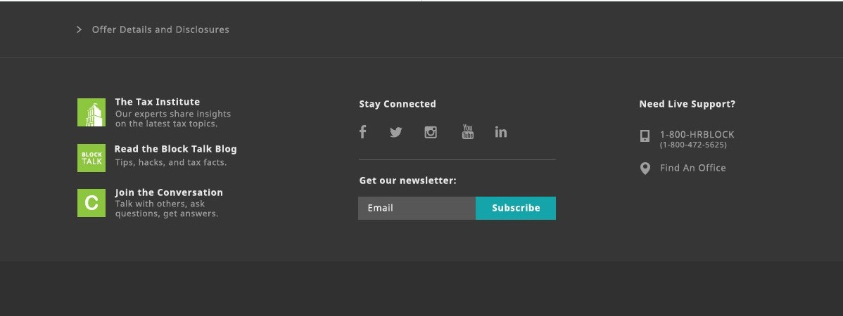

**H&R BLOC.K**

**FILING OPTIONS & PRODUCTS TAX INFORMATION & TOOLS** Q

**OVERVIEW BECOME A FRANCHISEE SELL YOUR BUSINESS LOCATIONS FOR SALE**

**SEARCH FOR FRAN CHI SES FOR SALE BY STATE:** Select a State **V Search**





# REQUEST MORE INFORMATION

Request more information about joining H&R Block or to sell your business.

Oops! Looks like there aren't any locations for sale at the moment.

Please check back often as we frequently update our list of locations for sale.





# COMPANY INFO

Learn about the history, values, and vision of the H&R Block brand.

***cclark***

*2017-05-22 17:12:08*

--------------------------------------------

Optimize buttons by wrapping link text and URL within an <a> tag. Do not embed text into the button.

***cclark***

*2017-05-22 17:12:05*

--------------------------------------------

Optimize buttons by wrapping link text and URL within an <a> tag. Do not embed text into the button.

***cclark***

*2017-05-22 17:25:17*

--------------------------------------------

Wrap an <h3> tag around this heading.

***cclark***

*2017-05-22 17:25:15*

--------------------------------------------

Wrap an <h3> tag around this heading.

***cclark***

*2017-05-22 17:26:56*

--------------------------------------------

Is there a way to access these franchises via link text? At minimum, they need to be submitted via XML Sitemap. However, it's recommended to internally link to these using an <a> link.

***cclark***

*2017-05-22 17:35:58*

--------------------------------------------

Avoid using words like "Learn More." Instead update anchor text to be: "Learn More About H&R Block" or "Learn More About Our Company"

**Contact Us Learn More**

