**[Visualforce Action Function Example.](http://sfdcsrini.blogspot.com/2014/07/visualforce-action-function-example.html)**

**Visualforce Action Function Example.**

Hi,   
In this post i am giving an example of simple usage of **<apex:actionFunction>** tag in visualforce page to call a apex method from Java script.  
  
**Controller Class:**

public class ActionFunctionCLS {

public Account actObj {get;set;}

PageReference prf= null;

public ActionFunctionCLS(){

actObj = new Account();

}

public pagereference Saverec(){

if(actobj.Name !='' ”){

insert actobj;

}

else{

ApexPages.Message myMsg = new ApexPages.Message(ApexPages.Severity.ERROR,'Error: Please Enter Name.');

ApexPages.addMessage(myMsg);

}

if(actobj.id !=null){

// Send the user to the detail page for the new account.

prf = new PageReference('/'+actobj.id);

prf.setRedirect(true);

}

return prf;

}

}

**Visualforce Page:**

<apex:page controller="ActionFunctionCLS" id="pg" >

  <script>

   function recSave(){

    var accountType = document.getElementById('pg:fm:pb:pbs:actType').value;

    alert('accountType -->'+accountType);

    if(accountType != 'Prospect'){

     alert('You Should Select Prospect to Save the Record');

     return false;

    }

    else{

saveAccount(); //this is the function name which calls our action function from java Script.

     return true;

    }

   }

 </script>

 <apex:form id="fm">

  <apex:actionfunction name="saveAccount" action="{!Saverec}" />

   <apex:pageBlock id="pb">

     <apex:pagemessages ></apex:pagemessages>

     <apex:pageblockButtons >

      <apex:commandButton value="Save" onclick="recSave();return false;"/>

     </apex:pageblockButtons>

     <apex:pageblockSection id="pbs">

       <apex:inputField value="{!actobj.Name}" id="actName"/>

       <apex:inputField value="{!actobj.type}" id="actType"/>

     </apex:pageblockSection>

   </apex:pageBlock>

 </apex:form>

</apex:page>

[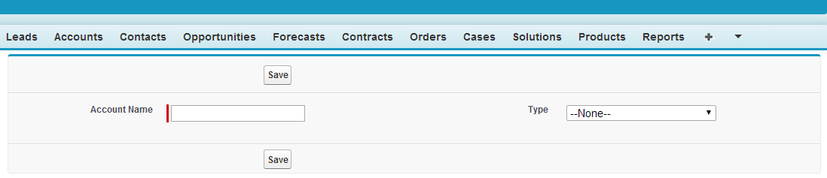](http://2.bp.blogspot.com/-iOpmkrk8vm0/U76LQeRhGAI/AAAAAAAAAJs/PUfD2fljgTA/s1600/ActionFunction1.png)

[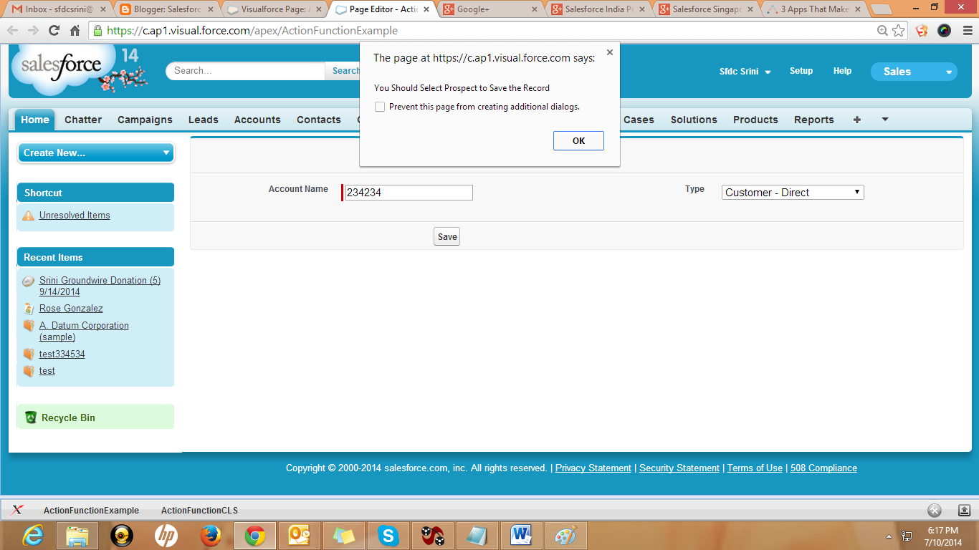](http://1.bp.blogspot.com/-AzJTT5CW4wI/U76LkPQE5II/AAAAAAAAAJ0/2s6itJpUFEM/s1600/ActionFunction2.png)

Once you select Account Type as "Prospect" Javascript method will call the <apex:actionfunction name="saveAccount" action="{!Saverec}" /> and controller method is going to execute.