**RESUME**

**PUSHPA KEERTHANA V**

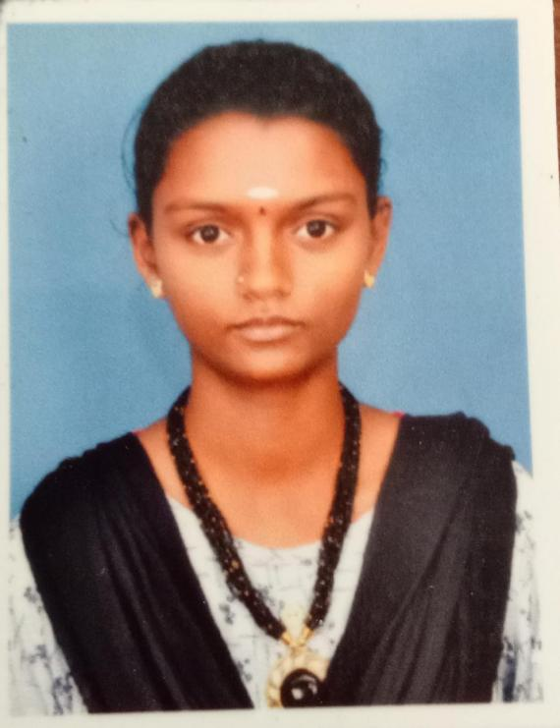

Cell : 6374335408

ADDRESS: Email id : keerthikaviya786@gmail.com

2/6C,Gandhi Street,

Kuthur,

Nagapattinam Dist

Pin Code -611105.

CAREER OBJECTIVES:

*To achieve excellence by applying my knowledge &skills in profession and continuously improving my knowledge base by learning through work experience and to make significant contribution in the growth of organization.*

EDUATION:

*CLASS X:*

*GHSS: Kurukkathi*

*Medium: English*

*Year of passing:2020*

*Grade:328*

*CLASS XII:*

*GHSS: Kurukkathi*

*Medium: English*

*Year of passing:2021*

*Grade:447*

*COLLEGE:*

*III-B.sc (Computer science) final year student*

*Thiru.Vi.Ka.Govt arts &S*cience, *college thiruvarur*

*Bharadhidasan university*

AMBHITION:

* *I Try to well salary for government job*
* *I Will be create App developer*

HOBBIES:

*Listening music, Watching thriller movie, Drawing , Play settle cork, tailoring, cooking, reading books.*

DECLARATION:

*I hereby declare that all above mentioned information is true to the best of my knowledge and belief.*

YOUR’S FAITHFULLY:-

V.PUSHPA KEERTHANA