“Argument Passing”
A Project Report Submitted in the partial fulfillment of the requirements for the award of the degree of

BACHELOR OF TECHNOLOGY
In

DEPARTMENT OF COMPUTER SCIENCE ENGINNERING

By

ANUMOLA JHANSI PRIYA 2520090205

KEERTHI PRIYA ANDE 2520090177

Under the Esteemed Guidance of

Raghupathi M
Assistant Professor
Department of Computer Science and Engineering




K L (Deemed to be) University DEPARTMENT OF COMPUTER SCIENCE ENGINEERING
&

DEPARTMENT OF COMPUTER SCIENCE AND INFORMATION TECHNOLY

Declaration

The Project Report entitled “Argument Passing” is a record of Bonafide work of ANUMOLA JHANSI PRIYA - 2520090205,KEERTHI PRIYA ANDE - 2520090177,submitted inpartial fulfillment for the award of B. Tech in Computer Science and Engineering (or) Computer Science and Information Technology to the K L University. The results embodied in this report have not been copied from any other departments/University/Institute.

ANUMOLA JHANSI PRIYA-2520090205

KEERTHI PRIYA ANDE-2520090177

K L (Deemed to be) University

DEPARTMENT OF COMPUTER SCIENCE ENGINEERING

CERTIFICATE

This is certify that the mini project based report entitled “Argument Passing” is a bonafide work done and submitted by ANUMOLA JHANSI PRIYA - 2520090205, KEERTHI PRIYA ANDE - 2520090177, in partial fulfillment of the requirements for the award of the degree of BACHELOR OF TECHNOLOGY in Department of Computer Science Engineering, K L (Deemed to be University), during the academic year 2024-2025.

Signature of the Guide

Signature of the Course Coordinator Signature of the HOD

ACKNOWLEDGEMENT
The success in this project would not have been possible but for the timely help and guidance rendered by many people. Our wish to express my sincere thanks to all those who has assisted us in one way or the other for the completion of my project.

Our greatest appreciation to my Course Coordinator Dr. K. Anusha, and my guide Raghupathi M , Department of Computer Science which cannot be expressed in words for his/her tremendous support, encouragement and guidance for this project.

We express our gratitude to Dr. Khaja Shareef (CSIT), Head of the Department for Computer Science Engineering for providing us with adequate facilities, ways and means by which we are able to complete this project-based Lab.

We thank all the members of teaching and non-teaching staff members, and also who have assisted me directly or indirectly for successful completion of this project. Finally, I sincerely thank my parents, friends and classmates for their kind help and cooperation during my work.

ANUMOLA JHANSI PRIYA-2520090205

KEERTHI PRIYA ANDE-2520090177

Abstract

Argument passing is an important concept in Operating Systems and Systems Programming that allows a program to receive information when it is executed. This project focuses on demonstrating how command-line arguments are passed from the Linux shell to a C program and how these arguments are received and processed using argc and argv. The project provides a practical understanding of program execution and the role of the operating system in supplying input to a running program.

The proposed solution will be implemented in a Linux/Ubuntu environment using C. The program will accept different numbers of command-line arguments, identify the number of arguments received, and display their corresponding values. To demonstrate the Operating Systems aspect of the project, process-related Linux/POSIX mechanisms such as fork(), exec(), and wait() will be used to show how a program can be executed with specified arguments.

The implementation will be tested with different test cases, including no arguments, a single argument, and multiple arguments. The project will include source code, build instructions, test results, screenshots, and a working demonstration.

The expected outcome is a clear practical understanding of argument passing, process execution, command-line interfaces, and Linux/POSIX system programming mechanisms.

Index

S. No. | Chapter | Topics / Subtopics | Page No.
 | Acknowledgement |  | i
 | Abstract |  | ii
1 | Introduction |  | 1–5
 |  | 1.1 Background of the Project
 |  | 1.2 Problem Statement
 |  | 1.3 Scope of the Project
 |  | 1.4 Objectives of the Project
 |  | 1.5 Importance of the Application
 |  | 1.6 Target Users / Audience
2 | OS Concepts and Background Study |  | 6–12
 |  | 2.1 Operating System Concepts Related to the Project
 |  | 2.2 Existing Methods / Algorithms
 |  | 2.3 Proposed Approach
 |  | 2.4 Advantages of the Proposed Approach
3 | System Requirements |  | 13–17
 |  | 3.1 Hardware Requirements
 |  | 3.2 Software Requirements
 |  | 3.3 Operating System Environment – Ubuntu / WSL
 |  | 3.4 Development Tools and Compilers
4 | Technology and Tools Used |  | 18–22
 |  | 4.1 C / C++ Programming
 |  | 4.2 GCC Compiler
 |  | 4.3 Linux System Calls
 |  | 4.4 POSIX Threads / Synchronization
 |  | 4.5 Linux Commands and Utilities
 |  | 4.6 Other Tools / Libraries Used
5 | System Architecture and Design |  | 23–29
 |  | 5.1 Overall System Architecture
 |  | 5.2System Workflow
 |  | 5.3 Flowchart / Data Flow
 |  | 5.4 Module Description
 |  | 5.5 Input and Output Design
6 | Implementation |  | 30–45
 |  | 6.1 Module-wise Implementation
 |  | 6.2 Algorithm / Pseudocode
 |  | 6.3 Core C / C++ Implementation
 |  | 6.4 Linux System Calls / APIs Used
 |  | 6.5 Process / Thread Implementation
 |  | 6.6 IPC / Synchronization Implementation
 |  | 6.7 Memory Management Implementation
 |  | 6.8 Optional User Interface Implementation
7 | Execution and Demonstration |  | 62–67
 |  | 7.1 Compilation in Ubuntu
 |  | 7.2 Execution Commands
 |  | 7.3 Sample Inputs and Outputs
 |  | 7.4 Screenshots of Execution
 |  | 7.5 Demonstration of OS Concepts
8 | Conclusion |  | 79–83
 |  | 8.1 Summary of the Project
 |  | 8.2 Objectives Achieved
 |  | 8.3 Results Achieved
 |  | 8.4 Skills and Learning Outcomes
9 | References |  | 84–86
 |  | 9.1 Books
 |  | 9.2 Research Papers
 |  | 9.3 Linux / GNU Documentation
 |  | 9.4 Online Resources

CHAPTER -1 INTRODUCTION

1.1 Background of the Project
An operating system provides an interface between the user and the computer hardware. Users normally interact with the operating system through commands, applications, and system interfaces. One important mechanism in Linux systems is argument passing, where information is passed to a program when it is executed from the command line.
In the C programming language, command-line arguments are received through the argc and argv parameters of the main() function. The argc parameter represents the number of arguments, while argv stores the actual argument values.
For example:
./co1_argument Jhansi 18 CSIT
In this command, the program receives four values including the program name. The program can access them using argc and argv.
The project was initially developed to demonstrate argument passing in Linux. It was extended into a GUI-based Operating System Concepts Simulator so that important operating system concepts can be demonstrated through a single graphical interface. The implementation uses C and Linux/POSIX system calls for the operating-system-related operations and Python Tkinter for the graphical interface.
The project demonstrates concepts such as command-line argument passing, process creation, process execution, process synchronization, inter-process communication, memory address translation, file operations, threads, and synchronization.
1.2 Problem Statement
Understanding operating system concepts only through theoretical explanations can make it difficult for students to visualize how processes, arguments, system calls, memory, files, and threads actually work.
In particular, command-line argument passing involves the interaction between the Linux shell and a C program. The user needs to understand how a command is entered, how arguments are passed, how argc counts them, and how argv stores their values.
The project addresses this problem by providing a GUI-based simulator that demonstrates argument passing and related operating system concepts. It also identifies valid and invalid command formats so that users can understand the difference between correct and incorrect command execution.
1.3 Scope of the Project
The scope of the project includes the development of a Linux-based GUI application for demonstrating important operating system concepts.
The project covers:
- Command-line argument passing.
- argc and argv.
- Linux shell interaction.
- Valid and invalid command handling.
- Process creation using fork().
- Program execution using exec().
- Parent-child synchronization using wait().
- Inter-process communication using an anonymous pipe.
- Basic paging and logical-to-physical address translation.
- File creation, writing, reading, and closing.
- POSIX threads.
- Mutex-based synchronization.
- Graphical demonstration using Python Tkinter.
- Compilation and execution using GCC in Ubuntu/WSL.
The project is intended primarily for educational and demonstration purposes.
1.4 Objectives of the Project
The main objectives are:
- To understand command-line argument passing in Linux.
- To demonstrate the use of argc and argv in C.
- To identify valid and invalid command formats.
- To understand the interaction between the Linux shell and a program.
- To demonstrate process creation using fork().
- To demonstrate program execution using exec().
- To demonstrate process synchronization using wait().
- To demonstrate communication between processes using pipes.
- To demonstrate basic paging and address translation.
- To demonstrate Linux file operations using system calls.
- To demonstrate POSIX threads and mutex synchronization.
- To provide all demonstrations through a simple GUI.
1.5 Importance of the Application
The application helps students understand operating system concepts through practical demonstrations instead of only theoretical explanations.
The Argument Passing module makes it easy to understand how a program receives data from the Linux shell. The process module demonstrates how a parent process creates a child and executes another program. The pipe module demonstrates communication between processes.
Similarly, the memory module provides a simple demonstration of paging, while the file module demonstrates file-related system calls. The thread module demonstrates concurrent execution and synchronization using a mutex.
The GUI makes the project easier to demonstrate during laboratory sessions, reviews, and presentations because the different concepts can be selected from one application.

1.6 Target Users / Audience
The main target users are:
- Operating System students.
- Computer Science and Information Technology students.
- Students learning Linux programming.
- Students learning C system programming.
- Faculty members demonstrating OS concepts.
- Beginners learning process management and system calls.
- Students preparing OS laboratory demonstrations.

CHAPTER -2 SYSTEM REQUIREMENTS

2.1 Operating System Concepts Related to the Project

The project is based on several operating system concepts.

Command-Line Arguments

Command-line arguments allow information to be supplied to a program during execution.

int main(int argc, char *argv[])

argc contains the number of arguments and argv contains the argument strings.

Process Management

A process is a program that is currently executing. Linux provides system calls such as fork(), exec(), and wait() for process management.

fork()

fork() creates a new child process from the existing parent process.

exec()

The exec() family of functions replaces the current process image with another program.

wait()

wait() allows the parent process to wait until a child process completes.

Inter-Process Communication

Processes can communicate using mechanisms such as pipes. The project uses an anonymous pipe for communication between a parent and child process.

Memory Management

Paging divides logical memory into pages and physical memory into frames. The project demonstrates basic logical address translation using a page table.

File Management

Linux provides system calls such as open(), read(), write(), and close() for file operations.

Threads and Synchronization

POSIX threads allow multiple threads to execute within a process. A mutex is used to protect shared data from simultaneous access.

2.2 Existing Methods / Algorithms

The traditional method for demonstrating argument passing is through the Linux terminal.

For example:

. /program argument1 argument2

The C program receives the values using argc and argv.

Similarly, process concepts are normally demonstrated by writing separate C programs and executing them from the terminal.

Although this approach is useful, students need to switch between different programs and commands to demonstrate different concepts. It may also be difficult for beginners to understand the relationship between the concepts.

2.3 Proposed Approach

The proposed system provides a GUI-based Operating System Concepts Simulator.

The GUI provides separate modules for different operating system concepts. Each module executes the corresponding C program and displays the result inside the application.

The main modules are:

CO1 → Argument Passing

CO2 → Process Control

CO3 → Anonymous Pipe

CO4 → Paging / Memory

CO5 → File System

CO6 → Threads and Mutex

The C programs perform the actual OS-related operations, while Python Tkinter provides the graphical interface.

2.4 Advantages of the Proposed Approach

The proposed approach provides the following advantages:

Simple graphical interface.

Easy to demonstrate during project reviews.

Reduces dependency on multiple terminal windows.

Demonstrates actual Linux/POSIX concepts.

Makes argc and argv easier to understand.

Shows parent and child processes clearly.

Demonstrates IPC using pipes.

Provides a basic visualization of paging.

Demonstrates Linux file operations.

Demonstrates thread synchronization.

Suitable for beginners.

Easy to compile and execute in Ubuntu/WSL.

CHAPTER -3 System Requirements

3.1 Hardware Requirements

The project does not require special hardware.

Minimum Requirements
Component | Requirement
Processor | Intel/AMD dual-core or above
RAM | 4 GB minimum
Storage | 2 GB available space
Keyboard | Standard keyboard
Mouse | Standard mouse
Display | Standard monitor
Internet | Required for initial software installation

The application can run on a normal student laptop or desktop computer

3.2 Software Requirements

The following software is required:

Ubuntu Linux or Ubuntu through WSL.

Python 3.

Tkinter.

GCC compiler.

C programming language.

POSIX libraries.

Linux Terminal.

Visual Studio Code, optionally.

Make/Makefile, if used.

Git/GitHub, optionally for project management.

3.3 Operating System Environment – Ubuntu / WSL

The project is designed to run in a Linux environment.

Ubuntu can be installed directly on a computer or used through Windows Subsystem for Linux (WSL).

WSL allows Linux commands and Linux development tools to be used within Windows.

The project can be stored on the Windows D: drive and accessed from WSL using:

cd /mnt/d

For example, if the project is located at:

D:\OS_Simulator

it can be accessed in Ubuntu/WSL using:

cd /mnt/d/OS_Simulator

3.4 Development Tools and Compilers

GCC

GCC is used to compile the C programs.

Example:

gcc co1_argument.c -o co1_argument

For the thread program:

gcc co6_threads.c -o co6_threads -pthread

Python

Python is used to create the GUI using Tkinter.

Visual Studio Code

VS Code can be used for editing the C and Python source files.

Linux Terminal

The terminal is used for compiling, testing, and executing the programs.

CHAPTER -4 Technology and Tools Used

4.1 C / C++ Programming

C is the main programming language used for implementing the operating system concepts.

C provides direct access to Linux/POSIX APIs and is suitable for demonstrating processes, system calls, file operations, pipes, and threads.

The project mainly uses C rather than C++ because the required Linux system calls and POSIX APIs can be directly demonstrated using C.

4.2 GCC Compiler

GCC stands for GNU Compiler Collection.

It is used to compile the C source files into executable programs.

Example:

gcc co1_argument.c -o co1_argument

The resulting executable can then be executed using:

./co1_argument

4.3 Linux System Calls

The project uses several Linux/POSIX APIs.

Important APIs include:

fork()

execv()

wait()

pipe()

read()

write()

open()

close()

pthread_create()

pthread_join()

pthread_mutex_lock()

pthread_mutex_unlock()

These APIs allow the project to demonstrate actual operating system functionality.

4.4 POSIX Threads / Synchronization

The project uses POSIX threads for demonstrating concurrent execution.

The pthread library provides functions for creating and managing threads.

A mutex is used to protect the shared counter.

The thread program uses:

pthread_mutex_lock()

pthread_mutex_unlock()

to prevent multiple threads from modifying the shared variable simultaneously.

4.5 Linux Commands and Utilities

Some important Linux commands used during development are:

cd

ls

pwd

gcc

./program

mkdir

cat

clear

For example:

ls

displays files and directories.

pwd

displays the current directory.

4.6 Other Tools / Libraries Used

Python Tkinter

Tkinter is used to create the graphical user interface.

Python subprocess

The subprocess module is used by the GUI to execute the compiled C programs.

Python shlex

The shlex module is used to process and validate command-style input.

Git/GitHub

Git can be used for version control and storing the project source code.

CHAPTER -5 System Architecture and Design

5.1 Overall System Architecture

5.2 System Workflow
- User starts the GUI.
- Main menu is displayed.
- User selects an OS concept.
- GUI collects required input.
- Input is validated.
- Python launches the corresponding C executable.
- The C program performs the required operation.
- Output is captured by the GUI.

Result is displayed to the user.

5.3 Flowchart / Data Flow

Parent Process

|

fork()

|

┌────┴─────┐

↓ ↓

Parent Child

↓ ↓

wait() exec()

↓ ↓

wait for Execute

child program

5.4 Module Description

Module | Description
CO1 Argument Passing | Demonstrates argc, argv and command validation
CO2 Process Control | Demonstrates fork(), exec() and wait()
CO3 Anonymous Pipe | Demonstrates communication between parent and child
CO4 Paging | Demonstrates logical address, page number, offset and physical address
CO5 File System | Demonstrates open, read, write and close
CO6 Threads | Demonstrates threads and mutex synchronization
GUI | Provides a single interface for all modules

5.5 Input and Output Design

Input
The application accepts:
- Command-line arguments.
- Process arguments.
- Logical address.
- Page size.
- Module selection.

Output
The application displays:
- Argument count.
- Argument values.
- Parent and child process IDs.
- Process execution information.
- Pipe messages.
- Page number and offset.
- Physical address.
- File data.
- Thread completion.
- Final synchronized counter.
- Error messages for invalid inputs.

CHAPTER -6 IMPLEMENTATION

6.1 Module-wise Implementation

The project is implemented as a set of small, independent C programs. Each program demonstrates one operating system concept, and a Python Tkinter interface (described in Section 6.8) is used to launch them from a single window. Keeping every concept in its own program makes the code easy to read, compile, test and explain during a review.

The two programs that form the core of the Argument Passing project are described below, followed by a summary of all modules.

Module 1: Argument Passing Program (argument_demo.c)

This program receives the command-line arguments supplied by the Linux shell through the argc and argv parameters of main(). It prints the program name, the number of user-supplied arguments, and every argument with its position. When no argument is given, it prints a message saying so instead of an empty list. This module was designed and implemented by A. Jhansi Priya.

Module 2: Process Argument Passing Program (process_argument.c)

This program demonstrates argument passing during process execution. The parent process reads its own arguments, creates a child process using fork(), and the child replaces itself with the argument_demo program using execv(), passing the same arguments forward. The parent waits for the child with wait() and reports its exit status. If no argument is supplied, the program prints a usage message and exits with status 1. This module was implemented and tested by Keerthi Priya Ande.

Summary of Modules
Module | OS Concept Demonstrated | Key Functions / APIs
CO1 Argument Passing | Command-line arguments, argc, argv, input validation | main(argc, argv), printf()
CO2 Process Control | Process creation, program execution, synchronization | fork(), execv(), wait(), getpid(), getppid()
CO3 Anonymous Pipe | Inter-process communication between parent and child | pipe(), read(), write(), close()
CO4 Paging | Logical to physical address translation | Page number, offset, page table lookup
CO5 File System | File creation, writing and reading | open(), write(), read(), close()
CO6 Threads | Concurrent execution and mutual exclusion | pthread_create(), pthread_join(), pthread_mutex_lock(), pthread_mutex_unlock()
GUI | Single interface for all modules | Python Tkinter, subprocess, shlex

6.2 Algorithm / Pseudocode

Algorithm 1: Argument Passing (argument_demo)
1. START
2. Receive argc and argv from the shell
3. Print the heading
4. Print argv[0] as the program name
5. Print (argc - 1) as the number of arguments
6. IF argc == 1 THEN
Print "No arguments were passed."
ELSE
FOR i = 1 TO argc - 1
Print "Argument i : argv[i]"
END FOR
END IF
7. Print the closing line
8. RETURN 0
9. STOP

Algorithm 2: Process Argument Passing (process_argument)
1. START
2. IF argc < 2 THEN
Print usage message
RETURN 1
END IF
3. Print parent PID using getpid()
4. Print all arguments received
5. pid = fork()
6. IF pid < 0 THEN
Print error using perror() and RETURN 1
7. IF pid == 0 THEN (child process)
Print child PID and parent PID
Build new_arguments[] = {"./argument_demo", argv[1..argc-1], NULL}
execv("./argument_demo", new_arguments)
Print "exec failed" and EXIT(1) (reached only if execv fails)
8. ELSE (parent process)
Print parent PID and child PID
wait(&status)
IF child exited normally THEN
Print child exit status using WEXITSTATUS(status)
END IF
Print "Parent process completed."
9. RETURN 0
10. STOP

6.3 Core C Implementation

The complete source code of the two programs is given below.
Program 1: argument_demo.c
#include <stdio.h>

int main(int argc, char *argv[])
{
printf("====================================\n");

printf(" ARGUMENT PASSING DEMO\n");
printf("====================================\n");

printf("Program Name: %s\n", argv[0]);
printf("Number of Arguments: %d\n", argc - 1);

if (argc == 1)
{
printf("No arguments were passed.\n");
}
else
{
printf("\nArguments received:\n");

for (int i = 1; i < argc; i++)
{
printf("Argument %d: %s\n", i, argv[i]);
}
}

printf("====================================\n");

return 0;
}

Explanation of argument_demo.c
- argc is an integer holding the number of command-line words, including the program name itself. Therefore the number of user arguments is argc - 1.
- argv is an array of strings. argv[0] holds the program name (for example ./argument_demo) and argv[1] onwards hold the user arguments.
- When argc is 1, only the program name is present, so the program reports that no arguments were passed.
- Otherwise, a for loop starting at index 1 prints every argument together with its position.
Program 2: process_argument.c
#include <stdio.h>
#include <stdlib.h>
#include <unistd.h>
#include <sys/wait.h>

int main(int argc, char *argv[])
{
printf("====================================\n");
printf(" PROCESS ARGUMENT PASSING DEMO\n");
printf("====================================\n");

if (argc < 2)
{
printf("Usage: %s <argument1> <argument2> ...\n", argv[0]);
return 1;
}

printf("Parent Process PID: %d\n", getpid());
printf("Arguments to be passed:\n");

for (int i = 1; i < argc; i++)
{
printf("Argument %d: %s\n", i, argv[i]);
}

printf("\nCreating child process using fork()...\n");

pid_t pid = fork();

if (pid < 0)
{
perror("fork failed");
return 1;
}

if (pid == 0)
{
printf("\n--- CHILD PROCESS ---\n");
printf("Child PID: %d\n", getpid());
printf("Parent PID: %d\n", getppid());

printf("Child is executing argument_demo using exec()...\n\n");

char *new_arguments[argc + 1];

new_arguments[0] = "./argument_demo";

for (int i = 1; i < argc; i++)
{
new_arguments[i] = argv[i];
}

new_arguments[argc] = NULL;

execv("./argument_demo", new_arguments);

perror("exec failed");
exit(1);
}
else
{
printf("\n--- PARENT PROCESS ---\n");
printf("Parent PID: %d\n", getpid());
printf("Child PID: %d\n", pid);

printf("Parent is waiting for child using wait()...\n");

int status;
wait(&status);

if (WIFEXITED(status))
{
printf("\nChild completed successfully.\n");
printf("Child Exit Status: %d\n", WEXITSTATUS(status));
}

printf("Parent process completed.\n");
}

printf("====================================\n");

return 0;
}

Explanation of process_argument.c
- The program first checks argc < 2. If no argument is supplied, it prints the correct usage and returns 1 to indicate an error.
- getpid() returns the process ID of the calling process. It is used to show the parent and child identities.
- fork() creates a child process. It returns a negative value on failure, 0 in the child process, and the child PID in the parent process.
- In the child, a new argument array is built. The first element is the program name ./argument_demo, the remaining elements are the original arguments, and the last element must be NULL because execv() uses NULL to detect the end of the list.
- execv() replaces the child process image with argument_demo. If it succeeds, the statements after it are never executed; perror() and exit(1) run only when execv() fails, for example when argument_demo has not been compiled.
- In the parent, wait() blocks until the child finishes. WIFEXITED() checks that the child ended normally and WEXITSTATUS() extracts its exit code.

6.4 Linux System Calls / APIs Used
API / Function | Header | Purpose in the Project
fork() | <unistd.h> | Creates a child process from the parent process
execv() | <unistd.h> | Replaces the child process image with argument_demo and passes the argument array
wait() | <sys/wait.h> | Makes the parent wait until the child terminates
WIFEXITED(), WEXITSTATUS() | <sys/wait.h> | Check normal termination and read the exit status of the child
getpid() | <unistd.h> | Returns the process ID of the calling process
getppid() | <unistd.h> | Returns the process ID of the parent process
perror() | <stdio.h> | Prints a system error message when fork() or execv() fails
exit() | <stdlib.h> | Terminates the child process with an error status if exec fails
printf() | <stdio.h> | Displays arguments, process IDs and status messages in the terminal
pipe(), read(), write(), close() | <unistd.h> | Used by the pipe and file modules (CO3 and CO5)
pthread_create(), pthread_join() | <pthread.h> | Create and join threads in the thread module (CO6)
pthread_mutex_lock(), pthread_mutex_unlock() | <pthread.h> | Protect the shared counter in the thread module (CO6)

6.5 Process / Thread Implementation

Process Implementation

Process creation in Linux follows the fork-exec-wait model, which is exactly what process_argument.c implements. After fork() there are two processes executing the same code. The return value of fork() tells each process who it is.
Return value of fork() | Meaning | Action in the program
Less than 0 | Process creation failed | perror() is called and the program returns 1
Equal to 0 | This is the child process | Builds the argument list and calls execv()
Greater than 0 | This is the parent process; the value is the child PID | Calls wait() and reports the child exit status

The relationship between the processes is shown below.
Terminal (bash)
|
| ./process_argument Jhansi 18 CSIT
v
process_argument (parent, PID = P)
|
|-- fork() --> child (PID = C, parent PID = P)
| |
| |-- execv("./argument_demo", args)
| | child image is replaced by argument_demo
| | argument_demo prints the received arguments
| '-- exits with status 0
|
'-- wait() returns, parent prints the child exit status

Thread Implementation (CO6)

The thread module uses POSIX threads. Several threads are created with pthread_create(), and each thread increments a shared counter. Because the threads run concurrently, the counter is a shared resource and must be protected. A mutex is locked with pthread_mutex_lock() before the counter is changed and released with pthread_mutex_unlock() afterwards, so only one thread can update the counter at a time. The main thread waits for all threads using pthread_join() and then prints the final counter value. The program is compiled with the -pthread option.

6.6 IPC / Synchronization Implementation

Inter-Process Communication using an Anonymous Pipe (CO3)

A pipe is a one-way communication channel between related processes. The pipe() call creates two file descriptors: one for reading and one for writing. The parent creates the pipe before calling fork(), so both processes inherit the two descriptors. The child writes a message into the write end and the parent reads it from the read end. Each process closes the end it does not use so that the data flows in one direction only.
pipe(fd) -> fd[0] = read end, fd[1] = write end
fork()
CHILD : close(fd[0]); write(fd[1], message); close(fd[1])
PARENT : close(fd[1]); read(fd[0], buffer); close(fd[0])
print the received message

Synchronization

Two kinds of synchronization are demonstrated in the project. The first is parent-child synchronization using wait(), where the parent does not continue until the child has finished. The second is mutual exclusion using a mutex in the thread module, which prevents a race condition on the shared counter. Without the mutex, two threads could read the same old value of the counter and both write back the same new value, so one increment would be lost.

6.7 Memory Management Implementation

The paging module (CO4) demonstrates how a logical address generated by a program is converted into a physical address. Logical memory is divided into pages and physical memory is divided into frames of the same size. A page table stores the frame number for each page. The module takes a logical address and a page size as input and calculates:
page number = logical address / page size
offset = logical address % page size
frame number = page_table[page number]
physical address = (frame number * page size) + offset

The page number, offset, frame number and physical address are displayed, and an error message is shown when the input is invalid, for example when the page size is zero or the address is outside the logical address space.

6.8 Optional User Interface Implementation

A graphical interface is provided using Python Tkinter so that all modules can be demonstrated from one window. The GUI does not replace the C programs; it only launches them and shows their output.
- Tkinter is used to build the main menu, the input fields and the output area.
- The shlex module splits the typed command into words the same way a shell does, so quoted arguments such as "Hello World" stay together as one argument. It is also used to check that the command is in a valid format.
- The subprocess module runs the compiled C executable with the validated arguments and captures its standard output and error messages.
- The captured output is displayed in the application window, and an error message is shown when the input is invalid or the executable is not found.

Workflow: User selects a module, enters the input, the input is validated by Python, the C executable is launched, the output is captured, and the result is displayed in the window.

CHAPTER -7 EXECUTION AND DEMONSTRATION

7.1 Compilation in Ubuntu

The programs are compiled in the Ubuntu terminal using the GCC compiler. First open the terminal and move to the project folder, then compile both programs.
cd ArgumentPassing
ls
gcc argument_demo.c -o argument_demo
gcc process_argument.c -o process_argument
ls -l

The same result can be obtained with the Makefile included in the project, by running the single command make. The -o option gives a name to the executable file. If the compilation is successful, GCC prints nothing and the two executable files argument_demo and process_argument appear in the folder.

Important: process_argument starts ./argument_demo using execv(), so argument_demo must be compiled first and both executables must be in the same folder from which the program is run. Otherwise the message "exec failed" is displayed.

7.2 Execution Commands
Test Case | Command | Purpose
TC1 | ./argument_demo | No arguments
TC2 | ./argument_demo Jhansi | Single argument
TC3 | ./argument_demo Jhansi 18 CSIT | Multiple arguments
TC4 | ./argument_demo "Hello World" 2026 | Argument containing a space, written in quotes
TC5 | ./process_argument | Process program without arguments (usage message)
TC6 | ./process_argument Jhansi 18 CSIT | Process-based argument passing using fork(), exec() and wait()

7.3 Sample Inputs and Outputs

TC1: No arguments
$ ./argument_demo
====================================
ARGUMENT PASSING DEMO
====================================
Program Name: ./argument_demo
Number of Arguments: 0
No arguments were passed.
====================================

Only the program name is present, so argc is 1 and the number of arguments is shown as 0.

TC2: Single argument
$ ./argument_demo Jhansi
====================================
ARGUMENT PASSING DEMO
====================================
Program Name: ./argument_demo
Number of Arguments: 1

Arguments received:
Argument 1: Jhansi
====================================

TC3: Multiple arguments
$ ./argument_demo Jhansi 18 CSIT
====================================
ARGUMENT PASSING DEMO
====================================
Program Name: ./argument_demo
Number of Arguments: 3

Arguments received:
Argument 1: Jhansi
Argument 2: 18
Argument 3: CSIT
====================================

The shell splits the command line at spaces, so each word becomes one element of argv. Note that 18 is received as the text "18" and not as a number; every argument is a string.

TC4: Argument containing a space
$ ./argument_demo "Hello World" 2026
====================================
ARGUMENT PASSING DEMO
====================================
Program Name: ./argument_demo
Number of Arguments: 2

Arguments received:
Argument 1: Hello World
Argument 2: 2026
====================================

The quotes tell the shell to treat Hello World as one argument, so the count is 2 and not 3.

TC5: process_argument without arguments
$ ./process_argument
====================================
PROCESS ARGUMENT PASSING DEMO
====================================
Usage: ./process_argument <argument1> <argument2> ...
$ echo $?
1

The program prints the correct usage and returns exit status 1. The command echo $? displays the exit status of the last command.

TC6: process_argument with arguments
$ ./process_argument Jhansi 18 CSIT
====================================
PROCESS ARGUMENT PASSING DEMO
====================================
Parent Process PID: 141
Arguments to be passed:
Argument 1: Jhansi
Argument 2: 18
Argument 3: CSIT

Creating child process using fork()...

--- PARENT PROCESS ---
Parent PID: 141
Child PID: 142
Parent is waiting for child using wait()...
--- CHILD PROCESS ---
Child PID: 142
Parent PID: 141
Child is executing argument_demo using exec()...

====================================
ARGUMENT PASSING DEMO
====================================
Program Name: ./argument_demo
Number of Arguments: 3

Arguments received:
Argument 1: Jhansi
Argument 2: 18
Argument 3: CSIT
====================================

Child completed successfully.
Child Exit Status: 0
Parent process completed.
====================================

The process IDs (141 and 142 above) are different every time the program is run, so the numbers in your own screenshot will not be the same. The line order of the parent and child messages can also change slightly because the two processes run at the same time.

Test Result Summary
Test Case | Expected Result | Actual Result | Status
TC1 | Count 0 and "No arguments were passed." | As expected | Pass
TC2 | Count 1 and Argument 1 displayed | As expected | Pass
TC3 | Count 3 and all three arguments displayed in order | As expected | Pass
TC4 | Quoted text received as one argument (count 2) | As expected | Pass
TC5 | Usage message and exit status 1 | As expected | Pass
TC6 | Child runs argument_demo with the same arguments; parent reports exit status 0 | As expected | Pass

7.4 Screenshots of Execution

Take each screenshot from the Ubuntu terminal so that the prompt (user name and folder) and the full output are visible, then replace the matching box below with the picture. Commands to type are written inside each box.
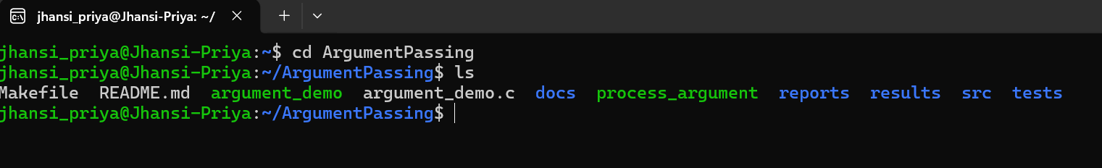
Figure 7.1: Project folder contents before compilation
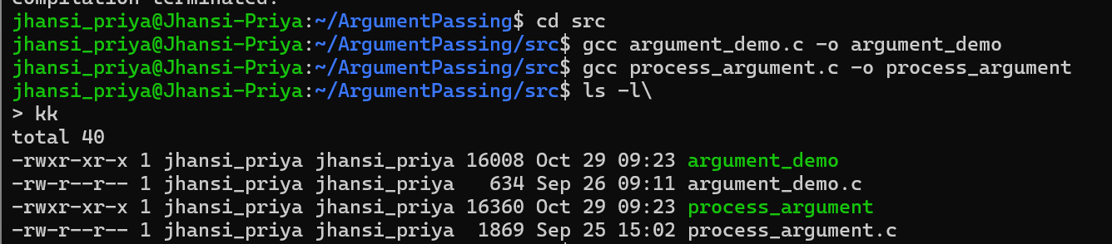
Figure 7.2: Compilation of both programs and the generated executables
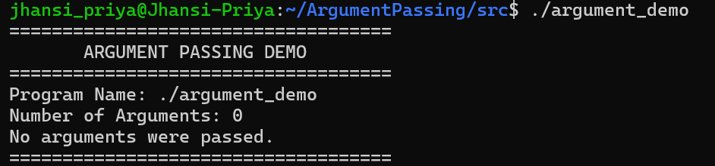

Figure 7.3: Execution with no arguments (TC1)
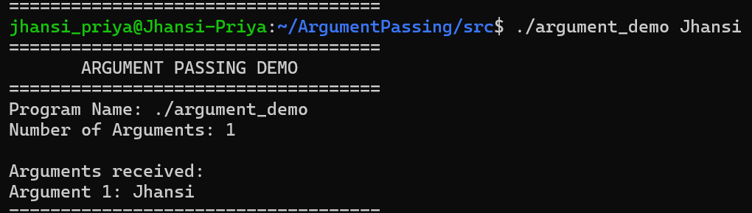
Figure 7.4: Execution with a single argument (TC2)
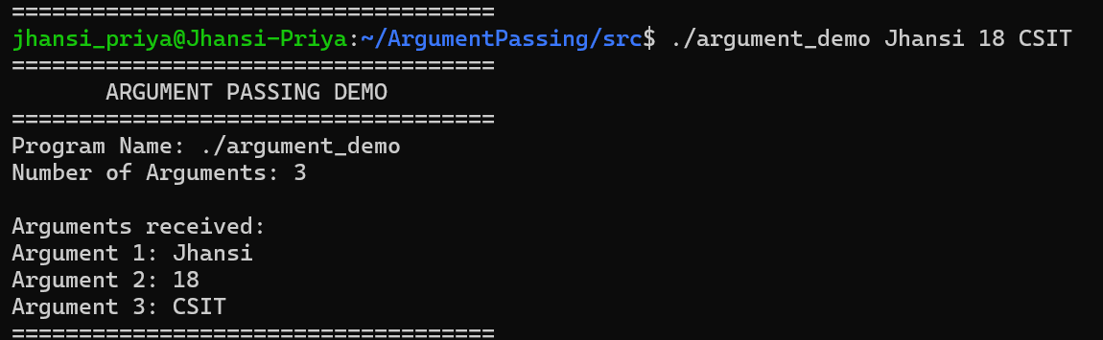
Figure 7.6: Execution with a quoted argument (TC4)
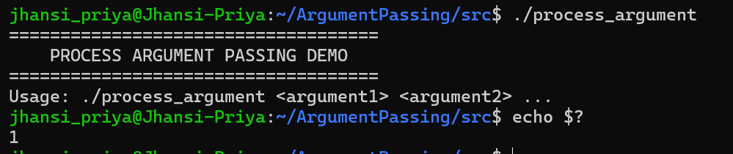

Figure 7.7: process_argument without arguments (TC5)
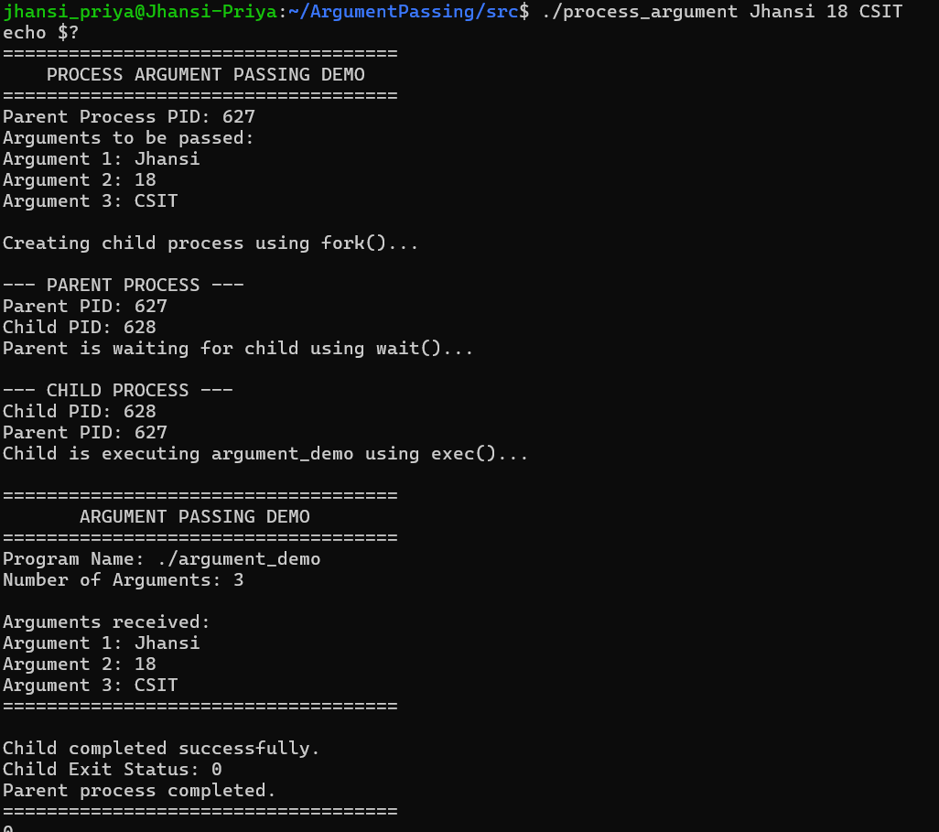
Figure 7.8: Process-based argument passing using fork(), exec() and wait() (TC6)
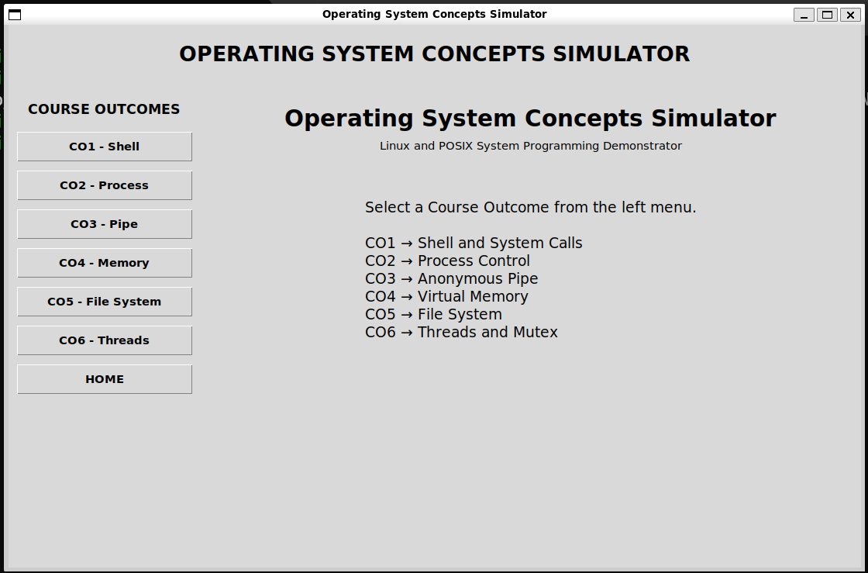

7.5 Demonstration of OS Concepts
OS Concept | Where it is seen in the execution
Command-line arguments | The shell passes the words typed after the program name to main() as argc and argv (TC1 to TC4).
Role of the shell | The shell splits the command line into words and handles quotes (TC4).
Process creation | fork() creates a child process with its own PID, shown in TC6.
Parent-child relationship | The child prints the parent PID, which matches the PID printed by the parent (TC6).
Program execution | execv() replaces the child with argument_demo, which prints the same arguments that were given to the parent (TC6).
Process synchronization | The parent prints the child result only after wait() returns (TC6).
Exit status | The child returns 0 and the parent reads it with WEXITSTATUS(); the usage error returns 1 (TC5, TC6).
Error handling | A missing argument produces a usage message, and a failed fork() or execv() produces a perror() message.

CHAPTER -8 CONCLUSION

8.1 Summary of the Project

The project Argument Passing was designed and implemented on Ubuntu using the C language and the GCC compiler. It shows how the Linux shell passes command-line arguments to a program and how the program receives them through argc and argv. The project then extends this idea to process execution by using fork(), execv() and wait(), so that a parent process starts another program with the same arguments and waits for it to finish.

The programs were compiled in the Ubuntu terminal and tested with no arguments, a single argument, multiple arguments, quoted arguments and process-based argument passing. In addition, the other operating system concepts included in the project (pipes, paging, file operations, threads and mutex) were demonstrated through a simple graphical interface.

8.2 Objectives Achieved
- Understood how command-line arguments are received by a program in Linux.
- Implemented a C program that accepts and processes command-line arguments using argc and argv.
- Demonstrated argument passing during process execution using fork(), exec() and wait().
- Tested the implementation with different inputs and verified that the received arguments and the program output were correct.
- Identified valid and invalid command formats and displayed a usage message for invalid input.
- Demonstrated pipes, paging, file operations and thread synchronization through the simulator.

8.3 Results Achieved
- The program correctly reports the number of arguments and displays every argument in order.
- The case of no arguments is handled without any error.
- Arguments written in quotes are treated as a single argument.
- The child process successfully executes argument_demo with the arguments passed by the parent.
- The parent process waits for the child and correctly reports its exit status.
- All test cases TC1 to TC6 passed, and terminal output and screenshots were documented as evidence.

8.4 Skills and Learning Outcomes
- C programming with argc, argv, arrays and pointers.
- Linux system programming using fork(), execv(), wait(), getpid() and getppid().
- Understanding of process creation, program execution, process IDs, exit status and parent-child synchronization.
- Compiling and running programs in the Ubuntu terminal with GCC and Make.
- Testing a program with different inputs and documenting the results.
- Using Git and GitHub to manage the project files, and teamwork in sharing the implementation between two members.

CHAPTER -9 REFERENCES

9.1 Books

[1] A. Silberschatz, P. B. Galvin and G. Gagne, Operating System Concepts, 10th ed., Wiley, 2018.

[2] B. W. Kernighan and D. M. Ritchie, The C Programming Language, 2nd ed., Prentice Hall, 1988.

[3] W. R. Stevens and S. A. Rago, Advanced Programming in the UNIX Environment, 3rd ed., Addison-Wesley, 2013.

[4] M. Kerrisk, The Linux Programming Interface, No Starch Press, 2010.

[5] A. S. Tanenbaum and H. Bos, Modern Operating Systems, 4th ed., Pearson, 2014.

9.2 Research Papers

[6] D. M. Ritchie and K. Thompson, "The UNIX Time-Sharing System," Communications of the ACM, vol. 17, no. 7, pp. 365-375, 1974.

[7] A. Baumann, J. Appavoo, O. Krieger and T. Roscoe, "A fork() in the road," Proceedings of the Workshop on Hot Topics in Operating Systems (HotOS), 2019.

9.3 Linux / GNU Documentation

[8] Linux manual pages: fork(2), execve(2), exec(3), wait(2), getpid(2), pipe(2), pthread_create(3). https://man7.org/linux/man-pages/

[9] GNU Compiler Collection (GCC) Online Documentation. https://gcc.gnu.org/onlinedocs/

[10] The GNU C Library Reference Manual. https://www.gnu.org/software/libc/manual/

[11] The Open Group, POSIX.1-2017 (IEEE Std 1003.1-2017) Base Specifications. https://pubs.opengroup.org/onlinepubs/9699919799/

9.4 Online Resources

[12] Project repository: https://github.com/keerthipriya2008/klh-csit-2025-2029-02-ArgumentPassing

[13] Python Documentation: tkinter, subprocess and shlex modules. https://docs.python.org/3/

[14] Ubuntu Documentation. https://ubuntu.com/tutorials

[15] Microsoft Learn: Windows Subsystem for Linux Documentation. https://learn.microsoft.com/en-us/windows/wsl/

