“Linux Process Watchdog and Auto-Restart System”
A Project Report Submitted in the partial fulfillment of the requirements for the award of the degree of

BACHELOR OF TECHNOLOGY
In

DEPARTMENT OF COMPUTER SCIENCE ENGINNERING

By

ANUMOLA JHANSI PRIYA 2520090205

KEERTHI PRIYA ANDE 2520090177

Under the Esteemed Guidance of

Raghupathi M
Assistant Professor
Department of Computer Science and Information Technology




K L (Deemed to be) University DEPARTMENT OF COMPUTER SCIENCE ENGINEERING
&

DEPARTMENT OF COMPUTER SCIENCE AND INFORMATION TECHNOLY

Declaration

The Project Report entitled “Linux Process Watchdog and Auto-Restart System” is a record of Bonafide work of ANUMOLA JHANSI PRIYA - 2520090205,KEERTHI PRIYA ANDE - 2520090177,submitted inpartial fulfillment for the award of B. Tech in Computer Science and Engineering (or) Computer Science and Information Technology to the K L University. The results embodied in this report have not been copied from any other departments/University/Institute.

ANUMOLA JHANSI PRIYA-2520090205

KEERTHI PRIYA ANDE-2520090177

K L (Deemed to be) University

DEPARTMENT OF COMPUTER SCIENCE ENGINEERING

CERTIFICATE

This is certify that the mini project based report entitled“Linux Process Watchdog and Auto-Restart System” is a bonafide work done and submitted by ANUMOLA JHANSI PRIYA - 2520090205, KEERTHI PRIYA ANDE - 2520090177, in partial fulfillment of the requirements for the award of the degree of BACHELOR OF TECHNOLOGY in Department of Computer Science Engineering, K L (Deemed to be University), during the academic year 2024-2025.

Signature of the Guide

Signature of the Course Coordinator Signature of the HOD

ACKNOWLEDGEMENT
The success in this project would not have been possible but for the timely help and guidance rendered by many people. Our wish to express my sincere thanks to all those who has assisted us in one way or the other for the completion of my project.

Our greatest appreciation to my Course Coordinator Dr. K. Anusha, and my guide Raghupathi M , Department of Computer Science which cannot be expressed in words for his/her tremendous support, encouragement and guidance for this project.

We express our gratitude to Dr. Khaja Shareef (CSIT), Head of the Department for Computer Science Engineering for providing us with adequate facilities, ways and means by which we are able to complete this project-based Lab.

We thank all the members of teaching and non-teaching staff members, and also who have assisted me directly or indirectly for successful completion of this project. Finally, I sincerely thank my parents, friends and classmates for their kind help and cooperation during my work.

ANUMOLA JHANSI PRIYA-2520090205

KEERTHI PRIYA ANDE-2520090177

Abstract

The Linux Process Watchdog and Auto-Restart System is an operating systems project designed to monitor the execution of a process and automatically restart it when it terminates unexpectedly. In Linux, many applications and background services need to run continuously to provide reliable and uninterrupted services. However, a process may stop working due to errors, unexpected termination, or other runtime issues. Manually checking and restarting such processes can be time-consuming and may lead to service interruptions. To address this problem, our project implements an automated process-monitoring and recovery mechanism using Linux process-management concepts.
The system is developed using C programming, Linux system calls, Python, and the Tkinter graphical user interface (GUI). The watchdog program monitors a sample service process and detects when it terminates. It uses system calls such as fork(), exec(), and waitpid() to create, execute, and monitor processes. When the monitored service terminates unexpectedly, the watchdog identifies the termination and attempts to restart the service automatically after a short delay. A maximum restart limit can be configured to prevent continuous restart attempts if the service repeatedly fails.
The project also provides a graphical dashboard through which users can start and stop the monitoring system and observe process activity, status messages, and failure events. Important events, including service startup, termination, and restart attempts, can be recorded in a log file for future reference and troubleshooting. The sample service generates periodic heartbeat messages, making it easier to verify whether the monitoring and automatic-restart mechanisms are functioning correctly.
This project demonstrates important operating system concepts, including process creation, process execution, parent-child process relationships, process termination detection, signal handling, and basic fault recovery. It also highlights how C and Python can be combined to develop a practical monitoring application with a user-friendly interface. The proposed system is intended for educational and demonstration purposes and provides a foundation for developing more advanced process-monitoring tools. Overall, the Linux Process Watchdog and Auto-Restart System aims to improve process reliability, reduce manual intervention, and provide a simple way to understand and implement automated process recovery in a Linux environment.

Index

S. No. | Chapter | Topics / Subtopics | Page No.
 | Acknowledgement |  | i
 | Abstract |  | ii
1 | Introduction |  | 7
 |  | 1.1 Background of the Project
 |  | 1.2 Problem Statement
 |  | 1.3 Objectives of the Project
2 | OS Concepts and Background Study |  | 8
 |  | 2.1 Operating System Concepts Related to the Project
3 | Technologies Used |  | 9
4 | System Architecture and Design |  | 10–11
 |  | 4.1 GUI Dashboard
 |  | 4.2 Watchdog Engine
 |  | 4.3 Test Service
 |  | 4.4 Working Methodology
 |  | 4.5 Implementation Modules
5 | Testing and Validation |  | 12–13
 |  | 5.1 Screenshots of Test Execution
6 | Results |  | 14
7 | Limitations |  | 15
8 | Future Enhancements |  | 16
9 | Team Contributions |  | 17
10 | Conclusion |  | 18

CHAPTER -1 INTRODUCTION
1.1 Background of the Project
Applications may stop unexpectedly because of errors, crashes, or external termination. When an application stops, a user may need to restart it manually. This project aims to automate that recovery process.
The watchdog runs as a parent process and launches a test service as its child. It waits for the child to terminate and starts it again when necessary, subject to a configured restart limit. The GUI provides a convenient way to control and observe the system.
1.2 Problem Statement
To develop a Linux-based system that continuously monitors selected processes and automatically restarts them when they terminate unexpectedly, reducing the need for manual intervention.
1.3 Objectives of the Project
- Monitor a selected test application.
- Detect process termination.
- Restart the application automatically.
- Display process IDs and restart events.
- Provide a graphical interface for monitoring.
- Maintain timestamped event logs.
- Demonstrate operating-system process-management concepts.

CHAPTER -2 OS CONCEPTS AND BACKGROUND STUDY
2.1 Operating System Concepts Related to the Project
- Process creation: fork() creates a child process.
- Program execution: exec() replaces the child process image with the test application.
- Process synchronization: waitpid() waits for child termination and retrieves its status.
- Signals: Signals support process termination and controlled shutdown.
- Parent-child relationship: The watchdog supervises the test service.
- Failure recovery: The watchdog restarts the child after unexpected termination.

CHAPTER -3 TECHNOLOGIES USED
- Programming language: C
- GUI language: Python
- GUI framework: Tkinter
- Operating system: Ubuntu Linux / Ubuntu on WSL
- Compiler: GCC
- Development environment: Visual Studio Code
- Version control: Git and GitHub

CHAPTER -4 SYSTEM ARCHITECTURE AND DESIGN
The system consists of three main components.
4.1 GUI Dashboard
The Python Tkinter dashboard provides Start Monitoring and Stop Monitoring controls. It displays monitoring status, process IDs, restart events, and event history.
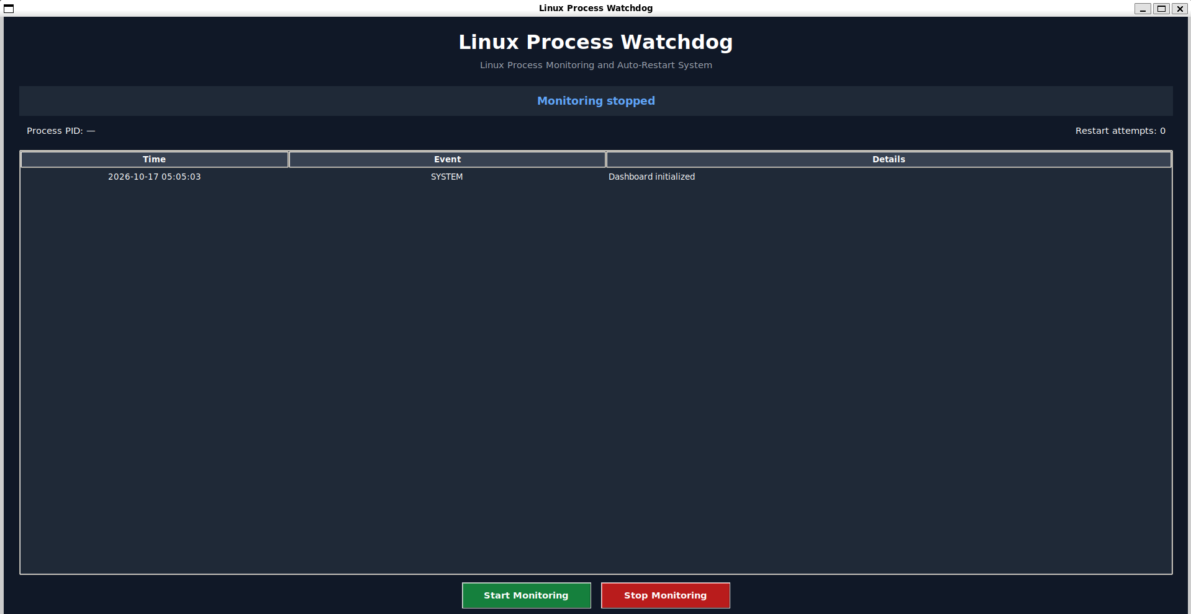y
Figure 4.1: GUI Dashboard
4.2 Watchdog Engine
The C program creates and monitors a child process. It uses fork() to create the child, exec() to execute the test application, and waitpid() to collect the child's termination status. It restarts the application according to the configured policy.
4.3 Test Service
The test service runs continuously and prints heartbeat messages. It is used to simulate a running application and safely test unexpected termination.
4.4 Working Methodology
- The user opens the GUI dashboard.
- The user selects Start Monitoring.
- The GUI launches the C watchdog.
- The watchdog creates the child test process.
- The test service prints heartbeat messages.
- The watchdog detects when the child terminates.
- The watchdog waits for the configured delay and restarts the service if the restart limit permits.
- The GUI displays the events and records them in the log file.
- The user can stop monitoring through the GUI.
4.5 Implementation Modules
- C watchdog engine
- Test service
- Python GUI dashboard
- Event logging
- Process restart and shutdown handling

CHAPTER -5 TESTING AND VALIDATION
The following tests are planned or performed to evaluate the system.
Test | Expected result
Start monitoring | The service starts and its PID is displayed
Unexpected termination | The watchdog detects termination
Automatic restart | The service starts with a new PID
Stop monitoring | The watchdog stops and cleans up its child
Restart limit | Restarting stops when the configured limit is reached
Log verification | Events appear in the log file

5.1 Screenshots of Test Execution
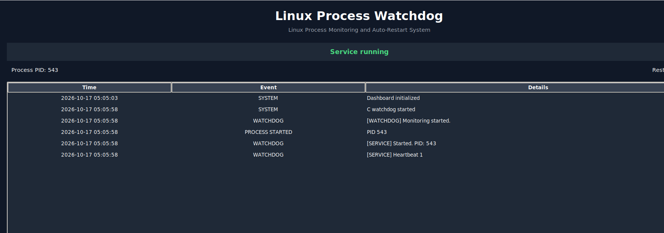after selecting Start Monitoring
Figure 5.1: Start monitoring: the service starts and its PID is displayed
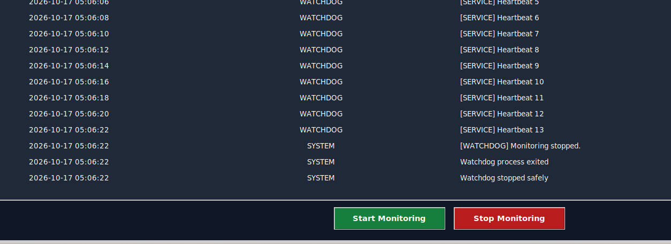

CHAPTER -6 RESULTS
The initial prototype successfully launches the test service, detects its unexpected termination, and restarts it with a new PID. The GUI displays process and restart events, and the event log records activity. Additional tests should verify the restart limit, shutdown behavior, and logging before final evaluation.

CHAPTER -7 LIMITATIONS
- The current prototype is designed for a controlled test service.
- The restart policy has a configured retry limit.
- The initial version does not provide advanced monitoring metrics or a production-grade service manager.
- Monitoring arbitrary system services would require additional permissions and safety checks.

CHAPTER -8 FUTURE ENHANCEMENTS
- Monitor multiple selected applications.
- Add configurable restart delays and retry limits.
- Improve crash detection and status reporting.
- Add filtering and export options for logs.
- Display uptime and restart statistics.
- Add configuration files and additional automated tests.

CHAPTER -9 TEAM CONTRIBUTIONS
- Team Member 1: C watchdog engine, Linux process management, and restart logic.
- Team Member 2: GUI development, test cases, event logging, documentation, and presentation.

CHAPTER -10 CONCLUSION
The Linux Process Watchdog and Auto-Restart System demonstrates how operating-system process-management mechanisms can be used to recover from unexpected application termination. By combining a C watchdog engine with a Python GUI, the project provides a practical demonstration of process creation, execution, synchronization, signal handling, and automatic recovery.

