**S3 – Simple Storage Service**

S3 – Popular for Object Storage Service

S3 and glacier are for same purpose – Object Storage

They will be replicated amount other AZ’s. It creates replica automatically.

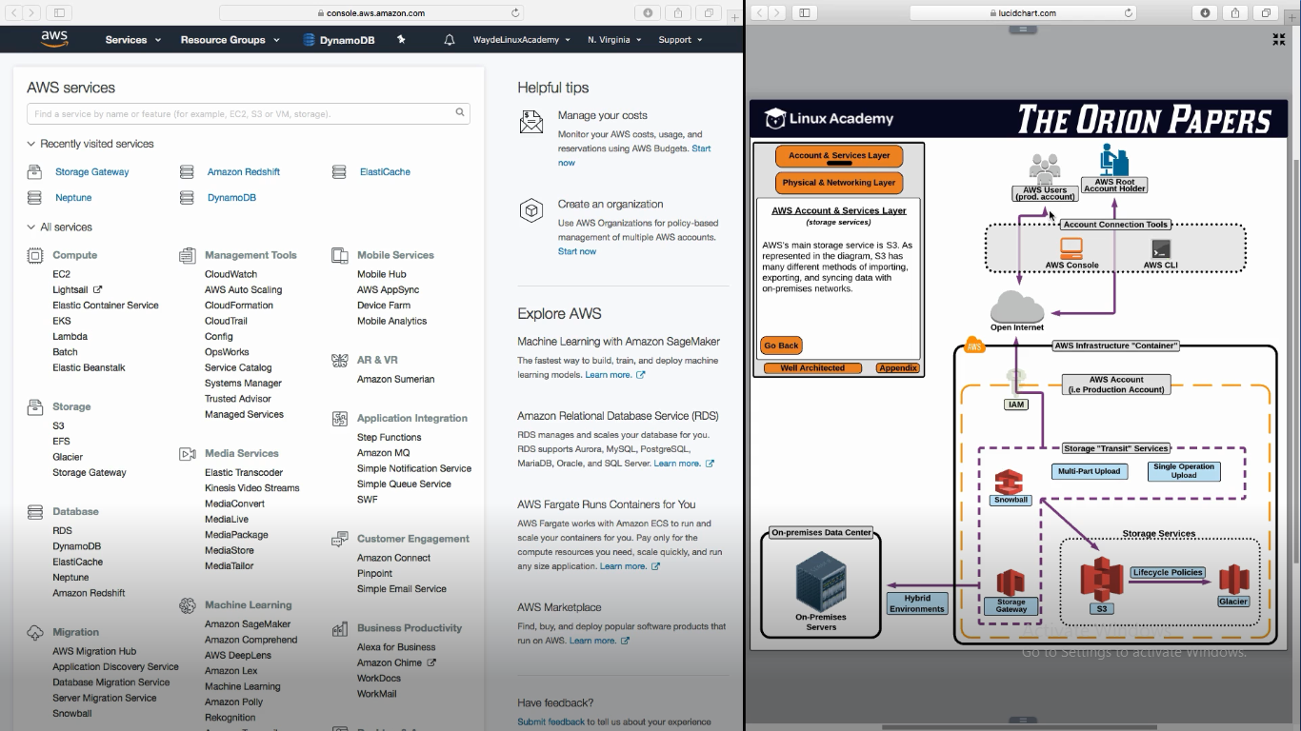

**S3 Essentials**

1. No need to provision how much space it needed before creating. Store object and pay how much GB we store. No limit to store. Each object should be 5TB or less
2. Can have MFA to delete
3. S3 can be used as a static website storing html and other web files

**Storage Gateway** – It takes care of storing the data in s3

Data center servers can write data to storage volumes. Storage Gateway is installed in ssd volume. Storage Gateway takes care of writing datas to S3 by making API Calls

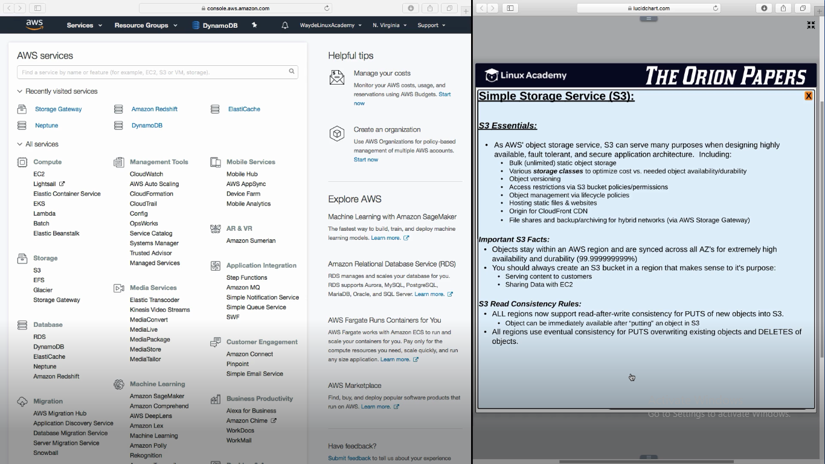

There is a data transfer charge if EC2 instance in one region (AU) is trying to fetch/write data to S3 in other region (ASIA)

**Side effects of having S3 in distributed storage system**

When we create a new object, and PUT returns a success, we are good

When we try to delete an object or overwrite an existing object, it will take a while to overwride/delete the object and sync it across all AZ’s

**CAPT** – Consistency Availability and Partition Tolerance

S3 accepted to compromise C (Consistency)

**S3 Components**

1. Buckets are containers which hold the container
2. We can encrypt and store the data in S3 bucket
3. One S3 bucket name cannot be used for other S3 bucket globally by any users
   1. Because we access a S3 bucket with url. If same url will be same
4. Don’t use uppercase and underscore for S3 bucket name

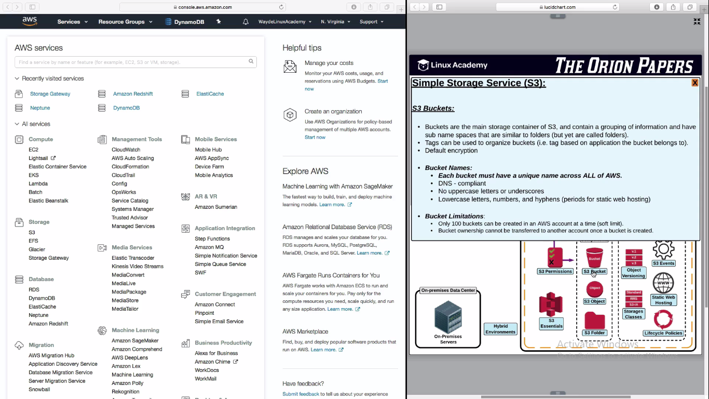

1. When we upload an object it wil have a unique key in your bucket
2. Key is the name of the object + a prefix, so that they are organized with same objects togather

Prefix = images/objName

Prefix = videos/objName

1. Randomize the beginning of object keys for quick fetch of objects if we have more objects

SSE KMS – Key Management System – Encryption done in server by the user and not in bucket

Bucket when created by default it is private

Even thought we make S3 bucket as public, we can make objects inside S3 bucket as private

**S3 Storage Class**

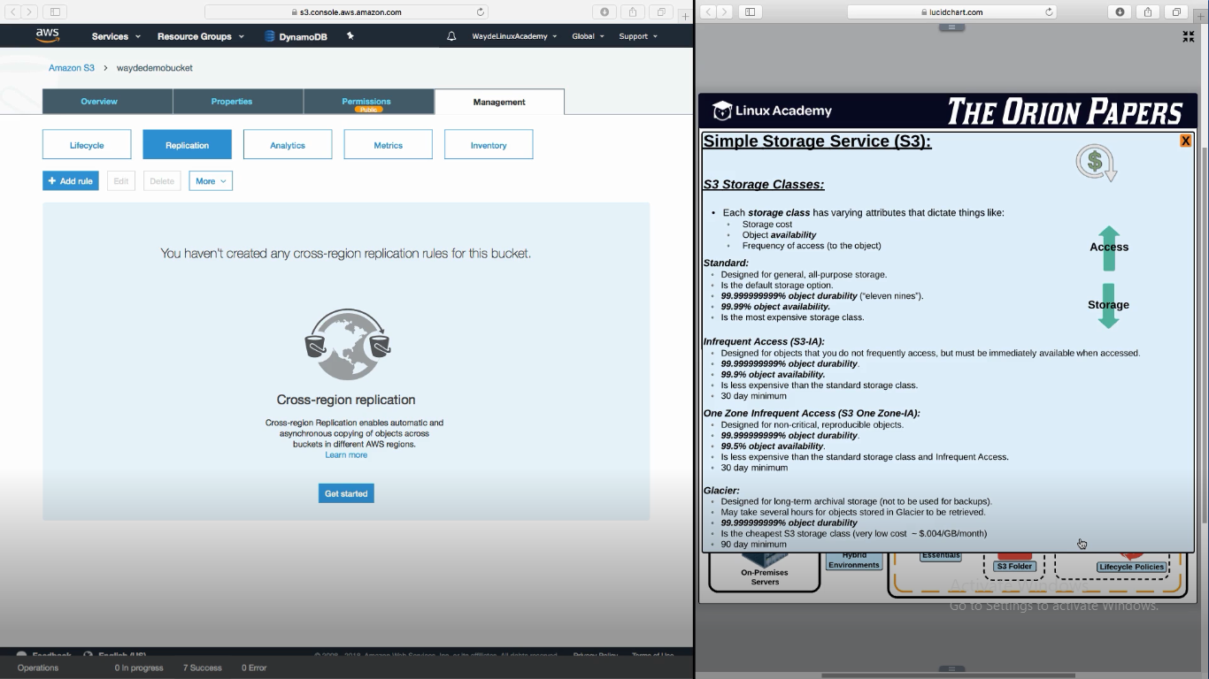

**Standard:**

1. Expensive. Bucket not available for 4 min per month

**Infrequent Access:**

1. It will not be available for 44 min per month
2. Storage cost is less, access cost is high
3. Min charge is 30 days before we move to to other plan below

**One zone infrequent access:**

1. Object not available for 3.5 hrs per month
2. Min charge is 30 days before we move to to other plan below

GLACIER:

For archival storage

Objects in S3 can be moved to Glacier for back up

90 day policy to opt out