**VPN – Virtual Private Network**

**Hybrid environments :** Expanding on premise network on to AWS

1. Connection can be made secure so that they work as one single private network

**VPN:**

Extending a network from one geographic network to another

Data’s are sent over internet with IPSec (Internet Protocol Security)

It does mutual authentication in both end. It encrypts data in transit

It is private because of mutual authentication and encryption in transit

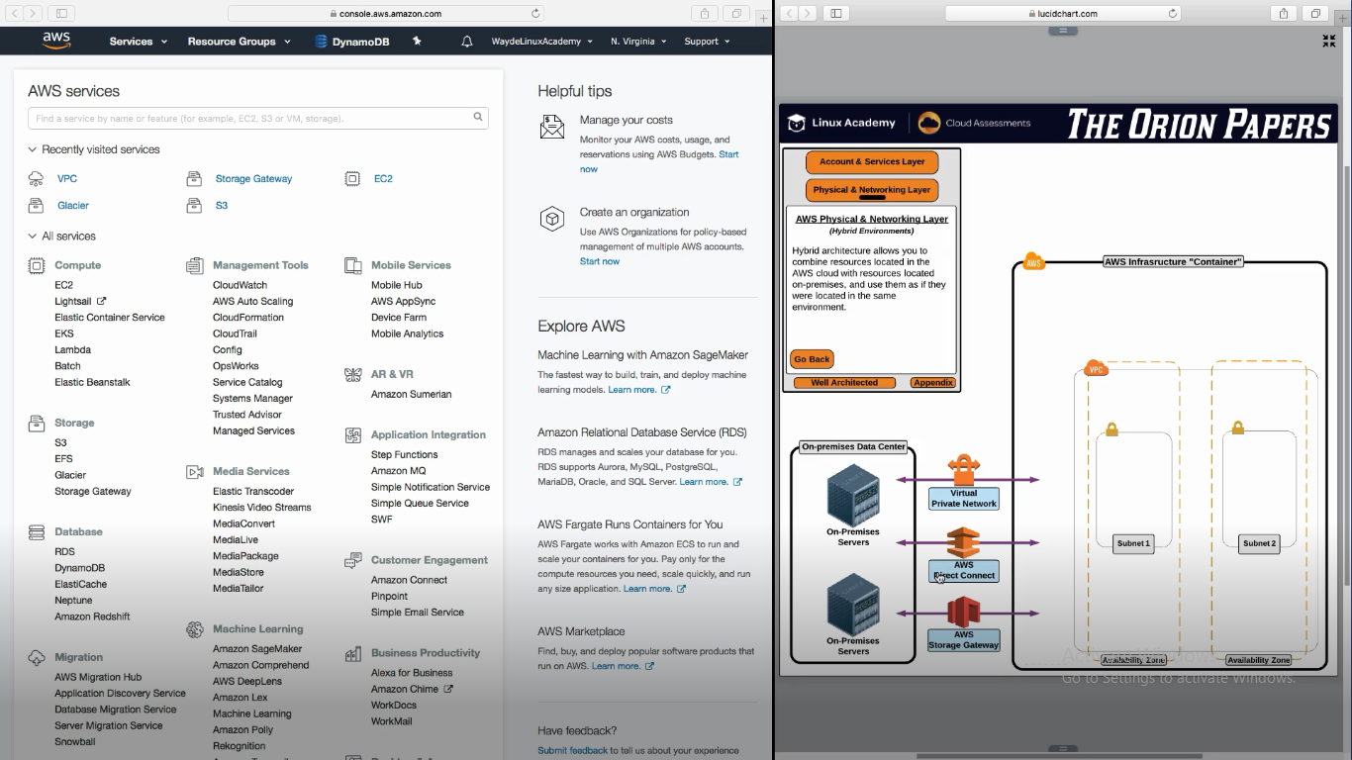

**Inside VPN**

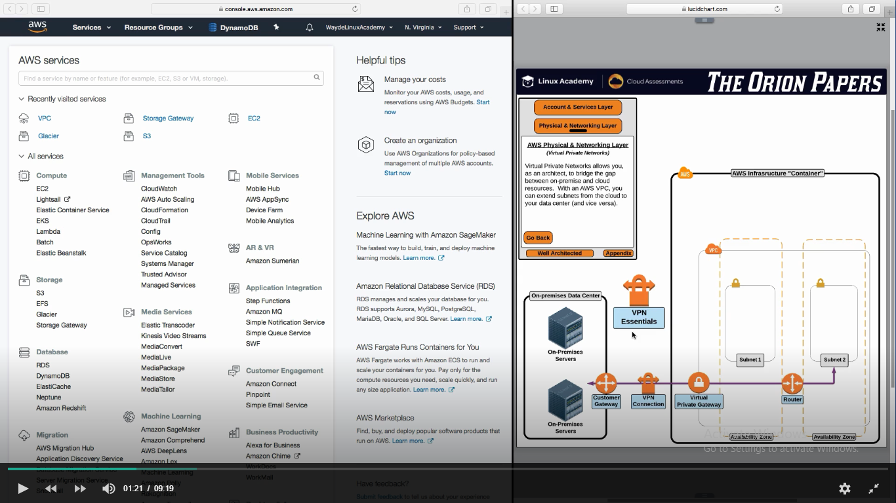

**Types of VPN**

1. Traditional software based VPN
   1. We run a VPN Server and VPN Client
   2. Connect from one server to another in different network and those severs can communicate to other servers in the network
   3. Here we manage he connections

**AWS Provides Hardware VPN**

Customer Gateway 🡪 Attach it to our on premise data center

Virtual Private Gateway 🡪 Attach it to our VPC in AWS

**VPN Essentials**

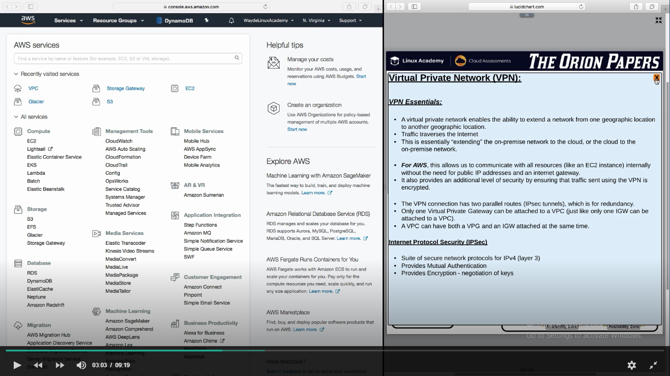

**Configuring a VPN**

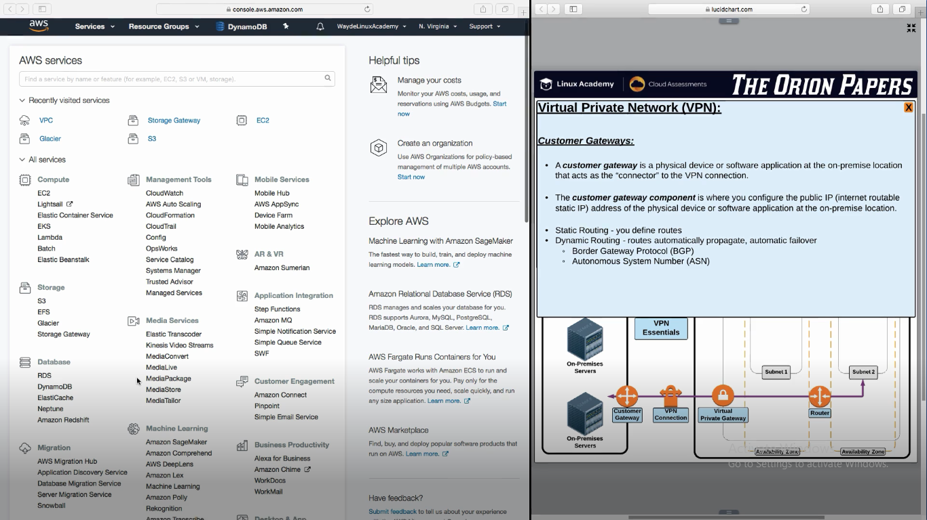

**Virtual Private Gateway**

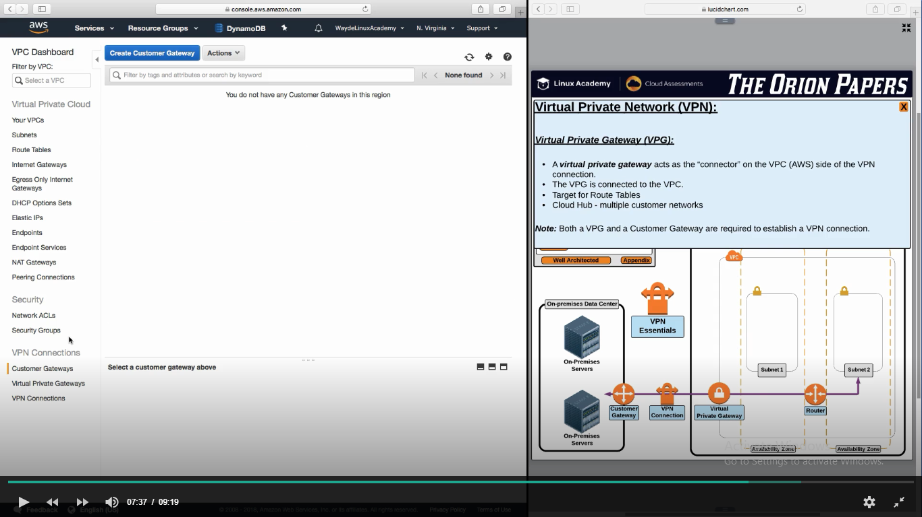

**Handson**

AWS Console -> Networking and content Delivery -> VPC

VPN Connections -> Customer Gateways

What ever information we give here are specific to customer gateway

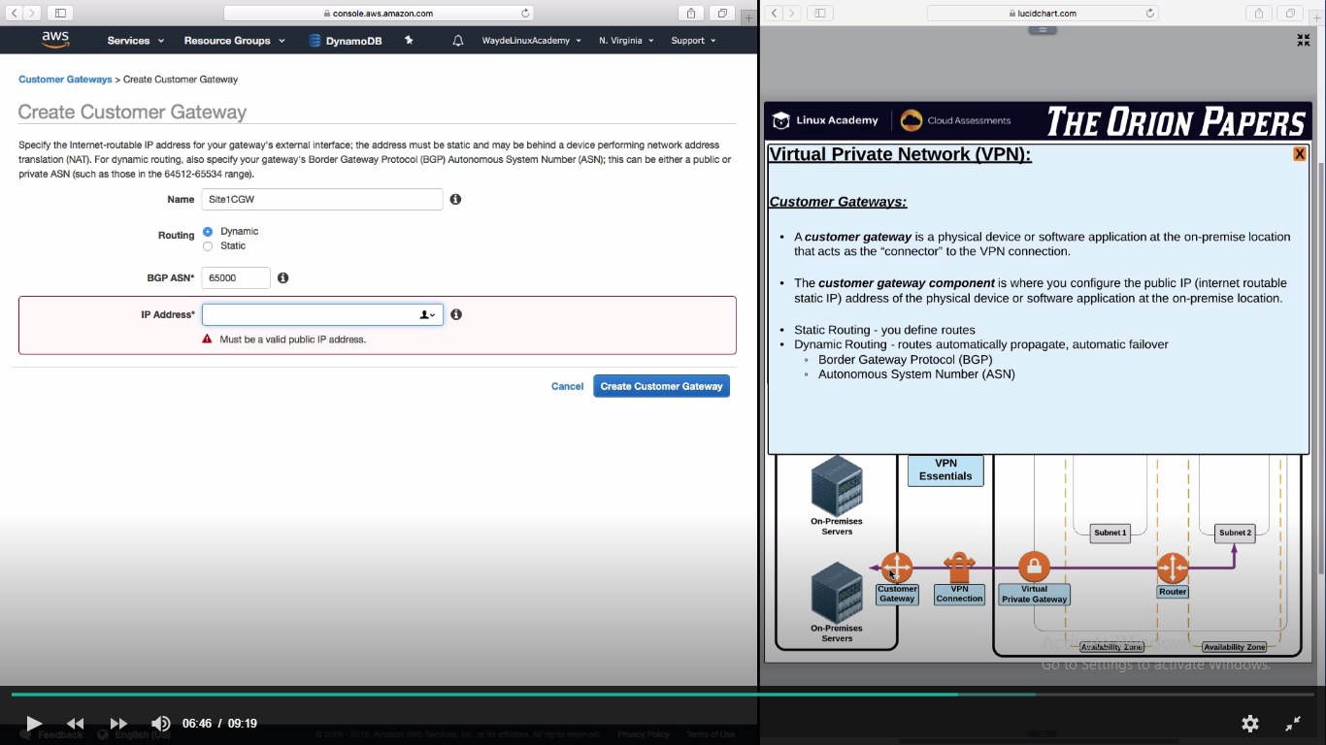

AWS Console -> Networking and content Delivery -> VPC

VPN Connections -> Virtual Private Gateways

Create and attach it to VPC

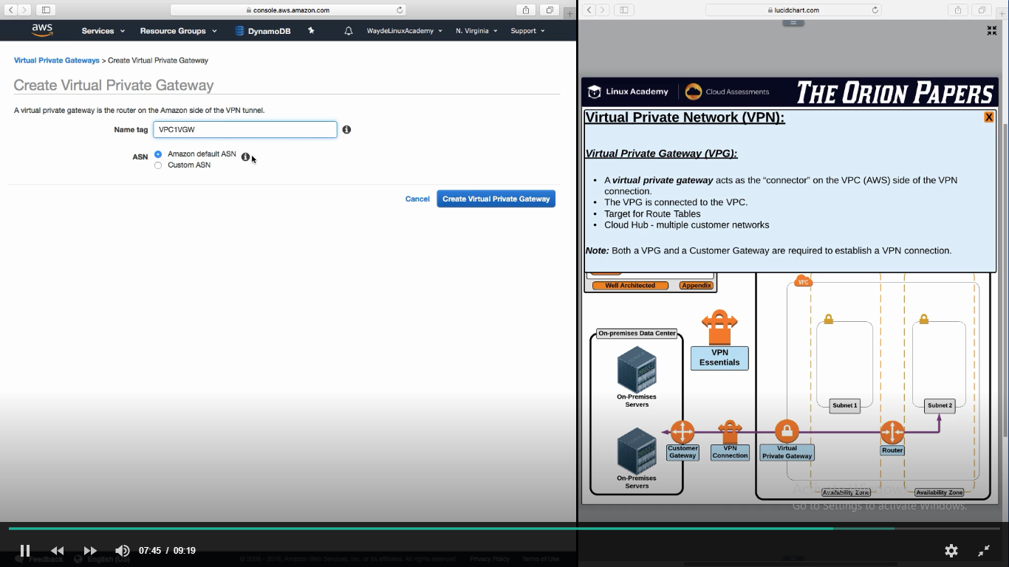

AWS Console -> Networking and content Delivery -> VPC

VPN Connections -> VPN Connections

Link both Customer gateway and Virtual Private Gateway

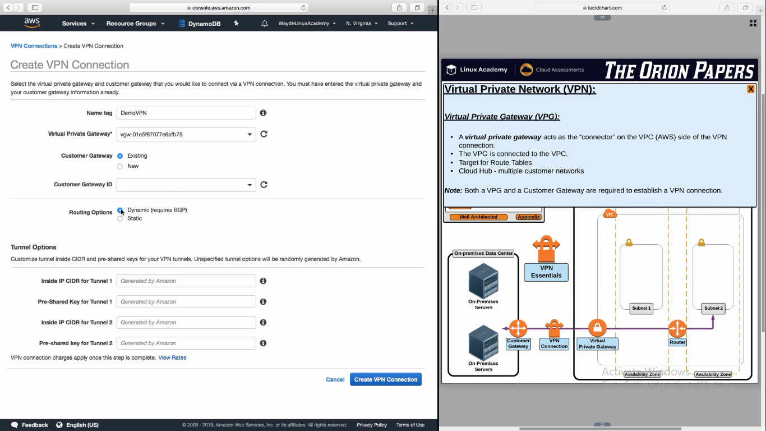

Tunnel options are automatically assigned by AWS

We have to setup route table. This is not discussed here

This route table should have the ip address of the on premise servers