**DirectConnect**

It is a dedicated private connection without internet

Using WAN (Fiber optic network) connected Data Center to Direct Connect Location of AWS

**Direct connection location** is associated to region

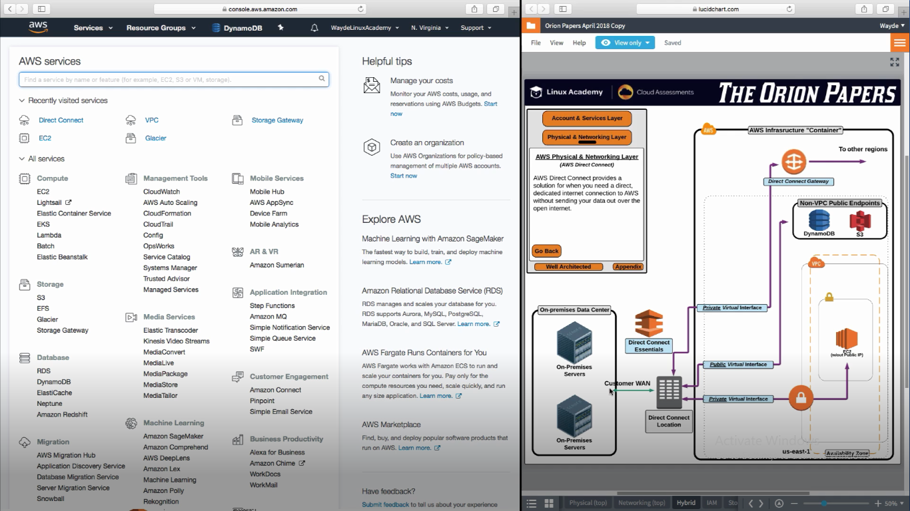

Direct Connect Gateway connecting to other regions

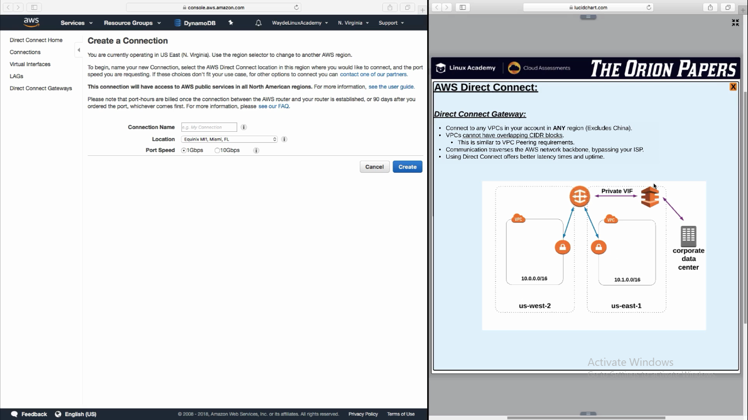

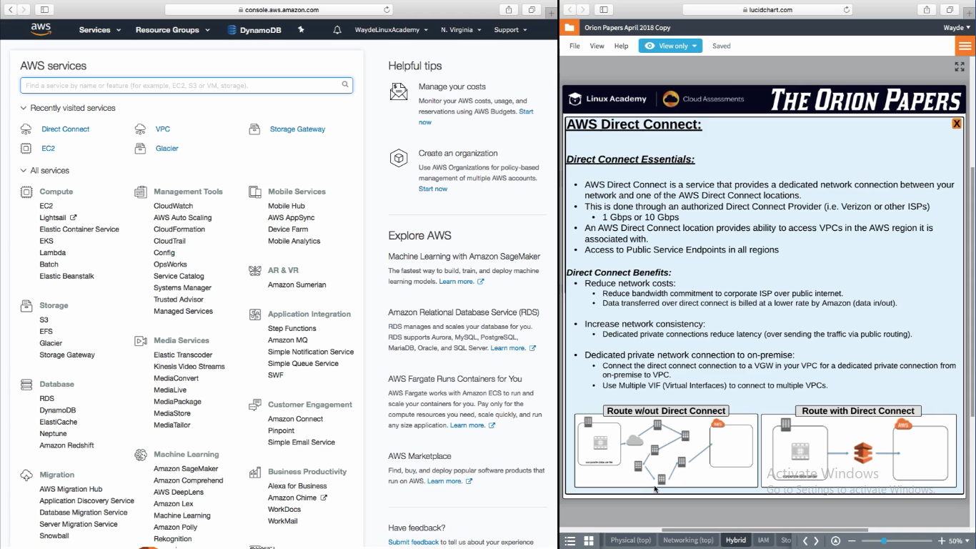

**VPC Peering**

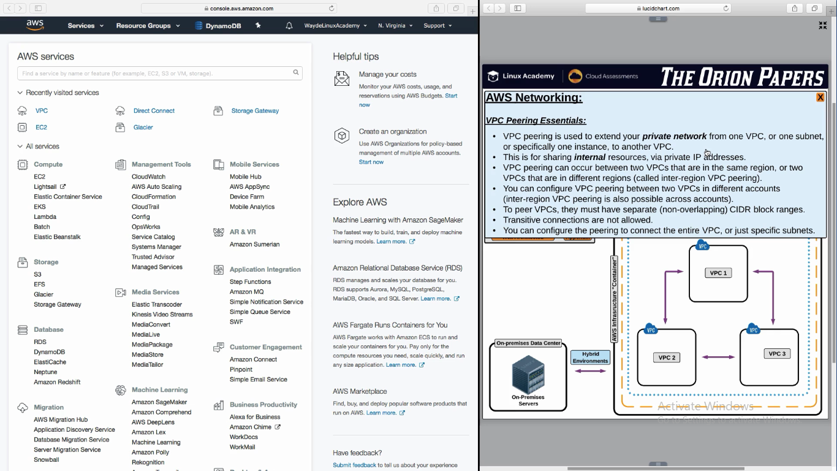

VPC to VPC peering is possible between regions

Peering is also possible between a subnet in a VPC to another subnet in another VPC

VPC peering between two VPC is possible even if it is owned by two different accounts, if the account owner approves it

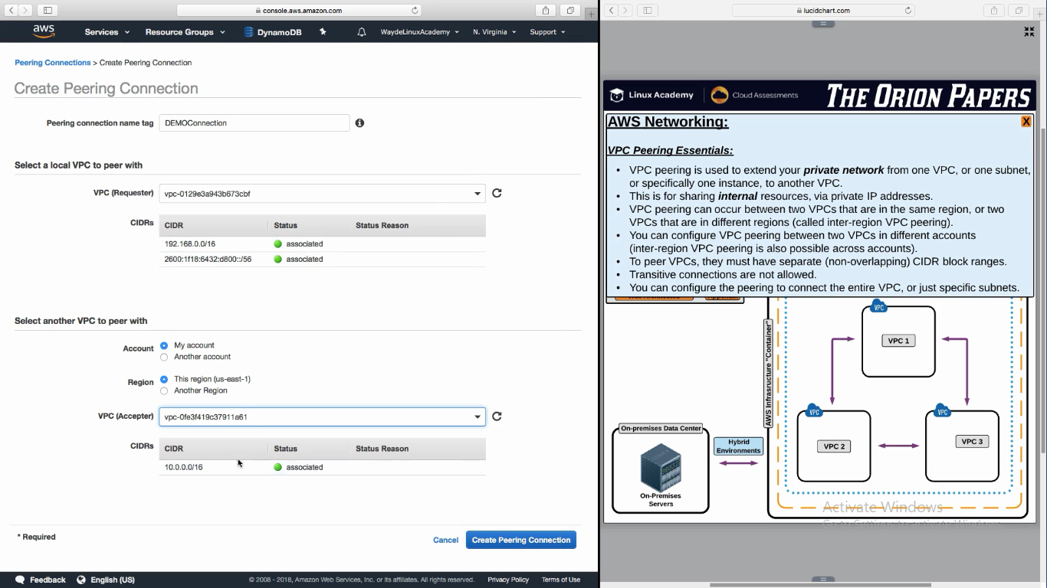

Modify route table in both VPC. Enter VPC2 ip in route table for VPC1 and vice versa.We are good.