**Monitoring**

1. Cloud Watch
2. Cloud Trail
3. VPC Flow logs and Access logs

Life cycle events – when a EC2 instance is stopped, started, terminated all these are events

1. **Cloud Watch**

Real time metrics for almost all service we use

Load balance, EBS volume, s3 bucket all provides logs for cloud watch

1. **Cloud watch metrics**

Real time monitoring of key metrics

* 1. **Standard Metrics – outside the instance**
     1. These are default. These are gathered at hypervisor level
     2. Cpu utilization, t2 cpu credit usage, instance store read/write per second, EBS volume metrics
  2. Cloud watch can monitor the status inside an EC2 instance. PUTS function can be used to get the memory utilization inside the EC2 instance and write it in metrics based on that we can trigger an event (eg lambda , another EC2 instance etc)

1. **Cloud watch log**
   1. Centralized repo for log files
   2. Eg Apache logs are automatically streamed to cloud log server where the metrics will be created and we it can be projected as a graph
   3. Install cloud watch logs and it will create a log in a centralized server
2. **Cloud watch events**
   1. Way to monitor events in infrastructure and trigger some type of action

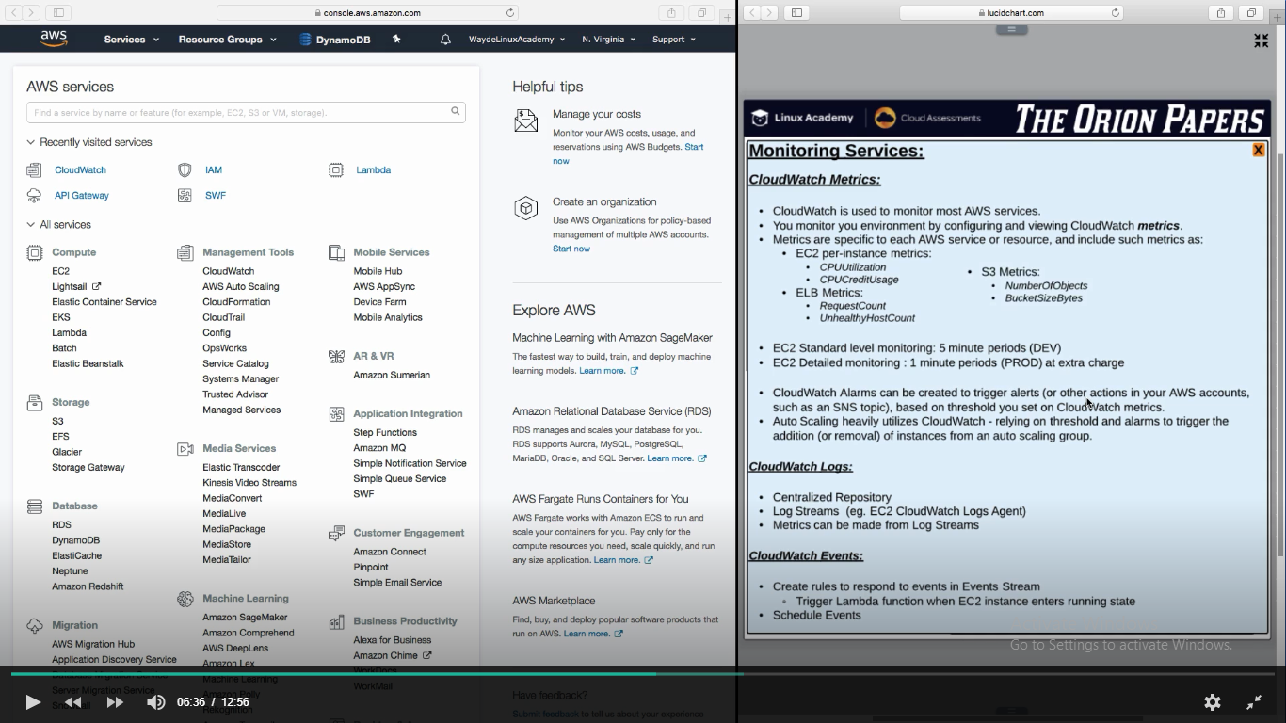

**Cloud Watch monitoring EC2**

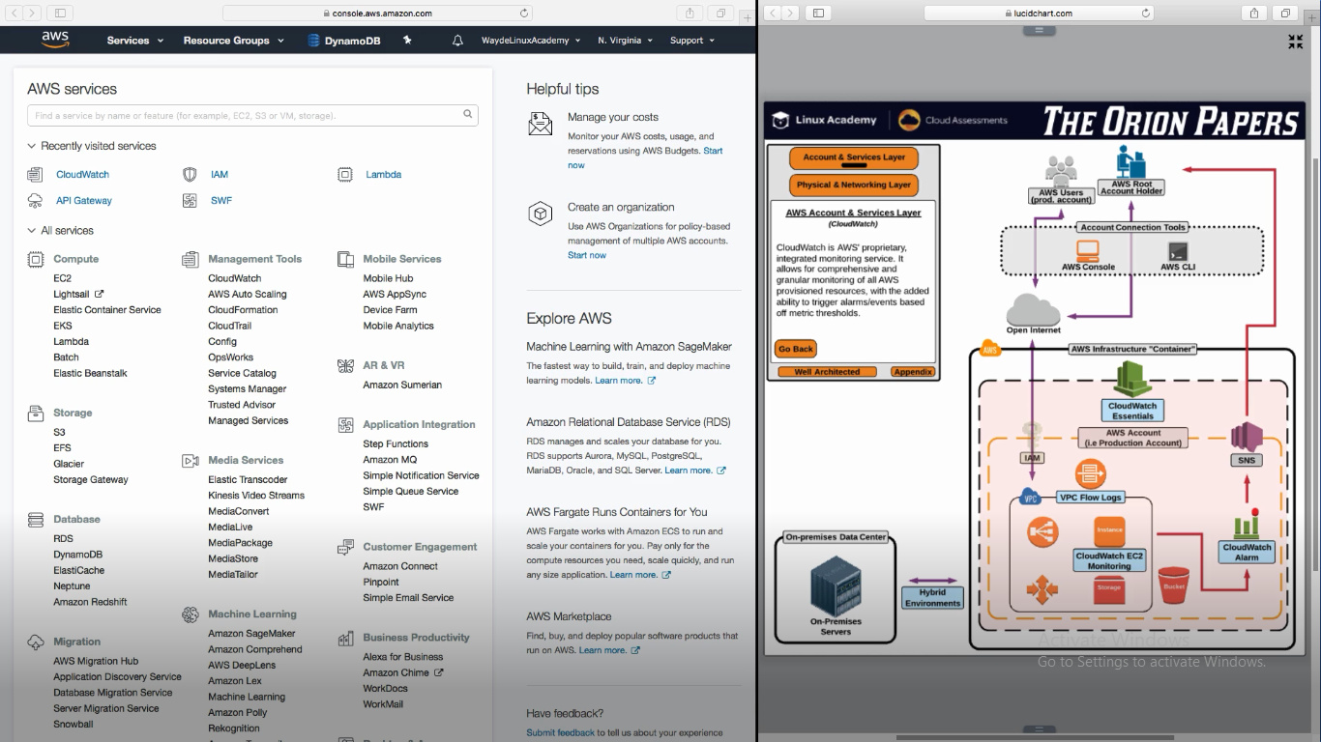

**Monitoring Service**

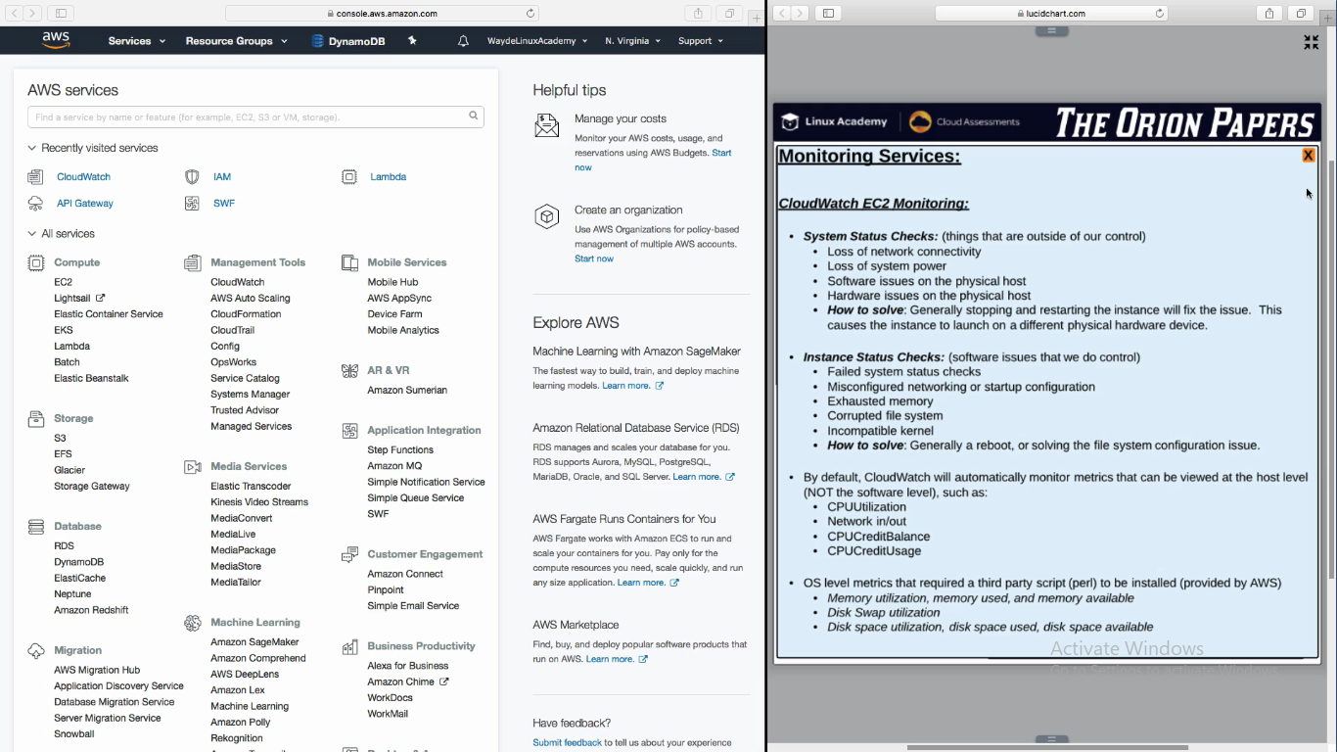

1. **Cloud watch trail**
   1. To watch any unauthorized transaction, firewall mis configurations if any etc
   2. We can feed the logs as input to cloud watch which in turn generate metrics

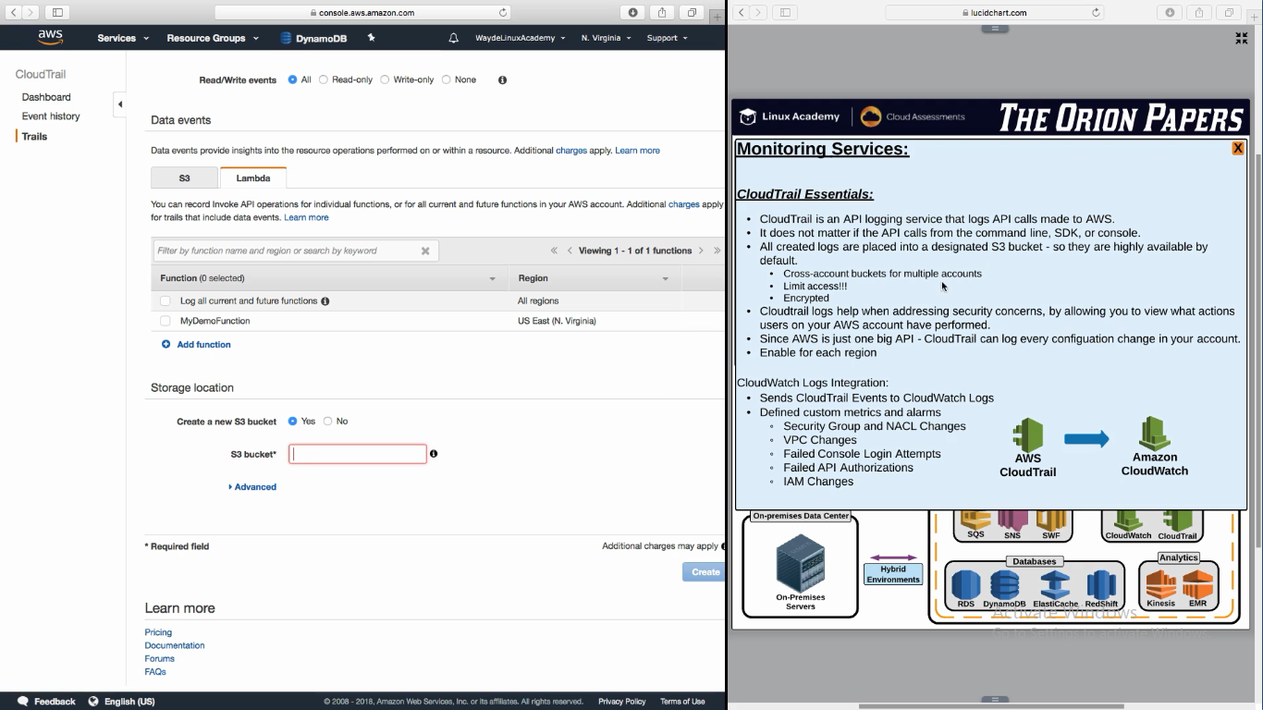

**VPC Flow logs and access logs**

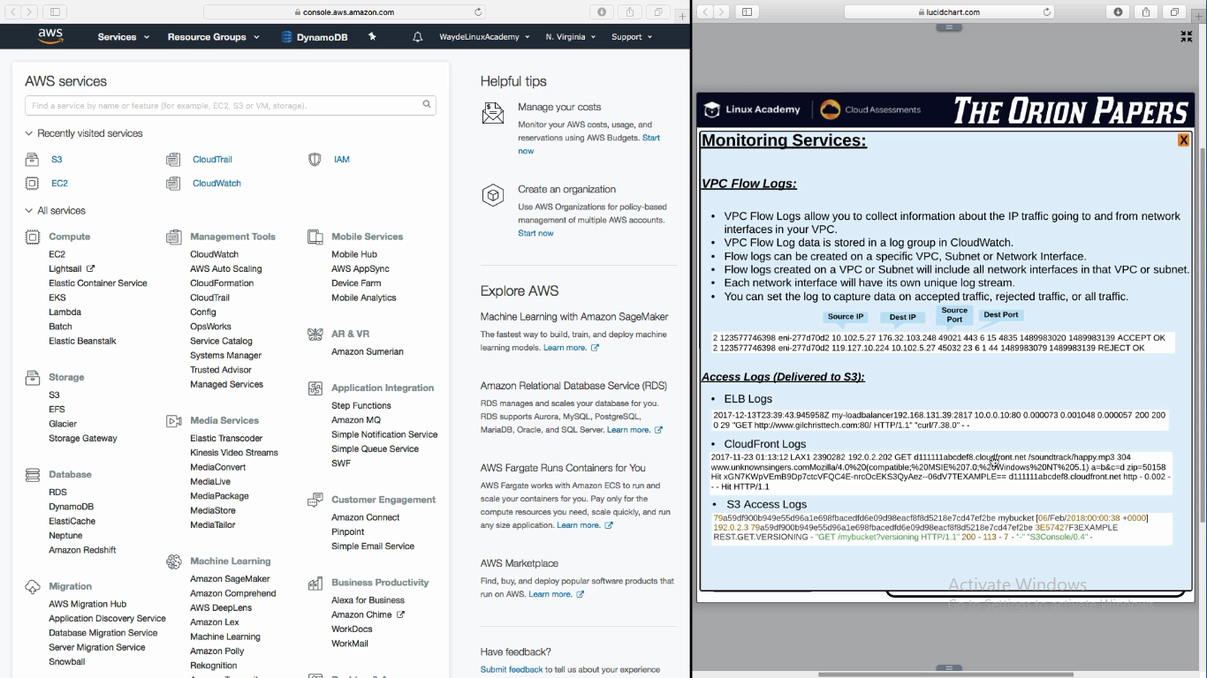

**VPC logs**

We will see incoming ip address and port numbers

**ELB Logs**

We will see http calls

**CloudFront Logs**

We will see edge location http calls

**S3 access logs**

Tells about access to a bucket