**OPERATE**

1. Amazon Cloud Watch
2. Amazon Cloud Trail
3. Flow logs
4. AWS X-rays
   1. It is to optimize the service oriented architecture. Eg analyze microservice app and provide solution to increase it performance

**AWS Config**

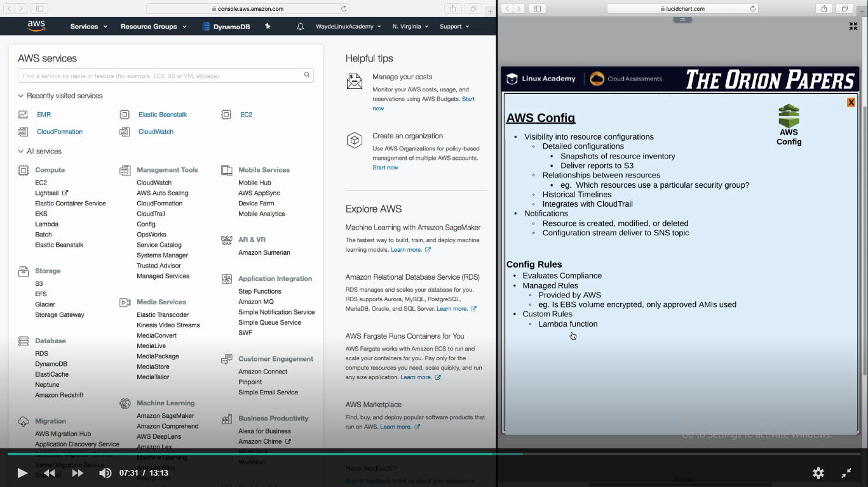

**AWS Xray**

1. If we have a micro service, and if we wish to optimize it, we have to use AWS Xray which monitors the service for performance and latency etc and say if the change is to be in code or in the underlying resources

