**IAM API Access Keys**

API Keys are just text

Access keys are for authenticating programmatic request to AWS

Access keys are permanent. They do not expire

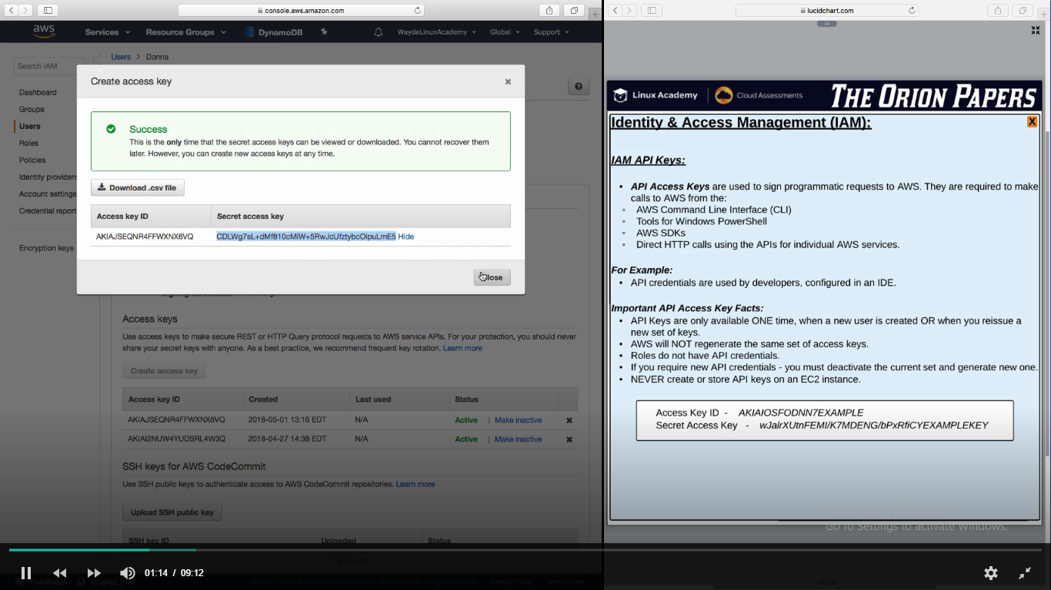

**Identity Federation**

-Way of authenticating user or applications outside of IAM

When users are already in Active Directory, use Identity Federation

**Custom Identity Provider**

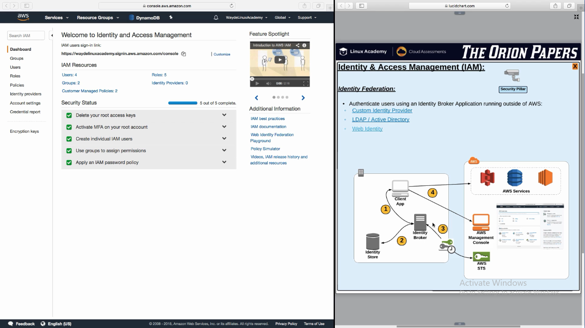

**LDAP Active Directory**

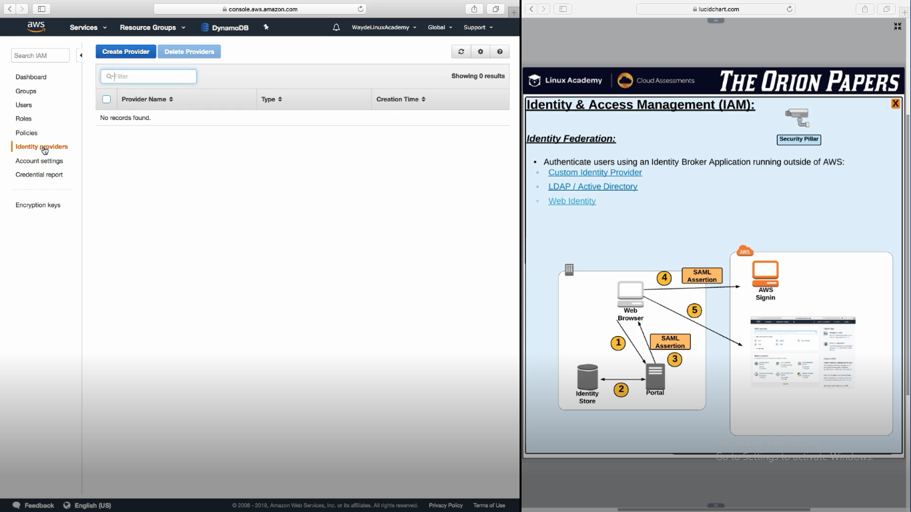

**Web Identity**

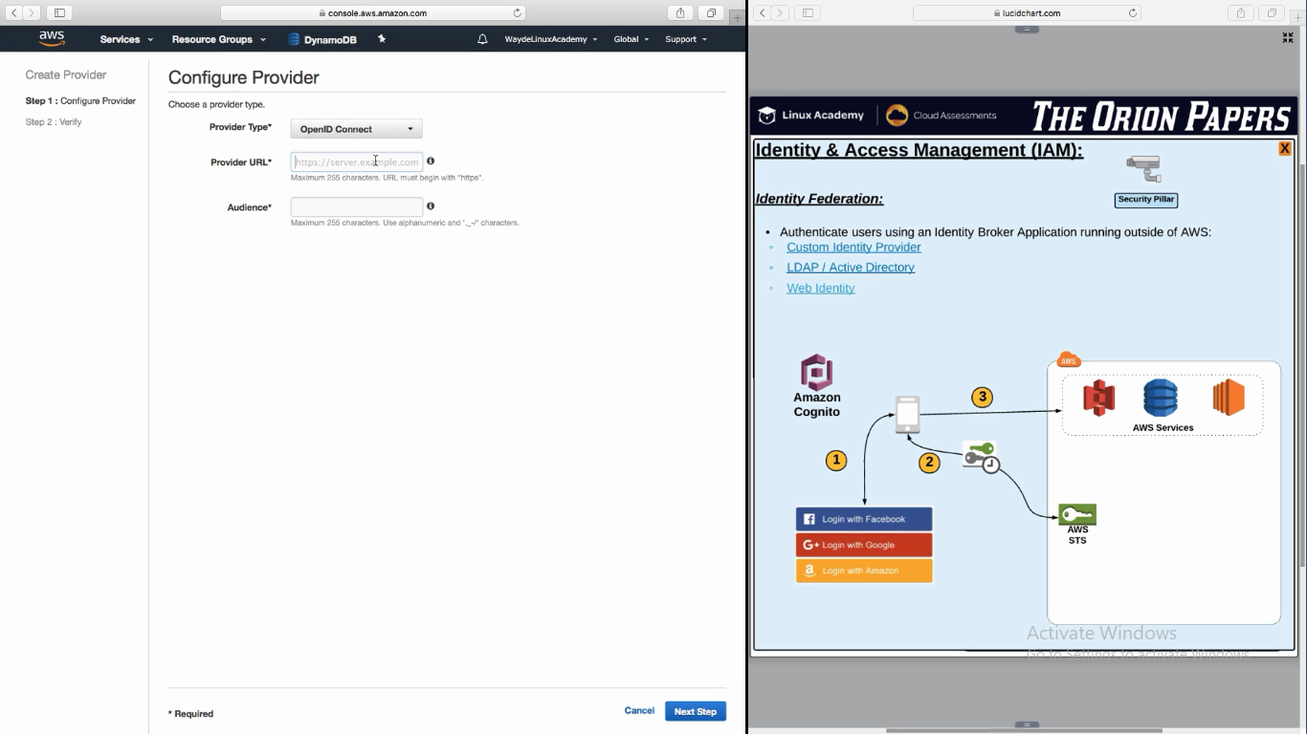

Cognito is reposible for transferring the web identity (email/fb login and password) to STS.

It eliminates us to write code

**AWS Organizations**

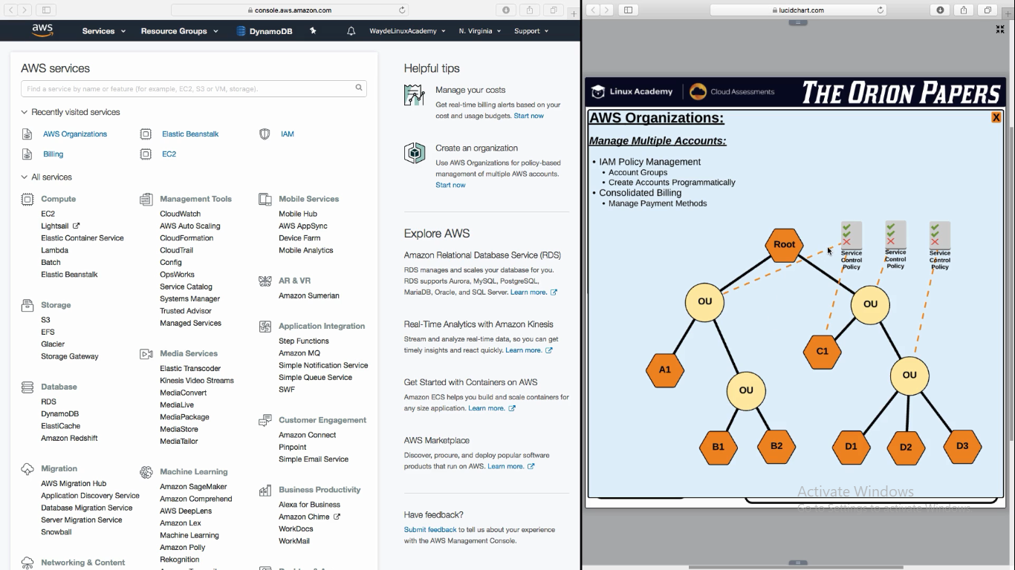

Service Control policy is like IAM Policy

**Reference:**

For more on AWS Identity Federation, see: <https://aws.amazon.com/identity/federation/>