**EFS – Elastic File system**

**Benefit**

1. Share file system across EC2 instance
   1. If web application running in multiple instance, we can update the war file in this EFS and it will be reflected in webapp in all EC2 instances
2. It automatically scales in size as we add files

**Features:**

1. We can use multiple file system
2. One EFS mount point per availability zone

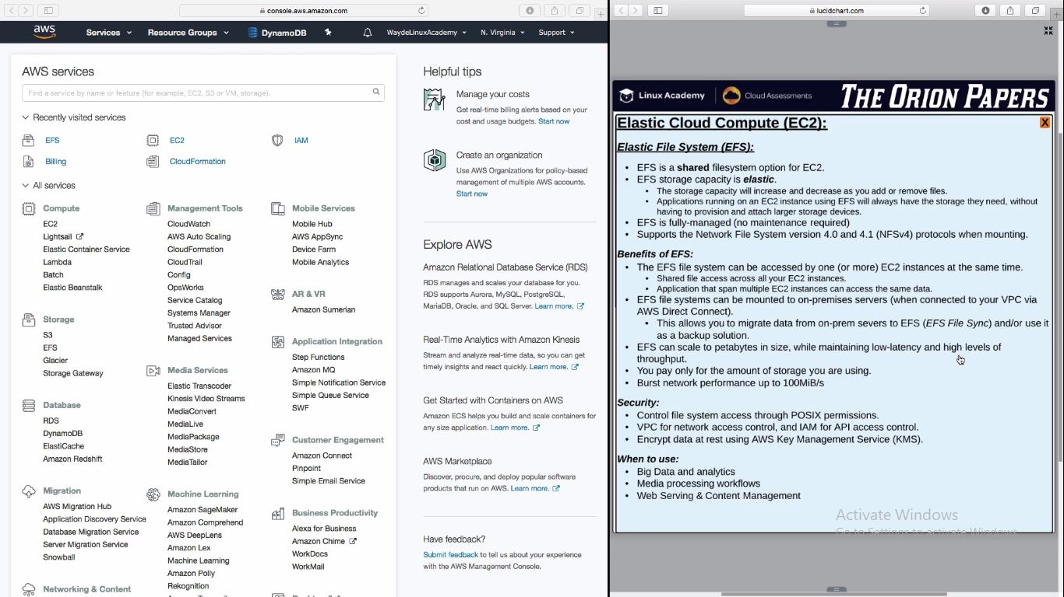

Put the EFS file system in VPC for security and create mount point

