**Load Balancing**

High input request 🡪 Many instances running

Vice Versa

ELB – Elastic Load Balancing

1. Ability to shrink and grow
2. It is self scaling
3. Adaptive

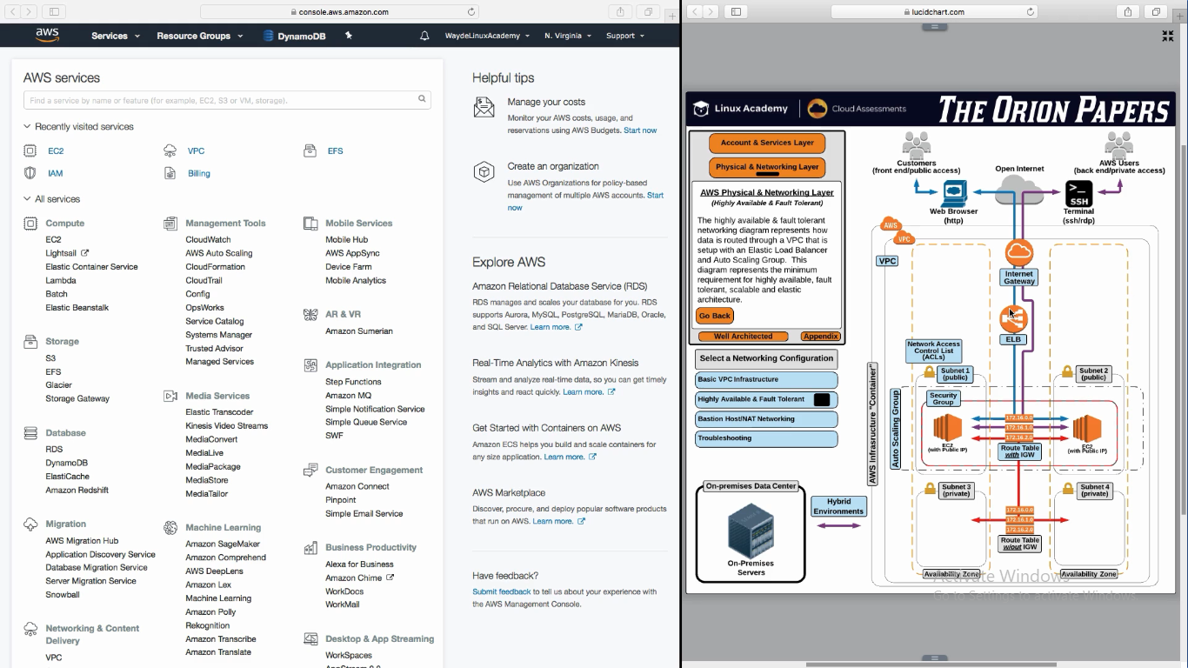

Load Balancing get information from “Auto Scaling Group” Whenever a new instance is been added/removed

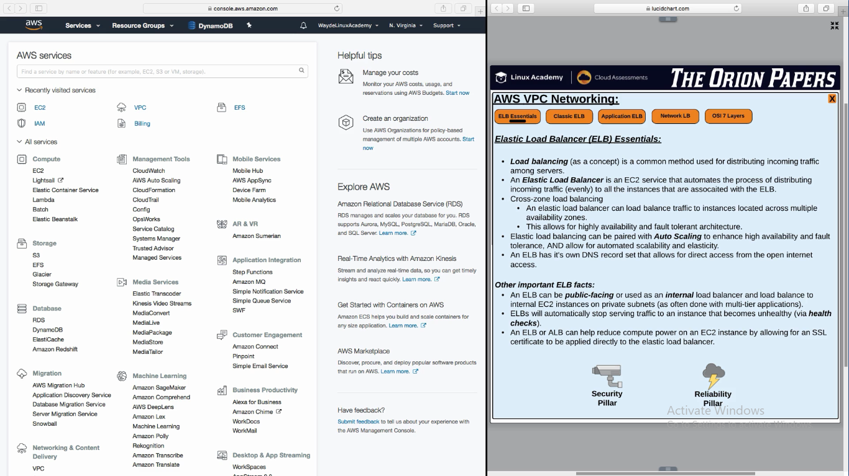

**Health Check**

Load Balancer sends a request to an instance and validates if it get a valid response 200. If not it determines that the instance is not healthy

**Classic ELB:**

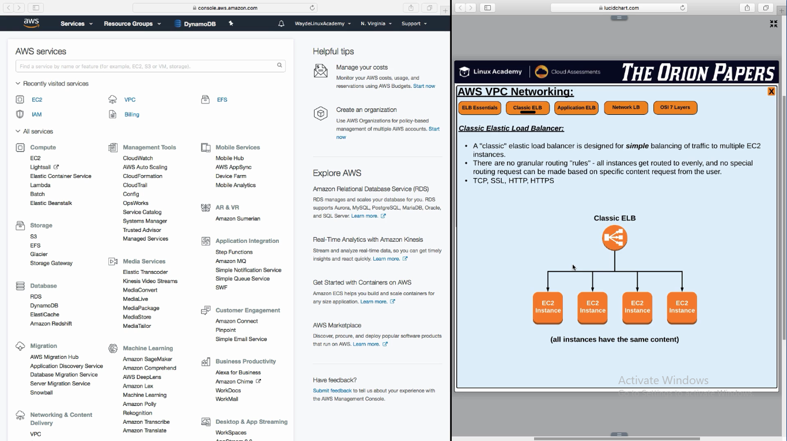

**Application ELB**

Application ELB is layer 7

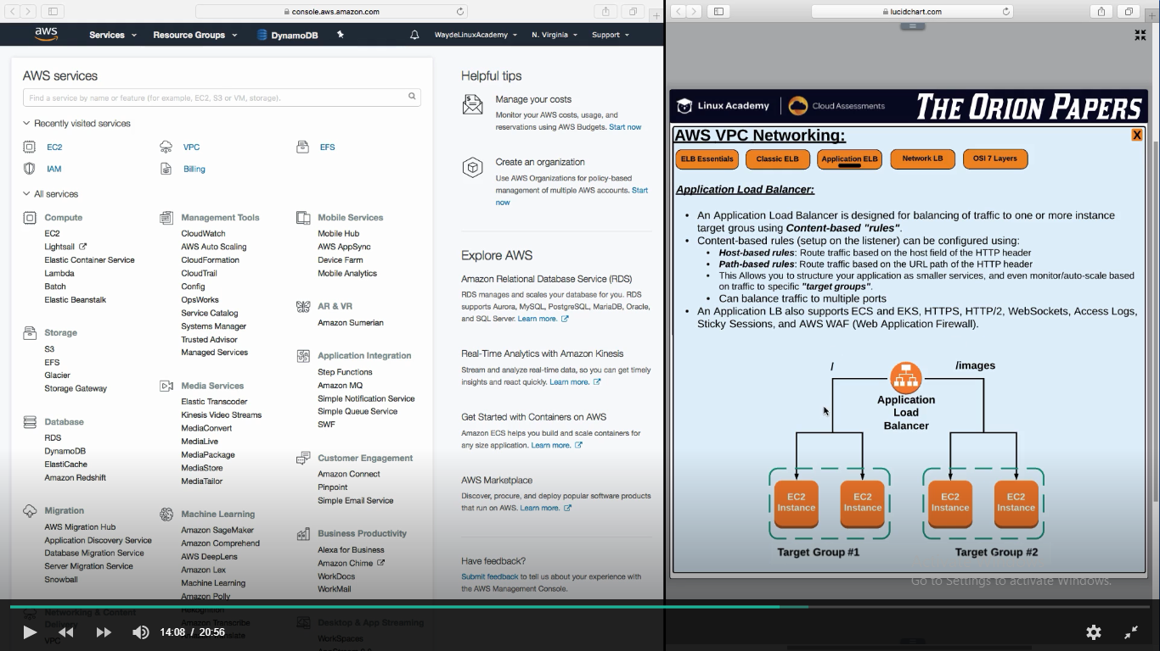

**Network Load Balancer**

This is layer 4

It does not launch instances

