**Serving traffic to and from Private Subnet**

Bastion Host and NAT Gateway

User 🡪 Internet 🡪 Internet Gatway 🡪 Load Balancer 🡪 EC2 Instance in Private subnet

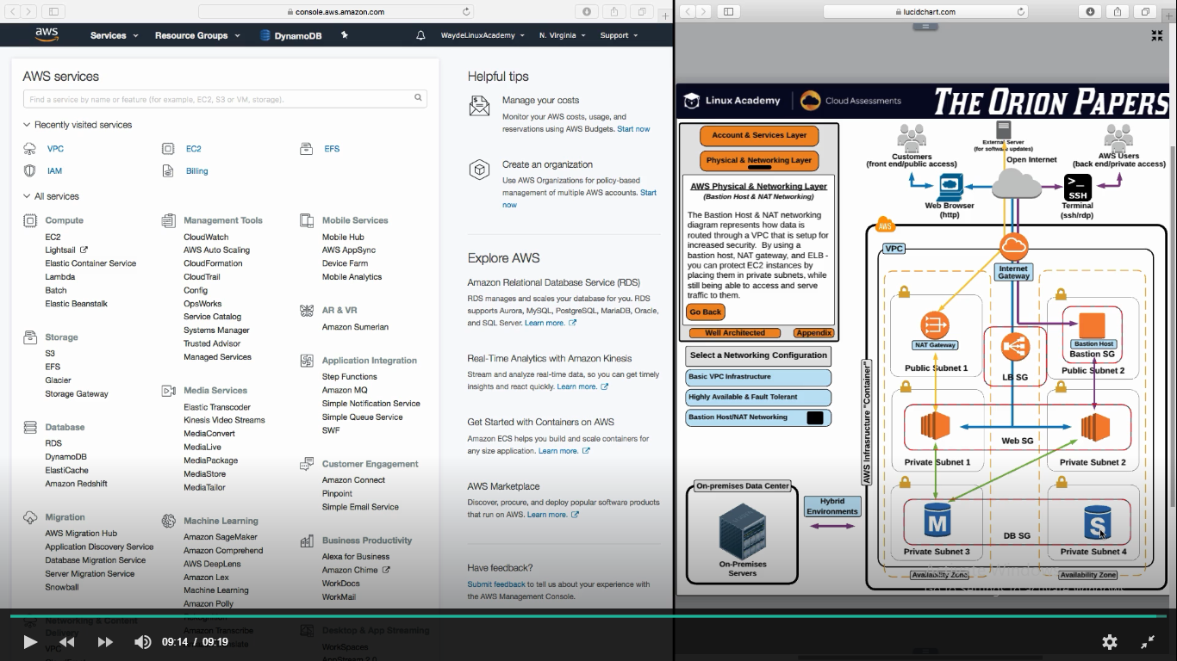

Install a ssl certificate in load balancer

User 🡪 Internet 🡪 Load balancer = HTTPS

Load Balancer 🡪 EC2Instance = HTTP

Reduces ec2 instances processing time

When we have load balancer, even admin cannot reach ec2 server directly to update some patch etc as ec2 server is in private subnet. It is not open to public calls

**Bastion Host :**

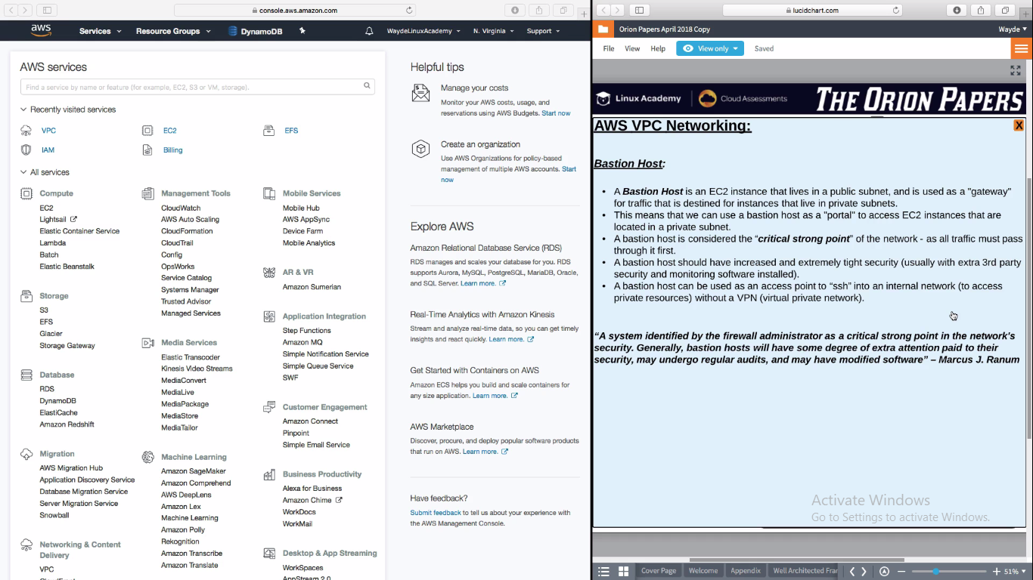

**NAT Gateway – Network Address Translation**

Suppose a server need to go to internet to download software patch or to access a external server or to user a webserver in external server or to fetch something in google, as they don’t have public ip, they can’t go out.

Servers send internet request to NAT Gateway. This NAT Gateway will use its public ip to go out to the internet via Internet Gateway and send the needed infro

**NAT is of two types:**

1. **NAT Instance**
   1. It is a EC2 instance
   2. Limited to the network througput of the instance
2. **NAT Gateway**
   1. Managed service from AWS
   2. It can bear lot of network traffic. 10GB per sec. So it is a better choice

